Experiment-1:
Installation, Environment Setup and starting with C language:
Name-Rahul Mankani
SAP ID-590014725
Batch- 38
Course Coordinator- DR. Tanu Singh

- Write a C program to print “Hello World”.
#include<stdio.h>
int main()
{
printf("Hello World\n");
return 0;
}
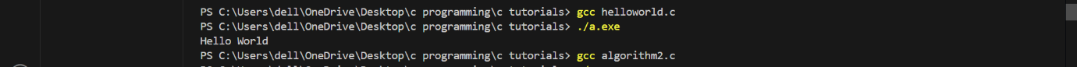

- Write a C Program to print the address in multiple lines (new line).
#include <stdio.h>
int main()
{
printf("House no.- 3-kh-30,\n3rd sector,\nBehind Badhir Vidyalya,\nVaishali Nagar,\nAjmer");
return 0;
}
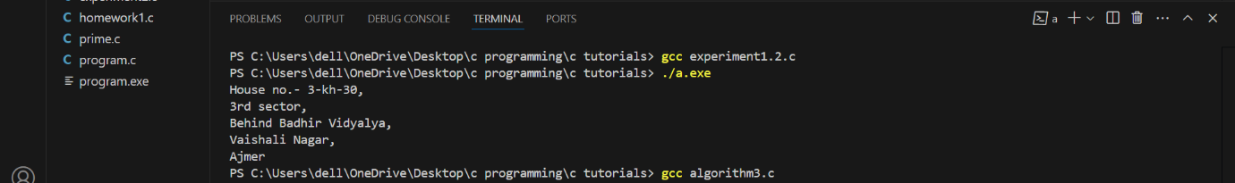

- Write a program that prompts the user to enter their name and age.
#include <stdio.h>
int main()
{
char firstname[20],lastname[20];
int age;
printf("Enter your firstname:\n");
printf("Enter your lastname:\n");
printf("Enter your age:\n");
scanf("%s%s%d",&firstname,&lastname,&age);
printf("Name:%s",firstname);
printf("%s\n",lastname);
printf("Age:%d",age);
return 0;
}
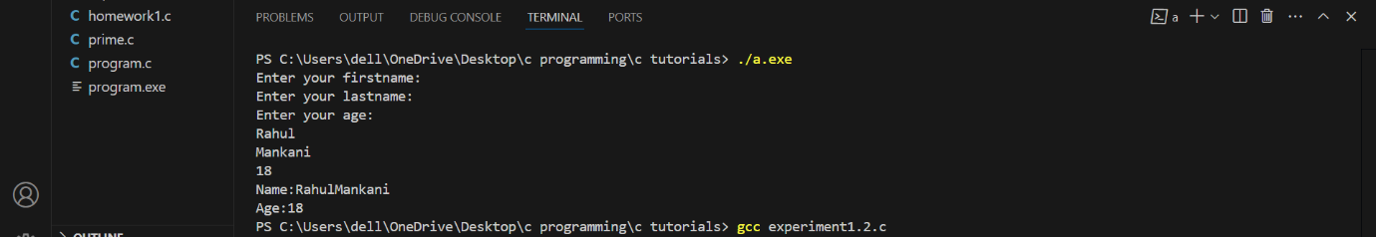
4.Write a C program to add two numbers, take number from user.
#include <stdio.h>
int main()
{
int num_1,num_2,sum; //declaration
printf("enter two numbers:\n");
scanf("%d%d",&num_1,&num_2); //sum of two numbers
sum = num_1+num_2;
printf("sum of two numbers is %d ",sum);
return 0;
}
