# WIREFRAME

E-Commerce

Dashboard

Mayank Rai

**Homepage**

* Dashboard

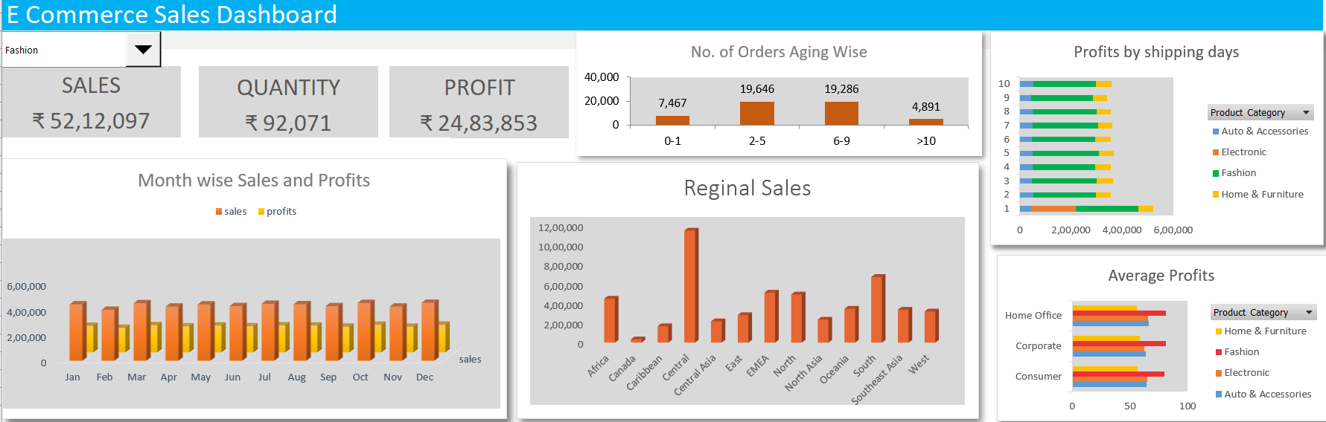

* Combo box

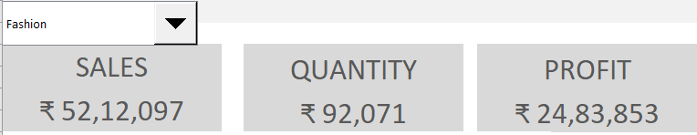

* Month wise Sales and Profits

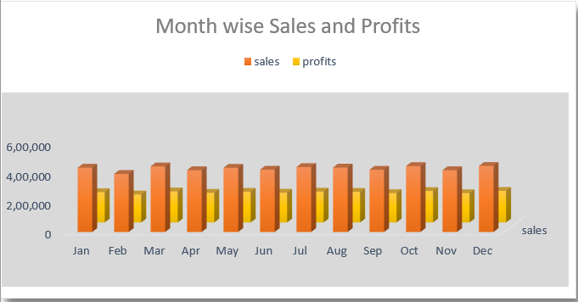

* Reginal Sales

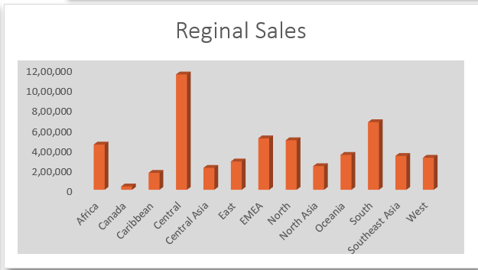

* No. of Orders Aging Wise

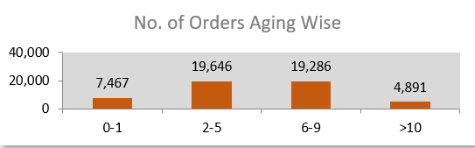

* Profits by shipping days

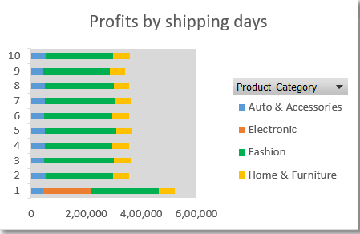

* Average Profits by product segment and categories

