**Ixigo Challenge**

**Assumptions Made :**

1. Data will be coming in JSON objects from different service providers
2. Collected Data from Make My Trip, Ibibo and Expedia websites
3. Checking if there are any common hotels exists in all the data.

**Architecture :**

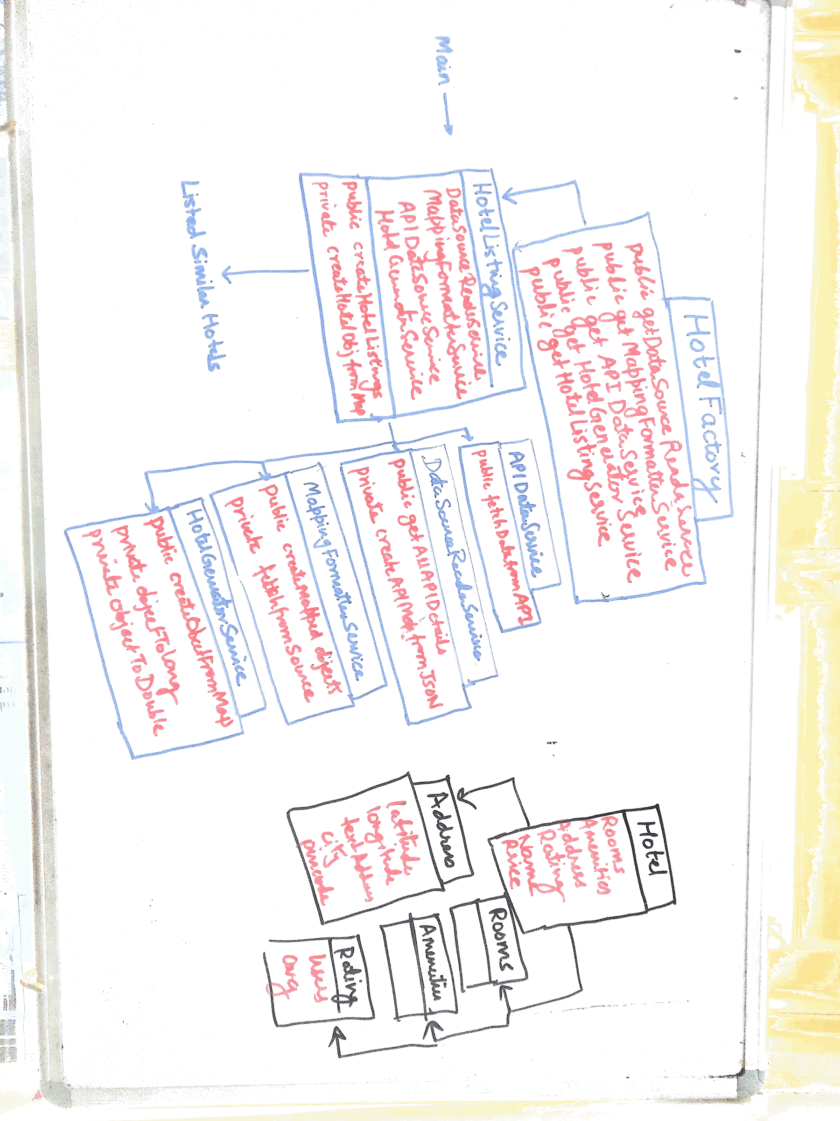

< Class Diagrams >

**How it works :**

1. There is a mapping file (mapping.json) that contains API url and recrusive mapping of specific fields that are required by Hotel Object.
2. At first, **DataSourceReaderService** reads the data from mapping file and generates an object of **APIMap** which contains mapping and api urls.
3. From **APIMap** we pass the URL to **APIDataService** which returns the API results containing hotel data.
4. After this, **MappingFormatterService** formats the data using a recursive parser into the desired format from the mapping given in **APIMap**.
5. This formatted maps are passed to **HotelGeneratorService** to create a hotel object.
6. **Hotel** and **Address** object’s equal method is overriden as to ensure if the address are equal by a margin then the two addresses must be same. And levensthein’s distance is applied to check if any typo errors or single word changes are there.

**How to run :**

Just do **“java -jar dist/ixigo-runnable.jar”**