Project Proposal For

Medical College and multi-speciality Healthcare centre for senior citizens and differently abled

**Introduction of the Project**

The project is the result of detailed study conducted by CADRE India under the leadership of Mr. Mohan Kumar. The theme chosen by CADRE was healthcare and the project delves into healthcare and medical standards and needs of senior citizens and differently abled citizens in India. So, in order to study this problem empirically, we began work in Kurumathoor village of Vilavancode Taluk in Kanyakumari District, Tamil Nadu, with a small set of activities for the disabled, children and women in the areas of health,education handicraft training and cultural activities.

Thereby, we have collected enough data and material to prepare a project which can we give insight into how we can improve the medical conditions of senior citizens and differently abled in Kurumathoor village of Vilavancode Taluk in Kanyakumari District, Tamil Nadu and why there is a **need for** **Medical college and multi-speciality Health Care Research and Retreat centre for senior citizens and differently abled.**

The Government of India adopted the National Policy on Older Persons in 1999, which defines a “‘senior citizen’ or ‘elderly’ as a person who is of age 60 years or above.” In India the elderly population accounted for 8.2% of the total population in 2011 and the number is expected to increase over the next decades. The link between aging and disability is a biological fact, and disability in the elderly is an important health indicator pointing to jeopardized quality of life. But at the same time, aging should not be treated as synonymous with disability as a large proportion of older people live with good health status. There are many studies from India that have addressed disability in the elderly population; however, they lack uniformity in defining disability and largely address mostly one aspect, that is, the medical model of disability. It is well recognized that “disability and elderly” encompasses a much larger spectrum of the conditions with unique requirements and needs to be studied as a much broader concept.

**Medical and Healthcare conditions in India**

Persons with Disabilities - Definition

Recently, The Rights of Persons with Disabilities Act, 2016, replaced the Persons with Disabilities (Equal Opportunity Protection of Rights and Full Participation) Act, 1995. The new act aims to protect the rights of persons with disabilities. It considers 21 disabilities, including Speech and Language Disability and Specific Learning Disability. According to this act, a ‘person with disability’ is a person with long term physical, mental, intellectual or sensory impairment which, in interaction with barriers, hinders his full and effective participation in society equally with others.

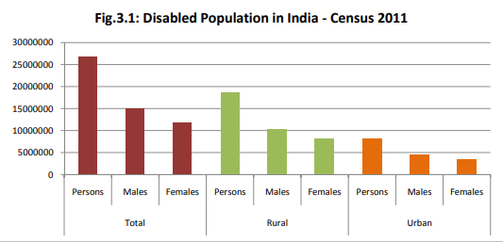

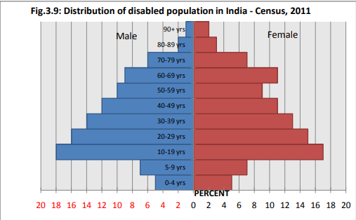

**Conditions of differently abled citizens in Tamil Nadu**

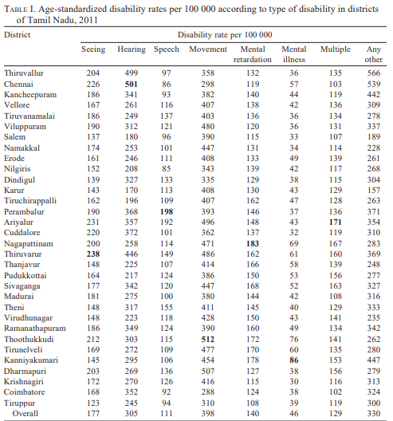

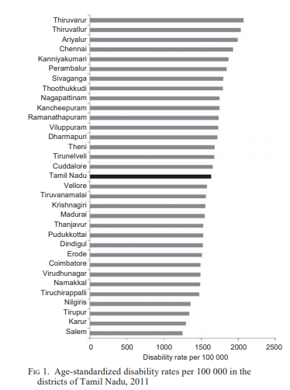

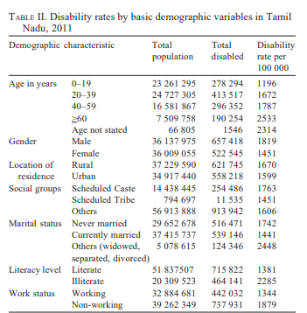

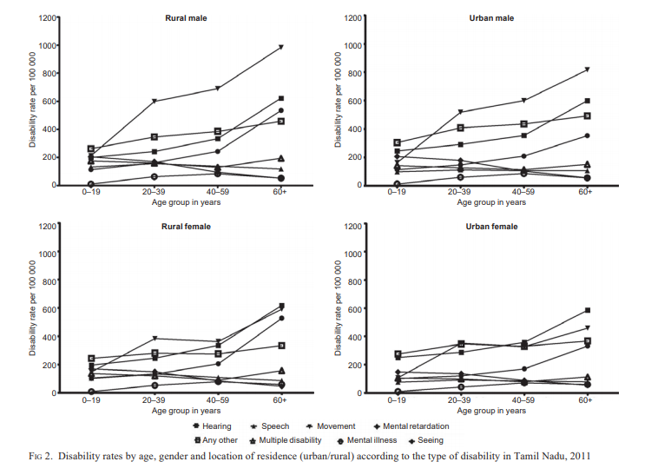

Senior Citizens – Definition

There is no United Nations standard numerical criterion on define old age, but the UN agreed cut-off is 60+ years when referring to the elderly population or the senior citizen.

Ageing is a relative term. Health influences the age of a person and on the other hand age also influences the health. As people above sixty years of age are accounted as senior citizens; the ‘grand parents’ or the ‘elderly people’ are synonymously used with the ‘senior citizens’. Traditionally, in India, it has been a part of culture, for society and the family to take care of older persons. Senior citizens are held in high esteem and are given priority and respect in all matters.

With rapid urbanization and the compulsions of modern working conditions, have lead to a breakdown of the traditional joint family system, resulting in the growth of nuclear families. Better medical facilities have lead to increased longevity of life. As per 2001 Census, India had around 81 million elderly out of one billion people. The number of Senior Citizens in the country has been steadily increasing. According to the 52nd round of National Sample Survey

63 per cent of the Indian elderly were found illiterate. Out of the 81 million elderly in 2001 census, almost 51 million elderly are below poverty line.

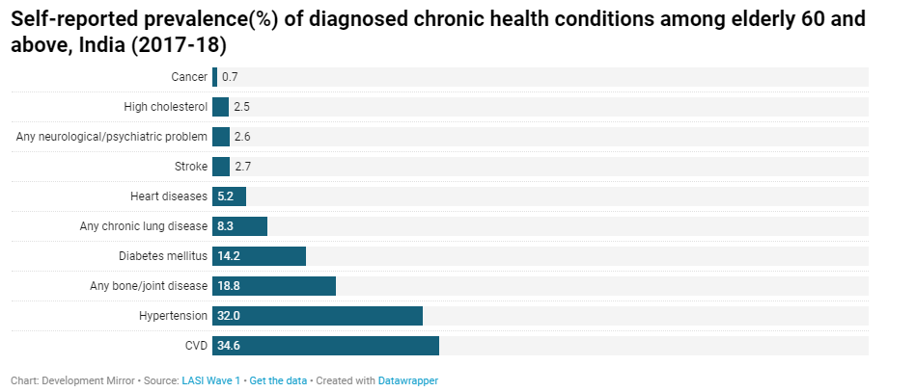

**PHYSICAL HEALTH**

During old age the metabolism processes slow down. Older person became weak in physically as well as mentally. Elderly have limited regenerative capabilities and are more prone to disease, syndromes, and sickness than other age groups. The immune system became weak. With the weaknesses many diseases get it easy to attack the body. There is often a common physical decline, and people become less active. Some of the common diseases prevailing during old age are: Obesity and diabetes, Hair loss, change of hair colour to grey or white, wrinkles and liver spots on the skin, agility and slower reaction times and reduced ability to clear thinking, lessened hearing, diminished eyesight, difficulty recalling memories, lessening or termination of sex and sexual behaviour, greater weakness to bone diseases such as osteoarthritis. Any disease can affect easily in the age group of 60+ years. Few of those as follows:

**Joint Pain:** - One of the most familiar problems faced by elderly people is joint pain. There are of course several types of problems that cause normal joint pain in ‘old’ people and ‘normal’ people alike. Bursitis, tendinitis, various types of arthritis, and other complaints, can be the cause of a person’s aching joints. Excess of body weight places added pressure into these joints causing pain and lessens overall mobility and flexibility of the joints.

**Constipation**: - When a person reach the age of 60 to 65 years, his habits are thoroughly deep-rooted in him and this is especially so with his dietary patterns. As a person ages and illnesses set in, it becomes compulsory for the elderly to change their dietary habits.

Here it is the question of having digestion. After we ingest food, the peristaltic movement of the intestine pushes it forward to facilitate digestion and absorption. Finally the leftovers are excreted outside the body as faeces. Peristalsis of the intestine in the elderly is usually weakened; hence they are more prone to constipation. Normally the causes of constipation are as follows:

* Inadequate water or lack of fibre in food, leading to hard faeces
* Psychological factors, e.g. using bedpan or commode chair without privacy, a dirty toilet, depression, etc.
* Drugs such as morphine group pain killers, calcium tablets etc.
* Diseases, e.g. diabetic, hypothyroidism etc.

**Problem in eye sight: -** The most common is age related (degenerative), affecting most of the elders. Other causes include inborn or congenital, injuries to the lens, and effects of drugs. Systemic illnesses like diabetes mellitus may lead to earlier onset of cataract.

*Symptoms:* Symptoms vary among patients and depend on the degree and site of opacity of the lens. The most common are: Gradual impairment of vision, Faded or dimmed vision, Glare or dazzle (particularly in bright sunlight, driving at night), Change in colour of objects seen, Double vision.

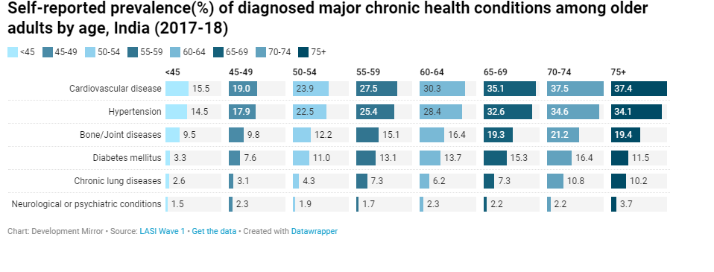

**Healthcare conditions in Tamil Nadu**

1. **Senior citizens**

**The challenges**

Most of the elderly in India are reluctant to live in old age homes and prefer to receive care at home. The changing structure of the traditional family makes this difficult to achieve. As young members of the family seek jobs to improve their economic condition, an elderly family member to care for, becomes a burden.

While the need for home care increases and organisations have begun offering trained home care services, there are several challenges. “The general tendency is to use other help, such as drivers or gardeners to double up as care givers. There is a reluctance to admit an outsider into the home,” says Arun Varma of Winage, an organisation dedicated to elder care. Many factors come into play. There is a preference for people who speak Tamil, same religion and even people of same community.

TN is very price-sensitive. Typically, home care givers, trained for basic care (not nursing care) demand between Rs 15,000 and Rs 18,000 per month plus food and stay. Nursing support with medical conditions costs closer to Rs 24,000 per month.

“Approaching elder care as charity cannot work. We believe in making elder care a protocol-based, paying job. How can we attract 22-year-olds to this profession if we cannot promote it as a paying profession,” asks Varma. The reluctance to employ an outsider stems from the need to share space with an outsider, isolated incidents of indifference from the care giver and cases of attenders being too demanding for food, television time, free time and money.

“Home care professionals are selected after a verification of their family background and their documents,” says T D S Mohan of TDS Manpower Consultancy.

Problems crop up when the attenders are treated as servants, expected to do other housework and not as professionals, he says.

Vaibhav Tewari, COO, Portea Medical says, “India has a hospital bed ratio that is one-eighth that of developed countries. Home care becomes even more important in this situation”. For Portea, home care has two parts – health management and health care. It is expected that India will have 35 crore people in the 60 plus age group by 2050. A significant number of them will need customised health management and care. Portea employs around 3,300 health care professionals and has a presence in 21 cities.

**Schemes for the elderly**

* Jayalalilthaa Medical Insurance: provides cover up to Rs 75,000
* The Ayushman Bharat Pradhan Mantri Jan Arogya Yojana: Provides Rs five lakh per family and Rs five lakh for women for health care
* Rashtriya Vayoshri Yojana: Provides assisted-living devices such as walking sticks, walkers, elbow crutches, tripods, hearing aids, wheelchair and dentures for the elderly below poverty line (BPL)
* Varishta Pension Bima Yojana: (VPBY) offers a sum assured of Rs 1 lakh and Rs 2 lakh for hospitalisation
* Jeevan Pramaan: A pension for employees of State, central govts. and govt. organisations

**Concessions**

* Interest rates on deposits are 0.5 to 1% higher than normal rates
* TN government issues free bus passes that can be collected from nearby depots on furnishing ID proof
* 50%concession for women on rail tickets while men can avail 40%.  If the elderly person is travelling for medical treatment, one attendant is also granted the benefit
* The number of crimes against senior citizens in Chennai has more than doubled to 484 in 2017, from 210 in 2016, data released by the National Crime Records Bureau (NCRB) shows. The number of crimes against senior citizens in the State reduced marginally to 2,769 from 2,895 in 2016, but was still the third highest in the country
* WHO says that countries such as France had almost 150 years to adapt to the increase in proportion of the elderly from 10 to 20 % of the population, India, Brazil and China had only 20 years to adapt.

1. **Differently abled citizens**
2. **EARLY Diagnostic Centres for Hearing Impaired Children Hearing** loss continues to be the most common birth defect in India. Early diagnosis is crucial for babies with profound or severe hearing loss. With early diagnosis, these children can be fitted with appropriate amplification devices and then receive early intervention, ideally before 6 months of age. Advancement in technology has provided ever-improving opportunities to identify hearing loss in infant soon after birth. Early diagnostic centres have been established for the hearing impaired in 27 districts. Hearing screening with Oto Acoustic Emission (OAE) and Auditory Brain Stem Response (ABR) are done in these centres. A large number of infants have been screened and received treatment at each of these centres.
3. **EARLY INTERVENTION CENTRES FOR THE DIFFERENTLY ABLED CHILDREN Research** in child development has shown that the rate of human learning and development is most rapid in the early stage of life. Early intervention is essential as the child may run the risk of missing an opportunity to learn during the early stages of life. Considering the above facts, Government of Tamil Nadu has established Early Intervention Centres for Children with various types of Disability. All children with disability along with an escort are allowed to travel free of cost in State Transport Corporation buses from their residence to these Centres and back.
4. **EARLY INTERVENTION CENTRES FOR MENTALLY RETARDED CHILDREN** Early Intervention Centres for Children with Mental Retardation in the age group of 0-6 years have been established in 31 districts through Non Governmental Organisations. These centres aim at training the children, their parents and families to maximise their capabilities in mobility, day-today living, socialization and other skills. “UPANAYAN” a systematic and structured programme for the training of children with delayed development and mental retardation developed by the Madhuram Narayanan Centre for Exceptional Children, Chennai is being followed in these centres. Teaching, learning and play materials are also provided at the Early Intervention Centres for the Mentally Retarded children. The Special educators of these Early Intervention Centres are given refresher course every year. 1460 Mentally Retarded Children are attending these centre.
5. **PROVISION OF WEANING FOOD AND SUPPLEMENTARY NUTRITIOUS FOOD TO CHILDREN IN EARLY INTERVENTION CENTRES** Infants and children with disabilities can suffer from the ill-effects of under nutrition in the same way as children without disabilities, leading to poorer health outcomes, missing or delayed developmental milestones, acquiring avoidable secondary conditions as well as unnecessary stunting in physical growth. In order to address the issue of access to nutritious food for children with disabilities, Weaning food and Noon Meal is provided at Early Intervention Centres through the nearby Anganwadi Centres functioning under the Integrated Child Development Services. As many as, 1952 children in these Early Intervention Centres are benefited under this scheme.

**STATE RESOURCE CUM TRAINING CENTRE AT CHENNAI**

The State Resource cum Training Centre, Chennai, was started in the year 2005, with the aim to provide specialized services and information under one roof to all categories of differently abled persons by Governmental and Non Governmental Organizations. Disability certificates and National Identity Cards are issued to all categories of differently abled persons at this centre. 8932 disability certificates were issued from the centre during 2019-2020. Early Intervention Centres for the Hearing Impaired, Cerebral Palsy, Visually Impaired, Autism, Mentally Retarded and Sensory Integration Unit are also functioning at this centre. Children with disabilities in the age of below 6 years are admitted in these Early Intervention Centres. Besides, various Training programmes are also organized at this centre.

**HEALTH PROBLEMS OF SCHEDULED TRIBES IN KANYAKUMARI DISTRICT OF SOUTH TAMIL NADU.**

**Methods:-**

The present study was undertaken Andipottai, Kazhaparai, Thanchanmalai, Thottamalai and Mudavarpottai tribal settlements in Kanyakumari district. This study based on primary data and used simple random sampling technique. The study covers the socio-economic condition like income, expenditure, savings, age, marital status, health conditions and health problems of the respondents. From each settlement 30 samples were selected on the basis of convenience random at the total of 150 samples.

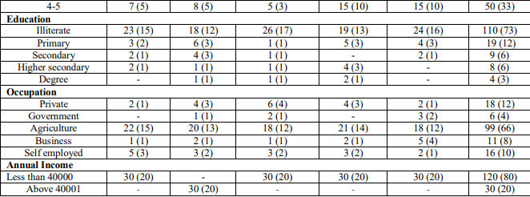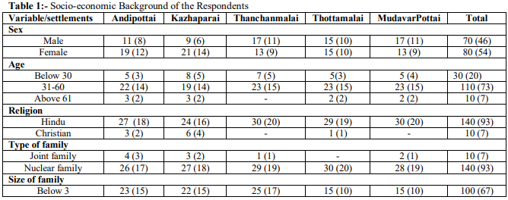

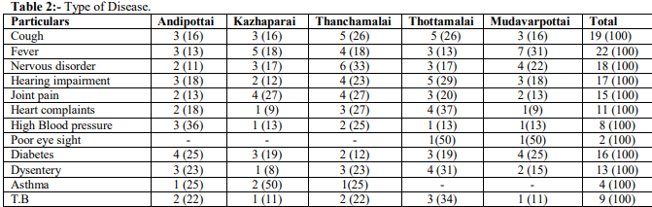

**Suggestion:-**

* To achieve holistic development, attention should be given more towards the health of the tribal in a realistic manner. Their health status can be improved significantly by scientifically executed intervention with target appropriate education material by picture formed and techniques.
* There is need for the educational empowerment of all tribal settlements in Kanyakumari district. The Information Education and Communication (IEC) should reach all tribal for enhancement of knowledge of communicable and non-communicable disease.
* The Behavioral Change Communication (BCC) should be strengthened to utilize more health care services.
* Building a medical college and multi-specialty Healthcare and Research and Retreat center for differently abled and senior citizens.

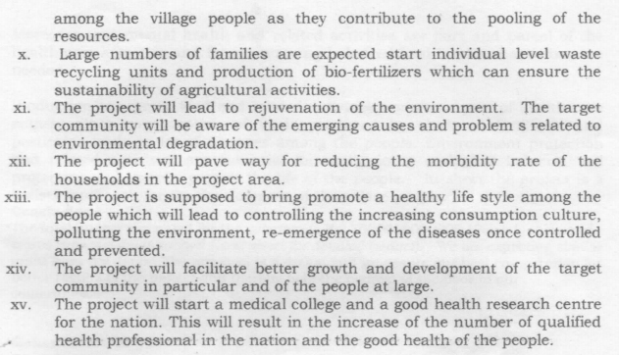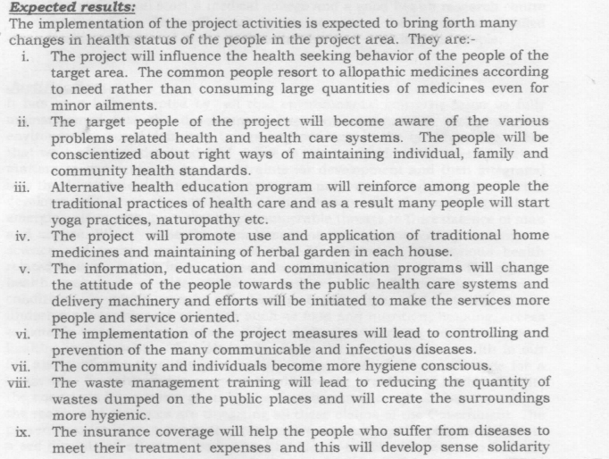

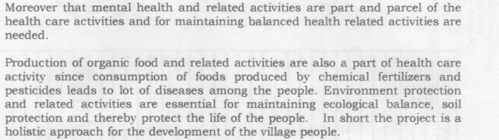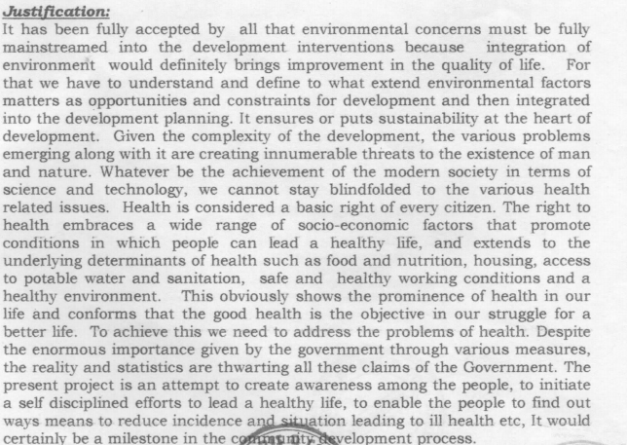

**Certificate: -**

