# **Step 1: Logging into Azure Portal**

Open your web browser and navigate to [https://portal.azure.com](https://portal.azure.com/).

Sign in using your Azure account credentials.

# **Step 2: Navigating to Virtual Machines**

1. After logging in, you’ll land on the Azure dashboard. In the left-hand menu, click on “**Virtual machines**”
2. This will take you to the Virtual machines section, where you can manage your VMs.

# **Step 3: Creating a New Virtual Machine**

Click the “**+ Add**” button to start creating a new virtual machine.

The process begins with configuring the basics of your VM:

* *Subscription:* Choose the appropriate subscription.
* *Resource Group:* Create a new or select an existing resource group.
* *Virtual machine name:* Give your VM a unique name.
* *Region:* Choose the data center region closest to you.
* *Availability options:* Select the availability preferences.
* *Image:* Choose the operating system image you want to use.
* 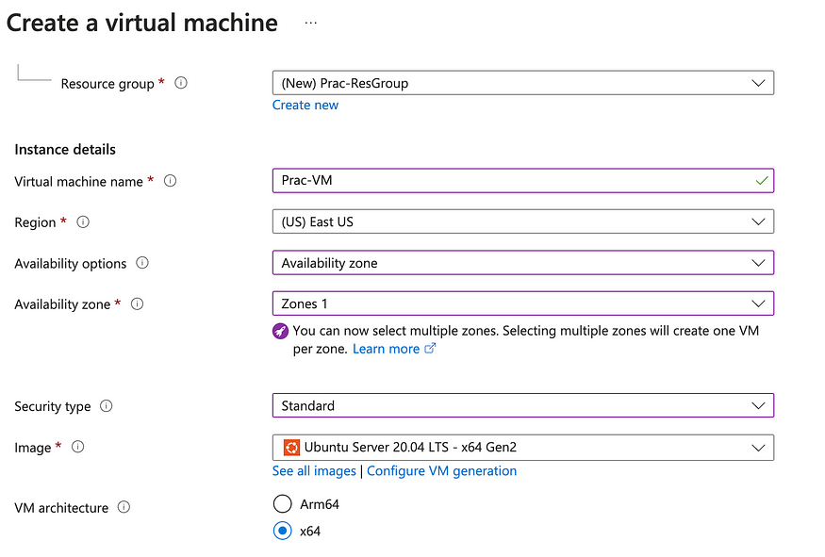

# **Step 4: Choosing VM Configuration**

1. Under “Size,” select the appropriate configuration for your VM based on CPU, memory, and storage requirements.
2. Carefully review the available sizes and consider your workload needs.



# **Step 5: Setting Up Authentication and Security**

1. Under “Authentication type,” choose either an SSH public key or a password.
2. Depending on your choice, provide the necessary credentials.
3. Configure inbound port rules to allow remote access via SSH or RDP.
4. Define public inbound ports for external connectivity.

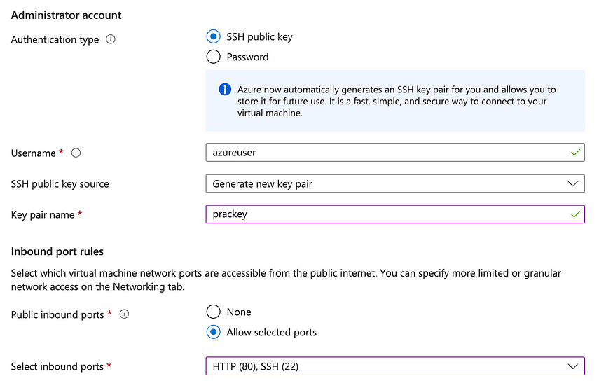

# **Step 6: Configuring Disks and Storage**

1. Under “Disks,” choose the OS disk type (Standard HDD, Standard SSD, Premium SSD).
2. Adjust the OS disk size according to your needs.

**Note**: Choose Standard SSD for practice purposes

# **Step 7: Network Configuration**

1. In the “Networking” section:
2. Choose an existing virtual network and subnet or create new ones.
3. Assign a public IP address if needed.
4. Configure network security groups to control traffic.

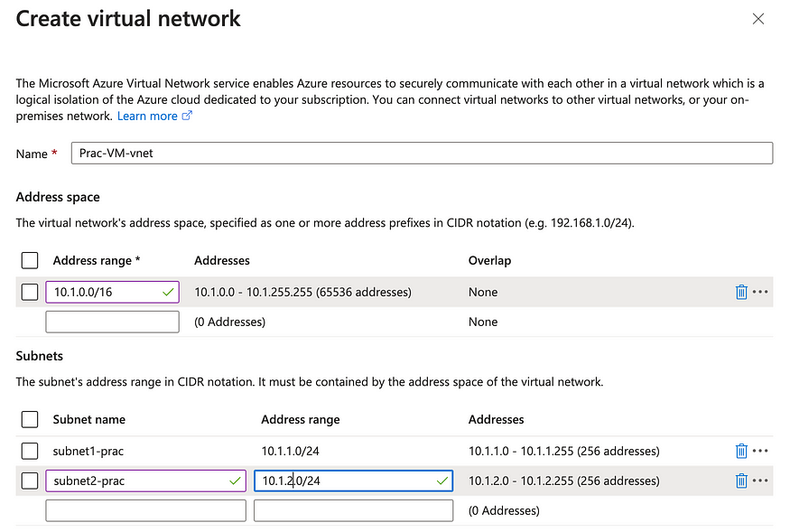

# **Step 8: Management and Monitoring**

1. Under “Management,” enable diagnostic settings for monitoring.
2. Configure boot diagnostics for troubleshooting.
3. Explore extensions for adding extra functionality.

# **Step 9: Review and Validation**

1. Review all your configuration settings to ensure accuracy.
2. Validate that your selections align with your intended VM setup.

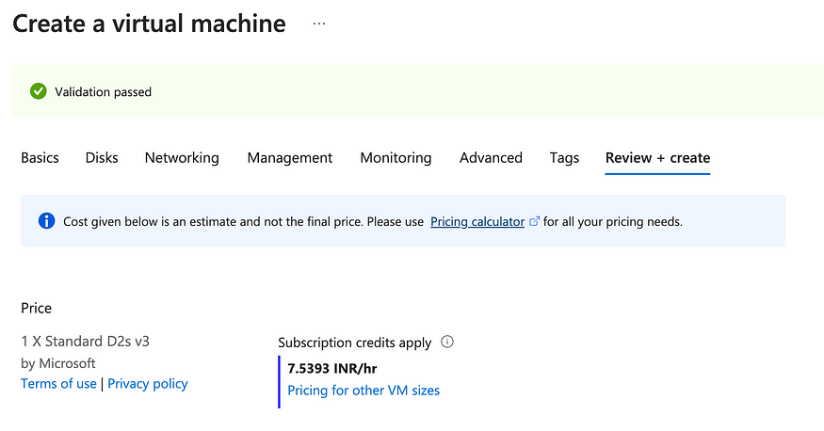

# **Step 11: Deploying the Virtual Machine**

* Click the “Create” button to initiate the VM creation process.
* Azure will begin provisioning your virtual machine based on your configuration.
* Now you have successfully deployed the Virtual Machine in your Virtual Network.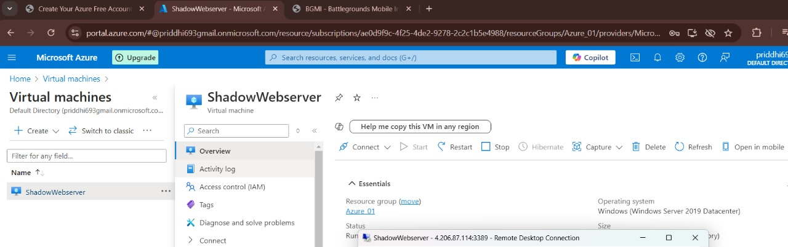

### **Hosting Static Web Application**

**1.** Install the Apache HTTP Server using the command,

sudo apt-get install apache2

**2.** Run the Apache service using the command,

sudo service apache2 start

**3.** Copy the public IP address of the VM and browse it on the internet specifying port number 80, as.

<VM's public IP address>:80

* You must be able to see that the webserver is running and the default web page is hosted on the internet.
* If you want, you can make changes to this web page residing in the path */var/www/html/index.html* and reload the web page to see the changes.

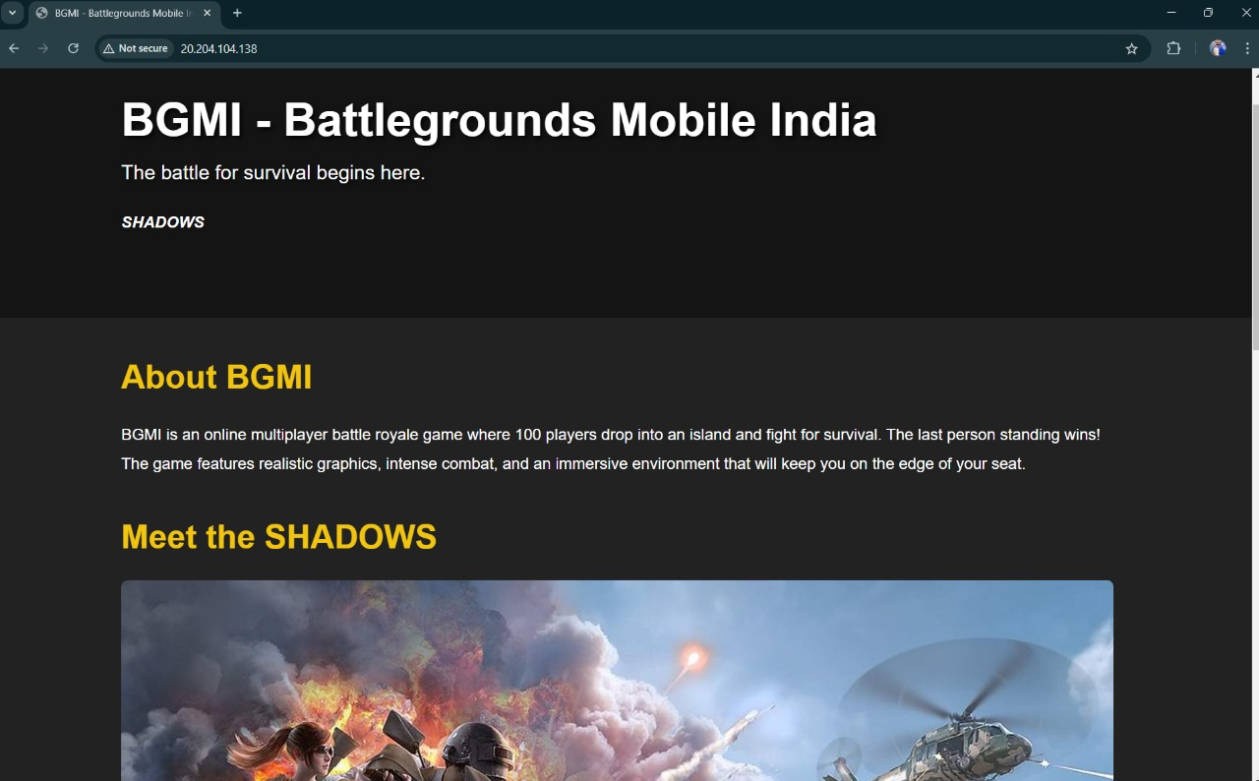

**4.** Now navigate to the path */var/www/* using the command*,*

cd /var57252714/www/

**5.** Delete the directory *html* using the command,

sudo rm -rf html

**6.** Clone your web application source from GitHub or any other version control if any, using the command,

sudo git clone <https://github.com/CODESofRishi/HAA-WebApp2.git>

**7.** Rename the directory cloned from GitHub as *html*, using the command,

sudo mv HAA-WebApp2/ html

**8.** Reload the web page.

Congratulations your static web application is now hosted on the internet.

### **Before wrapping up**

* As long as the VM will be running you will be billed for it.
* So do not forget to delete the resource group when you are done with the project.
* On the left panel of the Azure portal go to *Resource groups*.
* Select your resource group.
* Select the *Delete resource group* option.