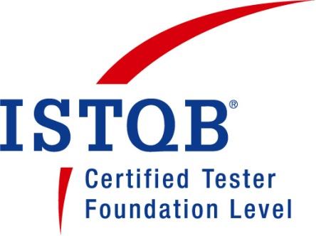

***MINESH PRAKASH JADHAV***

***Sr.QA Engineer***

***Mob No-7874305630/8200366773***

***Email-minish.p.jadhav@gmail.com***

***Vasant Vihar soc,Behind Bapunagar soc,***

***Gandevi Road,NAVSARI-396445***

**Job Objective:**

* To excel in the organization with the power of knowledge, sincerity, hard work and team spirit.

**Profile Summary:**

* **7+ years** of work experience that envelopes test planning, test management, test execution, controlling and successful delivery of designated projects.
* **7+ years** of Experience in **Manual Testing,** also having Basic knowledge in

**Automation Testing** using **Selenium WebDriver.**

* Sound Knowledge in **Database Testing** using MYSQL and Oracle Server databases.
* Strong knowledge of **STLC** and **SDLC** with experience in writing & executing test cases and test scenarios.
* Having area of interest on Database Management System.
* Prioritizing and analyzing the testing of various software applications and Quality Assurance activities.
* Having strong knowledge of **Integration Testing, Functional Testing, and Regression Testing.**
* Involved in Development of test cases, and Executing Test Cases.
* Having an knowledge to prepare **Test Plan**.
* Excellent communication skills with solid team playing capabilities.
* Having an Knowledge of different testing reports such as **DSR**,**WSR**,**TSR**.
* Hands on experience of Web services & API Testing.

**Professional Experience:**

* Worked At Finlogic Technologies India Pvt. Ltd.,Surat as Sr. Executive QA from 1st December 2014 - 31st July 2018.
* Worked At Trimantra Software Solutions LLP(Doyenhub Software Solutions) as a SR.QUALITY ANALYST from 6TH August 2018 - 11TH January 2019.
* Worked At At Uffizio Software Consultants PVT.LTD as a QA Team Lead from 21st January 2019 - 18th November.
* Working At Crest Infosystems PVT LTD as a Sr QA Engineer from 1st January 2020- Till Present.

**Certification**

* **ISTQB FOUNDATION LEVEL( Certified Tester Foundation Level)** Passed With **75%** (**30/40**).

**Project Profile :**

* 1. **MFund(Mutual Fund)**
  2. **Capital Market**

**3. Point Scoring System(PSS)**

**4. Partner Desk**

**5. Client Desk**

**6. KickPages**

1. **VTS(Vehicle tracking System)**
2. **Parcelpath**
3. **Upmerch**
4. **Coldco Logistics**

**Role & Responsibilities:**

* Involved in preparation of Test Plans, Test Scenarios, Test cases and Execution of Test cases.
* Responsible for GUI and Functional Testing using Black box Testing Techniques.
* Involvement in Test Execution, Results Analyzing and Defect Reporting, Troubleshooting.
* Involved in Performance Testing using **Jmeter**.

**Personal details:**

Date of birth : 01-11-1991

Language known : English, Hindi, Gujarati,Marathi

Marital Status : Married

Nationality : Indian

Hobbies : Photography, volleyball,cricket,participating in events,listening songs,Learning new Things(**Tools & Technologies**)

**Educational Qualification:**

|  |  |  |  |
| --- | --- | --- | --- |
| **Qualification** | **University** | **Year Of Passing** | **Percentage%** |
| **M.SC(IT)** | **S.P.U** | **2014** | **68.60** |
| **BCA** | **V.N.S.G.U** | **2012** | **51.50** |
| **H.S.C** | **GSHEB** | **2009** | **51.14** |
| **S.S.C** | **GSHEB** | **2007** | **55.23** |

**Other Achievements:**

* Participated in **Fusion Fashion Show**(**FFS**) and won **2nd prize.**
* Stood **3rd** in photo exhibition competition held at **FINLOGIC TECHNOLOGIES INDIA PVT.LTD**

**Declaration:**

I hereby affirm that the information provided in this document is true to the best of my knowledge**.**

**Minesh Jadhav**