AI Workflow Discovery Studio
Feature overview and reviewer guide for enterprise MVP evaluation
Purpose. This local app helps teams interview colleagues about repeatable workflows, structure the discovery, and package practical AI solution handoffs for Product, Engineering, Business, Governance, and enterprise platform review.

Executive Summary
AI Workflow Discovery Studio is a local, browser-based intake and analysis tool. It helps an AI or delivery lead guide a colleague through a workflow discovery conversation, then turns the results into reviewable documents, structured data, and connector-readiness artifacts.
The current build is enterprise MVP transfer-ready: it runs locally, exports packages, supports safe sample review, and includes checks that prevent secrets, generated app data, and local machine paths from entering the review ZIP.

What It Can Do
Area | What it does
Discovery | Guided interview for workflow name, start/end, systems, inputs, outputs, and A-to-Z steps.
Analysis Studio | Structured workspace for reviewing readiness, gaps, open questions, and output coverage.
Outputs | Generates Product, Engineering, Business, Governance, Build Recipe, Execution Plan, and Readiness artifacts.
Connector Readiness | Frames Microsoft 365, evidence uploads, approved storage, permissions, pilot data, and fallback mode.
Review Package | Builds a sanitized ZIP for code, logic, and enterprise review without secrets or generated app data.

How It Works
- Start in Discovery and describe a workflow in plain language.
- Capture the workflow frame: name, trigger, end point, business outcome, systems, data, inputs, and outputs.
- Add the rough A-to-Z process, then drill into steps, decisions, exceptions, access, and evidence.
- Review the Analysis Studio outputs and open-question routing.
- Export DOCX, Excel, JSON, Markdown, and local ZIP packages for review.
- Use the enterprise readiness and connector artifacts before requesting Microsoft 365, OpenAI, or write/action integrations.

Who Should Review It
Reviewer | What to review
Workflow owners | Can explain a repetitive workflow and confirm if the generated outputs are accurate.
AI builders | Can use the Solution Build Recipe and Execution Plan to plan a ChatGPT/Copilot implementation.
Engineering reviewers | Can inspect systems, data, connector assumptions, output manifest, and package contracts.
Governance / security | Can review data boundary, permission scope, approval gates, fallback mode, and stop criteria.
Pilot leads | Can run safe-sample pilots and decide promote, defer, or block using the decision packet.

Enterprise MVP Posture
The app is ready for controlled work-environment MVP review, not broad production rollout. The recommended first work-computer setting is ENTERPRISE_MODE=on and CONNECTOR_MODE=mock. Live Microsoft 365 connector access should stay disabled until Entra app registration, Microsoft Graph scopes, data boundary, source owner, and security review are approved.
- Use synthetic or approved internal examples first.
- Do not use client confidential, regulated, personal, MNPI, PCI, PHI, or production client data without explicit approval.
- Keep secrets only in work-machine .env.local or approved secret storage.
- Run the package doctor before sharing any ZIP.

Discovery intake workspace
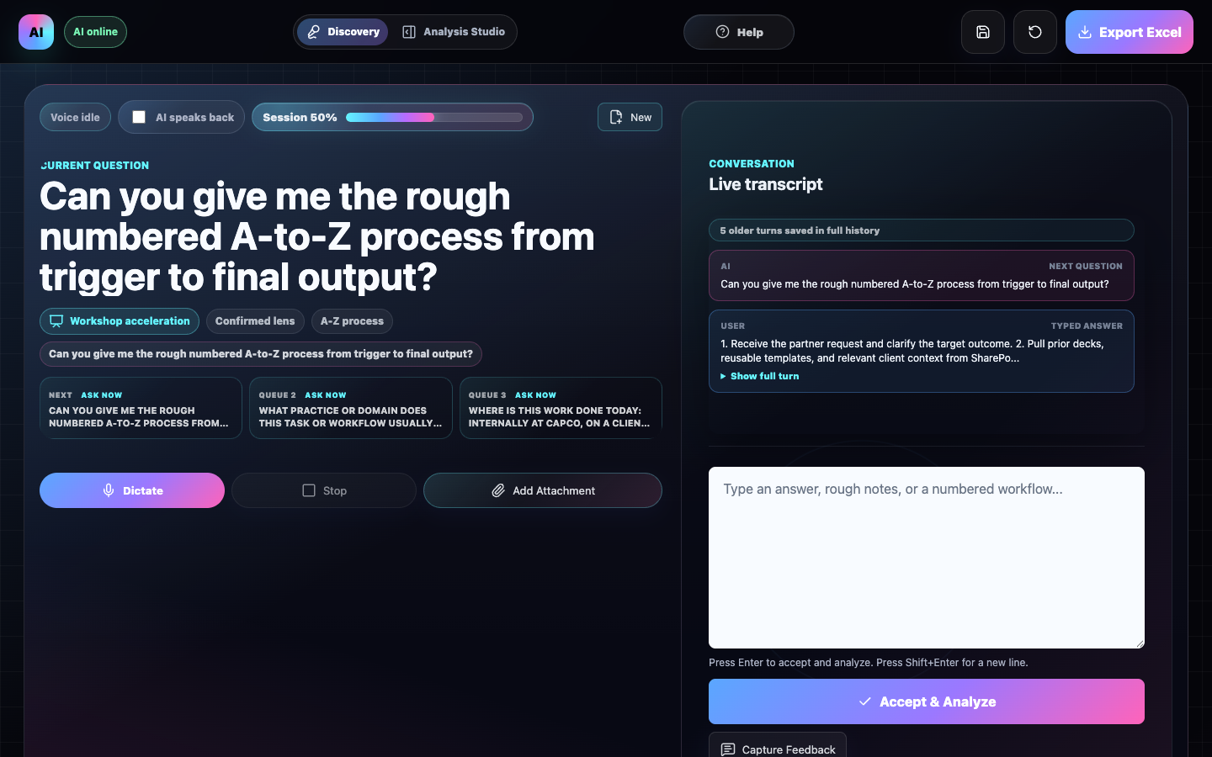
The interview starts with plain-language workflow discovery before drilling into data, access, governance, and build details.

Analysis Studio and output alignment
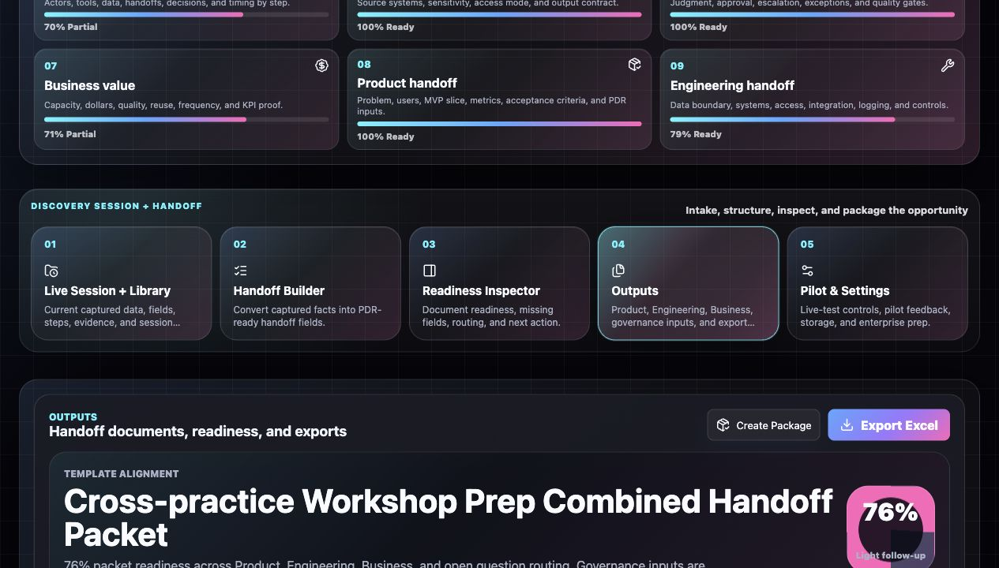
Analysis Studio turns intake into reviewable Product, Engineering, Business, Governance, and build artifacts.

Template Alignment and provenance
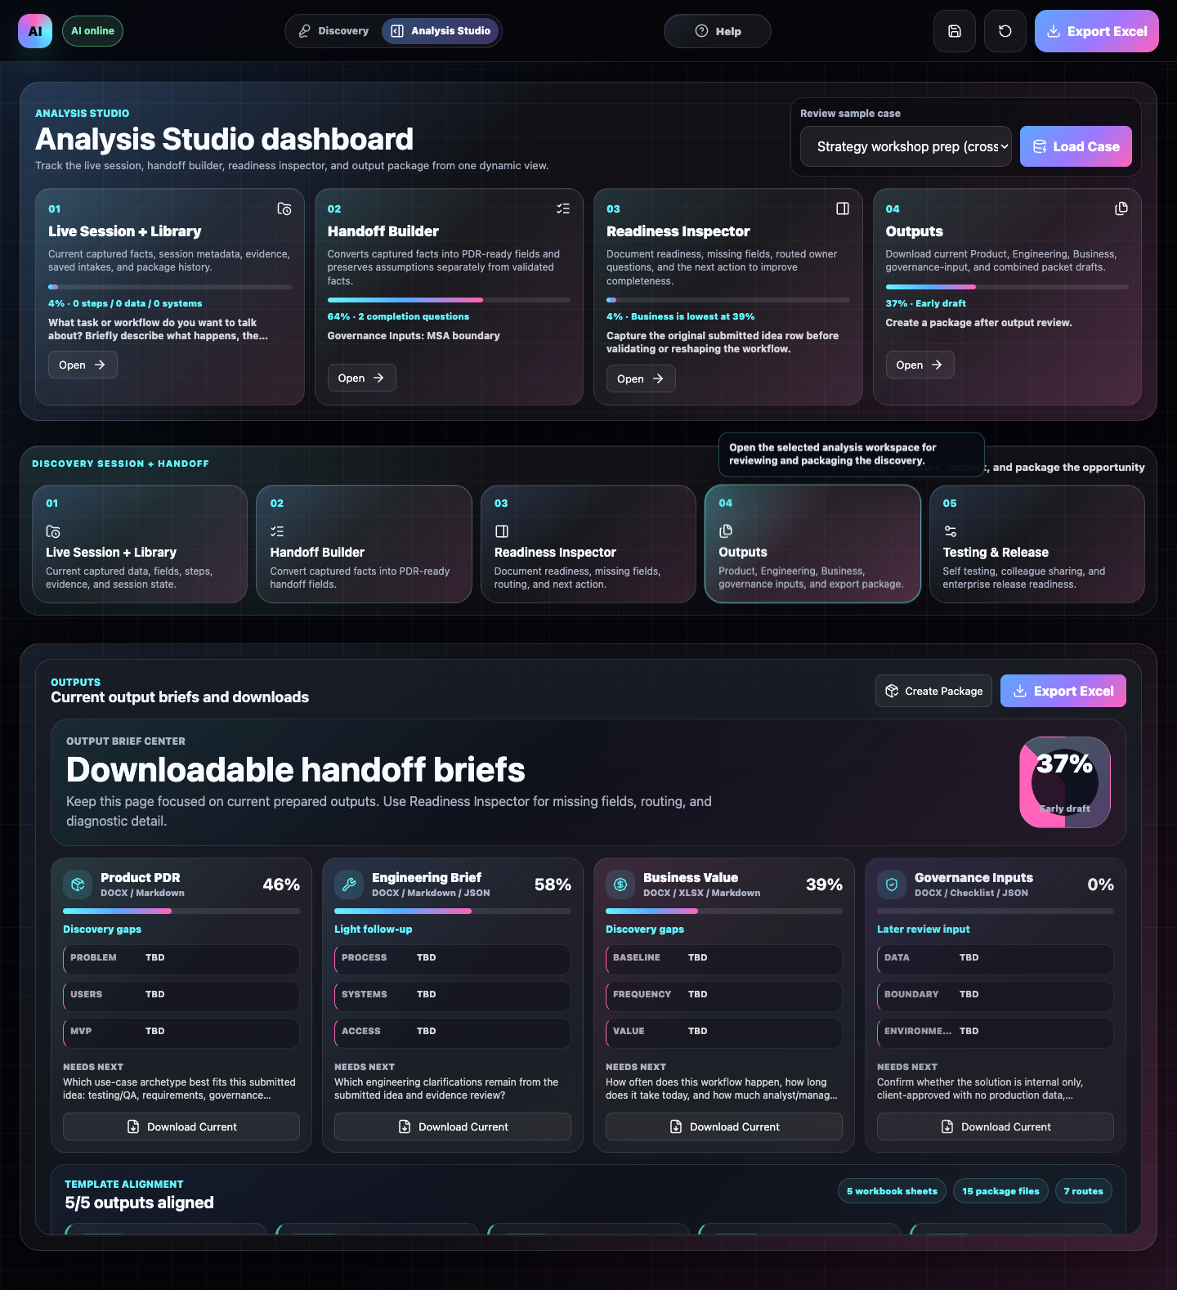
Output fields carry provenance and treatment metadata so reviewers can see what was captured, inferred, missing, or supplement-later.

Testing and release planning
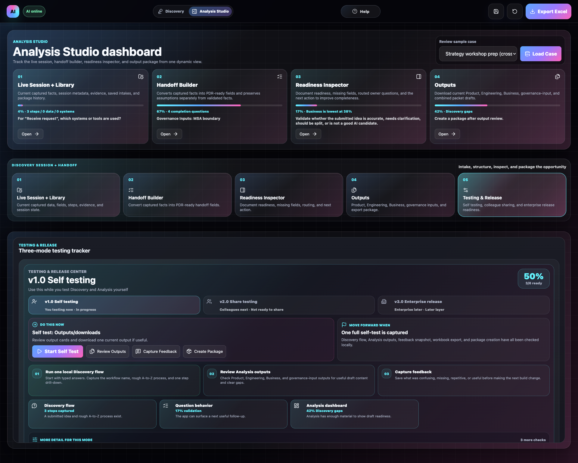
The app separates self testing, colleague pilot, and enterprise release gates.

First Review Script
- Open the app locally at http://localhost:5177/.
- Use one scenario from SAFE_SAMPLE_SCENARIOS.md.
- Run a short Discovery interview and capture the rough A-to-Z process.
- Open Analysis Studio and review output readiness.
- Download one or more outputs, then create a local handoff package.
- Run node scripts/check-work-environment-readiness.mjs and node scripts/check-review-package.mjs before sharing.

Included Enterprise Handoff Assets
- ENTERPRISE_DEPLOYMENT_GUIDE.md
- WORK_ENVIRONMENT_STANDUP_RUNBOOK.md
- GITHUB_ENTERPRISE_SETUP.md
- MICROSOFT_365_CONNECTOR_SETUP.md
- V1_RELEASE_CHECKLIST.md
- scripts/check-work-environment-readiness.mjs
- scripts/check-enterprise-transfer-kit.mjs
Current validated package. ai-workflow-discovery-studio-review-0.1.0-2026-06-05T11-50-53-306Z.zip passed full stabilization, clean-install smoke, and package-doctor validation.

