1) WAP to display the message ‘My first program’ on the screen.

2) WAP to display your name, and address on the computer screen.

3) WAP to input the values of Voltage and Resistance and calculate corresponding Current.

4) WAP to input the values of Principal, Rate, and Time and calculate SI and CI.

5) WAP which will raise any number ***x*** to a positive power ***n***. Obtain values of ***x*** and ***n*** from the user.

6) WAP to input principal amount and time. If time is more than 10 years, calculate the simple interest with rate 8%. Otherwise calculate it with rate 12% per annum.

7) WAP to input a number. If the number is even, print its square, otherwise print its cube.

8) WAP to find the roots of a quadratic equation.

9) WAP to input choice (1 or 2). If the choice is 1, print the area of a circle otherwise print the perimeter of a circle. Accept the radius of the circle from the user.

10) WAP that reads in a character <ch> from the keyboard and then displays one of the following messages:

* If <ch> is a lower case alphabet, the message

“*The upper case character corresponding to <ch> is* …”

* If <ch> is an upper case alphabet, the message

“*The lower case character corresponding to <ch> is* …”

* If <ch> is not an alphabet, the message

“*<ch> is* *not an alphabet*”

11) Write a menu driven program to calculate the total surface area and volume of a cube, cuboid, or sphere depending upon user’s choice. The program should continue until the user selects the option to exit the program.

12) WAP to input a number. If the number is negative, then again input the number. Keep on doing so until the user enters a positive number.

13) WAP to input two numbers ***m*** and ***n***. Then display first ***m*** multiples of ***n***.

14) WAP to input 10 numbers and then display their sum and average. Also display the largest and the smallest of the numbers entered.

15) WAP to input two numbers and find their LCM and HCF.

16) Write a program to input a number and check whether it is a prime or not.

17) WAP to display all the prime numbers between m and n, where m and n have to be input from the user.

18) WAP to input a list of n number and count how many of the entered numbers were prime.

19) WAP to input a number and check whether it is palindrome or not.

20) WAP to input a list of n number and count how many of the entered numbers were palindrome.

21) WAP to find the sum of first n terms of the following series x + x2 + x3 + . . .

22) WAP to find the sum of first n terms of the following series: x - x2 + x3 + . . .

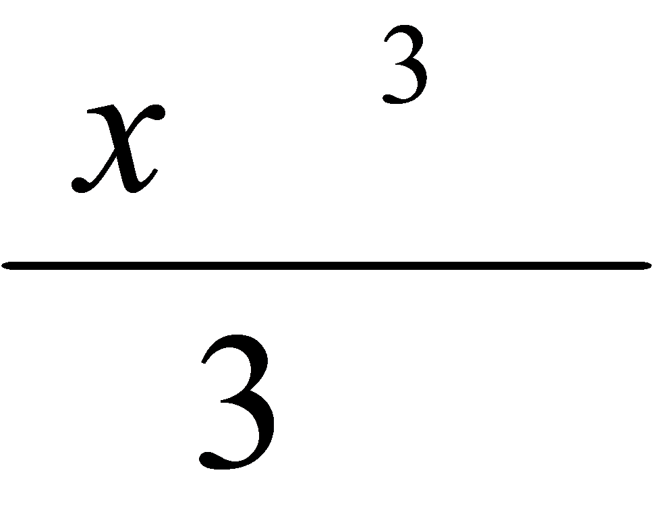

23) WAP to find the sum of first n terms of the following series: 1 + x + x^2/2 + x^3/3...

24) WAP to find the sum of first n terms of the following series: 1 + x + x^2/2! + x^3/3!

25) WAP to find the sum of first n terms of the following series: 1 – x + x^2/2! – x^3/3!

26) WAP to find the sum of first n terms of the following series: 1 + x^3/3! + x^5/5! + x^7/7!

27) WAP to find the sum of first n terms of the following series: 1 – x^3/3! + x^5/5! – x^7/7!

28) WAP to generate n lines of the following pattern on the computer screen:

1

12

123

29) WAP to generate n lines of the following pattern on the computer screen:

1

12

123

.

30) WAP to generate n lines of the following pattern on the computer screen:

1

121

12321

31) WAP to generate 2n+1 lines of the following pattern on the computer screen:

*

***

*****

*******

*****

***

*

32) WAP to generate 2n+1 lines of the following pattern on the computer screen:

*

@@@

*****

@@@@@@@

*****

@@@

*

33) WAP to generate 2n+1 lines of the following pattern on the computer screen:

*

* *

* *

* *

*********

*******

*****

***

*

34) WAP to generate 2n+1 lines of the following pattern on the computer screen:

*

* *

* *

* *

* *

* *

*

35) In an off-season sale various schemes of discounts are offered to the customers. The schemes are as follows:

* If a customer buys 1 kind of items for a total marked price of Rs. 1000/- to Rs. 2000 then the discount given is 10%.
* If the customer buys more than one kind of items for a total marked price of Rs. 1000/- to Rs. 2000/- then the discount given is 5%.
* If the customer buys any no. of items for a total marked price of more than Rs. 2000, then the discount given is 12%.

Your job is to write a program to input from the user the quantity and the value of each item purchased (do not input the total value or the number of various items purchased), and then calculate the total marked price, total discount, and gross total. Then apply VAT @4% and display the VAT amount and then the net amount payable by the customer.

36) WAP to input the name of a student and then display this name.

37) WAP to input a string and then display this string in reverse order.

38) WAP to input a string and count the number of ***a***’s in the string.

39) WAP to input a string and check whether it is a palindrome or not.

40) WAP to input a string and display a set of characters that appear in this string.

41) WAP to input a string a then find which character has the maximum frequency in this string.

42) Write a menu driven program to encode or decode a string depending upon user’s choice. A encoding scheme for a string should be to replace a consonant with the next consonant and to replace a vowel with the next vowel of the English alphabet. This replacement should be done in cyclic order. Character other than alphabets should remain the same.

E.g. for coding, if the input string is: **3 computers or 13 computerz**

then the output string should be **3 dunqauist us 13 dunqauisa**

43) WAP to input a string and find the presence of a given substring in it.

44) WAP to count the number of words in it.

45) WAP to input two strings and concatenate them into a third string.

46) WAP to input a list of 10 numbers and then display this list.

47) WAP to input a list of 10 numbers and then display the list of all those numbers which are greater than the average of this list.

48) WAP to input a string and find the frequency of each alphabet appearing in the string. (Alphabet counting should not be case-sensitive)

49) WAP to input a list of numbers and then reverse this list of numbers without using a second array. E.g. if the original list contains 5,2,3,4,1,9, then after reversal the list should contain 9,1,4,3,2,5.

50) WAP to input the aggregate marks of n students of a class. Then reproduce this marks list in the descending order of marks. Along with marks the program should also display the grade of each student. The grades are calculated as follows:

Marks Grade

>90 A

75 – 89 B

60 – 74 C

50 – 59 D

40 – 49 E

<40 F

51) WAP to input 10 numbers and then sort this list of numbers in ascending order.

52) WAP to input 10 numbers and then sort this list of numbers in ascending order or in descending order depending upon user’s choice.

53) WAP to input the n (n <= 50) numbers and then input another number *x* and search the list of n numbers for the presence of *x*.

54) WAP to input elements in two matrices and then find the sum of these matrices.

55) WAP that inputs the elements in a 2-D array and then finds the sum of all the non-zero elements of the array.

56) WAP to input 10 strings and then for each string find out whether it is palindrome or not.

57) WAP to input a list of numbers in an array and then rearrange this array in such away that all the odd numbers appear in the beginning of the array and all the even numbers appear in the end of the array. E.g., if the input list is 1,4,2,7,6,5,9, then after rearrangement the list should be: 1,7,5,9,4,2,6.

58) WAP to input the names, roll numbers and marks (aggregate) of each of the n (n<= 20) students in a class and then display a sorted marks list along with the grade of each student.

59) WAP to input the Item Code, Item Name, and Price of each of the n (n <= 10) items in a store. The program should then ask the user for the code of an item bought and the quantity, and then the program should display the price of an item and the total cost of the items bought.

60) WAP to input a number in digits and then print it in words.