CS 101, LAB 2: ASSIGNMENTS AND STRINGS

Name:_____________________Group:______________________Roll Number:___________________

The purpose of this lab is to get you comfortable with using assignment statements, strings, and their associated methods.

This lab is very similar to the previous one, in that you will be typing commands into the Python interactive shell and recording the results.

Variables and Assignment Statements

As we saw in class, assignment statements are diﬀerent from expressions. A statement like

a = 3 < 5
is a command to do something. In particular, this command

- evaluates the expression on the right-hand side of the = (in this case, 3 < 5), and
- stores its value in the variable on the left-hand side of the =, in this case, a.

Because it is not an expression, Python will not actually output a result when you type it in; it will just perform the command silently. It is important that you understand the diﬀerence. In the table on the next page, the first column contains either an expression or a command. If it is an expression, write the value. If it is a command, you should just write “None” (we have done the first one for you). Because some of the entries are commands, it is important that you enter the expressions or commands in exactly the order they are given.

Statement or | Expected | Calculated | Reason for
Expression | Value | Value | Calculated Value
i = 6 | None
i
j
j = 1
j+4
j = j + i
j
i
w = 'Hello'
i + w

String Expressions

Throughout this section, pay close attention to spaces and to the diﬀerent types of quotation marks being used. We use both ' (single quote) and " (double quote).

Expression | Expected | Calculated | Reason for
Expression | Value | Value | Calculated Value

'Truth ' + 'is ' + ‘always’ + 'best'
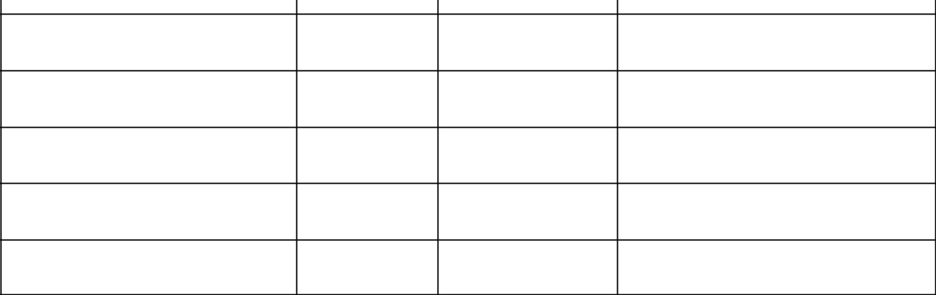
"Truth " + "is " + "best"

"Truth " + ('is ' + "best")

'A double quote: "'

"A single quote: '"

'A single quote: ''

Expression | Expected | Calculated | Reason for
Expression | Value | Value | Calculated Value
'' + 'lol'
'' + '4 / 2'
'' + 4 / 2
'' + str(4 / 2)

Functions

Built-in functions are those that do not require you to import a module to use them. You can find a list of them in the Python documentation:

http://docs.python.org/library/functions.html

Note that the casting and typing operations are listed as functions. While this is true in Python, this is not always the case in other programming languages.

Expression | Expected | Calculated | Reason for
Expression | Value | Value | Calculated Value
min(25, 6)
max(27, 4)
min(25, max(28, 4))
abs(26)
abs(-26)
round(23.6)
round(-23.6)
round(23.64, 0)
round(23.64, 1)
round(23.64, 2)
len('Truth')

Using a Python Module

One of the more important Python library modules is the math module. It contains essential mathematical functions like sin and cos. It also contains variables for mathematical constants such as pi. To learn more about this module, look at its online documentation:

http://docs.python.org/library/math.html

To use a module, you must import it. Type the following into the Python interactive shell:

import math

You can now access all of the functions and variables in math. However, to use any of them, you have to put “math.” before the function or variable name. For example, to access the variable pi, you must type math.pi. Keep this in mind as you fill out that table below.

Expression | Expected | Calculated | Reason for
Expression | Value | Value | Calculated Value
math.sqrt(16)
math.sqrt(-16)
math.floor(6.7)
math.ceil(6.7)
math.ceil(-6.7)
math.copysign(2,-6.7)
math.trunc(6.7)
math.trunc(-6.7)
math.pi
math.cos(math.pi)

In addition to the above expressions, type the following code into the Python interactive shell:

math.pi = 3 math.pi

What happens and why?
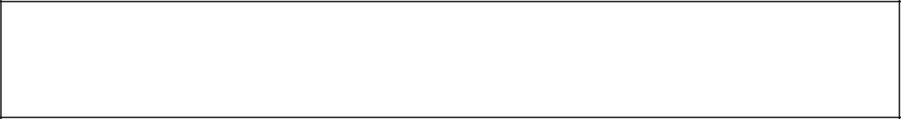

String Methods

Now that you understand strings and (calling) functions, you can put the two together. Strings have many handy methods, whose specifications can be found at the following URL:

http://docs.python.org/2/library/stdtypes.html#string-methods

Before starting with the table below, enter the following statement into the Python shell:
s = 'Hello World!'

Once you have done that, use the string stored in s to fill out the table, just as before.

Expression | Expected | Calculated | Reason for
Expression | Value | Value | Calculated Value
s[1]
s[15]
s[1:5]
s[:5]
s[5:]
'H' in s
'x' in s
s.index('w')
s.index('x')
s.index('l', 5)
s.find('e')
s.find('x')

Let q1 is a variable assigned as in the below given statement.

q1 = 'The phrase, "Don\'t panic!" is frequently uttered by consultants.'

You could also write a string like this using double quotes as the delimiters. Rewrite the assignment statement for

q1 above using a double-quoted string literal:

For your last exercise, we want you to write Python code to extract the substring inside the double quotes (which is "Don't panic!"). But we want to do it in a way that is independent of q1. That means, even if you change the contents of q1, your answer should still work, provided that q1 still has a pair of double-quote characters somewhere.

In the box below, write a sequence of one or more assignment statements, ending with an assignment to a variable called inner (the other variables can be named whatever you want). The assignment statements should use string slicing to remove the unwanted parts of q1. When you are done, the contents of inner should be the substring inside the double-quote characters (but not including the double quotes themselves).
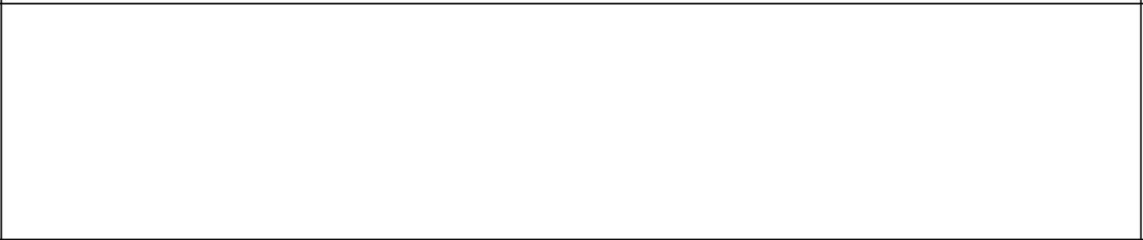

To test that your statements are correct, do the following. First, type in q1 = 'The phrase, "Don\'t panic!" is frequently uttered by consultants.'
Then type in your statements from the box above. Finally, print the value of inner. You should see Don't panic,

without the quotes (printing always removes the quotes from a string value).

Now, try the process again with

q1 = 'The question "Can you help me?" is often asked in consulting hours.'

Type in the assignment statement above, then type in your statements from the box, and finally print the value of inner. You should see Can you help me?, without the quotes. If you had to modify your answer in the box for the second q1, you have done it incorrectly.

