Subject | FUNCTION KEYS ON MDI KEYBOARD NOT WORKING
Product | CNC |  |  |  |  |  |  | Content/Solution |  |  |  |  | Software
Controller Model |  |  |  |  | FS-0i-LF PLUS |  |  |  | Controller Sl. No. |  |  |  |  |  | E211A2910
Laser/RO/RM Model |  |  |  |  | NA |  |  |  | Laser/RO/RM Sl. No. |  |  |  |  |  | NA
Machine Model |  |  |  |  | Fl-4020 |  |  |  | Machine Sl. No. |  |  |  |  |  | SIL4020FL0034
Machine Tool Builder |  |  |  |  | Suresh Indu Lasers Pvt. Ltd. |  |  |  |  |  | Configuration |  |  |  |  | 4 axis servo
End-User |  |  |  |  | GURUKRUPA ENGINEERING WORKS
Application |  |  | FIBER LASER |  |  |  |  |  |  |  |  | Installation Date |  |  |  |  |  | August 2021
MR No. |  | M66867500& M66867501 |  |  |  | MR Review | Multiple Visit |  |  | Visits Count |  |  |  | 3 |  |  | Hours Count |  | 10
Reason for Multiple/Repeat visits |  |  |  | Problem is intermittent
Reason for presenting this subject |  |  |  | To share information with other zones
Problem as reported by Enduser |  |  |  | MDI keyboard not working
Observation of the problem with detailed description |  |  |  | Function keys(POS , PROG , OFS , MSG, GRAPH, CUSTOM , SYSTEM and HELP) not working in MDI keyboard
Problem suspected by FSE/SRC |  |  |  | Problem due to hardware
History of the problem |  |  |  | NIL
Was there any specific external disturbance? |  |  |  | NIL
How many times has it occurred? |  |  |  | Problem is intermittent
Diagnosis information as per manual |  |  |  | NIL
How was the problem analyzed?
1st visit dtd.20-08-2021:
- Visited customer & problem not observed during visit, Incoming supply was 397,398 & 398VAC & Earth to neutral 0.4VAC. Control supply 24.2 & 24.3VDC.
- As problem was intermittent and taken hardware details. Found earthing to system and MDI keyboard were not connected. Asked customer to connect earth with help from MTB.
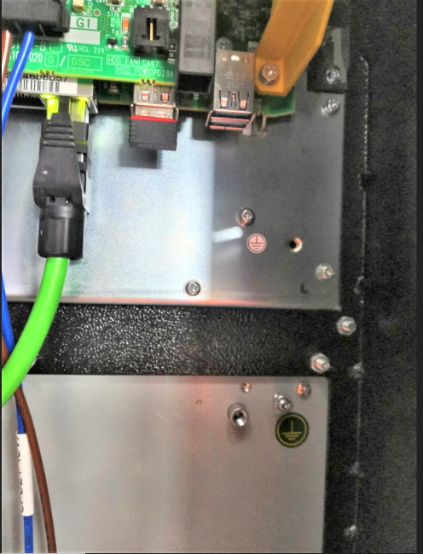
- As per customer feedback, function keys POS,PROG,OFS,MSG,GRP,CUS & SYS buttons were not working.

2nd Visit dtd. 27-08-2021:
- Problem observed during visit. Found Function Keys (POS , PROG , OFS , MSG, GRAPH, CUSTOM , SYSTEM and HELP) were not working in MDI and custom screen as well.

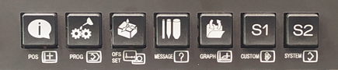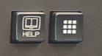

- Also when any of the function key is pressed it operates like a cursor key instead of its specific function.
- Also, earthing was not provided to controller and PANEL I. Requested MTB to connect the same and checked. found same issue.
- Replaced the MDI keyboard with new and observed same problem.

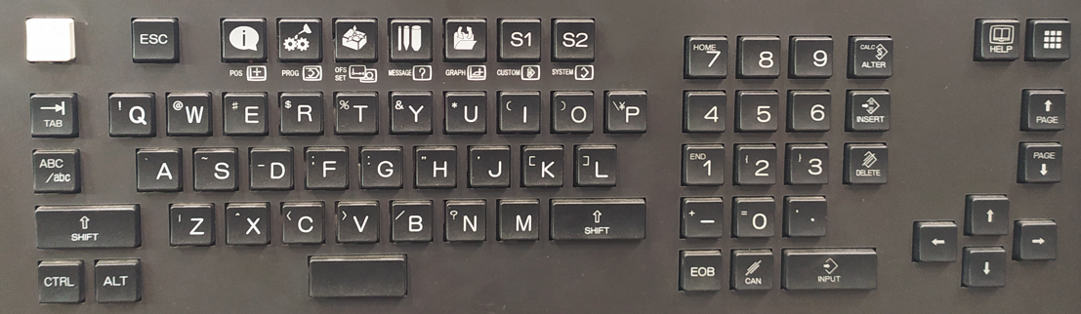

- Restored to original keyboard and Performed calibration of touch panel and found same issue.
- Discussed with service support team and suspected problem may be due to keyboard file software corruption.
- So collected the below software details to update and check the iHMI software

iHMI SOFTWARE VERSION: 6
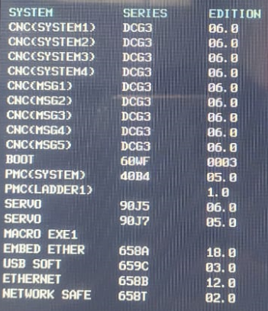

HARDWARE CONFIGURATION

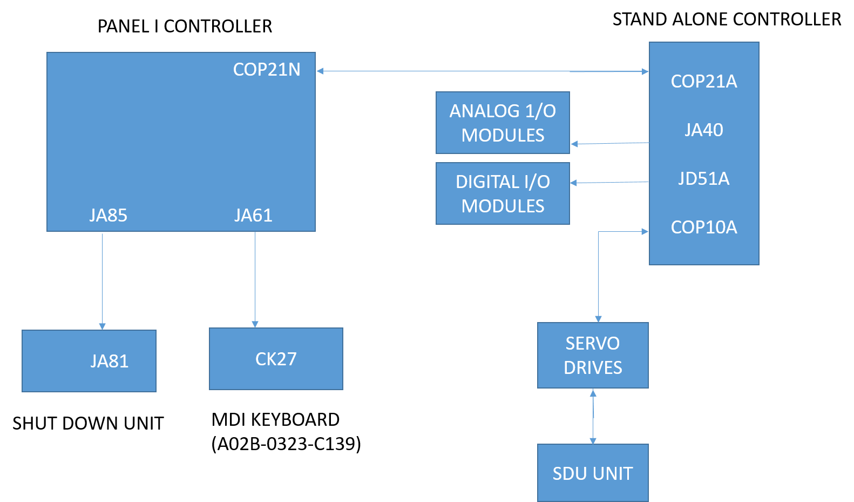

3rd Visit dtd. 27-10-2021:
- During visit, observed ALL Function keys and other function keys were not operating.
- Also found ALL Function key works like cursor movement and MSG key works as Right click on mouse.
- As per guidance from service support disabled mouse keys on control panel.
- Path is Control Panel>> Ease of access>>Ease access center>>Make the mouse easier to use>> Control the mouse with the keyboard>>Turn on mouse keys.
- Refer below image.
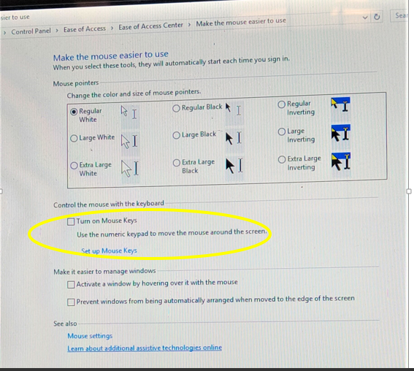

- Checked keyboard function and machine power reset done several time no issue.All keys are working normally.

How was the Problem Solved?
- Problem solved after disabling mouse keys option in control panel mouse with the keyboard option.
Justification for Parts replaced:
Specification | Qty | Reason
NIL | NIL | NIL

Any additional information:
Click or tap here to enter text.

For Reviewer’s:
Applicable for CNC/Servo/Robot/RM Models |  |  |  | CNC,RM
Content useful for Telephonic Support |  | Yes |  |  | Supports MTTR | Yes
Any Special Tool used for Troubleshooting |  |  | Click or tap here to enter text.
Addition information | Click or tap here to enter text.
Any alternate process to troubleshoot this subject | Click or tap here to enter text.
Remarks | Click or tap here to enter text.

Prepared by | Review by | Presented by | ST Review
Aravinthkailash & Mahaveer | Kiran V. Raskar | Aravinthkailash & Mahaveer | Click or tap here to enter text.

+++++End of Report+++++

