[](http://www.idup.gov.in/en)

**Flood Management Information System Centre (FMISC)**

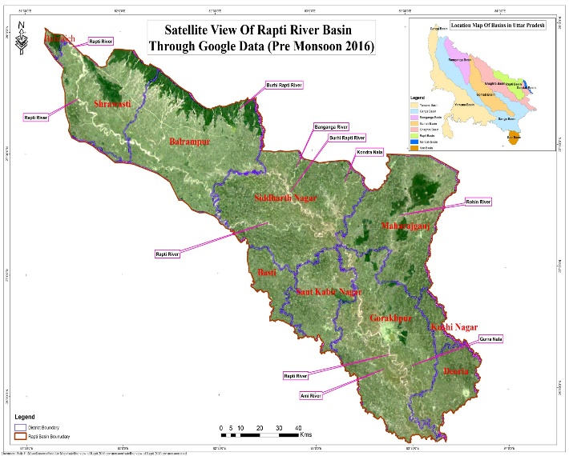

**CONSULTANCY SERVICES FOR**

**DEVELOPMENT OF EMBANKMENT ASSETS MANAGEMENT SYSTEM (EAMS) IN RAPTI BASIN**

**DESIGN REPORT**

**Version 1.0**

**By**

Bottom of Form

**TABLE OF CONTENTS**

1. INTRODUCTION 6

1.1 Purpose and Scope 6

1.2 Project Summary 7

1.2.1 System Overview 9

1.2.2 Assumption & Design Constraints 9

1.2.3 Future Contigencies 9

1.3 Document Organization 9

1.4 References 10

1.5 Definitions/Glossary/Abbreviations 10

2. SYSTEM ARCHITECTURE 12

2.1 Business Case and Logic for Development of System Architecture 13

2.1.1 Integration Strategies 13

2.1.2 User and Applicability of EAMS 13

2.1.3 Application Development and Technology Architecture 13

2.1.4 Sustainability & Future Directions 13

2.2 Hardware Architecture 13

2.2.1 Client Hardware 13

2.2.2 Centralised Hardware Architecture at FMISC 13

2.2.3 Network Characteristics at FIMSC 13

2.3 System Software Architecture 13

2.3.1 Database Server 13

2.3.2 GIS Server 13

2.4 Design Rational 13

3. DATA STORAGE DESIGN 13

3.1 Database Organization 13

3.1.1 Design of Geodatabase Models 14

3.1.2 Spatial and Non Spatial Data Content 14

3.1.3 System Tables 14

3.1.4 Features Class Data Store 14

3.1.5 Coded Value Domain and Entity Relationships 14

3.2 Raster Data 14

3.2.1 Provision of Raster Data Storage and Data Location 15

3.2.2 Raster Data Storage within the Enterprise Geodatabase 15

3.3 External Sources Data 15

3.3.1 RT-DAS Data Storage 15

3.3.2 India Meteorological Data Storage 15

3.3.3 Flood Forecast Model Data Storage 15

3.4 Non-Database Data Storage 15

4. FUNCTIONAL MODULES OF EAMS 15

4.1 Asset Database Module 15

4.2 Flood Store Material 16

4.3 Hydro Metrological Information System Database 16

4.4 Asset Monitoring System 16

4.4.1 Integration of Tablet Based Asset Inspection 16

4.5 Management Information System 18

4.6 Risk Assessment Module 18

4.7 Community Participation Module 18

4.7.1 Role of the Community Participation 19

4.8 Document Management Module 20

4.9 Analytical Module 20

4.10 Map Content and System Administration Module 20

5. USER INTERFACE 21

5.1 Software Detailed Design 21

6. SYSTEM INTEGRITY CONTROLS 21

7. APPENDIX 21

**LIST OF TABLE**

Table 1:1: Definitions/Glossary/Abbreviations 9

**LIST OF FIGURE**

Figure 6.3: Real Time Field Data Collection 13

Figure 6.4: Workflow for field data collection 14

Figure 6.5: Feedback/Reports from Communities 16

# INTRODUCTION

The Government of India (GOI)/ Government of Uttar Pradesh (Govt. UP) has received a credit from the International Development Association (IDA) to finance the UP Water Sector Restructuring Project (UPWSRP) Phase 2 and intends to apply part of the proceeds of this credit to payments under the contract for hiring services of consultancy firm for “Consultancy Services for Development of Embankment Assets Management Systems for Rapti basin, to optimally manage existing embankment assets for sustained benefits and at sustainable cost, and to develop new assets as needed. The EAMS should be developed to support decision making through the embankment assets.

**Egis India Consulting Engineers Pvt Ltd.** has been awarded the consultancy job of developing a comprehensive Embankment Asset Management System for Rapti basin, which will include visual and scientific inspection of the embankment status in the Rapti basin. This region is partially embanked and will need substantial investments for the development of new embankments.

This document, System Design Document (SDD), is a part of deliverable with the consultancy contract. The purpose of the SDD is to provide a roadmap that integrate various parameters in designing, development and deployment of EAMS for the Rapti-Basin. it identifies various workflows of the organization, how these can be integrated together and provide an approach that satisfied user functional requirements.

Recognizing the complexity of designing and development such as complex solution, the system design document takes into consideration a disciplined approach that link requirements analysis to implementation of those requirements. While there are various approaches in the design of enterprise GIS, this design document takes into consideration the following.

1. System architecture
2. Functional requirements – system modules, input, tools and outputs
3. Interfaces between various components

The aim of the system design document is to provide the developers enough details to successfully build the system and meet the project requirements.

## Purpose and Scope

The purpose of this document is to provide comprehensive details of the web based GIS system consisting of database. It depicts the technical aspects of

* Service Based Architecture and
* The functional modules within the EAMS and EIS Development Tool
* System Interfaces of all Functional Modules

The purpose of this document is also to identify in detail the various functional components that will be used in the development of EAMS and to extend the benefit of its GIS technology and assets to more business processes and non-GIS professionals in a variety of business units.

The scope of the design document is to do the following:

* Define the Architectural design of the hardware and software, the security architecture, communication architecture, data integration and update, integration with external /local data sources and models for forecasting and inundation, communication architecture and performance.
* Elaborate the various Human interface requirements using use-case scenarios.
* Develop a GIS database design that will take into consideration various database structures, handling entity relationships, naming conventions, etc.
* Defining and establishing a framework for GIS web based services that will include functionalities as defined in the SRS, especially related to map viewing, system security and protocols, user accounts etc.
* Define User Interfaces (UI) that focuses on the user experiences and interactions with the system and usually include components such as workflows, wireframes, prototypes, etc.
* Document all items such as interface definitions, workflow, models, use cases, etc.

## Project Summary

Recurring floods in Ganga, Yamuna, Ramganga, Gomti, Sharda, Ghagra, Rapti and Gandak rivers in Uttar Pradesh State annually affect about 2.7 million hectares, more than 21.1 million people and cause damages of INR 4.3billions. More than 30 percent of the total geographical area is flood-prone in 23 districts in the eastern, western and central regions of Uttar Pradesh State. Recurrent floods are devastating to the State economy and undermine poverty alleviation efforts. Floods not only affect lives, livelihoods, and productivity and security of existing investments, but are also a disincentive for additional investments.

The Himalayan tributaries (and Ganga) and local rainfall are responsible for most of the flooding. Most of these tributaries have a substantial portion of their basins in Nepal and China and hydro-climatic data collection and sharing are major problems. Travel times for some tributaries are short, river stage data is suspect due to lack of periodically updated rating curves in highly silt-laden rivers, hydrologic observations are still manually observed and not transmitted in real-time, no climate-based forecasts are available currently, and data sharing remains a serious issue. Even when short-lead warnings on river stages are received, issues remain on “last mile” on connectivity, dissemination, and community and institutional preparedness.

Traditional efforts at flood management have focused on hardware systems, mainly consisting of 2162 km. of marginal embankments, 13,825 km. drains, and 66 town protection works till 2008-09, providing protection to about 1.95 million ha at a total cost of INR 21billions. These flood control structures are constructed to then-prevailing standards and technology, and not well maintained. The data on embankments, both legacy and current data are scattered across offices, in different forms and formats, and not readily accessible for quick decision making. There is thus a need for an Embankment Asset Management System (EAMS), which would provide a central repository of all embankment and allied data, provide easy access, and support various analysis, and provide outputs.

The Consultation Meeting with participation from a cross-section of senior to field level engineers in UPIWRD Headquarters and Rapti basin concluded that:.

* The Key benefit from EAMS is the transparency in institutional processes including documentation and record of asset management.
* Decision making would be rational since the decision maker would see the same data as the field engineers
* EAMS would provide overview of river and embankment condition based on inspection reports, also reviewed at hqrs, and support rational prioritization of field proposals, and appropriate fund allocation for maintenance of critical problems flagged in the inspection report.
* EAMS would help monitor physical and financial progress in pre-flood activities, identify delays and reasons, identify critical closure actions and assess consequences of delay/partial completion, allocate funds, materials and labour, complete the works, and certify embankment safety.

EAMS would help in rationally prioritizing maintenance schemes at different levels, from Chief Engineer level to Secretariat level based on real criticality

Emergency actions would be monitored at hqrs, in the background of funds, material and labour availability and action identified, monitored for compliance,

* Currently needed data is not easily accessible for planning and monitoring
* Capacity building necessary for use of EAMS
* EAMS should include timeline or schedule for pre-monsoon activities like Anti Erosion Control schemes preparation and execution
* EAMS should not only provide related asset data, but also historic and current gauge observations on rainfall and river flow, as well as weather and flood forecasts
* Create a knowledge base of flood fighting procedures, including rare crisis events. Also include knowledge bank of best practices and also past experience in UP and other states and countries, and legacy documents, drawings and maps and reports
* Monitor physical and financial progress on pre-monsoon schemes to provide latest data to decision makers for instructions and guidance
* All reporting shall be on-line so that latest information is available to decision makers any time (currently paper reports are submitted but reach hqrs with delay and no systematic review of reports done for possible action, and alerts on delay in critical activities, to re-allocate funds and other resources to finish critical maintenance before floods
* EAMS should screen scheme proposals when submitted to ensure compliance with guidelines
* Database should support disaster management, including data on alternate sources for flood and mechanical stores, borrow-pits, etc,
* Include data on flood damages, revenue data on land use and ownership
* The EAMS warnings should be integrated in the disaster management plans in the state.
* Bandh Suraksha Samiti formed by Junior Engineer prior to flood season should be involved in reporting to EAMS on embankment asset and river flow conditions
* EAMS should monitor human encroachment on the embankment and consequent impact on embankment safety, while no action can be taken, the documentation of spread and intensification of encroachments would help appropriate decisions to be taken by the administration.
* Sustainability- learn lessons from MIS under the first phase of UPWSRP II, mandated use system should be continuously improved to make it user friendly, easy access, and beneficial to users, monitoring use by different users to improve system.

An EAMS will be designed, developed, implemented, and fully operationalized during UPWSRP II and will build on global best practices. The EAMS will support select core flood management functions, including rational maintenance, management and strengthening of the flood management assets - embankment, bank protection works, and river training works. Community participation for Embankment Asset surveillance and to update status information in the AMS will also be pursued. The EAMS will be web-and GIS enabled to support transparent decision making by all stakeholders for improved asset management through its life cycle, covering i) Planning new or strengthening existing structures, ii) inventory, iii) condition assessment, iv) risk analysis, v) cost analysis, vi) Operation and Maintenance, and vii) Emergency response.

### System Overview

### Assumption & Design Constraints

### Future Contigencies

## Document Organization

This document is intended to serve as the basis of the system development along with it being a key deliverable. It has two target groups as readers. Firstly, it is meant to be read by key Officials of the FMISC and other stakeholders, and hence it has to provide them a concrete idea about what the EAMS shall be. Secondly it shall be used by the Developers of the consultants, in order to develop the various components and modules of the EAMS.

This document is divided into various chapters in order to provide an organized view of the Design Specifications of the System.

The First Chapter contains an introduction to this Document as well as the EAMS. It provides a high level view of the document itself, the project and the design of the EAMS.

The Second Chapter contains the detailed description of the system and its design. It describes the system architecture for the project, both from an Hardware and software point of view. It also contains the rationale behind selecting this system design.

The Third Chapter contains the Data storage Design. It shall talk in detail about the design of the database for spatial, non-spatial as well as system tables. It will also detail the storage of raster data on the file system.

The fourth chapter contains the details description of EAMS modules and its design and workflow. This section will describe the detailed process of spatial and non-spatial data flow between various modules for providing view/updated/edit/delete and report generation functionalities in EAMS application. It will contain detailed description of integrating external data sources such as hydrological and metrological data and output of models for flood forecasting and inundation in the EAMS application.

The Fifth Chapter provides the detailed design of the system and subsystem inputs and outputs relative to the user/operator. It will detail the User Interface and screens visible to the user, along with an function description of the Actions that need to be performed by the user, and the Output provided by the system as a result of these Actions.

The Sixth Chapter is a section describing the functionalities of this System, to be developed in order to maintain the Integrity of the system.

The final Section, the Appendix, contains those elements that aid in the understanding of the Software Design Document, but do not fall within the scope of any earlier chapters.

## References

* TOR “Term of Reference” Designing, Developing and Deploying Embankment Asset Management System for Rapti Basin
* ESRI (2003) "Spatial Data Standards and GIS Interoperability".
* http://www.opengeospatial.org/standards.

## Definitions/Glossary/Abbreviations

Table 1:1: Definitions/Glossary/Abbreviations

| **ABBREVIATIONS** | **FULL FORM** |
| --- | --- |
| AEC | Anti-Erosion Committee |
| AOI | Area Of Interest |
| CWC | Central Water Commission |
| DBA | Database Administrator |
| DMD | Disaster Management Department |
| EAMS | Embankment Assets Management System |
| FMC | Flood Monitoring Circle |
| FMISC | Flood Management Information System Centre |
| GPS | Global Positioning System |
| GUI | Graphic User Interference |
| HFL | Height Flood Level |
| HIS | Hydrological Information System |
| IMD | Indian Meteorological Department |
| LIDAR | Light Detection And Ranging |
| LIS | Levee Information System |
| MOU | Memorandum Of Understanding |
| NLD | National Levee Database |
| NRSC | National Remote Sensing Centre |
| NSL | Natural Surface Level |
| RTK | Real Time Kinematic |
| SOI | Survey of India |
| SRS | Software Requirement Specification |
| USACE | United States Army Corps Engineer |
| UPIWRD | Uttar Pradesh Irrigation and Water Resources Department |
| TOR | Terms Of Reference |
| HIS | Hydrological Information System |
| IMD | Indian Meteorological Department |
| LIDAR | Light Detection And Ranging |
| LIS | Levee Information System |
| MOU | Memorandum Of Understanding |
| NLD | National Levee Database |
| NRSC | National Remote Sensing Centre |
| NSL | Natural Surface Level |
| RTK | Real Time Kinematic |
| SOI | Survey of India |
| SRS | Software Requirement Specification |
| USACE | United States Army Corps Engineer |
| UPIWRD | Uttar Pradesh Irrigation and Water Resources Department |
| TOR | Terms Of Reference |

# SYSTEM ARCHITECTURE

To develop successful GIS enterprise system, it is essential to access existing hardware and software system within FMISC provide specific recommendations on the upgrade of hardware, software and network variables so that the system architecture developed meets with the requirements.

It must also be emphasized that building a high-performance GIS requires more than getting the hardware right. User workflows must be designed to optimize client productivity (simple maps) and efficiently manage heavier geo-processing loads (service request queue). The geodatabase design and data source selection should be optimized to address system performance and scalability requirements. The selected production platform components (servers, workstations, storage) must have the capacity to handle peak user workflow processing loads within an acceptable service response time. The system architecture design must address performance needs and bandwidth constraints over distributed communication networks—technology and solution architecture must be selected to conserve shared infrastructure resources. System architecture design can provide a solid foundation for building a productive operational environment.

Workflow complexity determines processing and data flow loads that must be handled by the computing infrastructure. The computing architecture must be selected with the appropriate capacity to service the required business loads. Workflow complexity is a measure of the amount of processing loads and network traffic required to refresh the user display. Complexity is imposed on the computing architecture by the following design attributes:

* Database design and data format: DBMS, Geodatabase, and ArcSDE
* User workflow software design: Application development

The computing infrastructure must provide sufficient capacity to handle peak operational loads.

* Server platform processor core and deployment architecture must handle peak processing loads.
* Network bandwidth and remote site connectivity must be adequate to avoid traffic contention.
* Storage access performance and capacity must be adequate to provide required data access.

Server performance, network capacity, and efficient storage strategies can improve user productivity and reduce system cost. The system Architecture within FMISC for developing a web based GIS solution combines the knowledge of complex GIS systems with the standards and best practices of Information Technology to design and implement an end-to-end system that deliver geospatial data services, tools and applications on the web. In order to design an optimal solution that fits well with an enterprise workflow and provide robust, reliable, responsive and scalable map services and applications, it is important to understand the various components of the web GIS framework and consider the key factors that affect them when deciding on the type of technology stack that works best. In this section, the business case, hardware system architecture, software architecture and Web design rational for the development of EAMS have been discussed.

Note: system architecture logic diagram need to be prepared

## Business Case and Logic for Development of System Architecture

### Integration Strategies

### User and Applicability of EAMS

### Application Development and Technology Architecture

### Sustainability & Future Directions

## Hardware Architecture

### Client Hardware

### Centralised Hardware Architecture at FMISC

### Network Characteristics at FIMSC

## System Software Architecture

### Database Server

### GIS Server

## Design Rational

# DATA STORAGE DESIGN

This section will detail the design and structure of the database for the storage of the spatial, non-spatial as well as system tables. It will also go into details about the storage of the Raster data.

## Database Organization

This section reveals the final design of the RDBMS and includes the following information:

1. Design of Geodatabase Model

2. Spatial & Non-Spatial Data Contents

i. Development of Multi-user Database

ii. Spatial Data & Non-spatial Data Layers

3. System Tables

4. Feature Class Data Storage

5. Coded Value Domains & Entity Relationships

### Design of Geodatabase Models

The Geodatabase model is being developed of EAMS and EIS which will integrate different spatial and non-spatial data. The design of the proposed EAMS Geodatabase model is aimed to include following database models.

### Spatial and Non Spatial Data Content

For an effective enterprise-wide Web GIS services, it is essential that spatial and non-spatial data contents be identified and integrated within the enterprise Geodatabase. Based on the user requirements and subsequent interactions with the relevant FMISC officials, the spatial and non-spatial data contents were identified and which will be made available within EAMS and EIS. This section will provide information related to the following:

1. Development of the Multi-user Database

2. Spatial & non-spatial data layers.

3. Data structure and data storage.

4. Geodatabase model – Feature Class, Tables, Coded Domains, Relationships.

5. Integration of Data Model with other web based Systems.

### System Tables

This section will describe the tables of the database which are require for the system to function. It will involve tables like user, group, permissions, group_permissions, user_permissions, user_profile, admin_log, user_log etc.

### Features Class Data Store

Within the EAMS Geodatabase, all feature class data storage includes the schema and rule base for each geographic dataset plus simple, tabular storage of the spatial and attributes data. All three primary datasets in the Geodatabase (feature classes, attribute tables, and raster datasets), as well as other Geodatabase elements, are stored using tables. These geometries are stored and managed in attribute columns along with traditional tabular attribute fields.

### Coded Value Domain and Entity Relationships

## Raster Data

Satellite imagery play a key role in flood management system where it is used for a host of applications ranging from evaluating changes in river morphology, change in flood conditions, monitoring breaches along embankments etc. Huge quantities of satellite data are required especially during the flood season and may pose difficulties in managing, processing, and distributing data to users. It is therefore important that flood managers get quick access to massive quantities of satellite imagery. These imageries need to be easily processed on the fly and available for visualization.

### Provision of Raster Data Storage and Data Location

### Raster Data Storage within the Enterprise Geodatabase

## External Sources Data

### RT-DAS Data Storage

### India Meteorological Data Storage

### Flood Forecast Model Data Storage

## Non-Database Data Storage

The Previous sections talked about the storage of Spatial, non-spatial, and system tables in the Database, as well as storage of Raster Data. Besides this the EAMS also contains other types of Data that needs to be stored on the File System. This Includes Data such as:

# FUNCTIONAL MODULES OF EAMS

The EAMS system will incorporate following functional modules.

## Asset Database Module

Asset Information System would include all the data related to current and historic data of embankment. Current data as per inspection check list will be taken by the field inspectors using PC Tablet. Asset database module will be designed with updating functionalities for future spatial and non- spatial data. This module would provide a tool for visualization of all stored data that may be used for different activities related to embankment in the EAMS system. This system would have the provision to upload the bulk data in the EAMS system. The following assets has been identified in the project and planned to maintain these assets related information in the EAMS system in the various GIS layers.

1. Embankment
2. Bank Protection Work
3. Barrage
4. Spur
5. Cross section
6. Road
7. Bridge
8. Canal

## Flood Store Material

There is provision of Store Material Information in EAMS system to access current status of flood fighting material available in various stores. Store locations along with current status of flood fighting material will be shown on web based GIS interface which can be accessed by concerned officer at any time. This will help field inspector to get quick information of flood fighting store materials. This module will incorporate material information for following stores.

1. Flood Store
2. Site Store

## Hydro Metrological Information System Database

Hydrological information system database module will include rainfall, upgraded hydrological stations network, water level / discharge at stream gauge, model forecast data.

## Asset Monitoring System

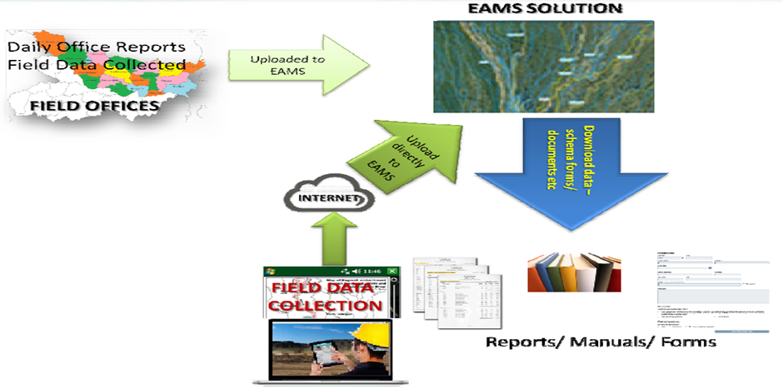

**Figure 6.3: Real Time Field Data Collection**

### Integration of Tablet Based Asset Inspection

Based on the discussion with the specialists at FMISC, the process of integrating inspection reports with the EAMS has been devised taking into consideration various guidelines of the stakeholders. It is envisaged that the inspection of embankments shall be a regular activity for collection of field data by the engineers of various levels before flood season, during flood season and post flood season.

Generic workflow adopted for the field data collection is as follows:

1. User will start internet on the handheld device and log into the appropriate inspection collection application.

**OR**

In cases, where internet connectivity is absent, users will log into the device and then choose the appropriate inspection collection application.

1. The user will login into application and select the appropriate form.
2. The user will add information regarding the various locations of the embankment assets in by either selection. The user will have the functionality to add feature attributes based on the ground situation and save it in the database
3. Once the information is collected and saved, the user will come back to the office and upload the inspection collected onto the web site so provided for the purpose.
4. Administrator will validate and approve data that is submitted into the EAMS application.

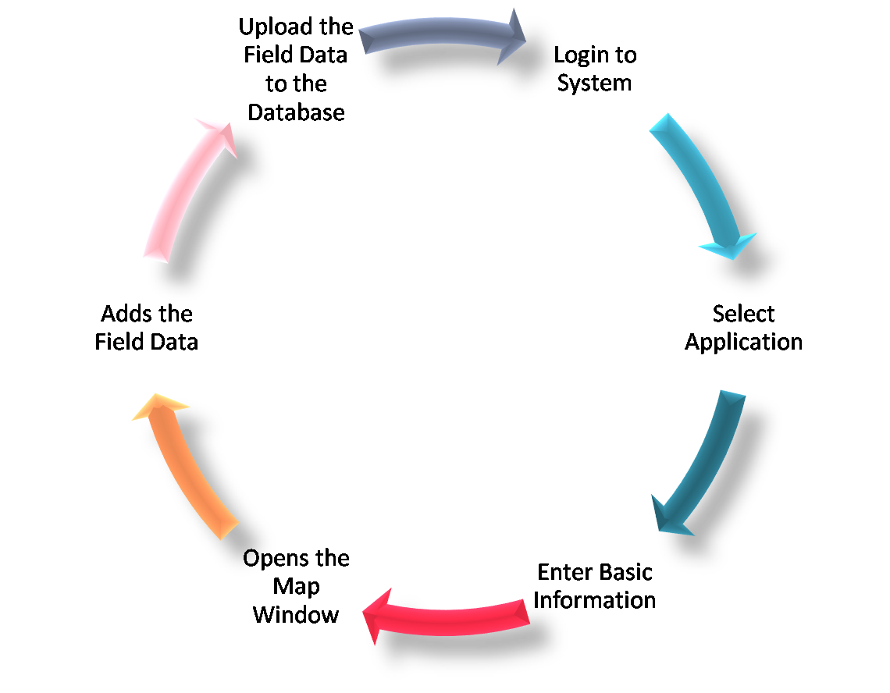

**Figure 6.4: Workflow for field data collection**

A similar process is suggested for the collection of emergency flood report from field supervisor. The user will open the application in the handheld device and login and open the application for emergency flood report and enter the appropriate information as per the template Emergency Flood Report from Field Supervisor. Once the data is collected and saved, the field supervisor will return to the field office and upload the data over the internet.

## Management Information System

Asset Management Information System (AMIS) including.

* Report schedules
* Formats and protocols for tracking management activities (physical, financial and administrative) during the asset life cycle.
* Existing formats and protocols would be used unless updating is required, to support easy adoption by the agencies.
* The AMIS should also include tools for tracking use of AMIS in UPIWRD’s business processes and decision making
* evaluate impact in terms of outputs and outcomes
* Evaluate key performance measures for evaluation of EAMS effectiveness and continued improvement.

## Risk Assessment Module

The risk assessment module for evaluating:

* The hazard,
* The system response/performance, and
* The consequences.

The primary hazard for assets in the State is the likelihood of flood loading. Flood hazard maps will be prepared for the area protected by the embankments. The asset may be subjected to other hazards, such as earthquake loading, but those hazards are to be included in the risk assessment only when they have potential to compromise the ability of the system to reduce inundation risk. The system response/performance is the integrity of the embankment system and the likelihood that it will perform as intended. The consequences include the exposure and vulnerability of people and property located within the “impacted area,” along with the potential for inundation to cause economic, environmental and societal harm.

## Community Participation Module

Currently community participates by informing UPIWRD offices over phone and personally on impact on embankment, but mostly seem to be frivolous when checked by field engineers. However, the participants felt communities should be encouraged and empowered to help UPIWRD in embankment surveillance to provide a sense of ownership and stake holding in embankment safety. The FMISC contract professional would assist in develop in the mechanism and modalities for community participation

It was concluded that the Panchayat Raj representative nominated by the District Magistrate (DM) could be the contact point for each community. The DM would also be requested to provide a list of cell phone numbers to whom the flood alerts would be sent by EAMS.

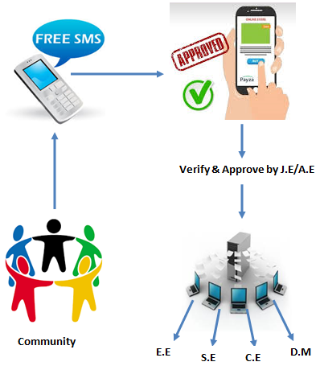

**Figure 6.5: Feedback/Reports from Communities**

### Role of the Community Participation

As Communities living on river embankments/banks have their own vast experience of river behavior and floods and hence their probable suggestions for flood fighting are very much valuable. There are numerous reasons causing failure of Embankment but with proper action after receiving feedback/reports from communities immediate remedial measures can be expedited and breaks can be avoided. Moreover, once community in every abutting village is made familiar with causes of Embankment failure, they will at least check the failures caused by human actions.

The EAMS system will provide the two services for community participation.

1. Web Site Interface
2. SMS Interface

By using above mentioned technologies, Community can send its feedback to EAMS system which may be helpful in the following ways.

* During pre-floods, they can report in advance for.
* Works completed or pending
* Vulnerable spur location and embankment stretches, If any
* Repair to be carried out for embankment slop, protection work , approach roads etc. If not complete completed before on set of monsoon.

## Document Management Module

Design Document Management System, to archive all documents.

* Maps
* Drawings and reports relating to asset management life-cycle.
* The input data could be in either analogue or digital format and in different file formats.
* The documents should be appropriately catalogued and hot-linked to geospatial data in EAMS.

## Analytical Module

Design analytical modules for asset management, including

* Erosion detection and proneness
* Annual planning and prioritization of flood management O&M based on risk assessment evaluated for each asset
* Annual planning and prioritization of new schemes
* Asset deterioration assessment
* Risk and vulnerability analysis,
* Cost analysis
* Generating outputs including management alerts,
* Asset safety certification
* Asset watch/alert/outlook.

## Map Content and System Administration Module

System administration, including

* Operation, maintenance, and upgrading, security,
* Accountability and responsibility of system personnel and users,
* Skill upgrading.

In this business tier, we have tried to explain the number and types of different user who will be responsible to handling the EAMS as per the business need.

# USER INTERFACE

The aim of this chapter to provide the detailed description of user interfaces which will be designed so as to develop a tool to visualize and monitor embankments and it’s assets of Rapti-Basin.

The EAMS is to develop various functions that will not only provide the current status of embankments and its assets but will be able to generate summary statistics on various user-selected databases. Data collection and update of existing embankment and its assets will be augmented with the help of field data collection mobile devices. The GIS viewer will need to be available to all stakeholders especially in various CE jurisdictions so the individual geographic areas can be precisely monitored through automatic or manual zoom. Provision for warning or alarm status within the Web based viewer through a combination of cartographic information (colours, forms, symbols, or characters) on respective maps will allow decision makers to make informed decisions in flood management.

This chapter specifically provides detailed interfaces for all modules within EAMS and its subsystem. It describes detailed design of the solutions or application being developed and the hardware usage process design. Within the detailed design of the software, the emphasis is on the development of the User Interface (UI), the various screen Images that will display screenshots/wireframe models showing the interface from the user’s perspective, and the screen objects and actions that are associated with these objects.

## Software Detailed Design

# SYSTEM INTEGRITY CONTROLS

# APPENDIX