AWS EC2 Deployment Assignment

Student Name: Mayank Mishra
Cloud Platform: Amazon Web Services (AWS)
GitHub Repo: https://github.com/mayank2229/docker-assignment
Deployed App URL: http://43.205.231.1:3000

Deploy Flask Backend & Express Frontend on AWS EC2

PART 1 – DEPLOY ON SINGLE EC2 INSTANCE

In this part, both the Flask backend and Node.js Express frontend were deployed together on a single AWS EC2 instance using Docker Compose.

Step 1 – Launch EC2 Instance:
Instance Name: flask-node-single
AMI: Ubuntu Server 22.04 LTS (Free Tier eligible)
Instance Type: t2.micro (Free Tier)
Key Pair: Created and downloaded .pem file
Security Group Rules: SSH (22), HTTP (80), Port 3000, Port 5000 – Allow All

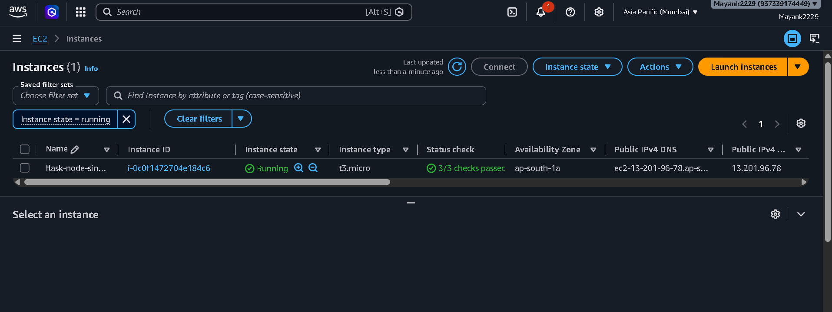
Step 2 – Connect to EC2 via SSH:
ssh -i "your-key.pem" ubuntu@<EC2-PUBLIC-IP>

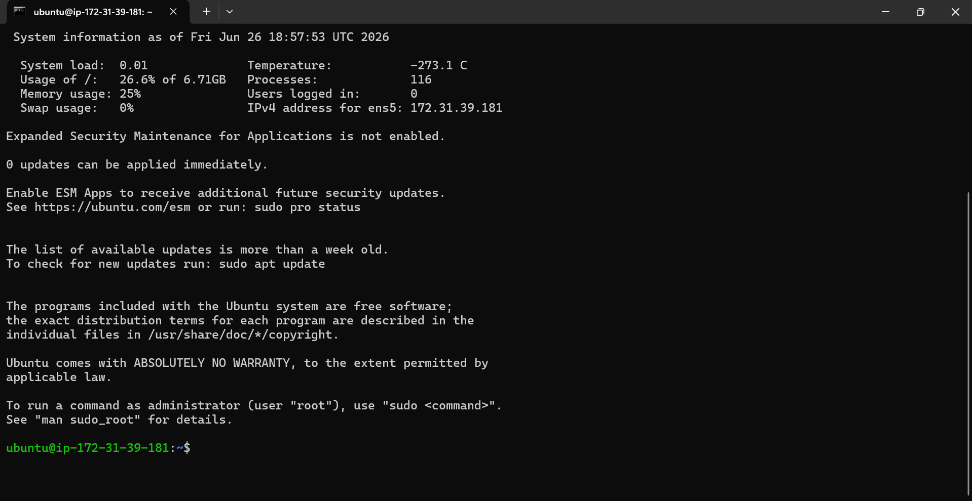
Step 3 – Install Docker & Docker Compose:
sudo apt update
sudo apt install docker.io -y
sudo apt install docker-compose -y
sudo usermod -aG docker ubuntu
newgrp docker

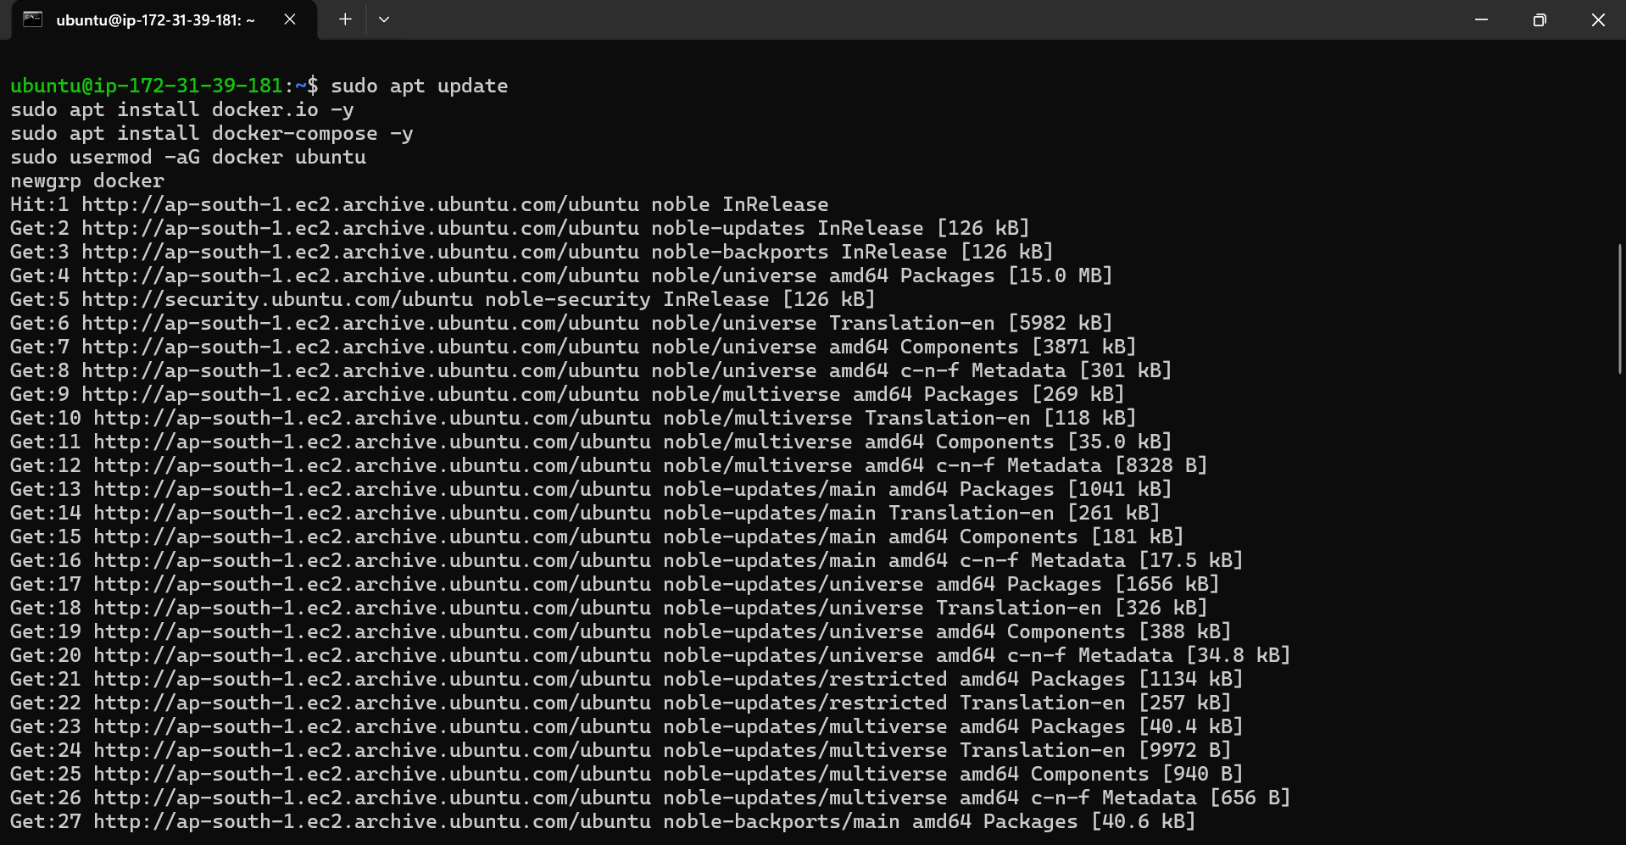
Step 4 – Clone GitHub Repo & Run:
git clone https://github.com/mayank2229/docker-assignment.git
cd docker-assignment
docker-compose up --build -d

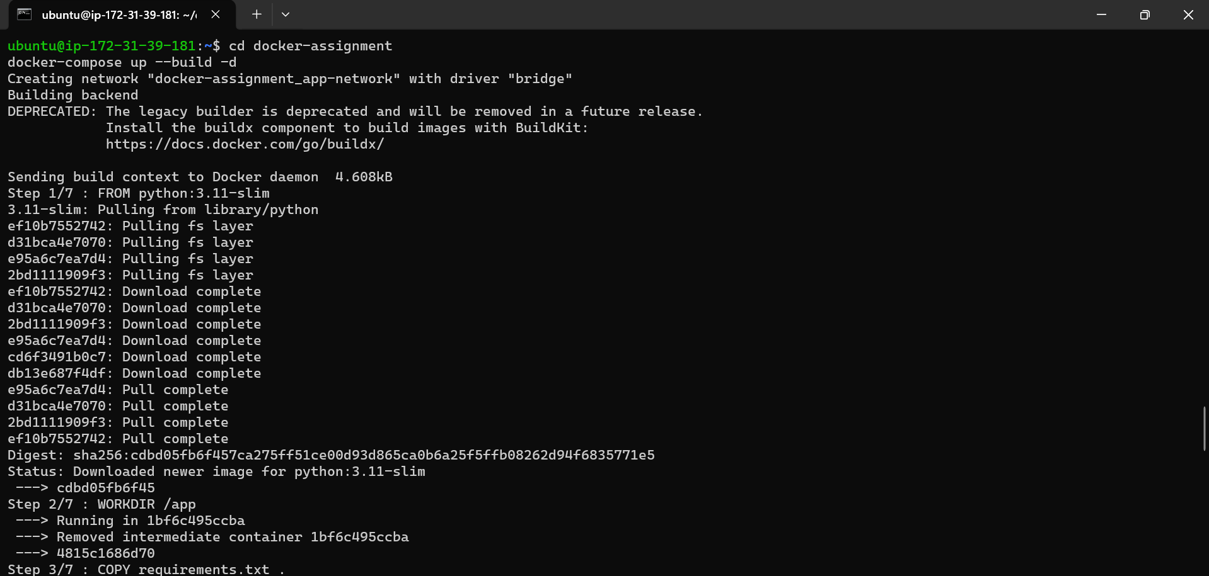
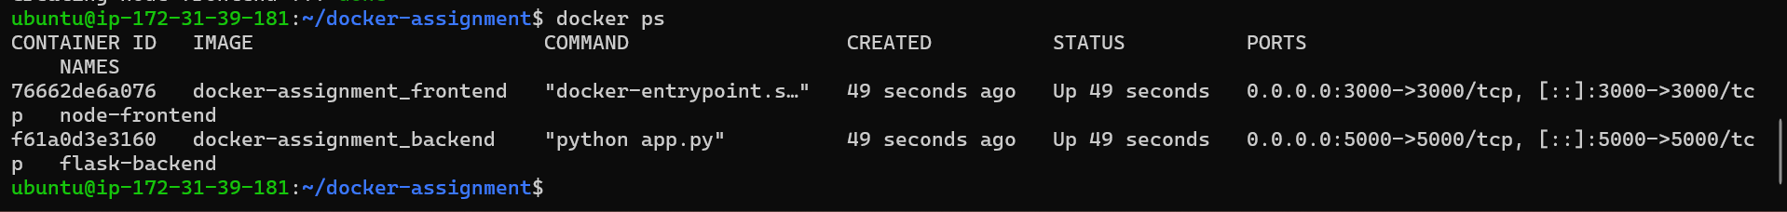
Step 5 – Access the Application:
The application was accessed publicly using the EC2 public IP address on port 3000.
Frontend URL: http://<EC2-PUBLIC-IP>:3000
Backend URL: http://<EC2-PUBLIC-IP>:5000

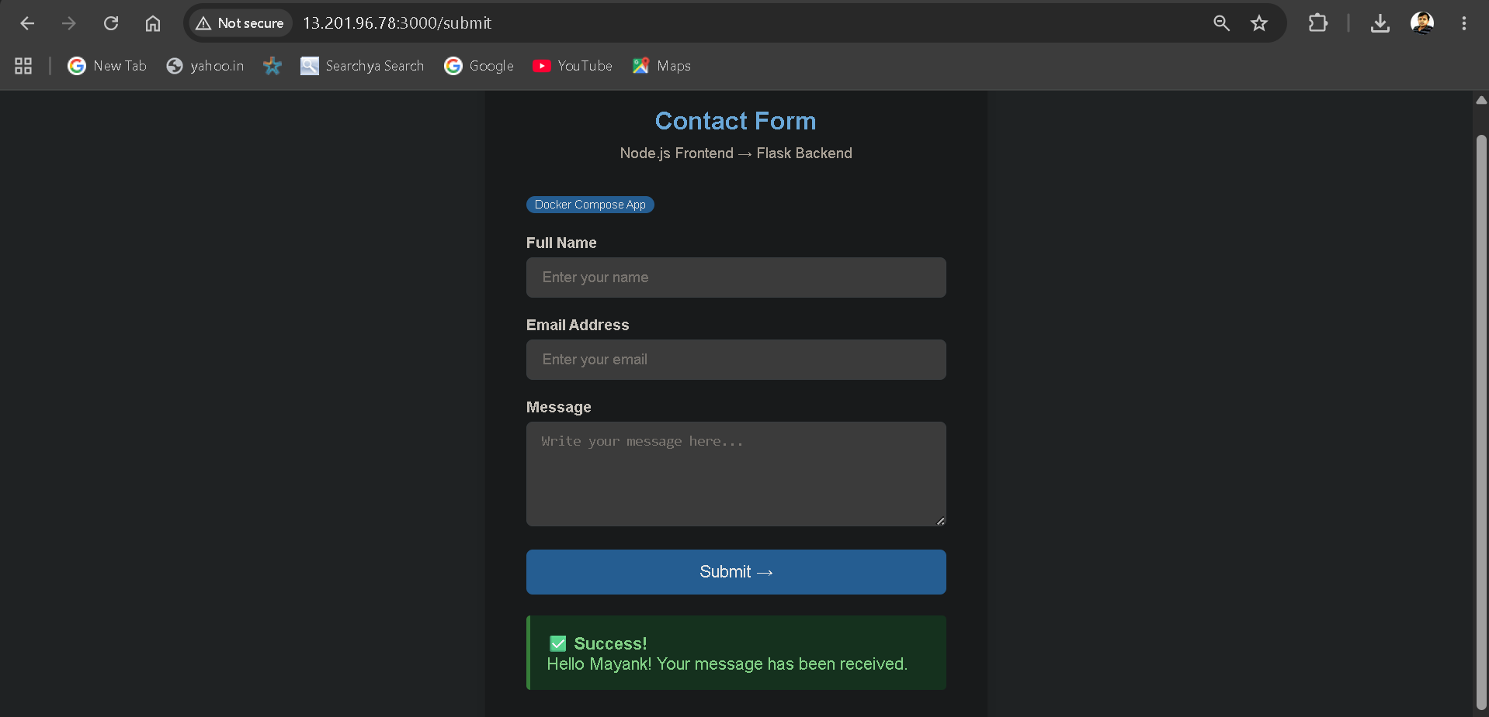

PART 2 – DEPLOY ON SEPARATE EC2 INSTANCES

In this part, the Flask backend and Node.js Express frontend were deployed on two separate AWS EC2 instances, communicating with each other via their public IP addresses.

Step 1 – Launch Two EC2 Instances:
Instance 1 Name: flask-backend-ec2
Instance 2 Name: node-frontend-ec2
AMI: Ubuntu Server 22.04 LTS
Instance Type: t2.micro (Free Tier)
Security Group: SSH (22), Port 5000 for backend / Port 3000 for frontend

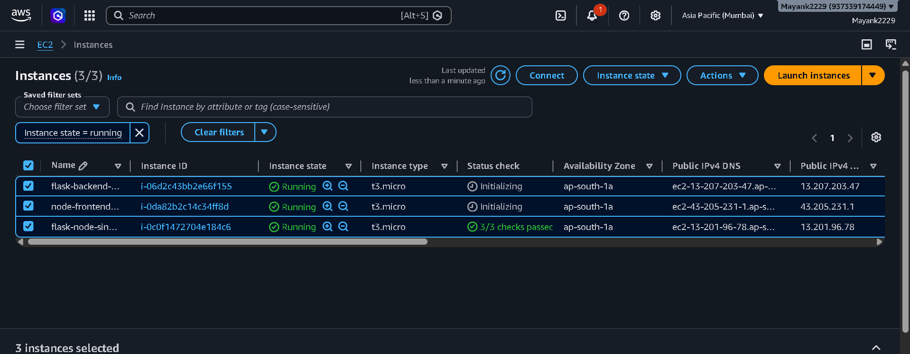
Step 2 – Deploy Flask Backend on Instance 1:
ssh -i "your-key.pem" ubuntu@<BACKEND-EC2-IP>
sudo apt update
sudo apt install docker.io -y
git clone https://github.com/mayank2229/docker-assignment.git
cd docker-assignment/backend
docker build -t flask-backend .
docker run -d -p 5000:5000 flask-backend

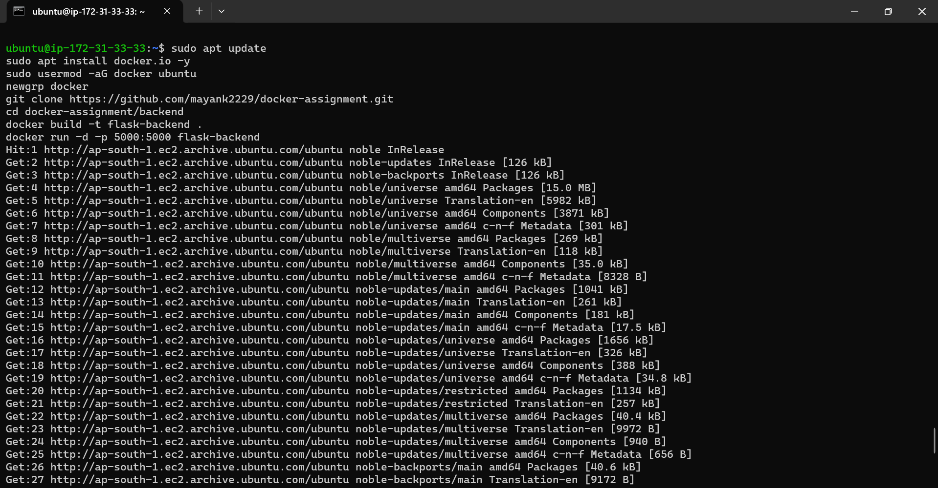
Step 3 – Deploy Node.js Frontend on Instance 2:
ssh -i "your-key.pem" ubuntu@<FRONTEND-EC2-IP>
sudo apt update
sudo apt install docker.io -y
git clone https://github.com/mayank2229/docker-assignment.git
cd docker-assignment/frontend
docker build -t node-frontend .
docker run -d -p 3000:3000 \
-e FLASK_URL=http://<BACKEND-EC2-IP>:5000 \
node-frontend

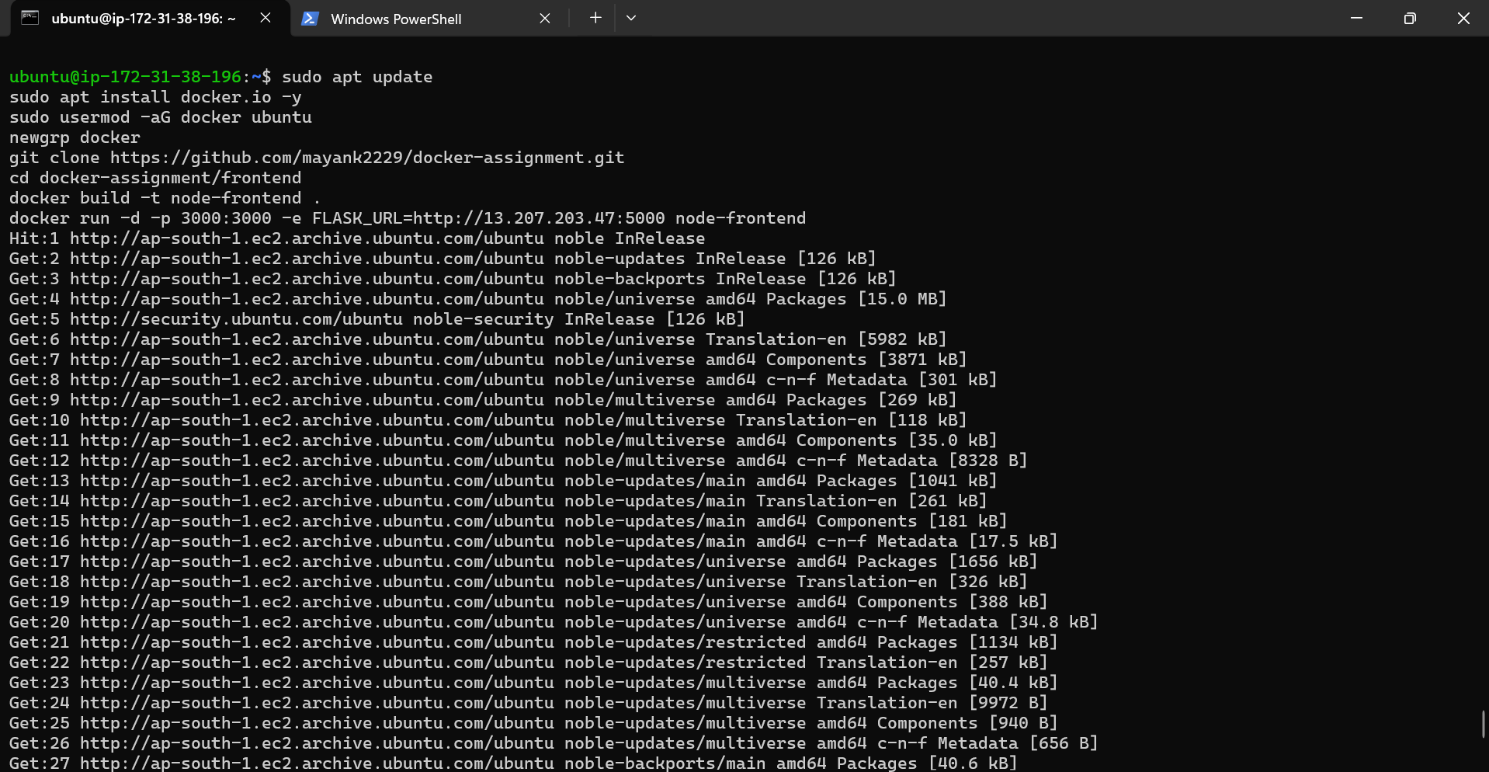
Step 4 – Access the Application:
Frontend URL: http://<FRONTEND-EC2-IP>:3000
Backend URL: http://<BACKEND-EC2-IP>:5000

PART 3 – DEPLOY USING AWS ECR, ECS & VPC

In this part, Docker images were pushed to Amazon ECR (Elastic Container Registry) and deployed using Amazon ECS (Elastic Container Service) within a custom VPC.

Step 1 – Create ECR Repositories:
Repository 1: flask-backend
Repository 2: node-frontend
Region: ap-south-1 (Mumbai)

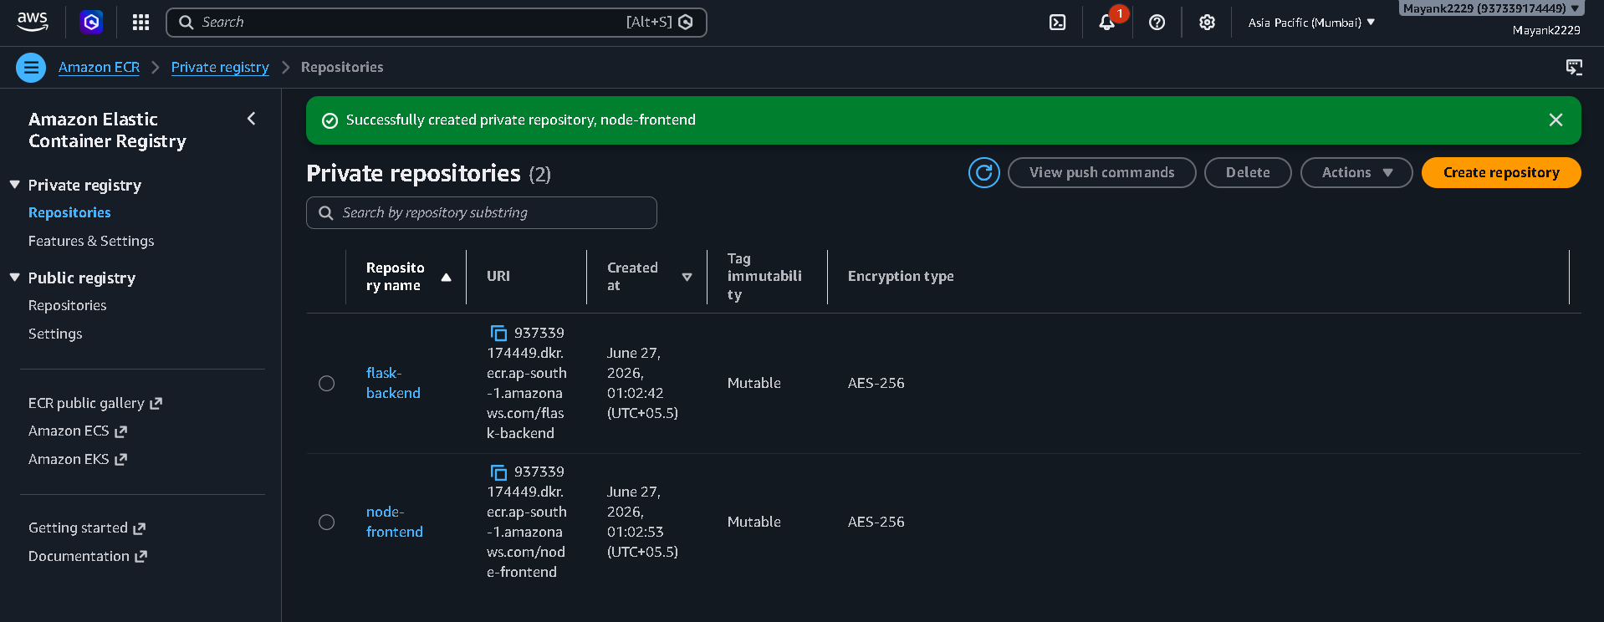
Step 2 – Push Docker Images to ECR:
aws ecr get-login-password --region ap-south-1 | \
docker login --username AWS \
--password-stdin <AWS-ACCOUNT-ID>.dkr.ecr.ap-south-1.amazonaws.com

docker build -t flask-backend ./backend
docker tag flask-backend:latest \
<AWS-ACCOUNT-ID>.dkr.ecr.ap-south-1.amazonaws.com/flask-backend:latest
docker push \
<AWS-ACCOUNT-ID>.dkr.ecr.ap-south-1.amazonaws.com/flask-backend:latest

docker build -t node-frontend ./frontend
docker tag node-frontend:latest \
<AWS-ACCOUNT-ID>.dkr.ecr.ap-south-1.amazonaws.com/node-frontend:latest
docker push \
<AWS-ACCOUNT-ID>.dkr.ecr.ap-south-1.amazonaws.com/node-frontend:latest

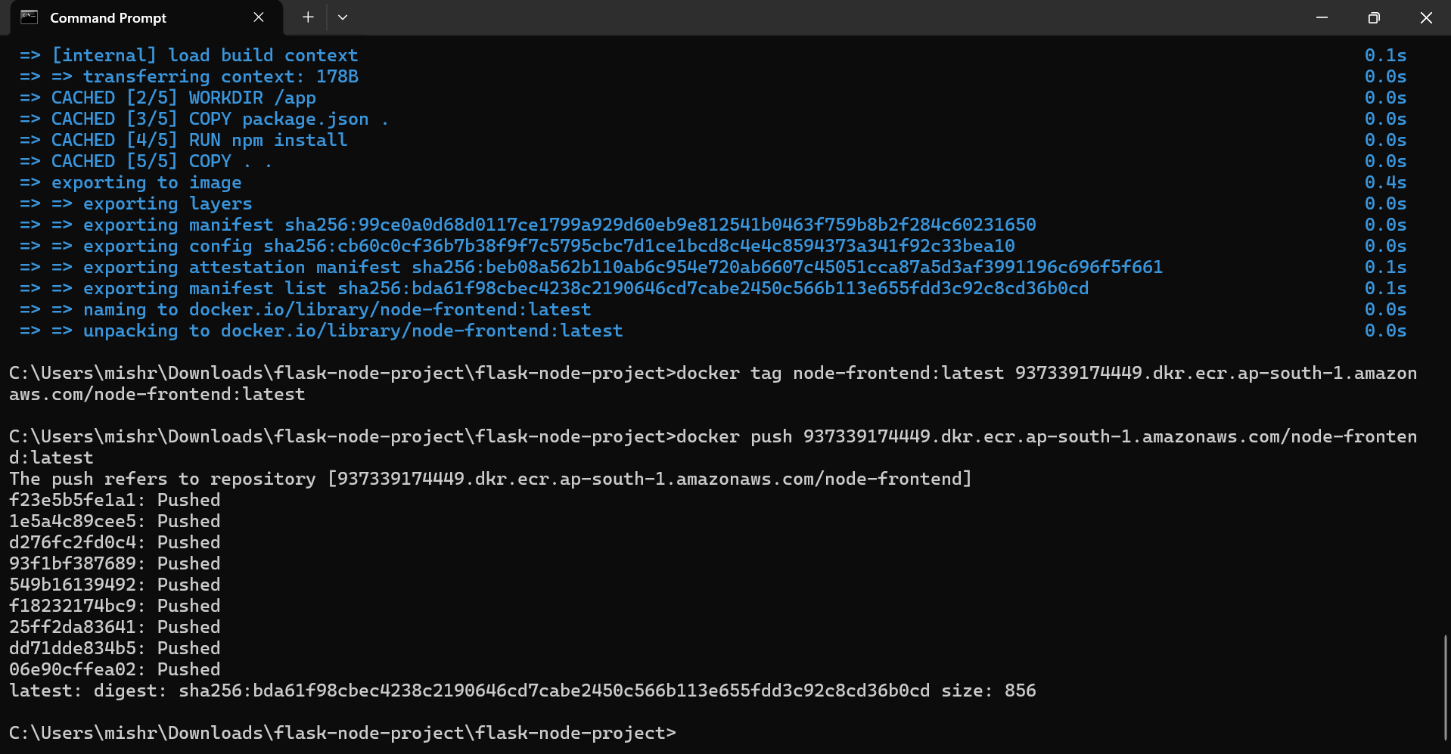
Step 3 – Create VPC & Subnets:
VPC Name: flask-node-vpc
CIDR Block: 10.0.0.0/16
Subnets: Public Subnet – 10.0.1.0/24
Internet Gateway: Attached to VPC

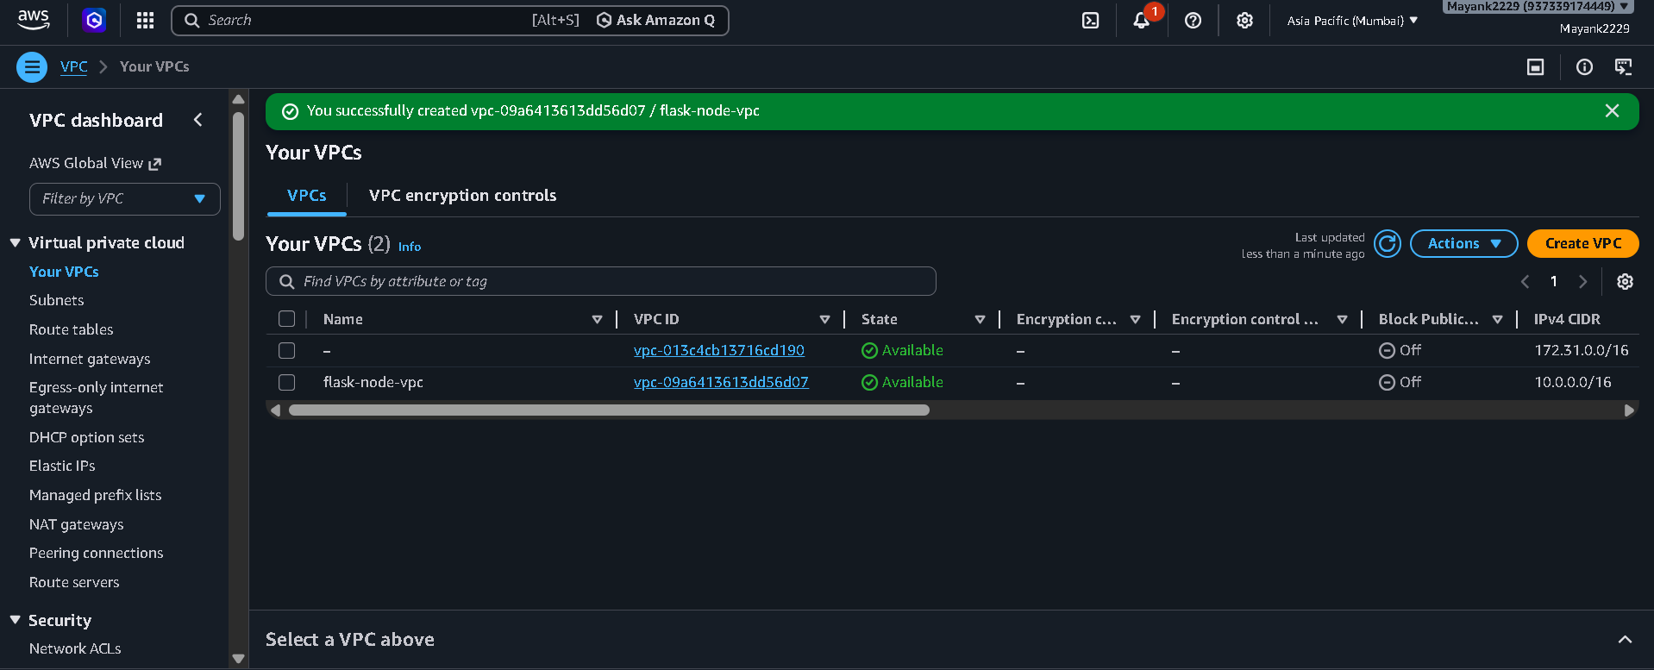
Step 4 – Create ECS Cluster & Task Definitions:
Cluster Name: flask-node-cluster
Launch Type: Fargate
Task 1: flask-backend-task – ECR image, port 5000
Task 2: node-frontend-task – ECR image, port 3000
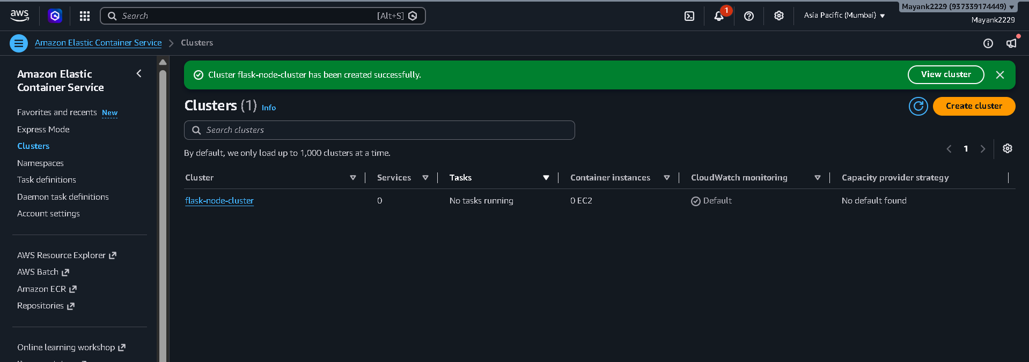
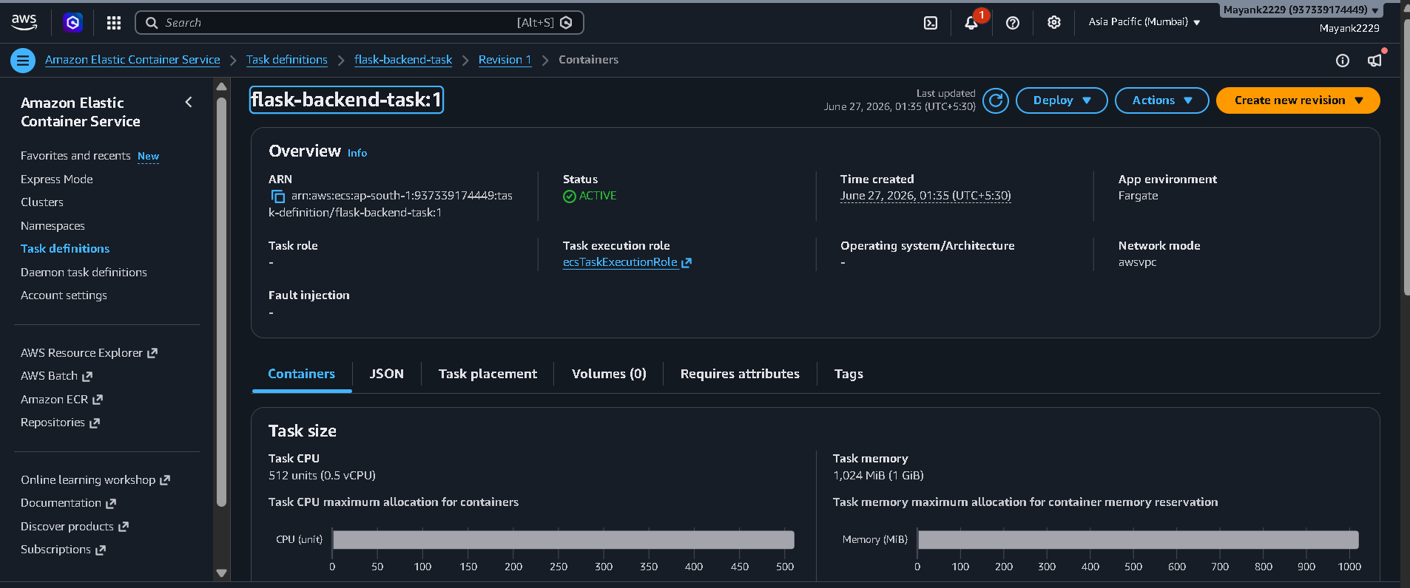

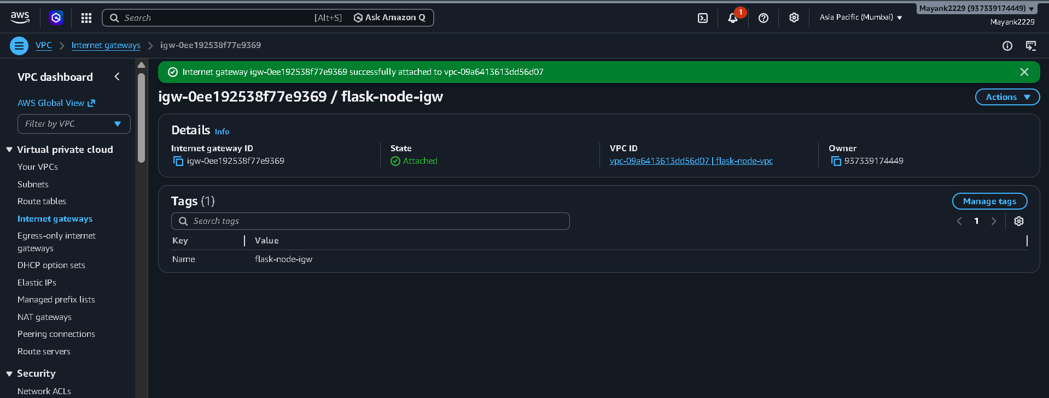
Step 5 – Run ECS Services:
Service 1: flask-backend-service
Service 2: node-frontend-service
Network: flask-node-vpc – Public Subnet
Auto-assign Public IP: Enabled

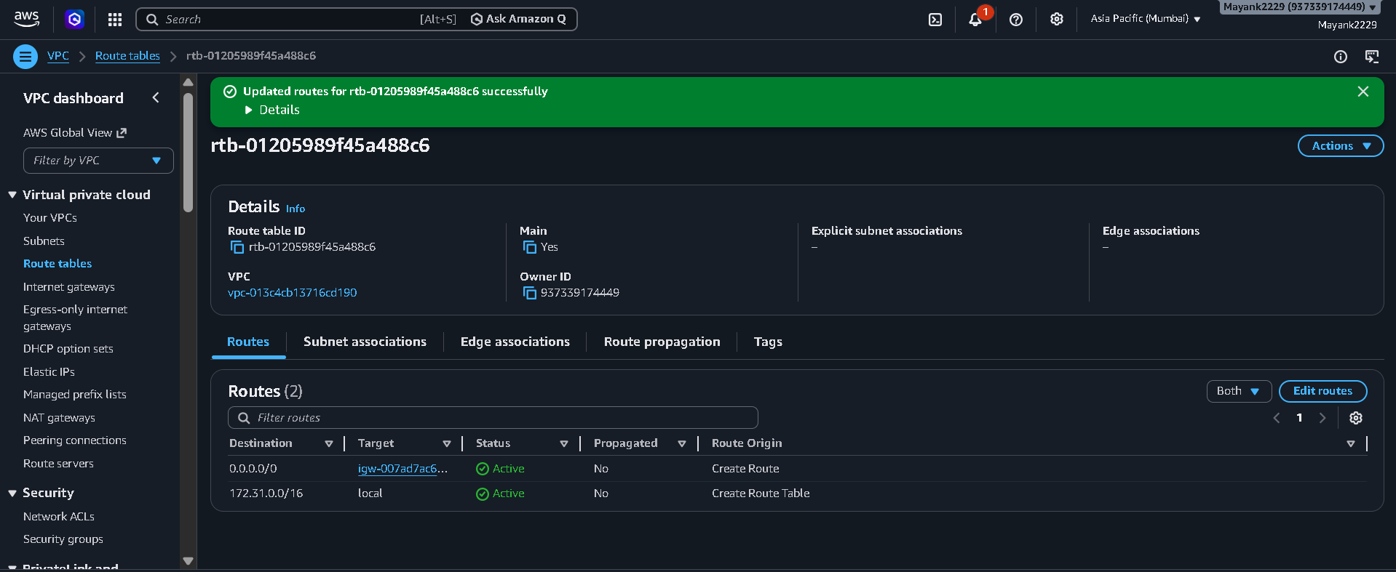

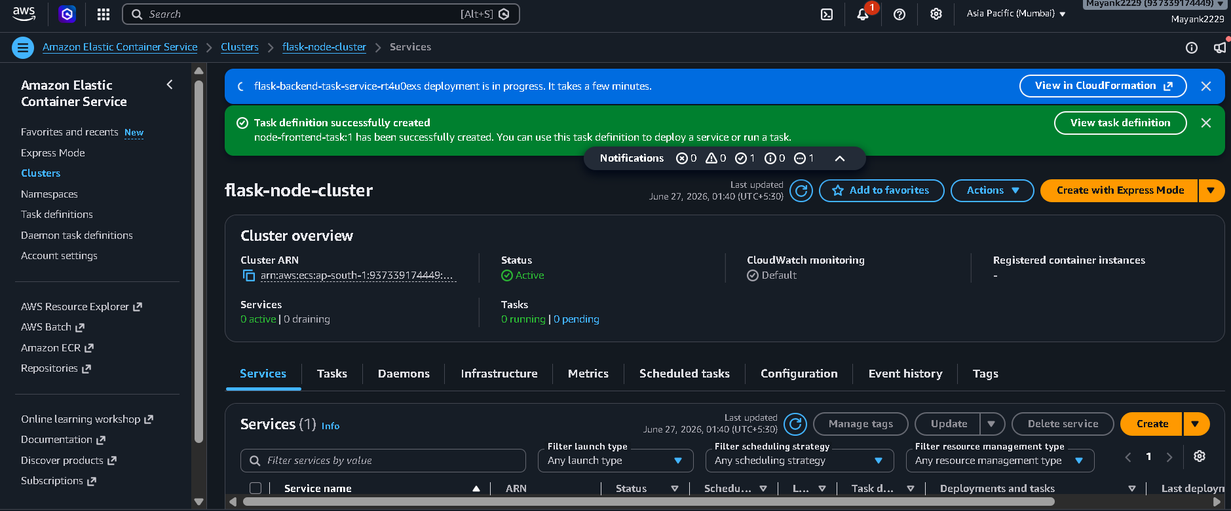
Step 6 – Access the Application:
The application was accessed using the public IP assigned by ECS Fargate to the frontend task.
Frontend URL: http://<ECS-TASK-PUBLIC-IP>:3000

SUMMARY

This assignment demonstrated three different methods of deploying a full-stack Flask + Node.js application on AWS:

- Single EC2 Instance – Both services deployed together using Docker Compose on one Ubuntu EC2 t2.micro instance.
- Separate EC2 Instances – Flask backend and Node.js frontend deployed on two individual EC2 instances, communicating via public IPs.
- ECR + ECS + VPC – Docker images pushed to Amazon ECR and deployed as Fargate containers inside a custom VPC using ECS services.

