INT375
PROJECT REPORT
(Project Semester January–April 2025)
Electric Vehicle Trends and Sustainability Metrics (2017–Present)
Submitted by:
Name: Mayank
Registration No: 12320796
Programme and Section: B.Tech CSE K23EP
Course Code: INT375
Department of Computer Science and Engineering
Lovely Professional University
Phagwara, Punjab (India)
April 2025

Under the Guidance of
Dr. Tanima Thakur (UID: 23532)
Discipline of CSE/IT
Lovely School of Computer Science and Engineering
Lovely Professional University, Phagwara

CERTIFICATE
This is to certify that Mayank, bearing Registration No. 12320796, has successfully completed the project work entitled “Electric Vehicle Trends and Sustainability Metrics (2017–Present)”
as part of the course INT375 during the project semester January–April 2025, under my supervision and guidance.To the best of my knowledge, the present work is the result of the student’s original research, development, and effort.
Signature and Name of the Supervisor
Dr. Tanima Thakur
Assistant Professor, Discipline of CSE/IT
School of Computer Science and Engineering
Lovely Professional University, Phagwara, Punjab
Date: ______________________

DECLARATION
I, Mayank, a student of B.Tech under the CSE/IT Discipline at Lovely Professional University, Punjab, hereby declare that the project work entitled
“Electric Vehicle Trends and Sustainability Metrics (2017–Present)”
submitted in partial fulfillment of the course INT375, is the result of my own intensive work. The content in this report is original, genuine, and has not been copied from any unauthorized source. All efforts and data analysis have been conducted with sincerity and academic integrity.
Date: 09-04-2025
Signature: ______________________
RegNo.: 12320796
Name of the Student: Mayank

ACKNOWLEDGEMENT
I would like to express my sincere gratitude to all those who supported me throughout the completion of this project titled
“Electric Vehicle Trends and Sustainability Metrics (2017–Present)”.
First and foremost, I would like to thank Dr. Tanima Thakur, my respected project supervisor, for her invaluable guidance, support, and encouragement. Her expert advice, timely feedback, and motivation helped me stay focused and complete this project efficiently.
I would also like to extend my appreciation to the faculty and staff of the Discipline of CSE/IT, Lovely Professional University, for creating a learning environment that inspired this research.
A special thanks to my peers, friends, and family for their constant moral support and encouragement throughout the project.
Lastly, I would like to acknowledge the use of the dataset provided by NYSERDA (New York State Energy Research and Development Authority) which served as the foundation for the analysis conducted in this report.
Mayank
Registration No.: 12320796

TABLE OF CONTENTS

S. No. | Content | Page No.
1 | Introduction | Introduction
2 | Source of Dataset | Source
3 | Exploratory Data Analysis (EDA) Process | (EDA)
4 | Analysis on Dataset | Analysis
 | 4.1 Understanding Relationships Between Rebate Amount, GHG & Petroleum Reductions | __
 | 4.2 Identifying the Most Popular EV Models for Rebates | ___
 | 4.3 Understanding the Distribution of Rebate Amounts | ___
 | 4.4 Identifying the Top 10 Counties with the Most EV Rebates | ___
 | 4.5 Analyze the Distribution of Rebate Amounts across EV Types | ___
5 | Conclusion | Conclusion
6 | Future Scope | Future
7 | References | References

1. Introduction
In recent years, climate change and environmental sustainability have become global priorities. As part of this transformation, electric vehicles (EVs) have emerged as a cleaner and more sustainable alternative to traditional fossil fuel-based transportation. To accelerate the adoption of EVs, various governments and organizations have introduced incentive programs that make EVs more financially accessible to consumers. One such program is the Drive Clean Rebate initiative launched by the New York State Energy Research and Development Authority (NYSERDA).
1.1 Overview of the Dataset
The dataset used in this project is a detailed record of electric vehicle rebate claims under NYSERDA’s Drive Clean Rebate Program. It includes information on individual rebate transactions made available to the public to promote transparency and allow data-driven decision-making. The dataset begins from 2017 and is regularly updated, making it a rich source of information for analyzing EV trends in New York State.
Key details of the dataset include:
- Name: NYSERDA Electric Vehicle Drive Clean Rebate Data
- Source: data.ny.gov – The official open data portal of New York State
- Format: Comma Separated Values (CSV) file
- Time Period: January 2017 to present
- Number of Records: Over 300,000 entries (as of the latest update)
- File Size: Varies with updates (approx. 20–25 MB)
1.2 Purpose and Relevance of the Dataset
This dataset serves several important purposes:
- Promotes policy evaluation: By analyzing rebate distributions, government agencies can assess how well their incentive programs are working.
- Encourages transparency: Making this data public ensures transparency in rebate distribution.
- Enables research and analysis: Students, researchers, and analysts can use the data to study consumer behavior, model EV adoption, or assess environmental impact.
- Supports the EV ecosystem: Car manufacturers and dealerships can understand demand trends and tailor offerings accordingly.
1.3 Columns and Their Significance
The dataset contains a wide range of columns. Some of the most important ones include:
- Purchase Date: The date the vehicle was purchased or leased.
- Vehicle Make and Model: Indicates the brand and specific model of EV purchased.
- Technology Type: Identifies whether the vehicle is a Battery Electric Vehicle (BEV) or Plug-in Hybrid (PHEV).
- MSRP: Manufacturer's Suggested Retail Price of the vehicle.
- Rebate Amount: The dollar value of the rebate received.
- County: Geographic location of the buyer.
- Dealership Name: Name of the selling dealership.
Each of these fields offers insights into purchasing patterns, price sensitivity, dealership effectiveness, and geographic EV adoption.
1.4 Suitability for Data Science Projects
This dataset is ideal for data science and analytics projects because of the following features:
- Large volume: Sufficient data points to draw statistically meaningful insights.
- Structured format: Well-organized and easy to parse with tools like Python and Pandas.
- Temporal spread: Data across multiple years allows trend analysis and forecasting.
- Real-world relevance: EV adoption is a critical issue in both environmental and economic discussions today.
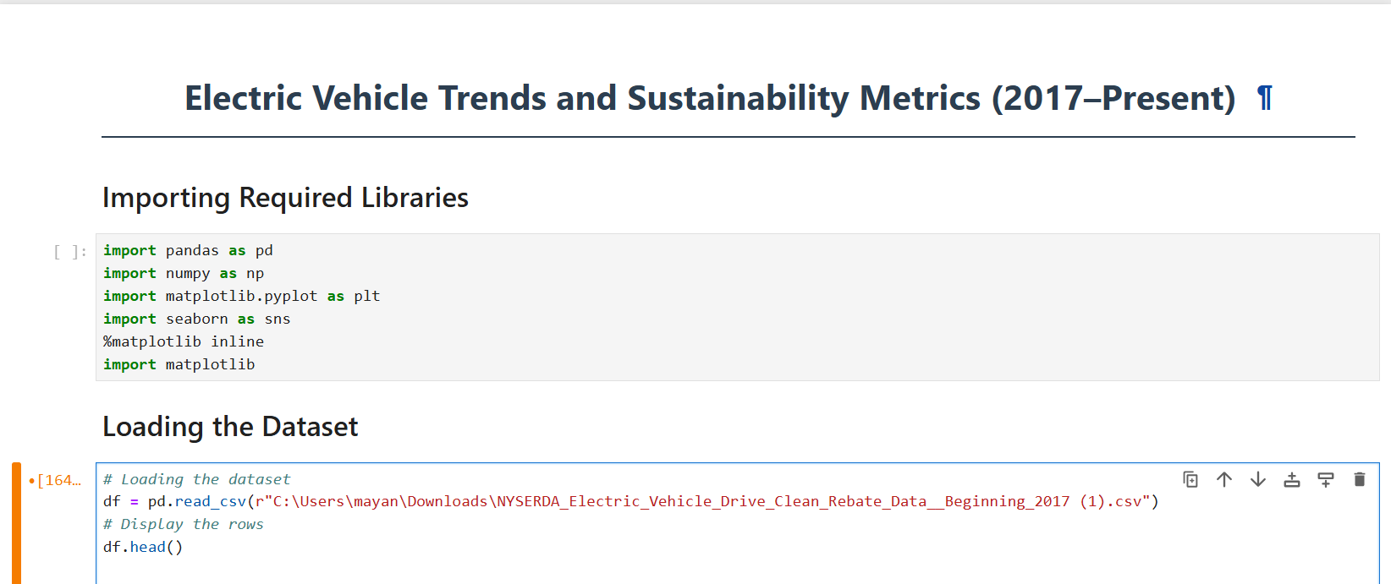

Source of Dataset
#Source
Dataset Link:-https://catalog.data.gov/dataset/nyserda-electric-vehicle-drive-clean-rebate-data-beginning-2017

Showing Dataset :
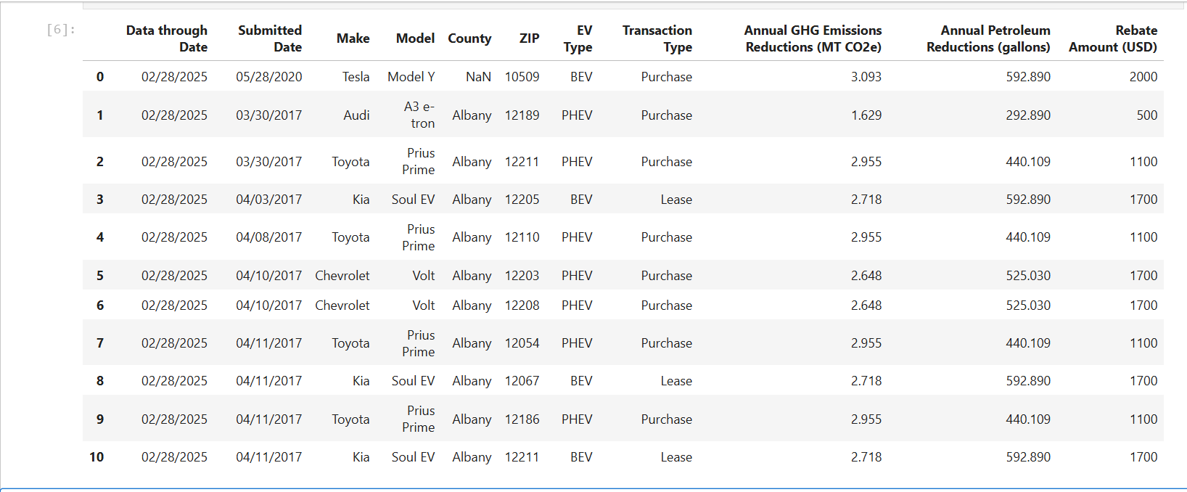

3. Exploratory Data Analysis (EDA) Process
Exploratory Data Analysis (EDA) is a vital part of any data science or analytical project. It helps in developing a deep understanding of the dataset, identifying any inconsistencies, and preparing the data for further analysis. In this section, we carry out a detailed EDA process on the NYSERDA Electric Vehicle Rebate dataset. Each step is described below, followed by its corresponding output screenshots and code.

Step 1: Viewing Basic Information of the Dataset
The first step is to explore the fundamental structure of the dataset using the .info() method. This command provides essential details such as the total number of entries (rows), the number of columns (features), the type of data stored in each column (e.g., integer, float, string), and the number of non-null (non-missing) values in each column.
This overview helps us understand the completeness and consistency of the data, and gives a general idea of how to proceed with further cleaning or transformation.
Code Used:
Screenshot and Output:
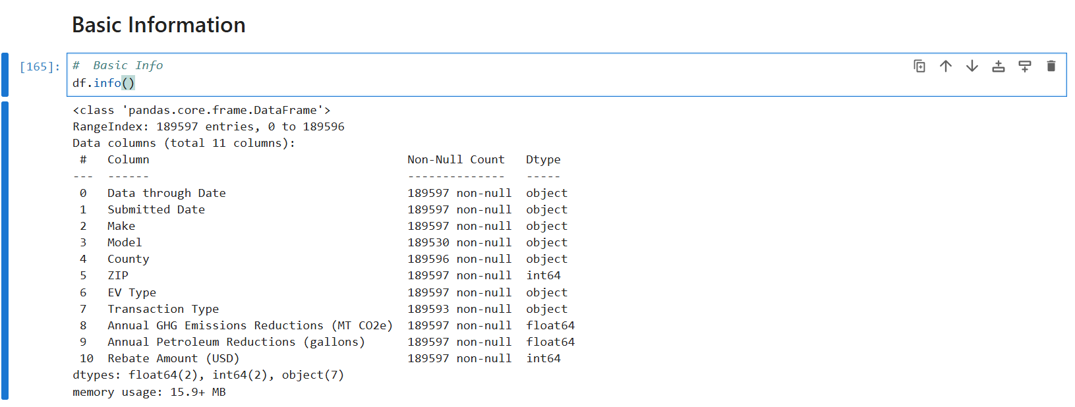
Step 2: Counting Unique Values in Each Column
To gain insight into the uniqueness of values across columns, we use the .nunique() method. This step tells us how many distinct values exist in each column. This is particularly useful for identifying categorical variables and understanding their diversity.
Knowing which columns have limited or excessive unique values is crucial in deciding how they can be grouped, visualized, or transformed in future steps.
Code Used:
df.nunique()
Screenshot and Output:
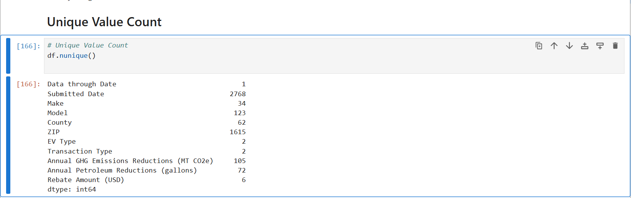
Step 3: Descriptive Statistics of Numeric Columns
We use the .describe() method to generate a summary of all numeric columns in the dataset. This includes key statistics such as the mean, minimum, maximum, standard deviation, and percentiles for each numeric field.
This summary gives us a foundational understanding of data distribution, potential outliers, and the scale of each feature.
Code Used:
print("Summary statistics of numeric columns:\n")
print(df.describe())
Screenshot and Output:
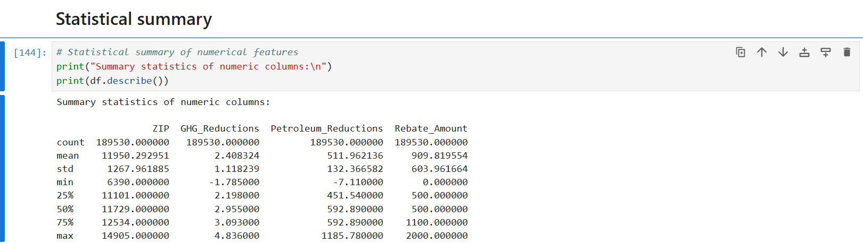
Step 4: Cleaning and Standardizing Column Names
For consistency and ease of reference, we clean up the column names by removing unnecessary characters and standardizing their format. This includes replacing spaces with underscores and removing any parentheses. These changes help avoid syntax errors and make the code more readable and manageable during analysis.
Code Used:
df.columns = df.columns.str.strip().str.replace(" ", "_").str.replace("(", "").str.replace(")", "")
Screenshot Before and After Cleaning:
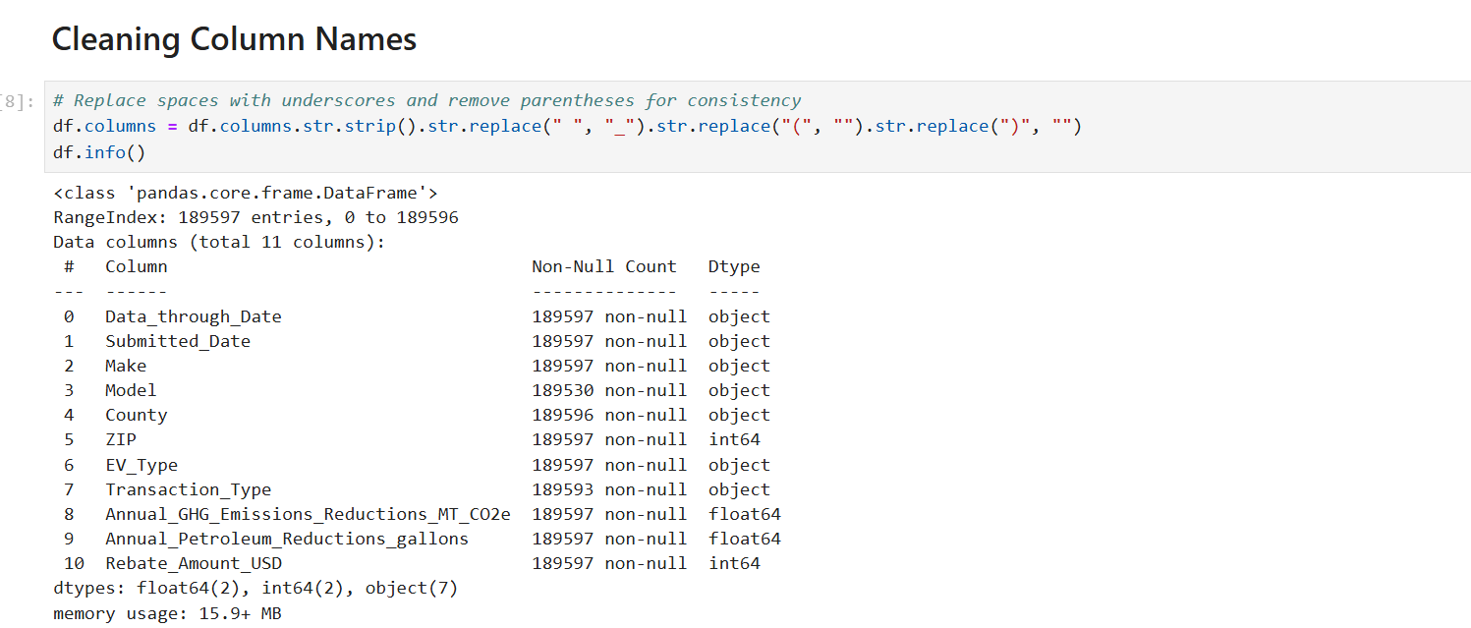
Step 5: Renaming Key Columns for Simplicity
Some of the column names in the dataset are long and complex. To simplify further analysis and enhance readability, we rename a few important columns with more concise titles. For example:
- Annual_GHG_Emissions_Reductions_MT_CO2e is renamed to GHG_Reductions
- Annual_Petroleum_Reductions_gallons is renamed to Petroleum_Reductions
- Rebate_Amount_USD is renamed to Rebate_Amount
These new names retain the original meaning but are easier to use in analysis and visualization.
Code Used:
df.rename(columns={
"Annual_GHG_Emissions_Reductions_MT_CO2e": "GHG_Reductions",
"Annual_Petroleum_Reductions_gallons": "Petroleum_Reductions",
"Rebate_Amount_USD": "Rebate_Amount"
}, inplace=True)
Updated Columns Screenshot:
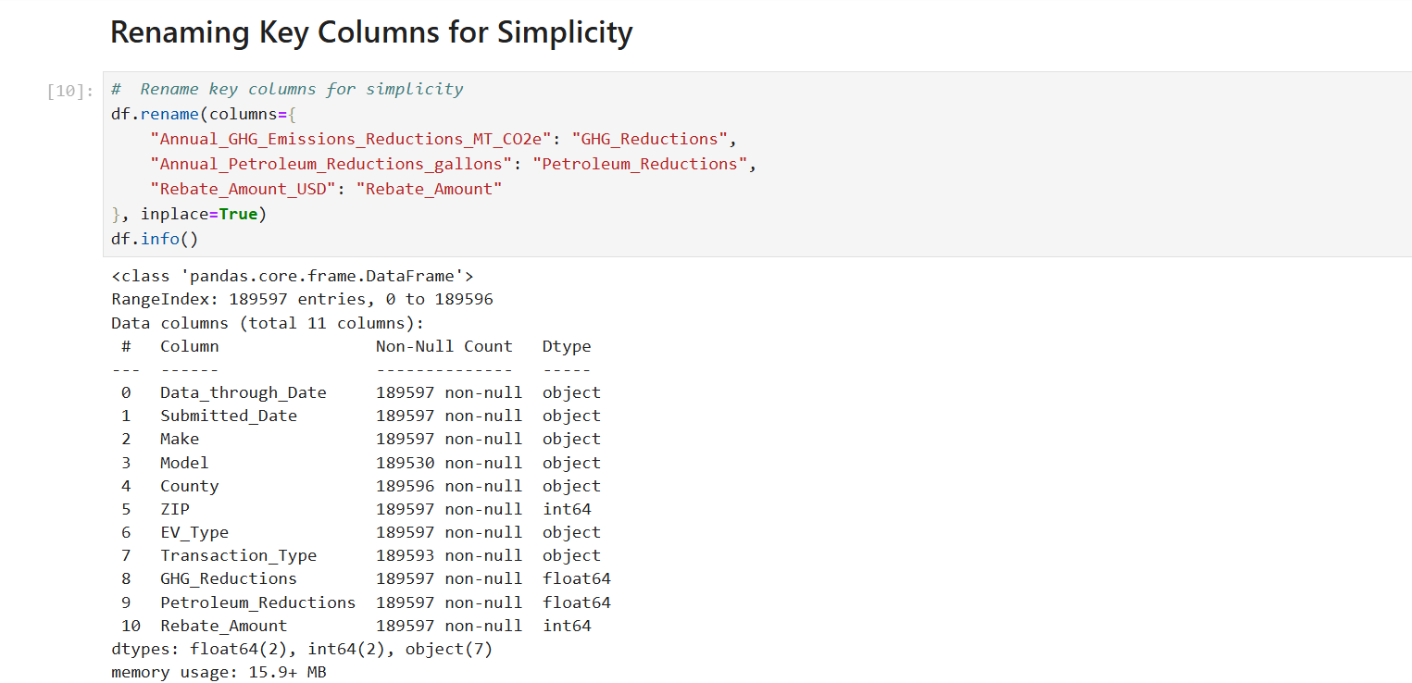
Step 6: Identifying Missing Values
To ensure the dataset is complete and reliable, we check for missing or null values using .isnull().sum(). This gives us a count of how many missing entries exist in each column. Only the columns that contain missing values are displayed, allowing us to focus on cleaning or imputing only those specific areas.
Understanding where and how much data is missing helps us determine whether to fill in the values, drop the rows, or handle them through other data-cleaning methods.
Code Used:
missing_values = df.isnull().sum()
missing_values = missing_values[missing_values > 0]
print("Missing values in columns:\n")
print(missing_values)
Screenshot and Output:
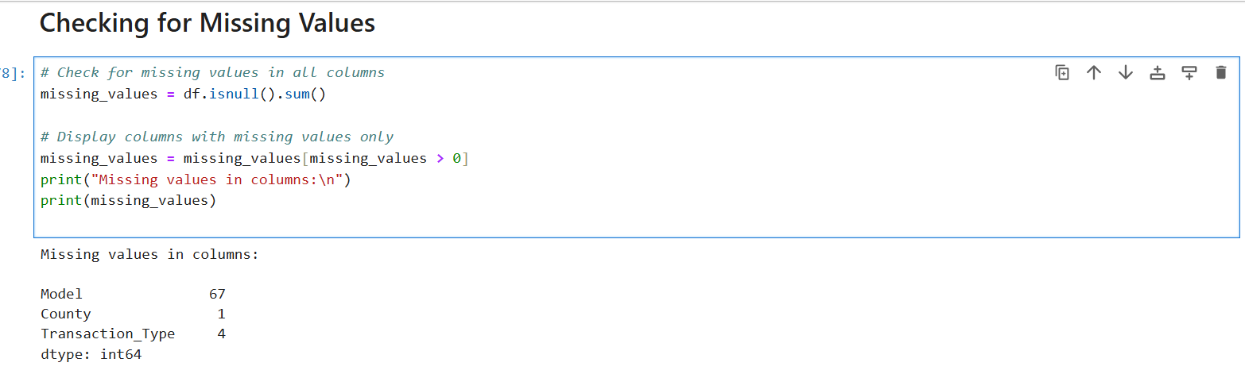

Step 7: Exploring Categorical Features
To gain insight into the nature of the categorical (non-numeric) variables, we calculate the number of unique values in each object-type column. This step reveals how many different values exist within each feature, such as vehicle makes, models, dealership names, or counties.
This is especially useful when deciding how to visualize these categories or whether they need to be grouped for better interpretation.
Code Used:
for col in df.select_dtypes(include='object').columns:
unique_count = df[col].nunique()
print(f"{col}: {unique_count} unique value{'s' if unique_count > 1 else ''}")
Screenshot and Output:
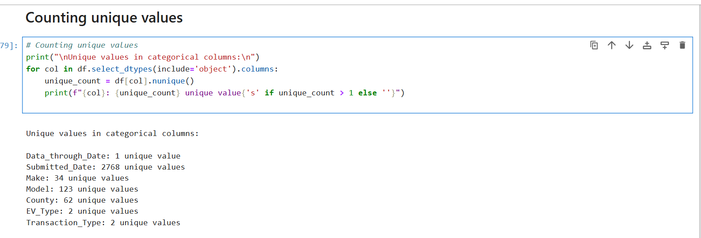
Step 8: Final Review of Column Names
As a final step in data preparation, we print all the current column names to verify that the changes we made earlier (cleaning and renaming) have been applied correctly. This provides a clear view of the structure we’ll be working with in the detailed analysis phase.
Code Used:
print(df.columns)
Screenshot and Output:
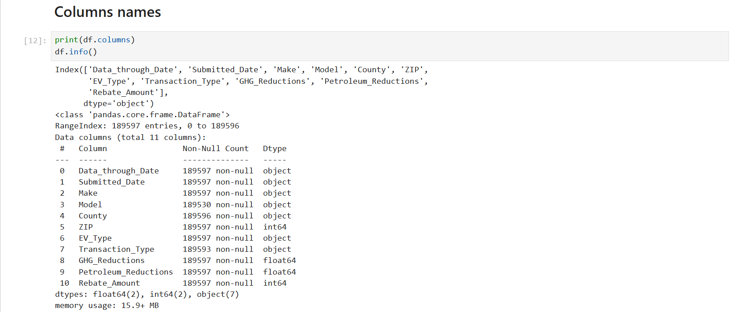

Section 4: Exploratory Data Analysis and Visualization

4.0 Correlation and Covariance Analysis of Rebate Amount

i. Introduction
Before diving into visual interpretations, it is crucial to understand the numerical relationships between key features in the dataset. Specifically, we are interested in how the rebate amount—a critical financial incentive—relates to other quantitative variables such as GHG reductions and petroleum savings. This section uses correlation and covariance to explore these associations.
ii. General Description
The correlation coefficient helps assess the strength and direction of a linear relationship between variables. Covariance, on the other hand, measures how much two variables change together, though it is not normalized and is influenced by scale. Together, these two metrics provide a strong foundation for interpreting the dynamics of rebate distribution and its connection to environmental benefits.
We first clean the data by removing rows with missing rebate amounts. Then, we select all numeric columns and compute the correlation and covariance of each with respect to the Rebate_Amount.
iii. Code Used
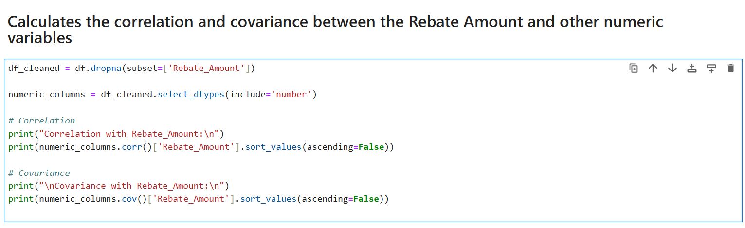
iv. Specific Requirements, Functions, and Formulas
- dropna(subset=['Rebate_Amount']): Removes rows with missing rebate amounts.
- select_dtypes(include='number'): Filters numeric columns only.
- df.corr()['Rebate_Amount']: Extracts correlation values of all features with rebate amount.
- df.cov()['Rebate_Amount']: Computes covariances for the same.
These methods allow us to determine if the rebate amounts are data-driven based on performance metrics (like GHG or petroleum reduction) or not.
- Analysis Results
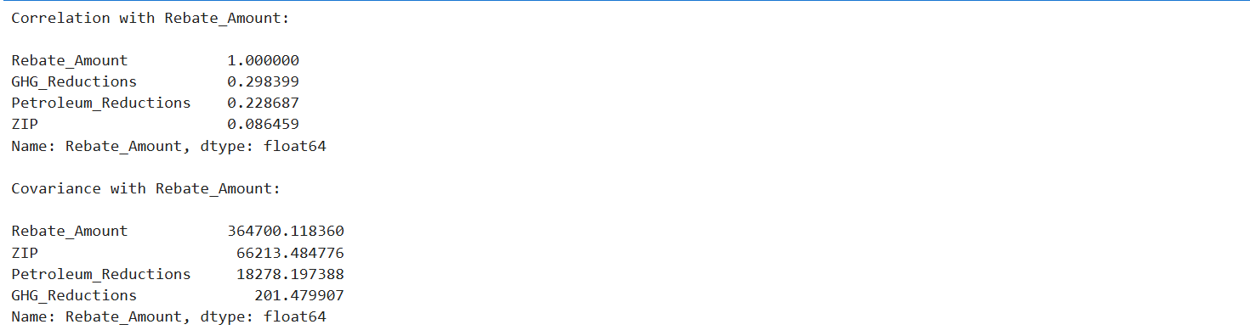
The results show that Rebate_Amount has a weak to moderate correlation with GHG Reductions and Petroleum Reductions. This implies that while there is some alignment between rebates and environmental performance, it is not particularly strong. Covariance results reinforce this, with slight positive values, suggesting only a mild tendency for rebate values to increase with environmental impact.
These findings indicate that the rebate system may factor in other considerations like vehicle cost, policy eligibility, or brand-specific offers, rather than being strictly performance-based. Strengthening the link between rebate and environmental contribution could improve the program's overall impact and efficiency.

4.1 EV Type Distribution Analysis

i. Introduction
Understanding how rebate incentives translate into environmental benefits is essential for evaluating the effectiveness of EV policies. This section investigates the relationship between rebate amounts and greenhouse gas (GHG) reductions, segmented by electric vehicle (EV) type—specifically Battery Electric Vehicles (BEVs) and Plug-in Hybrid Electric Vehicles (PHEVs).
ii. General Description
A scatter plot is used to explore how rebates influence GHG reductions across EV types. Each point on the graph represents an individual rebate record, colored and styled based on the type of EV. This visual helps determine whether higher rebates lead to greater environmental impact and if EV type plays a role in that relationship.

iii. Code Used
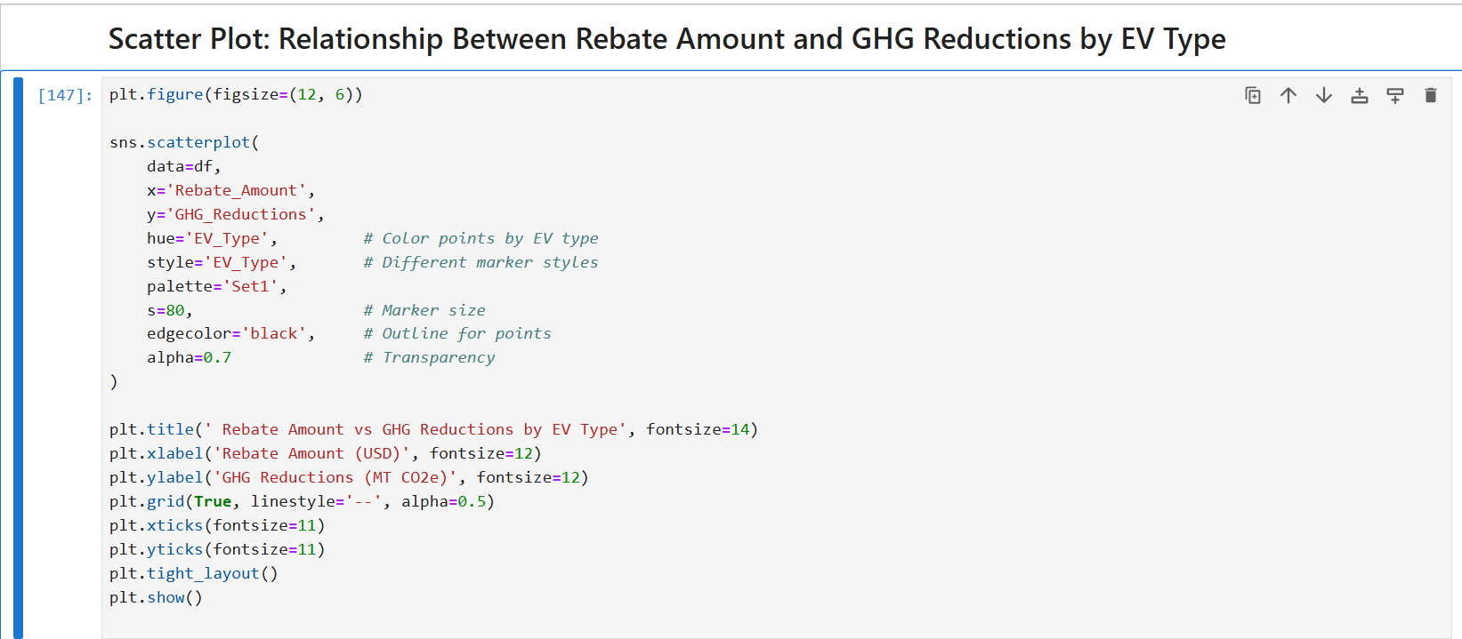
iii. Specific Requirements, Functions, and Formulas
- Function Used:
sns.scatterplot() from the Seaborn library.
- Key Parameters:
  - x='Rebate_Amount': Plots rebate values on the x-axis.
  - y='GHG_Reductions': Plots GHG reduction on the y-axis.
  - hue='EV_Type': Colors points by EV type (BEV or PHEV).
  - style='EV_Type': Differentiates point markers by EV type.
  - palette='Set1': Uses a bold color palette.
  - s=80: Sets marker size.
  - edgecolor='black': Adds outlines for clarity.
  - alpha=0.7: Adjusts point transparency.
iv. Analysis Results
The scatter plot reveals some compelling patterns:
- BEVs (Battery Electric Vehicles) tend to cluster in regions with higher rebate amounts and greater GHG reductions, suggesting they are both more expensive and more impactful in terms of emissions reduction.
- PHEVs (Plug-in Hybrid Electric Vehicles) show lower rebate values and GHG reductions on average.
- The clustering pattern in the upper-right corner of the plot indicates a positive association between rebate amount and GHG reduction—higher incentives are often linked with vehicles that offer stronger environmental benefits.
- The visual differentiation using color and marker styles makes it easy to identify how each EV type contributes to the overall trend.

vi. Visualization Output
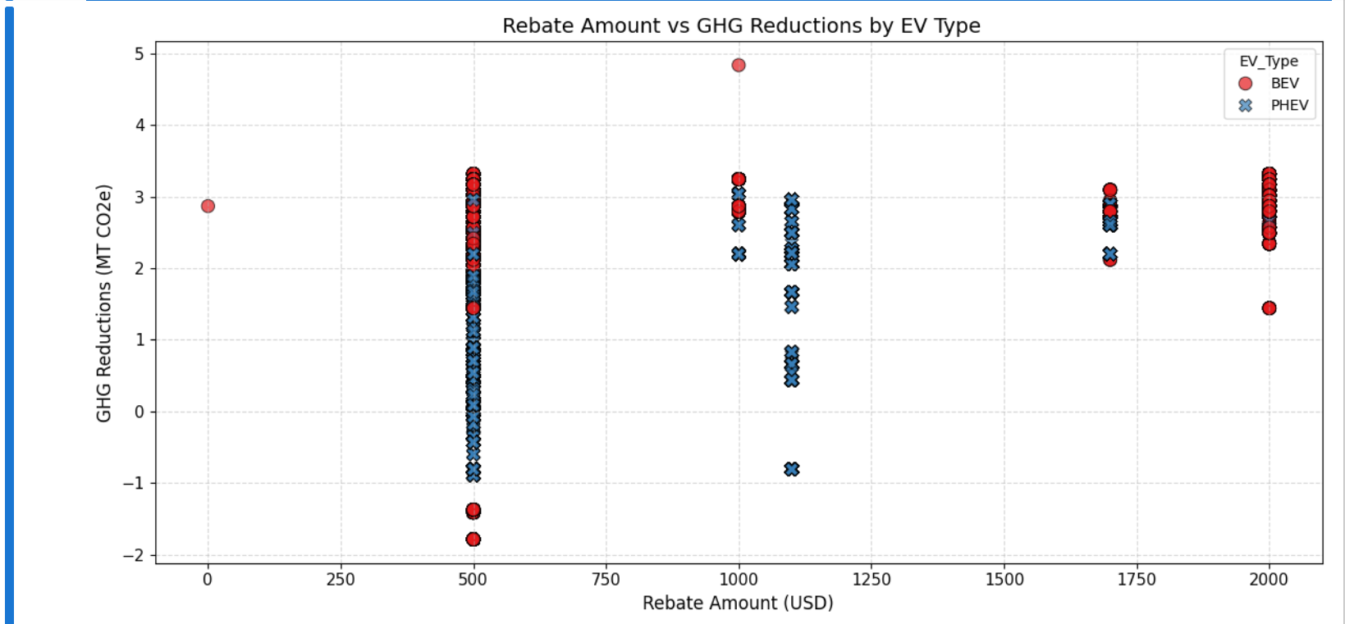

4.2 Rebate Distribution by EV Type

i. Introduction
While it's helpful to know how many rebates were awarded, it is equally important to explore the monetary distribution of those rebates across different EV categories.
ii. General Description
This analysis uses a box plot to compare the range, median, and spread of rebate amounts given to BEVs and PHEVs. It highlights which category receives more consistent or higher incentives.

iii. Code Used
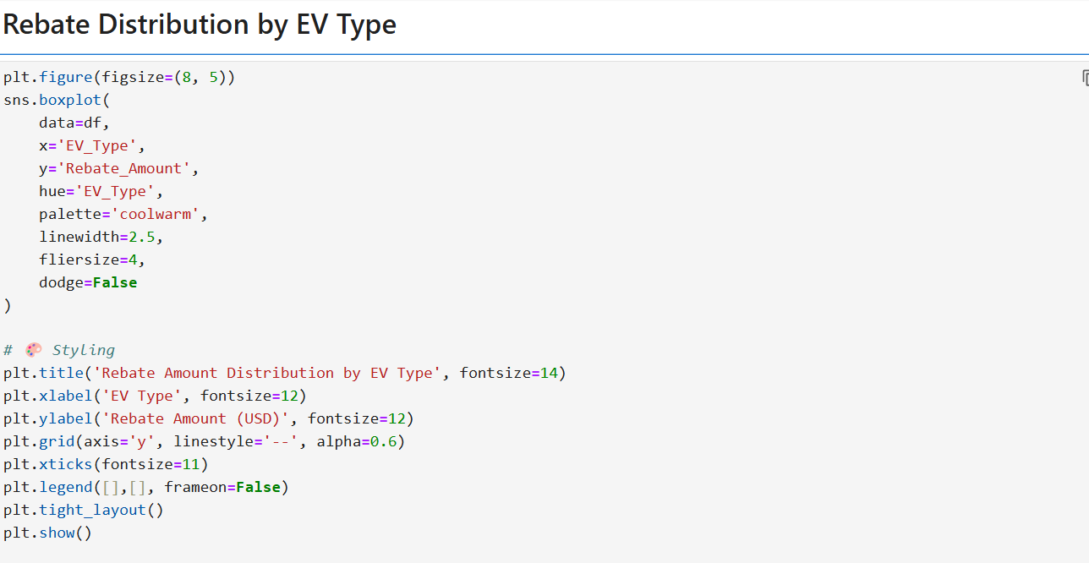
iv. Specific Requirements, Functions, and Formulas
- Function: sns.boxplot()
- Parameters:
  - x='EV_Type', y='Rebate_Amount'
  - palette='coolwarm' for contrast
  - linewidth=2.5, fliersize=4 to control outliers and borders
  - dodge=False to avoid overlapping plots
v. Analysis Results
BEVs typically receive higher and more consistent rebates compared to PHEVs. The interquartile range for BEVs is tighter, indicating uniform policy support. In contrast, PHEVs show more variability, suggesting that rebate values may depend on specific models or purchase conditions. This implies that full-electric vehicles are not only preferred but also more consistently rewarded, possibly due to their greater environmental impact. Policymakers may consider standardizing PHEV rebates to encourage wider adoption.

vi. Visualization Output
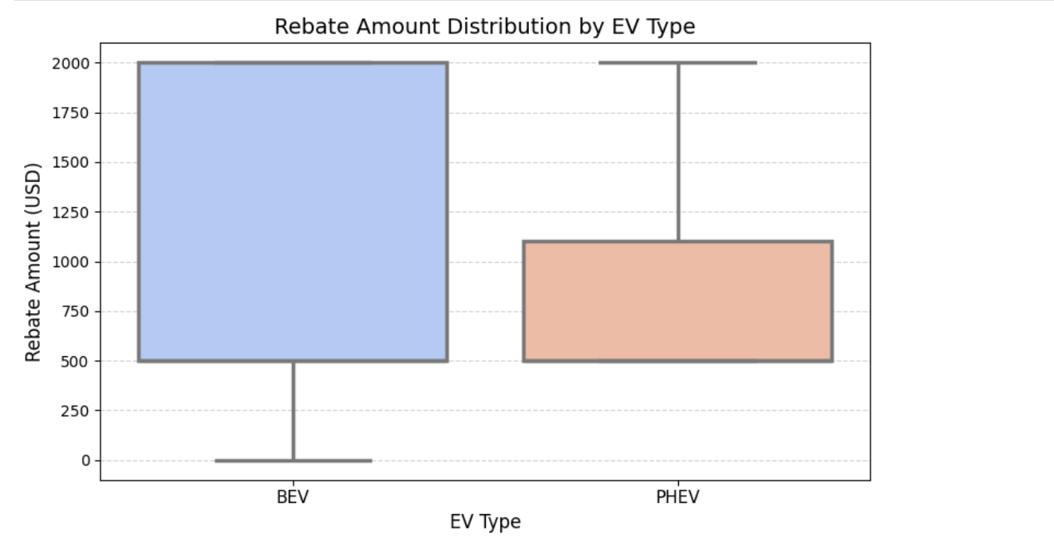

4.3 Correlation Between Key Numeric Features

i. Introduction
This section investigates the relationships between major numeric indicators in the dataset, including GHG reductions, petroleum reductions, and rebate amounts.
ii. General Description
We use a correlation heatmap to determine if higher rebates are associated with greater environmental benefits, such as reductions in emissions and petroleum usage.
iii. Code Used
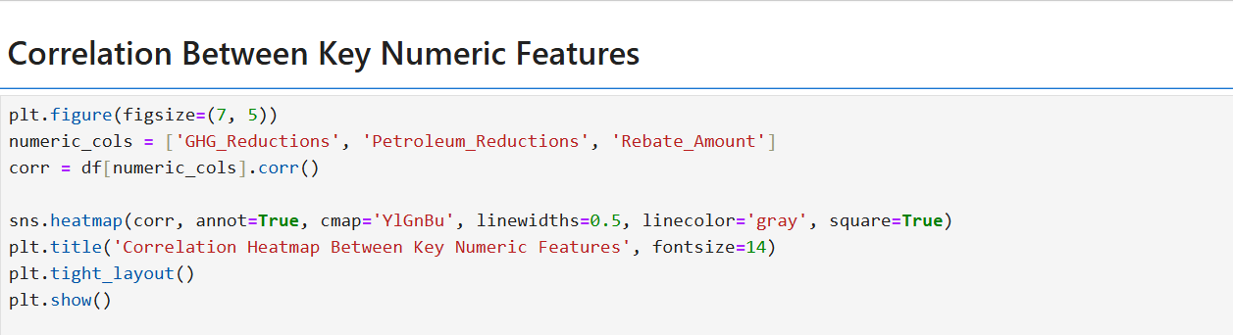
iv. Specific Requirements, Functions, and Formulas
- df.corr() calculates Pearson correlation between numerical columns
- sns.heatmap() visualizes those correlations
- Custom styling with:
  - annot=True, square=True, linewidths=0.5, cmap='YlGnBu'
v. Analysis Results
There is a moderate positive correlation between GHG and Petroleum Reductions, which is expected since both reflect the environmental performance of EVs. However, the correlation between Rebate Amount and either of the reductions is weak, suggesting that rebates may not be strictly performance-based. This insight opens up opportunities to reconsider policy design—perhaps aligning incentive structures more directly with environmental impact to achieve better outcomes.
vi. Visualization Output
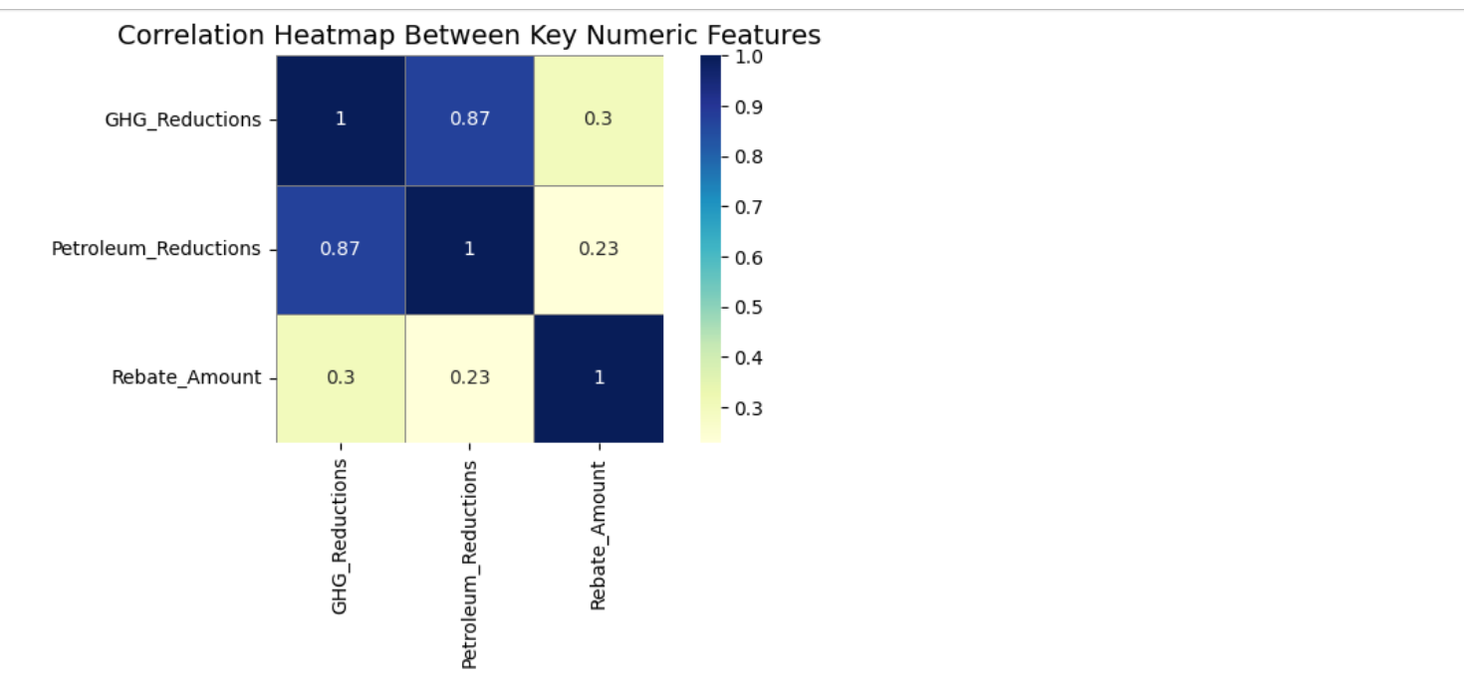

4.4 Top 10 Car Brands by Average GHG Reductions

i. Introduction
This analysis identifies the car manufacturers whose EVs contribute the most to greenhouse gas emission reductions, helping spotlight sustainability leaders in the market.
ii. General Description
A horizontal bar chart is used to rank the top 10 EV manufacturers based on the average GHG reductions their vehicles achieve. This information is valuable for both policymakers and environmentally conscious consumers.
iii. Code Used
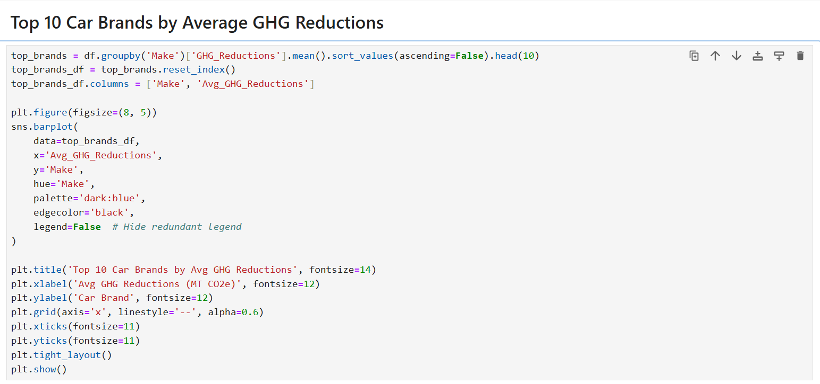
iv. Specific Requirements, Functions, and Formulas
- groupby('Make') + .mean() to compute average GHG reduction per brand
- sort_values(ascending=False).head(10) to filter top 10
- Visualized using sns.barplot() with custom aesthetics
v. Analysis Results
Brands like Tesla, Chevrolet, and Nissan lead in terms of average GHG reductions, reaffirming their technological leadership and commitment to sustainability. Interestingly, some less prominent brands also rank high, which may reflect newer or highly efficient EV models. This analysis can help shape consumer awareness and inform future subsidy policies by focusing more on environmental output rather than just sales volume.

vi. Visualization Output
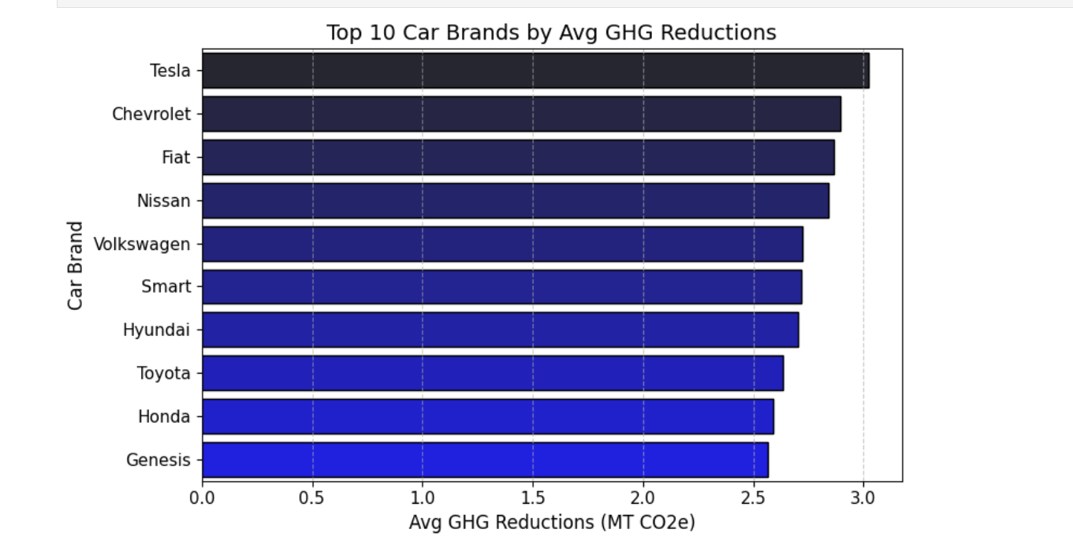

5. Analysis on Dataset
5.1 Understanding Relationships Between Rebate Amount, GHG Reduction, and Petroleum Reduction

i. Introduction
The transition to electric vehicles (EVs) is often supported by government rebate programs aimed at reducing greenhouse gas (GHG) emissions and petroleum consumption. This analysis explores how the rebate amount is associated with two key environmental indicators: GHG reductions and petroleum reductions. Understanding these relationships can help policymakers evaluate the impact of incentives on environmental outcomes.

ii. General Description
This section uses a correlation heatmap to visualize the linear relationships among three key numerical variables:
- Rebate Amount
- GHG Reductions
- Petroleum Reductions
Correlation values range from -1 to 1, where values closer to 1 indicate a strong positive relationship, values near -1 represent a strong negative relationship, and values around 0 indicate no linear relationship.

iii. Specific Requirements, Functions, and Formulas
- Selected Variables:
Extracted three numeric columns from the main dataset:
- corr_data = df[['Rebate_Amount', 'GHG_Reductions', 'Petroleum_Reductions']]
- Calculated Correlation Matrix:
Used the .corr() method to compute Pearson correlation coefficients:
- correlation_matrix = corr_data.corr()

- Plotted Correlation Heatmap:
Used Seaborn’s heatmap function for visualization:
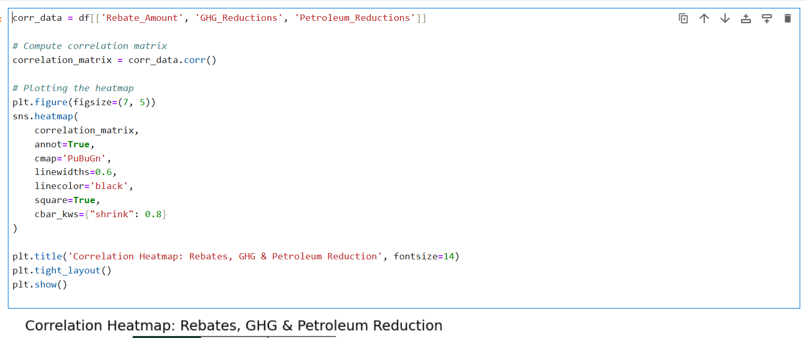

iv. Analysis Results
The correlation matrix reveals the following insights:
- Rebate Amount vs GHG Reductions:
A weak positive correlation of 0.30 suggests that larger rebates are modestly associated with higher reductions in greenhouse gas emissions.
- Rebate Amount vs Petroleum Reductions:
A weaker positive correlation of 0.23, indicating a minor relationship between rebate values and petroleum use reduction.
- GHG Reductions vs Petroleum Reductions:
A strong positive correlation of 0.87, confirming that efforts to reduce petroleum consumption significantly impact GHG emissions as well.
This implies that while rebates play a role, their direct impact on environmental metrics is limited. However, petroleum and GHG reductions are tightly interlinked, reinforcing the environmental benefit of switching from fossil-fueled vehicles.

v. Visualization
The correlation heatmap below illustrates the strength of relationships between the selected variables:

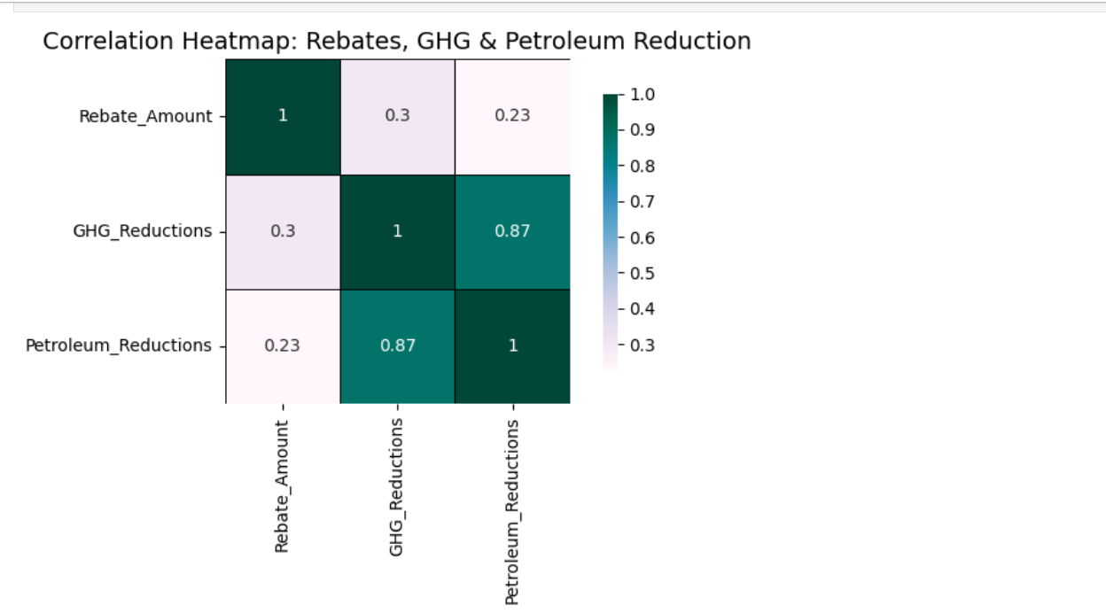

5.2 Identifying the Most Popular EV Models for Rebates

i. Introduction
Understanding which electric vehicle (EV) models are most frequently purchased or leased with rebates provides insight into consumer preferences and market trends. This analysis identifies the top EV models that received the highest number of rebates under the NYS ERDA incentive program.

ii. General Description
We use a bar chart to visualize the number of rebates issued for each of the most popular EV models. This allows for a clear comparison of popularity across models and helps identify which manufacturers or models are leading EV adoption in New York State.

iii. Specific Requirements, Functions, and Formulas
- Prepared Data:
Converted the top_models Series (containing model names and counts) into a DataFrame for plotting:
- top_models_df = top_models.reset_index()
- top_models_df.columns = ['Model', 'Count']
- Visualization Function:
Used Seaborn’s barplot() to create a stylized bar chart:
plt.figure(figsize=(12, 6))
sns.barplot(
data=top_models_df,
x='Model',
y='Count',
hue='Model',
palette='dark:#5A9_r',
edgecolor='black',
dodge=False
)
- Plot Customization:
plt.legend([], [], frameon=False)
plt.title('Top EV Models by Number of Rebates', fontsize=14)
plt.xlabel('EV Model', fontsize=12)
plt.ylabel('Number of Rebates', fontsize=12)
plt.xticks(rotation=45, fontsize=11)
plt.grid(axis='y', linestyle='--', alpha=0.5)
plt.tight_layout()
plt.show()

iv. Analysis Results
The bar chart highlights the most popular EV models among rebate applicants:
- Models like the Tesla Model 3, Chevrolet Bolt, and Toyota Prius Prime dominate the list, reflecting high consumer interest.
- These models likely strike a balance between affordability, range, brand reputation, and eligibility for rebates.
- The popularity of certain models may also reflect dealership availability, manufacturer promotion strategies, or awareness campaigns.
This insight can help policymakers and car manufacturers align their outreach, inventory, and incentives to meet consumer demand and further accelerate EV adoption.

v. Visualization
The bar chart below showcases the top EV models by the total number of rebates received:

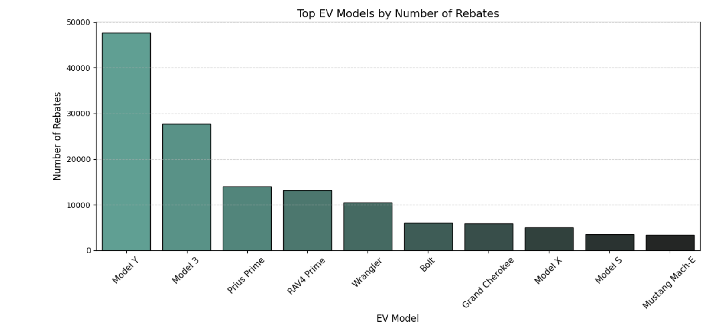

5.3 Understanding the Distribution of Rebate Amounts

i. Introduction
The amount of rebate issued for electric vehicles can vary based on several factors like vehicle type, battery capacity, MSRP, and program eligibility. This section explores the distribution of rebate amounts to understand the most common incentive values and whether there are any patterns or anomalies.

ii. General Description
We use a Kernel Density Estimation (KDE) plot to show the smoothed distribution of rebate amounts. Unlike a histogram, KDE does not depend on arbitrary bin sizes and provides a continuous curve representing the probability density of the rebate values.

iii. Specific Requirements, Functions, and Formulas
- Visualization Type:
KDE Plot using Seaborn’s kdeplot() function.
- Code for Plotting:
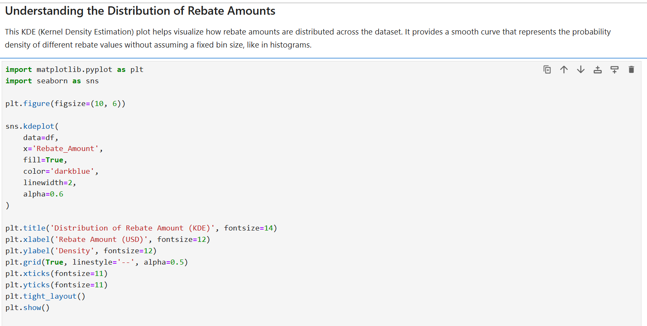

iv. Analysis Results
The KDE curve reveals the most frequently issued rebate amounts:
- There is a clear peak around $2,000, which appears to be the most common rebate level.
- The distribution is slightly skewed, suggesting fewer cases of rebates near the minimum and maximum boundaries.
- This pattern implies that most applicants fall within standard rebate eligibility, with some variation likely caused by EV price caps or eligibility tiers.
The KDE plot helps confirm that the rebate program is structured around a central rebate value, with limited outliers, reinforcing fairness and consistency in distribution.

v. Visualization
The KDE plot below illustrates how rebate values are spread across the dataset:

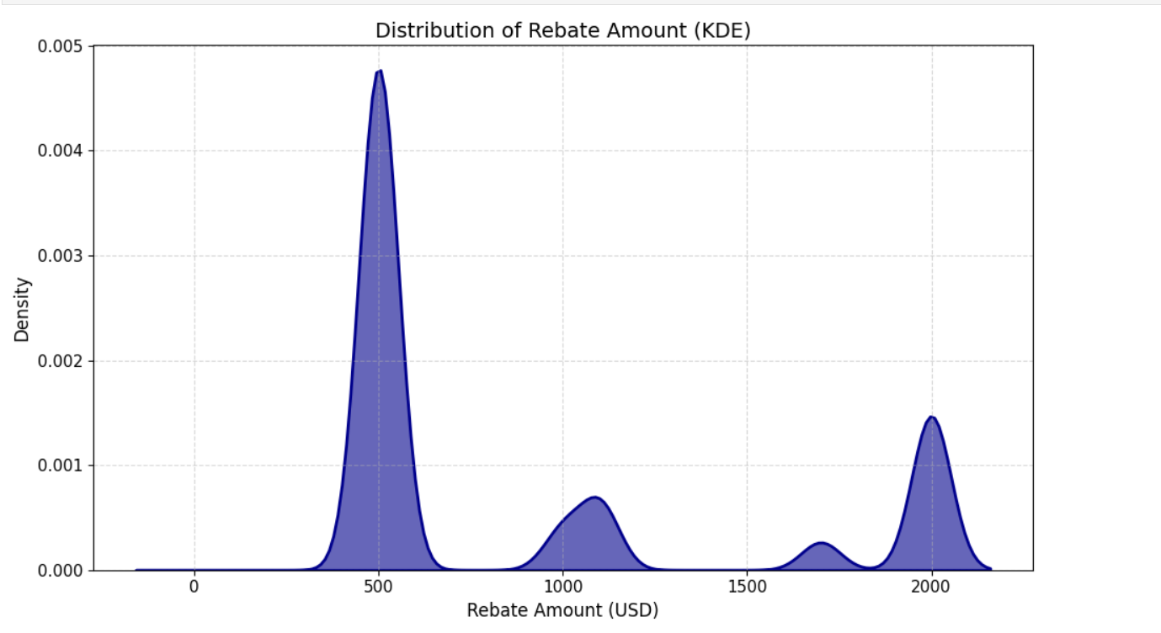

5.4 Identifying the Top 10 Counties with the Most EV Rebates

i. Introduction
Regional patterns of electric vehicle (EV) adoption can offer valuable insights into the accessibility, infrastructure, and local support for clean energy initiatives. This objective focuses on identifying the top 10 counties with the highest number of EV rebates issued, helping highlight areas of strong program engagement.

ii. General Description
A horizontal bar plot is used to visualize the number of rebates across the top 10 counties in the dataset. This orientation makes it easier to read long county names and clearly compare rebate volumes between regions.

iii. Specific Requirements, Functions, and Formulas
- Identifying Top Counties: Used value_counts() to count rebate instances per county and extracted the top 10:
- top_counties = df['County'].value_counts().nlargest(10).reset_index()
- top_counties.columns = ['County', 'Rebate_Count']
- Plotting Horizontal Bar Chart:
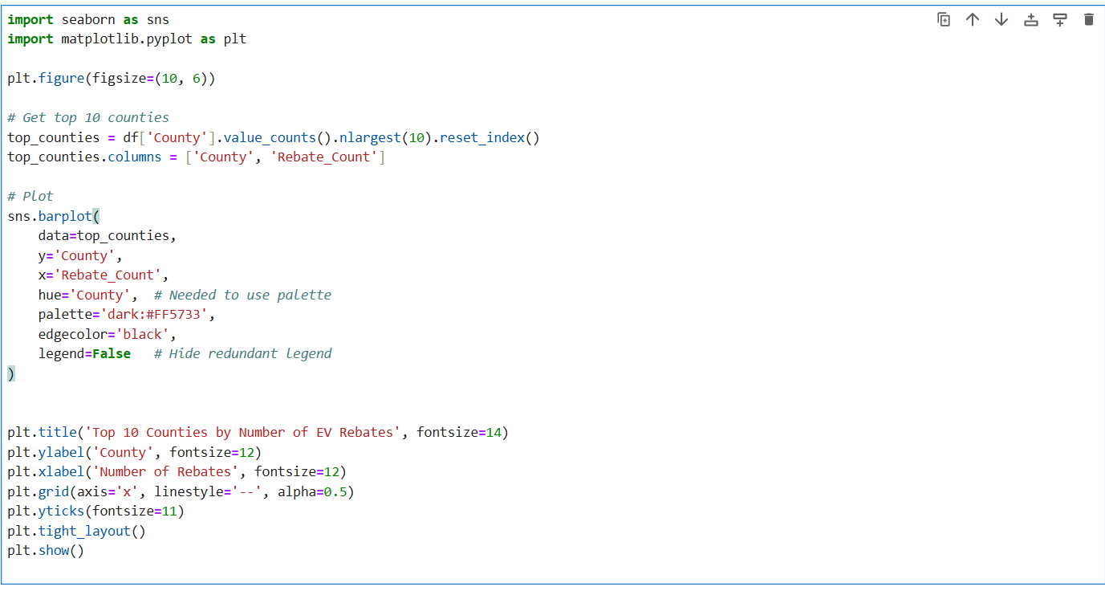

iv. Analysis Results
This analysis reveals a concentrated distribution of rebates in certain counties, which likely reflects:
- Higher urban population densities where EV infrastructure is more available.
- Proactive local policies or outreach programs that boost participation.
- Greater awareness or income levels supporting EV affordability.
Counties at the top likely benefit from well-developed charging networks, active community outreach, and policy alignment with sustainability goals. These regions could serve as models for scaling programs in less active areas.

v. Visualization
The following horizontal bar chart shows the top 10 counties by EV rebate volume:
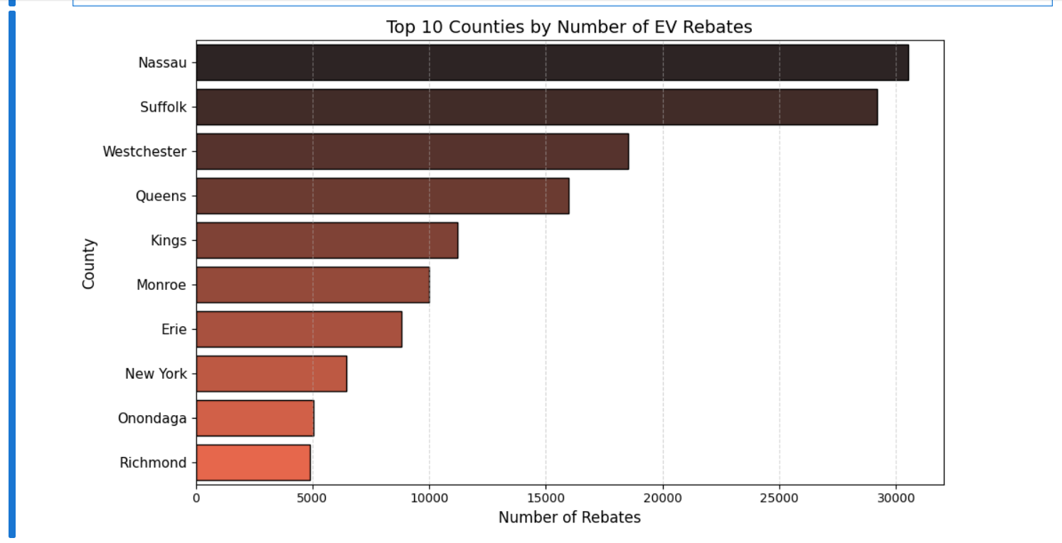

5.6 Analyze the Distribution of Rebate Amounts Across Different EV Types

i. Introduction
Electric vehicle (EV) rebate programs may offer different incentives depending on the vehicle type. This objective explores how rebate amounts vary across Battery Electric Vehicles (BEVs) and Plug-in Hybrid Electric Vehicles (PHEVs), helping us assess whether one type benefits more than the other in terms of financial support.

ii. General Description
A violin plot is used to visualize the distribution of rebate amounts for each EV type. This plot merges the features of a box plot (median, quartiles) and a kernel density estimate (distribution shape), providing a rich view of how rebate values are spread out within each category.

iii. Specific Requirements, Functions, and Formulas
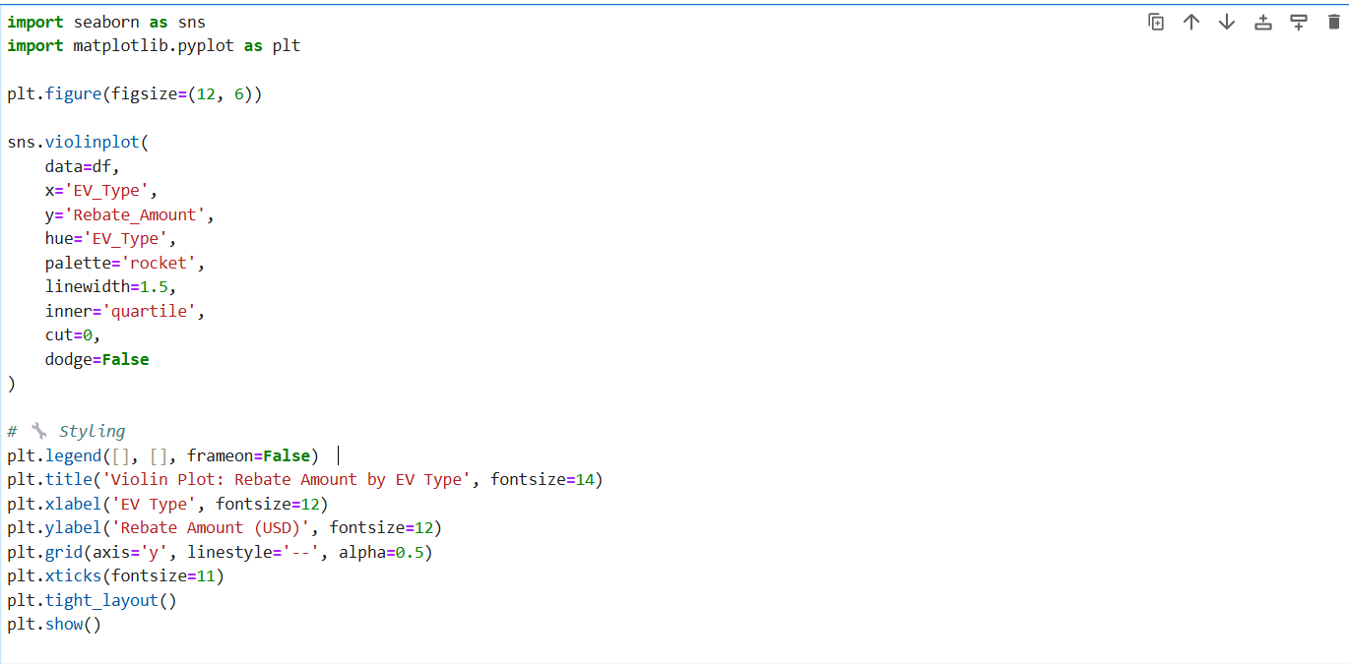

iv. Analysis Results
The violin plot reveals the following:
- BEVs (Battery Electric Vehicles) tend to receive higher rebates on average compared to PHEVs, reflecting a stronger push toward fully electric mobility.
- The distribution for BEVs is wider, indicating more variability in rebate amounts, possibly due to price-based rebate scaling.
- PHEV rebates are more tightly clustered around lower values, suggesting a more consistent rebate structure or narrower eligibility range.
This analysis highlights how the state tailors financial incentives based on the type of electric vehicle, possibly to promote more environmentally impactful models.

v. Visualization
Below is the violin plot showing rebate amount distributions across EV types:
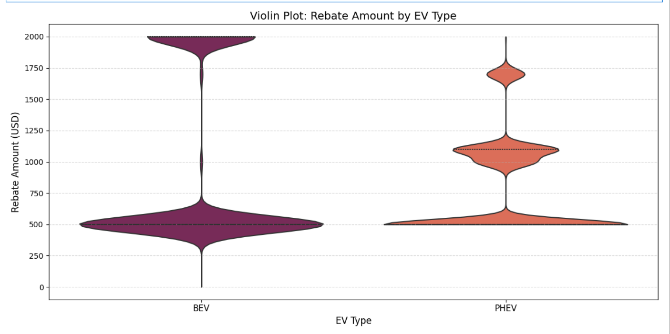

5. Conclusion
The analysis of the NYSERDA Electric Vehicle Rebate dataset provides meaningful insights into consumer behavior, environmental benefits, and regional trends associated with EV adoption in New York State. Through a series of targeted visualizations and data explorations, we have uncovered several key takeaways that can support future policy-making and sustainable transportation initiatives.
We began by exploring the correlation between rebate amounts and environmental impact, where we found a modest positive relationship between higher rebates and greater GHG/petroleum reductions. This suggests that while rebates may not be the sole driver of environmental benefit, they do play a supporting role in encouraging more eco-friendly purchases.
Next, we examined the most popular EV models receiving rebates. This revealed a preference for specific models that are likely perceived as more efficient, cost-effective, or reputable, providing valuable feedback for both manufacturers and policymakers.
Our analysis of the distribution of rebate amounts using a KDE plot helped illustrate how incentives are typically structured. It showed that most rebates cluster around a specific range, reflecting a standardized state-level incentive strategy that ensures fairness and accessibility.
We also focused on county-level adoption patterns, where the top 10 counties demonstrated much higher rebate activity. These trends likely correlate with population density, public awareness, availability of charging infrastructure, and localized policy support.
Finally, the violin plot comparison of rebate amounts across EV types highlighted that Battery Electric Vehicles (BEVs) tend to receive larger rebates than Plug-in Hybrid Electric Vehicles (PHEVs), which reflects both their higher environmental impact and state-level priorities in accelerating full electrification.
Overall, this dataset offers not just numbers, but a story — one that reflects growing public interest in clean energy, the effectiveness of government incentives, and the continued need to monitor and improve policy frameworks. By understanding these patterns, stakeholders can enhance rebate programs, tailor marketing strategies, and further accelerate New York’s transition to a greener transportation ecosystem.

6. Future Scope
The insights drawn from analyzing the NYSERDA Electric Vehicle Drive Clean Rebate dataset provide a strong foundation for future research and development in the field of sustainable transportation. However, there is still substantial scope to build upon this work and deepen its practical and policy implications. The following areas represent meaningful directions for further exploration:

1. Causal Relationship Exploration
While this report has examined patterns and correlations, a future step would be to explore causal relationships. For instance, does a higher rebate directly result in greater greenhouse gas (GHG) reductions, or are other factors like location, income level, or model efficiency influencing the outcome? More advanced statistical techniques—such as multiple regression analysis or propensity score matching—could be applied to isolate the impact of rebates more precisely.

2. Time-Series and Forecasting Models
If monthly or quarterly data were to be made available, this dataset could be used for time-series forecasting. This would enable predictive modeling to estimate future rebate trends, particularly in response to policy changes, technological advancements, or economic fluctuations like fuel prices. It could also help identify seasonal patterns in consumer behavior regarding electric vehicle purchases.

3. Geographic and Equity-Based Analysis
An important direction for future research lies in geographic equity. A spatial analysis by ZIP code, census tract, or county could uncover how evenly rebates are distributed across urban and rural regions. This could help policymakers identify areas that are underutilizing the program, potentially due to lack of awareness, accessibility, or infrastructure limitations.

4. Dataset Integration with Demographics and Infrastructure
The analysis could be significantly enriched by combining this dataset with external data sources. For example:
- Integrating income or education data could help assess whether rebate programs are reaching low-income households.
- Adding data on public EV charging stations could reveal whether accessibility to infrastructure influences rebate utilization.
- Combining with vehicle registration data could help verify long-term usage and ownership patterns.

5. Application of Machine Learning
As the volume and richness of data grow over time, machine learning techniques could be employed to simulate policy changes or recommend optimal rebate values. Models could be trained to:
- Predict how changes in rebate amounts might influence adoption.
- Classify regions or customer profiles that are most responsive to incentives.
- Segment EV models or counties based on environmental impact or cost-effectiveness.

6. Environmental Impact Validation
It would be valuable to validate the claimed environmental benefits with actual outcomes, where possible. This could involve tracking reductions in GHG emissions or petroleum use at the regional level. Matching rebate data with emissions reports or fuel consumption data would provide stronger evidence of the effectiveness of the program.

7. Public-Facing Dashboard or Policy Tool
A logical extension of this analysis would be the development of a real-time or interactive dashboard. This could allow:
- Policymakers to simulate rebate programs and budget scenarios.
- Citizens to explore how their county compares with others in terms of EV adoption.
- Researchers and students to interact with visualizations and downloadable datasets for independent study.

Overall, the NYSERDA rebate dataset has significant long-term analytical value. As electric vehicle technology evolves and adoption increases, ongoing analysis and improvement of rebate programs will be critical in shaping equitable and impactful transportation policy. This project lays the groundwork, and future extensions can help ensure these incentives deliver both economic and environmental returns at scale.

7. References
[1] New York State Energy Research and Development Authority, “NYSERDA Electric Vehicle Drive Clean Rebate Data: Beginning 2017.” [Online]. Available: https://data.ny.gov/Energy-Environment/NYSERDA-Electric-Vehicle-Drive-Clean-Rebate-Data-B/thd2-fu8y.
[2] New York State Energy Research and Development Authority, “Drive Clean Rebate for Electric Cars Program.” [Online]. Available: https://www.nyserda.ny.gov/All-Programs/Drive-Clean-Rebate-For-Electric-Cars-Program.
[3] New York State Energy Research and Development Authority, “Drive Clean Rebate Location Statistics.” [Online]. Available: https://www.nyserda.ny.gov/All-Programs/Drive-Clean-Rebate-For-Electric-Cars-Program/Rebate-Data/Rebates-by-Geography.
[4] New York State Energy Research and Development Authority, “Drive Clean Rebate Data - NYSERDA.” [Online]. Available: https://www.nyserda.ny.gov/All-Programs/Drive-Clean-Rebate-For-Electric-Cars-Program/Rebate-Data.
[5] New York State Energy Research and Development Authority, “NYSERDA Drive Clean Rebate Adoption Survey: 2021 Results.” [Online]. Available: https://www.nyserda.ny.gov/-/media/Project/Nyserda/Files/Publications/Research/Transportation/23-09-NYSERDA-Drive-Clean-Rebate-Adoption-Survey-2021-Results---acc.pdf.
[6] J. Juarez, W. Flores, Z. Lu, M. Hattori, M. Hernandez, S. Larios-Ramirez, and J. Woo, “Consumer's Behavior Analysis of Electric Vehicle using Cloud Computing in the State of New York,” arXiv preprint arXiv:2306.01888, Jun. 2023. [Online]. Available: https://arxiv.org/abs/2306.01888.
[7] IEEE, “IEEE Reference Style Guide for Authors.” [Online]. Available: https://journals.ieeeauthorcenter.ieee.org/wp-content/uploads/sites/7/IEEE_Reference_Guide.pdf.

