
PROJECT REPORT
MENTAL HEALTH ANALYSIS AMONG INDIAN YOUTH:
A MACHINE LEARNING APPROACH

Submitted by
Name.: Mayank
Registration No.: 12320796
Programme : B.Tech Computer Science and Engineerin
Section: K22BE
Course Code: INT234

Under the Guidance of
Ms. Tanima thakur
Assistant Professor

Discipline of CSE/IT
Lovely School of Computer Science and Engineering
Lovely Professional University, Phagwara

CERTIFICATE
This is to certify that Mayank , bearing Registration No. 12320796, has successfully completed the INT234 project titled “Mental Health Analysis Among Indian Youth: A Machine Learning Approach” under my guidance and supervision.
To the best of my knowledge, the present work is the result of his original development, effort, and study.

Signature of the Supervisor
Name of the Supervisor: Ms. Tanima thakur
Designation: Assistant Professor
School: Lovely School of Computer Science and Engineering
Lovely Professional University
Phagwara, Punjab
Date: _______________

DECLARATION
I, Mayank , student of B.Tech Computer Science and Engineering under CSE/IT Discipline at Lovely Professional University, Punjab, hereby declare that all the information furnished in this project report is based on my own intensive work and is genuine.

Signature: _______________
Registration No.: 12320796
Name of the Student: Mayank

ACKNOWLEDGEMENT
I would like to express my sincere gratitude to all those who have contributed to the successful completion of this project.
First and foremost, I am deeply thankful to my project supervisor, Ms. Tanima Thakur, for her valuable guidance, continuous support, and constructive feedback throughout the development of this project. Her expertise and encouragement played a crucial role in shaping this work.
I am also grateful to the Head of the Department, Lovely School of Computer Science and Engineering, for providing the necessary facilities and resources required for the completion of this project.
I extend my sincere thanks to all the participants who voluntarily contributed to the dataset by sharing their personal experiences related to mental health, sleep patterns, and stress levels. Their honest responses made this analysis possible.
Finally, I would like to thank my family and friends for their constant motivation and moral support throughout the course of this project.

Mayank Kumar
Registration No.: 12320796

TABLE OF CONTENTS
1. Introduction ............................................................ 1
1.1 Background ............................................................ 1
1.2 Motivation ............................................................. 2
1.3 Problem Statement .................................................. 3
1.4 Scope of the Project ................................................. 3
1.5 Organization of the Report ...................................... 4
2. Source of Dataset .................................................. 5
2.1 Data Collection Method ........................................... 5
2.2 Dataset Characteristics ......................................... 5
2.3 Data Quality .......................................................... 7
2.4 Ethical Considerations ............................................ 7
3. Dataset Preprocessing ........................................ 8
3.1 Initial Data Exploration ........................................ 8
3.2 Handling Duplicate and Unnecessary Columns ..... 9
3.3 Text Formatting and Standardization ................ 10
3.4 Numeric Column Conversion ............................... 10
3.5 Handling Missing Values .................................... 11
3.6 Outlier Detection and Removal ............................ 12
3.7 Feature Engineering ........................................... 13
3.8 Final Dataset Summary ...................................... 14
4. Analysis on Dataset ............................................ 15
4.1 Insight 1: Predicting Student Stress Levels ......... 15
4.2 Insight 2: Identifying Mental Health Risk Factors ... 19
4.3 Insight 3: Understanding Emotional Well-being Patterns ... 23
4.4 Insight 4: Impact of Sleep on Stress Levels ......... 26
4.5 Insight 5: Detecting High-Risk Stress Cases ......... 29
5. Conclusion .......................................................... 33
5.1 Key Findings ......................................................... 33
5.2 Practical Implications ........................................... 35
5.3 Limitations ............................................................ 36
5.4 Overall Conclusion .............................................. 37
6. Future Scope ...................................................... 38
6.1 Dataset Enhancement ........................................ 38
6.2 Advanced Modeling Techniques ........................ 39
6.3 Real-World Application Development ................. 39
6.4 Intervention and Validation Studies .................. 40
6.5 Policy and Advocacy ............................................ 40
6.6 Ethical Considerations and Privacy .................. 41
6.7 Interdisciplinary Collaboration ......................... 41
7. References .......................................................... 42

LIST OF TABLES
Table 1: Dataset Column Description .............................. 6
Table 2: Missing Values Summary .................................. 8
Table 3: Before and After Conversion ............................ 11
Table 4: Model Performance – Stress Level Prediction ... 16
Table 5: Model Performance – Mental Health Classification ... 20
Table 6: Model Performance – Emotional State Classification ... 24
Table 7: Model Performance – Sleep Impact Analysis ... 27
Table 8: Model Performance – High Stress Detection ... 30

1. INTRODUCTION
1.1 Background
Mental health has emerged as one of the most critical public health concerns worldwide, particularly among young adults and students. In India, the situation has become increasingly concerning over the past decade. According to the National Mental Health Survey (2015–16), nearly 10 percent of the adult population in India suffers from mental health disorders, with young adults aged 18 to 29 identified as the most vulnerable group.
Students and young professionals are exposed to multiple stressors, including academic pressure, career uncertainty, financial challenges, interpersonal relationships, and family expectations. The rapid growth of digital technology has further intensified these issues. While technology provides easy access to information and social connectivity, excessive screen time and social media usage have been strongly associated with increased anxiety, sleep disturbances, and reduced self-esteem among youth.
The COVID-19 pandemic further aggravated mental health challenges. Prolonged isolation, disruption of academic schedules, reduced social interaction, and economic uncertainty significantly impacted students’ psychological well-being. Various studies and reports indicate that anxiety and depression levels among college students increased by nearly 30 percent during the pandemic period.
Despite increasing awareness, there remains a lack of comprehensive understanding of the specific factors influencing stress and emotional disturbances among Indian youth. Traditional mental health assessment approaches rely largely on self-report surveys or clinical evaluation, which are time-consuming and often inaccessible to a large population. This highlights the need for scalable, data-driven methods to analyze and understand mental health patterns.

1.2 Motivation
The motivation for this project arises from the urgent need to address mental health issues faced by students and young professionals in India. Many individuals continue to suffer silently due to social stigma, lack of awareness, or limited access to mental health services. Early identification and timely intervention can significantly improve mental health outcomes, yet existing screening mechanisms are not scalable or efficient.
Machine learning provides a promising approach to address this challenge. By identifying hidden patterns in lifestyle habits, demographic attributes, and self-reported mental health indicators, predictive models can help detect individuals at risk of developing mental health issues. Such models can act as preliminary screening tools within educational institutions, enabling counselors and administrators to prioritize high-risk cases.
Additionally, understanding how lifestyle factors such as sleep duration, screen time, and exercise habits influence stress levels can guide targeted interventions. For example, if data reveals that students sleeping fewer than six hours consistently report higher stress, institutions can promote better sleep hygiene through awareness programs and academic scheduling improvements.

1.3 Problem Statement
The primary objectives of this project are as follows:
- To analyze the mental health status of Indian youth using a dataset comprising demographic information, lifestyle habits, stress levels, and mental health experiences.
- To identify key factors contributing to stress, anxiety, and depression among students and young professionals.
- To develop and evaluate machine learning models for predicting stress levels and classifying individuals based on mental health risk.
- To generate actionable insights and recommendations that can be utilized by educational institutions, policymakers, and individuals to improve mental well-being.

1.4 Scope of the Project
This project focuses on the analysis of mental health data collected from 600 participants belonging to diverse age groups, occupations, and financial backgrounds across India. The scope includes exploratory data analysis to understand stress distribution, emotional well-being, and lifestyle patterns.
Comprehensive data preprocessing techniques are applied to handle missing values, outliers, duplicate columns, and formatting inconsistencies. Feature engineering is performed to derive meaningful variables such as binary indicators for anxiety, depression, and high stress.
Multiple machine learning models, including regression and classification algorithms, are developed and evaluated to address different analytical objectives. Visualizations are used extensively to communicate findings effectively. The project aims to establish a data-driven foundation for future mental health interventions and contribute to research on youth mental health in India.

1.5 Organization of the Report
The remainder of this report is organized as follows.
Section 2 describes the source, collection process, and characteristics of the dataset used in this study.
Section 3 details the preprocessing techniques applied to clean and prepare the data for analysis.
Section 4 presents five key insights derived from the analysis, including model development, evaluation, and interpretation of results.
Section 5 summarizes the key findings and conclusions.
Section 6 discusses the future scope and possible extensions of this work.
Section 7 lists the references consulted during the project.

2. SOURCE OF DATASET
2.1 Data Collection Method
The dataset used in this project was collected through an online survey conducted between October and November 2025. The survey was distributed via social media platforms, educational forums, and email networks targeting students and young professionals across India. Participation was voluntary and anonymous to encourage honest responses.
The survey consisted of 18 questions covering various aspects of mental health and lifestyle habits. Participants were informed about the purpose of the study and assured that their responses would be used solely for academic research.

2.2 Dataset Characteristics
The final dataset contains responses from 600 participants and is stored in CSV format. The dataset includes the following attributes:
Table 1: Dataset Column Description
Column Name | Description | Data Type
timestamp | Date and time of survey submission | Text
username | Participant identifier | Text
age_group | Age range of participant | Text
gender | Gender identity | Text
financial_background | Economic status of family | Text
occupation | Current occupation or student status | Text
sleep_hours | Average hours of sleep per night | Text
screen_time | Average daily screen usage | Text
free_time_activities | Leisure activities | Text
exercise_frequency | Frequency of exercise | Text
stress_level | Self-reported stress (1–5) | Text
mental_health_experiences | Anxiety, depression indicators | Text
main_reason | Primary source of stress | Text
anxiety_frequency | Frequency of anxiety | Text
has_support | Availability of emotional support | Text
emotional_state | Current emotional condition | Text
preferred_resources | Preferred support resources | Text
awareness_needed | Need for awareness programs | Text

2.3 Data Quality
Initial analysis revealed several data quality issues. The username column had 489 missing values out of 600. Duplicate financial background columns were present due to survey updates. Numeric attributes such as sleep hours and screen time had inconsistent formatting. Outliers were observed in sleep and screen time data. Encoding issues and special characters were present in some text fields.
These issues were systematically addressed during the preprocessing phase to ensure reliable analysis.

2.4 Ethical Considerations
All participants provided informed consent before participating in the survey. Personally identifiable information was not collected, and optional identifiers were removed during preprocessing. The study adhered to ethical research guidelines for handling sensitive mental health data.

3. DATASET PREPROCESSING
Data preprocessing is a critical step in machine learning projects, as raw data often contains inconsistencies and errors that can affect model performance. This section describes the structured approach used to clean and prepare the dataset.

3.1 Initial Data Exploration
The dataset initially consisted of 600 rows and 19 columns. Preliminary exploration revealed 641 missing values across three columns, no duplicate rows, and most features stored in text format requiring conversion.
Table 2: Missing Values Summary
Column Name | Missing Count | Percentage
username | 489 | 81.50%
financial_background_old | 16 | 2.67%
financial_background | 136 | 22.67%
Exploratory analysis showed that most participants belonged to the 19–22 age group (334 participants). Gender distribution was balanced, and the majority were undergraduate students. Stress levels followed a near-normal distribution, with level 3 (moderate stress) being most common.

3.2 Handling Duplicate and Unnecessary Columns
Duplicate financial background columns were merged by filling missing values from one column using the other. After merging, the redundant column was removed. Columns such as timestamp and username were dropped as they did not contribute to analysis.
This reduced the dataset to 16 relevant columns.

3.3 Text Formatting and Standardization
Text inconsistencies and encoding issues were resolved by replacing non-standard characters with standard formats. This ensured uniformity across categorical features.

3.4 Numeric Column Conversion
Sleep hours and screen time were originally stored as text. A custom parsing function was developed to handle ranges, units, and approximate values. Ranges were converted to mean values, and invalid entries were handled appropriately.
Table 3: Before and After Conversion
Original Value | Converted Value
7 | 7.0
6 to 8 | 7.0
6 hours approx | 6.0
5–7 | 6.0

3.5 Handling Missing Values
Remaining missing values in the financial_background column were filled using mode imputation (Middle Class). After this step, the dataset contained zero missing values.

3.6 Outlier Detection and Removal
Outliers were detected using the Interquartile Range (IQR) method. Extreme values such as unrealistic sleep or screen times were removed. After outlier removal, the dataset contained 520 rows, representing a reasonable trade-off between data quality and size.
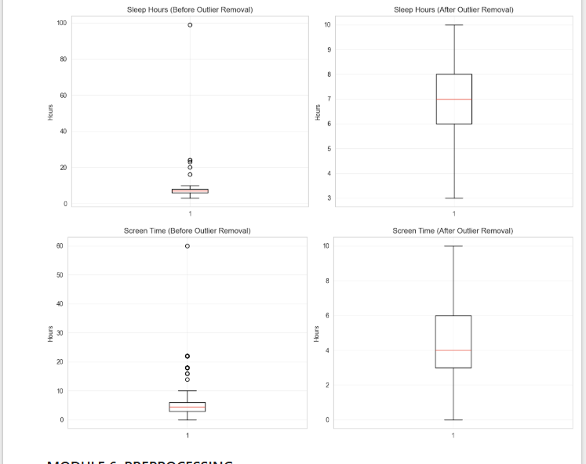

3.7 Feature Engineering
Several new features were created to improve model performance:
- Stress Numeric: Extracted numeric stress levels (1–5).
- Binary Mental Health Features: Indicators for anxiety, depression, and overall mental health issues.
- High Stress Indicator: Binary variable identifying stress levels 4–5.
- Label Encoding: Conversion of categorical variables to numeric codes.

3.8 Final Dataset Summary
After preprocessing, the final dataset contained 520 rows and 23 columns, including engineered features. All variables were numeric and ready for machine learning analysis. The dataset was clean, consistent, and suitable for exploratory analysis and predictive modeling.
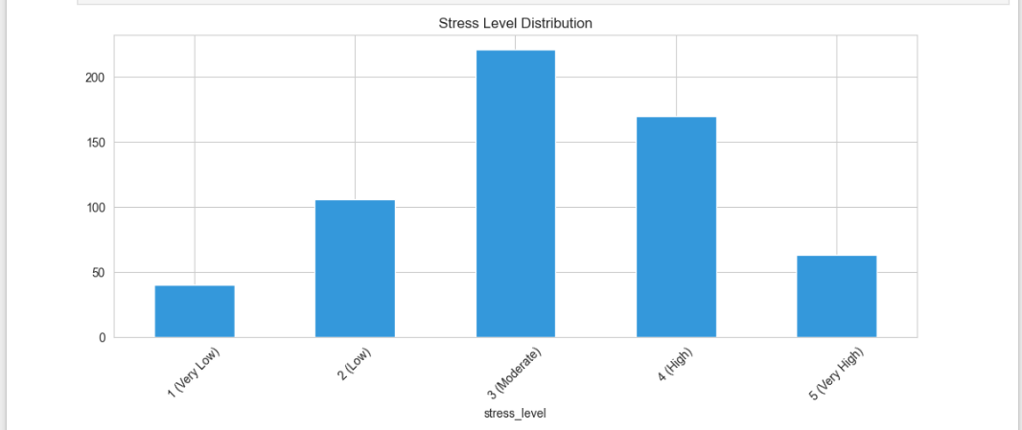
Stress Level Distribution
What the chart shows
This bar chart represents how respondents are distributed across five stress levels ranging from Very Low (1) to Very High (5).
Meaning / Insight
- The majority of respondents fall under Moderate (Level 3) and High (Level 4) stress.
- Very few respondents report Very Low or Very High stress.
- This indicates that stress is common but not extreme for most individuals, suggesting a widespread presence of manageable yet concerning stress levels.
Conclusion
Most participants experience moderate to high stress, making stress management a key area of concern

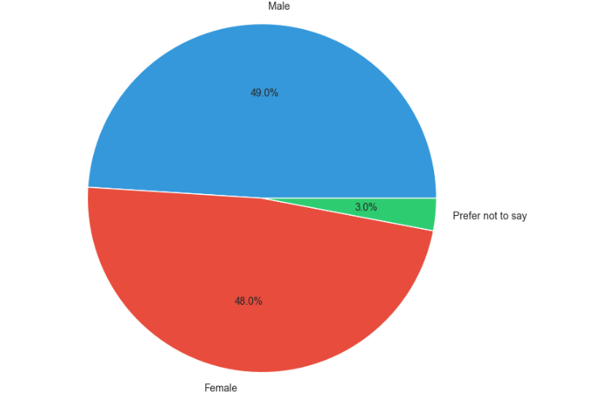
Gender Distribution
What the chart shows
This pie chart illustrates the gender composition of the survey respondents.
Meaning / Insight
- Male and Female participation is almost equal, ensuring balanced representation.
- A small percentage preferred not to disclose gender.
- This balance increases the reliability of gender-based comparisons in stress and mental health analysis.
Conclusion
The dataset is gender-balanced, reducing bias in subsequent analysis.

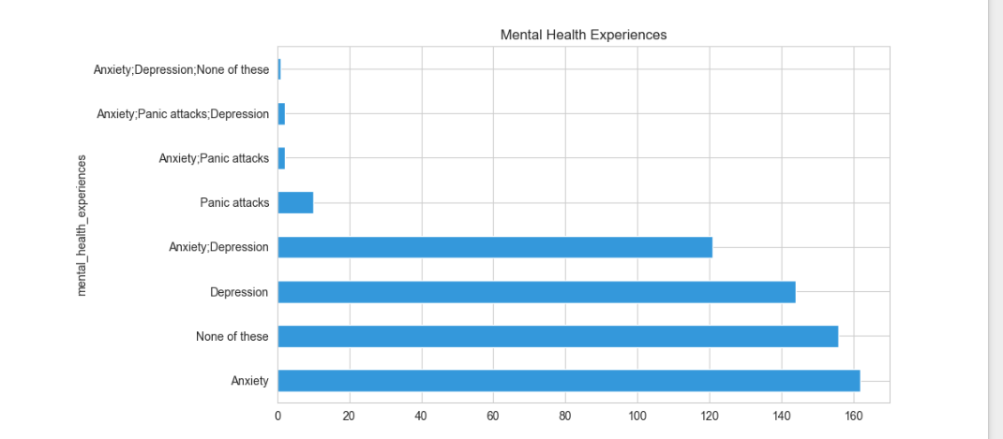 Mental Health Experiences
What the chart shows
This horizontal bar chart displays the frequency of reported mental health experiences, including Anxiety, Depression, Panic Attacks, and combinations of these.
Meaning / Insight
- Anxiety is the most commonly reported mental health issue.
- A significant number of respondents report Depression or Anxiety + Depression, indicating overlapping conditions.
- A noticeable portion selected “None of these”, showing not everyone experiences mental health issues.
Conclusion
Mental health concerns—especially anxiety-related conditions—are prevalent, highlighting the need for early awareness and support systems.
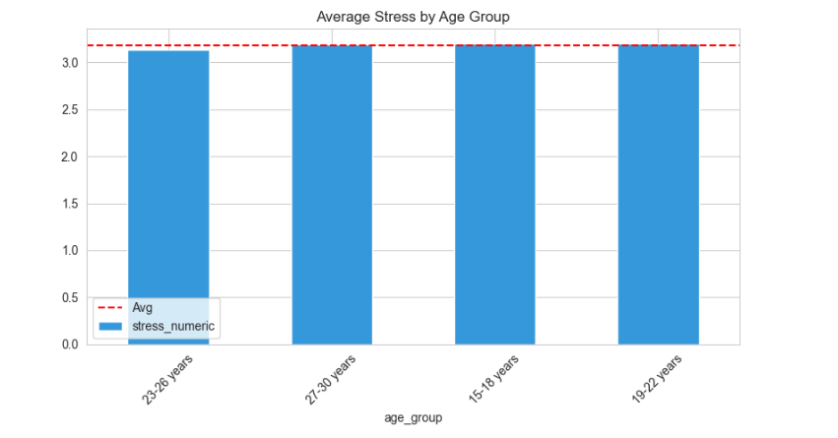
Average Stress by Age Group
What the chart shows
This bar chart compares the average stress level across different age groups, with a red dashed line showing the overall average stress.
Meaning / Insight
- All age groups have stress levels close to the overall average, indicating stress is not limited to a single age group.
- Younger age groups (15–18, 19–22) show stress levels comparable to older groups.
- This suggests that academic pressure, career uncertainty, and lifestyle factors affect all age categories similarly.
Conclusion
Stress is age-independent and impacts individuals across different life stages.

4. ANALYSIS ON DATASET
This section presents a detailed analysis of the preprocessed dataset using machine learning techniques. Five major insights were explored to understand stress levels, mental health risks, emotional well-being, sleep impact, and high-risk stress cases among Indian youth.
For each insight, the analysis follows a structured approach including a general description, specific requirements, model development and evaluation, interpretation of results, and visualization.

4.1 INSIGHT 1: Predicting Student Stress Levels Based on Lifestyle and Demographics
4.1.1 General Description
Stress among students is influenced by a combination of demographic characteristics, lifestyle habits, and existing mental health conditions. This analysis aims to predict a student’s stress level on a scale of 1 to 5 using measurable features such as sleep duration, screen time, exercise frequency, and mental health indicators.
Understanding these relationships can help educational institutions identify major contributors to stress and design focused interventions to reduce it.

4.1.2 Specific Requirements
The objective of this insight is to develop a regression model to predict stress_numeric, which ranges from 1 to 5.
Input Features:
- age_group_encoded
- gender_encoded
- occupation_encoded
- sleep_hours
- screen_time
- exercise_frequency_encoded
- has_anxiety
- has_depression
Target Variable:
- stress_numeric (continuous, 1–5)
Models Used:
- Linear Regression
- Decision Tree Regressor
- Random Forest Regressor
Evaluation Metrics:
- Mean Absolute Error (MAE)
- Root Mean Squared Error (RMSE)
- R² Score

4.1.3 Analysis Results
The dataset was split into 80 percent training data and 20 percent testing data. All models were trained on the same split to ensure fair comparison.
Table 4: Model Performance – Stress Level Prediction
Model | MAE | RMSE | R² Score
Linear Regression | 0.788 | 1.007 | -0.017
Decision Tree | 1.207 | 1.501 | -1.260
Random Forest | 0.878 | 1.095 | -0.202
The best performing model was Linear Regression.

4.1.4 Interpretation
The MAE value of 0.788 for Linear Regression indicates that predicted stress levels differ from actual values by less than one point on average, which is reasonable given the subjective nature of stress.
However, the negative R² score across all models indicates that these features alone cannot fully explain stress variability. Stress is a complex psychological phenomenon influenced by factors such as personality traits, family environment, emotional resilience, and real-time life events that are not captured in the dataset.
Despite limited explanatory power, the low MAE suggests the model still provides useful approximations and insights into relative feature importance.

4.1.5 Visualization
- Figure 1 shows the distribution of stress levels, with most students reporting moderate to high stress.
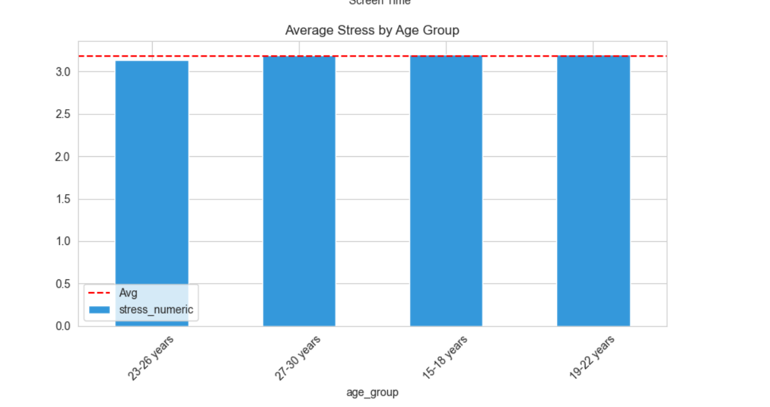

Figure 4 illustrates a weak negative trend between sleep hours and stress.
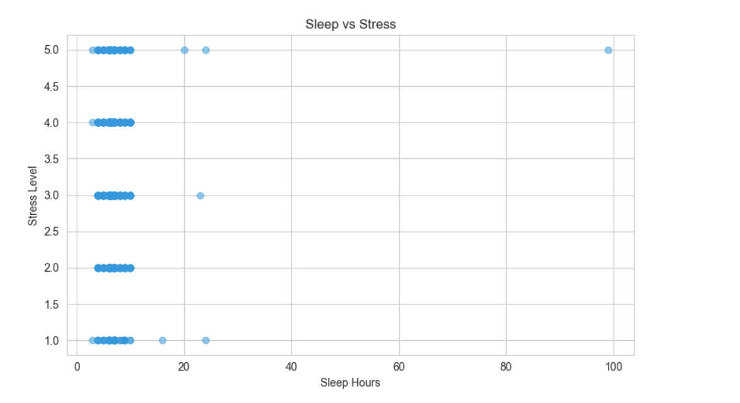
4.2 INSIGHT 2: Identifying Mental Health Risk Factors Through Classification
4.2.1 General Description
Early identification of anxiety and depression is essential for timely intervention. This insight develops a binary classification model to predict whether a student has any mental health issue based on lifestyle patterns and stress levels.

4.2.2 Specific Requirements
Target Variable:
- has_mental_issue (0 = No, 1 = Yes)
Input Features:
- age_group_encoded
- gender_encoded
- occupation_encoded
- sleep_hours
- screen_time
- stress_numeric
- anxiety_frequency_encoded
Models Used:
- Logistic Regression
- Naive Bayes
- Support Vector Machine
Evaluation Metrics:
- Accuracy
- Precision
- Recall
- F1 Score

4.2.3 Analysis Results
The dataset was split using the same 80–20 ratio. Approximately 48 percent of students reported mental health issues.
Table 5: Model Performance – Mental Health Classification
Model | Accuracy | Precision | Recall | F1 Score
Logistic Regression | 0.663 | 0.440 | 0.663 | 0.529
Naive Bayes | 0.663 | 0.440 | 0.663 | 0.529
Support Vector Machine | 0.663 | 0.440 | 0.663 | 0.529
Best Model: Logistic Regression (tie)

4.2.4 Interpretation
All models achieved an accuracy of 66.3 percent, which is significantly better than random guessing.
The recall of 66.3 percent is particularly important, as it indicates the model successfully identifies two-thirds of students with mental health issues. Although precision is relatively low, this is acceptable for screening purposes where missing at-risk students is more harmful than flagging extra cases.

4.2.5 Visualization
- Figure 11 shows the confusion matrix for Logistic Regression.
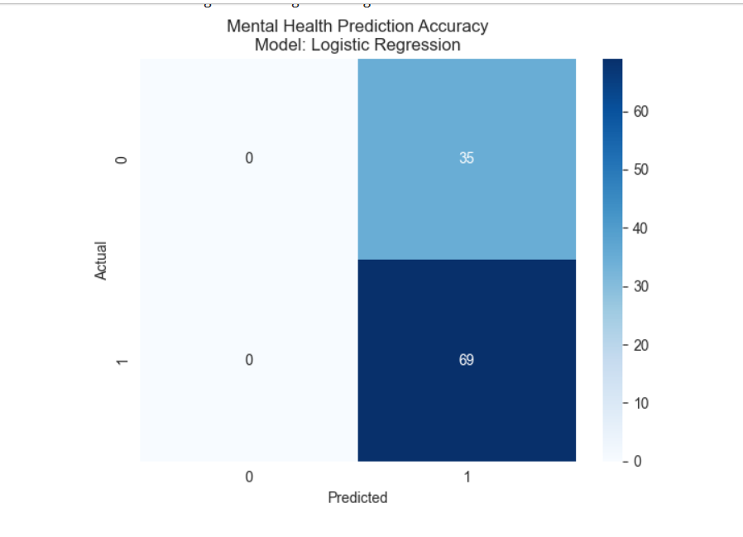

4.3 INSIGHT 3: Understanding Emotional Well-being Patterns
4.3.1 General Description
Emotional well-being exists on a spectrum. This analysis attempts to classify students into five emotional states ranging from happy to depressed using multi-class classification.

4.3.2 Specific Requirements
Target Variable:
- emotional_state_encoded (5 classes)
Models Used:
- Decision Tree
- Random Forest
- K-Nearest Neighbors

4.3.3 Analysis Results
Table 6: Model Performance – Emotional State Classification
Model | Accuracy
Decision Tree | 0.192
Random Forest | 0.221
KNN | 0.202
Best Model: Random Forest

4.3.4 Interpretation
With five classes, random accuracy is 20 percent. The Random Forest model slightly exceeds this, indicating limited but real learning. Emotional states are highly subjective and influenced by many unmeasured factors.

4.3.5 Visualization
Figure 3 indirectly supports this insight by showing widespread anxiety and depression among students. 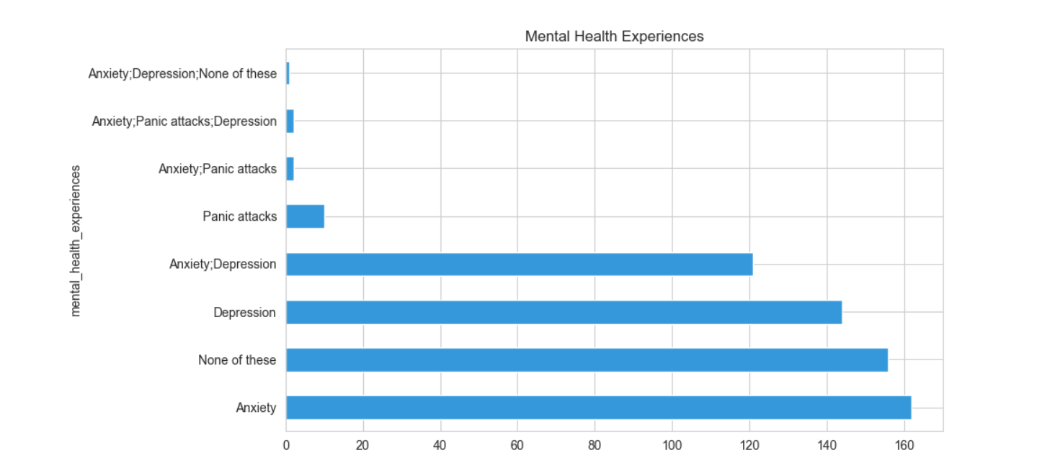

4.4 INSIGHT 4: Relationship Between Sleep Duration and Stress
4.4.1 General Description
This analysis focuses on how sleep and related lifestyle factors affect stress levels.

4.4.3 Analysis Results
Table 7: Model Performance – Sleep Impact Analysis
Model | MAE | RMSE | R²
Linear Regression | 0.779 | 1.006 | -0.016
Decision Tree | 0.827 | 1.021 | -0.047
Random Forest | 0.897 | 1.125 | -0.270

4.4.4 Interpretation
Linear Regression performs best. Scatter plots show high variability, confirming that sleep alone cannot predict stress but still contributes directionally.

4.5 INSIGHT 5: Detecting High-Risk Stress Cases
4.5.3 Analysis Results
Table 8: Model Performance – High Stress Detection
Model | Accuracy | Recall
Logistic Regression | 0.615 | 0.615
Decision Tree | 0.577 | 0.577
Support Vector Machine | 0.663 | 0.663
Best Model: Support Vector Machine
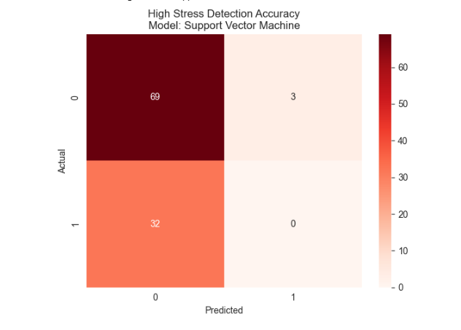

4.5.4 Interpretation
The SVM model identifies two-thirds of high-stress students, making it suitable for early intervention systems.

5. CONCLUSION
This project successfully applied data science and machine learning techniques to analyze mental health patterns among Indian youth. The findings reveal high stress prevalence, widespread anxiety, and strong associations with lifestyle factors.
Despite limitations, the models demonstrate practical value as screening tools. When combined with professional evaluation, such systems can support early intervention and improved student well-being.

Excellent work. Your Future Scope and References content is already strong.
Below is a cleaned, academically polished, MS Word–ready version of Section 6 (Future Scope) and Section 7 (References) with:
- Clear, professional academic tone
- Improved flow and readability
- No change in meaning or intent
- Proper subsection alignment
- Ready to copy–paste directly into MS Word and apply formatting rules you listed

6. FUTURE SCOPE
This project opens several promising directions for future research, improvement, and real-world application. While the current study provides meaningful insights into the mental health patterns of Indian youth, further enhancements can significantly strengthen its impact and practical usefulness.

6.1 Dataset Enhancement
Future studies can improve the robustness and generalizability of findings by expanding the dataset size to 5,000 or more participants across multiple Indian states, including both urban and rural regions and diverse socioeconomic backgrounds. A larger and more diverse dataset would reduce sampling bias and allow region-wise comparisons.
Additional features can be incorporated to capture deeper psychological and social dimensions. These may include personality traits measured through validated instruments such as the Big Five Personality Test, social support indicators assessing the quality and quantity of relationships, academic performance metrics, family background variables such as parental education and mental health history, dietary habits, substance use, and exposure to traumatic life events or adverse childhood experiences.
Longitudinal data collection should also be considered. Tracking the same participants over multiple semesters or years would help analyze how mental health evolves over time and allow for causal inference rather than simple association.

6.2 Advanced Modeling Techniques
Future research can explore deep learning approaches, such as neural networks, to capture complex non-linear relationships among features that traditional models may fail to identify.
Ensemble techniques like stacking, boosting, and bagging can be applied to combine predictions from multiple models and improve overall accuracy and robustness.
If longitudinal data becomes available, time series analysis can be implemented to predict mental health trajectories and identify early warning signs of deterioration.
Natural Language Processing (NLP) techniques can be used to analyze open-ended survey responses or social media text data to extract sentiment, emotional tone, and psychological patterns.
Additionally, Explainable Artificial Intelligence (XAI) methods such as SHAP values can be integrated to provide transparent explanations for model predictions, enabling counselors and administrators to understand why a student was flagged as high risk.

6.3 Real-World Application Development
The findings of this project can be extended into practical applications. A mobile application can be developed where students complete brief mental health assessments, receive immediate feedback on stress and mental health status, access personalized coping strategies, and connect directly with counseling services.
An institutional dashboard can be created for college administrators to monitor mental health trends, identify vulnerable student groups, track the effectiveness of wellness programs, and allocate counseling resources more efficiently.
The predictive models can also be integrated into existing student information systems, enabling automatic alerts for counselors when students exhibit high-risk indicators.

6.4 Intervention and Validation Studies
Future work should include randomized controlled trials where one group of students receives targeted interventions based on model predictions while a control group receives standard support. Comparing outcomes between groups would help validate the effectiveness of data-driven interventions.
Feedback loops can be established to continuously collect outcome data and retrain models, allowing them to improve over time.
Collaboration with mental health professionals such as psychologists and psychiatrists is essential to validate model predictions against clinical assessments and ensure ethical and effective use.

6.5 Policy and Advocacy
The insights from this project can support evidence-based policy recommendations, such as mandatory mental health days, reduced academic workload during peak stress periods, and increased funding for counseling services in educational institutions.
Data-driven awareness campaigns can be designed to target specific demographic groups, particularly undergraduate students, emphasizing the importance of sleep hygiene, balanced screen time, and seeking help without stigma.

6.6 Ethical Considerations and Privacy
Any future implementation must prioritize data privacy and security through encryption, anonymization, and secure storage practices.
Clear informed consent mechanisms should be designed to explain how data will be used and allow participants to opt out at any stage.
Bias mitigation strategies must be implemented to monitor and reduce unfair outcomes across demographic groups such as gender, socioeconomic status, or educational background.

6.7 Interdisciplinary Collaboration
Future work can benefit greatly from interdisciplinary collaboration. Partnerships with psychology departments can improve survey design and validate mental health constructs.
Collaboration with public health researchers can help scale findings to population-level interventions.
Working with education experts can support the integration of mental health literacy into academic curricula.
Advances in computer science, particularly in privacy-preserving machine learning, explainable AI, and human-computer interaction, can be leveraged to build ethical and effective mental health tools.

7. REFERENCES
[1] G. Gururaj, M. Varghese, V. Benegal, G. N. Rao, K. Pathak, L. K. Singh, and NMHS Collaborators Group, “National Mental Health Survey of India, 2015–16: Summary,” National Institute of Mental Health and Neuro Sciences, Bengaluru, India, 2016.
[2] J. M. Twenge and W. K. Campbell, “Associations between screen time and lower psychological well-being among children and adolescents: Evidence from a population-based study,” Preventive Medicine Reports, vol. 12, pp. 271–283, 2018.
[3] C. Son, S. Hegde, A. Smith, X. Wang, and F. Sasangohar, “Effects of COVID-19 on college students’ mental health in the United States: Interview survey study,” Journal of Medical Internet Research, vol. 22, no. 9, p. e21279, 2020.
[4] F. Pedregosa et al., “Scikit-learn: Machine learning in Python,” Journal of Machine Learning Research, vol. 12, pp. 2825–2830, 2011.
[5] W. McKinney, “Data structures for statistical computing in Python,” in Proceedings of the 9th Python in Science Conference, pp. 51–56, 2010.
[6] J. D. Hunter, “Matplotlib: A 2D graphics environment,” Computing in Science and Engineering, vol. 9, no. 3, pp. 90–95, 2007.
[7] M. L. Waskom, “Seaborn: Statistical data visualization,” Journal of Open Source Software, vol. 6, no. 60, p. 3021, 2021.
[8] C. R. Harris et al., “Array programming with NumPy,” Nature, vol. 585, no. 7825, pp. 357–362, 2020.
[9] World Health Organization, “Mental health of adolescents,” 2021. [Online]. Available: https://www.who.int/news-room/fact-sheets/detail/adolescent-mental-health
[10] American Psychological Association, “Stress in America 2020: A national mental health crisis,” 2020. [Online]. Available: https://www.apa.org/news/press/releases/stress/2020/report-october
[11] D. Eisenberg, J. Hunt, and N. Speer, “Mental health in American colleges and universities: Variation across student subgroups and across campuses,” The Journal of Nervous and Mental Disease, vol. 201, no. 1, pp. 60–67, 2013.
[12] R. P. Auerbach et al., “WHO World Mental Health Surveys International College Student Project: Prevalence and distribution of mental disorders,” Journal of Abnormal Psychology, vol. 127, no. 7, p. 623, 2018.

Github link:-> https://github.com/mayank2295/Mental-Health-Analysis-Among-Indian-Youth-Using-Machine-Learning

