**PIZZA SALES SQL QUERIES**

**A .KPI’s**

1. **Total Revenue :**

SELECT SUM(total_price) AS Total_Revenue FROM pizza_sales;

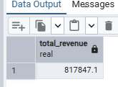

**2. Average Order Value**

SELECT (SUM(total_price) / COUNT(DISTINCT order_id)) AS Avg_order_Value

FROM pizza_sales

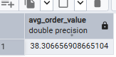

**3. Total Pizzas Sold**

SELECT SUM(quantity) AS Total_pizza_sold FROM pizza_sales

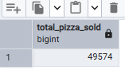

**4. Total Orders**

SELECT COUNT(DISTINCT order_id) AS Total_Orders FROM pizza_sales

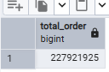

**5. Average Pizzas Per Order**

SELECT CAST(CAST(SUM(quantity) AS DECIMAL(10,2)) /

CAST(COUNT(DISTINCT order_id) AS DECIMAL(10,2)) AS DECIMAL(10,2))

AS Avg_Pizzas_per_order

FROM pizza_sales

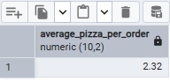

**B. Daily Trend for Total Orders**

SELECT TO_CHAR(Order_date,'Day') as order_day, count(distinct order_id) from pizza_sales

GROUP BY TO_CHAR(Order_date,'Day') ;

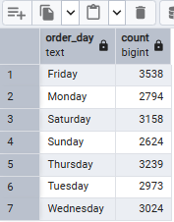

**C. Hourly Trend for Orders**

SELECT EXTRACT( 'HOUR' FROM ORDER_time) as order_hours, count(distinct order_id) as total_order from pizza_sales

GROUP BY EXTRACT( 'HOUR' FROM ORDER_time ) order by EXTRACT( 'HOUR' FROM ORDER_time);

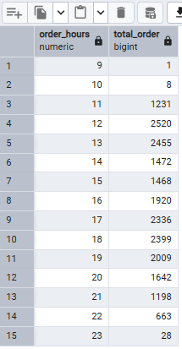

**D. % of Sales by Pizza Category**

SELECT PIZZA_CATEGORY , CAST(SUM(unit_price)AS DECIMAL(10,2)) as

total_revenue ,CAST(sum(unit_price) * 100 / (select sum(unit_price) from

pizza_sales )as decimal(10,2)) as PCT from pizza_sales

GROUP BY pizza_category

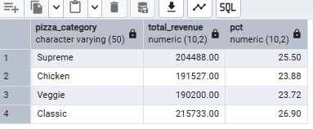

**E. % of Sales by Pizza Size**

SELECT pizza_size, CAST(SUM(unit_price) AS DECIMAL(10,2)) as total_revenue, CAST(SUM(unit_price) * 100 / (SELECT SUM(unit_price) from pizza_sales) AS DECIMAL(10,2)) AS PCT FROM pizza_sales

GROUP BY pizza_size ORDER BY pizza_size

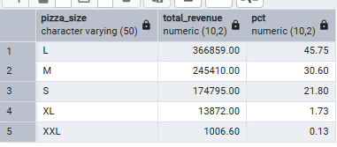

**F. Total Pizzas Sold by Pizza Category**

Select pizza_category,sum(quantity) as Total_pizza_sold from pizza_sales

group by pizza_category order by Total_pizza_sold desc

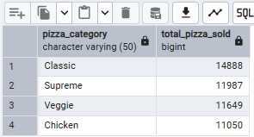

**G. Top 5 Best Sellers by Total Pizzas Sold**

SELECT pizza_name, SUM(quantity) AS Total_Pizza_Sold FROM pizza_sales

GROUP BY pizza_name ORDER BY Total_Pizza_Sold DESC

limit 5 ;

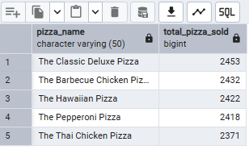

**H. Bottom 5 Best Sellers by Total Pizzas Sold**

SELECT pizza_name, SUM(quantity) AS Total_Pizza_Sold

FROM pizza_sales

GROUP BY pizza_name

ORDER BY Total_Pizza_Sold ASC

LIMIT 5 ;

