SOFTWARE ENGINEERING MINI PROJECT
RETAIL INVENTORY AND STOCK MANAGEMENT SYSTEM
Software Architecture & Design Specification

Deliverable Part-1 | Team E10
Team Members
Name | SRN
Malavika A | PES1UG24CS257
Manoj Kumar | PES1UG24CS264
Mayank M | PES1UG24CS266
LG Vivyn Krishnaa | PES1UG24CS248

1. Introduction

1.1 Purpose
This document describes the software architecture and detailed design of the Retail Inventory and Stock Management System . It explains how the requirements captured in the Software Requirements Specification are realised as a set of components, interfaces, data structures and interactions, and it provides enough detail for the team to implement the system and for the Test Plan to be traced back to design elements.It translates the Phase 1 requirements into components, interfaces, data formats and behaviour that the team will implement in C++ and verify through the Test Plan.

1.2 Scope
RISMS is a menu-driven C++ console application that lets an authorised Inventory User maintain product records, search and view products, increase or decrease stock, check availability, review stock movement history and view an inventory summary with low-stock items. All data is persisted in local files. A graphical or web interface, a database server, barcode scanners, point-of-sale integration and multiple user roles are outside the scope of Part-1.

1.3 Definitions, Acronyms and Abbreviations
Term | Meaning
RISMS | Retail Inventory and Stock Management System
SRS | Software Requirements Specification (Phase 1 document)
FR / VFR / NFR | Functional / Verifiable Functional / Non-Functional Requirement
SR | Security Requirement
UC | Use Case (UC01–UC11 as in the SRS)
Stock-in / Stock-out | An adjustment that increases / decreases a product's quantity
Ledger | The append-only stock movement history file (stock_ledger.csv)
Low-stock threshold | Configured quantity at or below which a product is flagged (VFR09)
Atomic write | Writing to a temporary file and renaming it over the original, so a crash never leaves a half-written file
Repository | Class that hides file formats and I/O from the business logic

1.4 References
- SRS – Retail Inventory and Stock Management System, Team E10, Phase 1 deliverable (FR01–FR14, VFR01–VFR09, UC01–UC11).
- Test Plan – Retail Inventory and Stock Management System, Team E10, Part-1 deliverable.
- IEEE Std 1016-2009, Systems Design – Software Design Descriptions.
- ISO/IEC/IEEE 42010:2011, Architecture description.
- SEI CERT C++ Coding Standard .

1.5 Document Overview
Section 2 presents the architecture: drivers, chosen pattern, component diagram and descriptions, deployment, data design, traceability to requirements and the security architecture. Section 3 presents the detailed design: UML sequence diagrams, API (module interface) design, error handling and key algorithms. Section 4 lists constraints and assumptions and Section 5 records the design-to-test hooks used by the Test Plan.

1.6 Assumptions on Non-Functional and Security Requirements
The Phase 1 SRS lists functional requirements only. The following non-functional requirements and security requirements are assumed as the architectural drivers used throughout this document. If the numbering or thresholds in the final SRS differ, the traceability tables in Section 2.7 must be updated accordingly.
ID | Requirement (measurable)
NFR01 Performance | Search by product ID shall return in under 1 second with 10,000 stored products.
NFR02 Reliability | No product or ledger record shall be lost or corrupted if the program is terminated during a save.
NFR03 Usability | Every menu operation shall complete in at most 5 prompts, and every error message shall state the reason.
NFR04 Portability | The program shall build as C++17 with g++ 9+ or MSVC 2019+ and run on Windows and Linux without code changes.
NFR05 Maintainability | Each service and repository class shall be unit-testable without the console layer.
SR01 | Passwords shall never be stored in plain text; only a salted SHA-256 hash shall be stored.
SR02 | Login shall be locked for 60 seconds after 3 consecutive failed attempts.
SR03 | No menu option other than Login and Exit shall be reachable without an authenticated session.
SR04 | All user input shall be length-limited and type-checked before use.
SR05 | Stock history shall be append-only and each entry shall record the acting user and time.
SR06 | A failed or interrupted save shall not corrupt existing data files.
SR07 | Data files shall be readable and writable only by the operating-system account running RISMS.

Stakeholders and Concerns

Stakeholder | Primary design concerns
Inventory User (A01) | Simple menus, clear messages, accurate stock figures, no lost data
Store owner | Correct low-stock reporting, audit trail of stock changes, restricted access
Developers | Modular code, clear interfaces, independent module testing
Testers / evaluators | Every requirement traceable to a component and a test case

2. Architectural Design

2.1 Architectural Drivers
The following requirements influence the architecture the most:
- Correct stock arithmetic (VFR05, VFR06): quantity must change only through controlled stock-in and stock-out operations, never through a general product edit.
- Traceable history (FR09, VFR07, SR05): every successful adjustment must reach the ledger, so product save and ledger append must be coordinated in one place.
- Persistence without a database (FR13, FR14, VFR08, NFR02): files must survive restarts and crashes, so all file I/O is concentrated in one component that performs atomic writes.
- Modifiability (NFR05): the SRS schedule analysis splits the work into product records, stock adjustment, lookup and history/report modules that are developed and tested independently, so module boundaries must be explicit.

2.2 Architectural Pattern
RISMS uses a strict three-layer architecture with the Repository pattern at the data layer. Each layer calls only the layer directly below it. The presentation layer never touches a file, and the service layer never knows a file name or format.
Layer | Responsibility | Modules
Presentation layer | Show menus, read and parse input, print results and error messages, check that a session exists before dispatching a command. | MenuController, ConsoleIO
Business logic layer (services) | Business rules: authentication, validation, stock arithmetic, ledger entries, low-stock detection, reports. | AuthService, ProductService, StockService, HistoryService, ReportService, Validator
Data access layer (repositories) | Load, cache, save and query records; hide file formats; atomic writes and appends. | UserRepository, ProductRepository, MovementRepository, ConfigRepository
Persistent storage | CSV and text files in a local data/ directory. | Local file system
Why this pattern
- Separation of concerns: the rule “stock-out cannot exceed available quantity” lives only in StockService, so it is tested once without driving the console (NFR05).
- Testability: services receive repository interfaces in their constructors, so unit tests pass in-memory fakes instead of real files.
- Replaceable persistence: moving from CSV files to SQLite later means one new repository class, not a rewrite of the business logic.
- Right-sized for the project: a single process with an in-memory cache needs no threads, sockets or external libraries.
Alternatives considered
Alternative | Reason for rejection
Single-file procedural program (functions and global arrays) | Fastest to start, but validation, file I/O and menu code become entangled, which makes VFR tests hard to isolate.
Model–View–Controller | Adds little over layering for a console application with one view; the controller role is already covered by MenuController.
Client–server with a database | Out of scope per the SRS (file handling, no external database) and adds installation cost.

2.3 Component Diagram
Figure 1 shows the components of RISMS grouped by layer and the dependencies between them. Orange components are security- and integrity-critical.
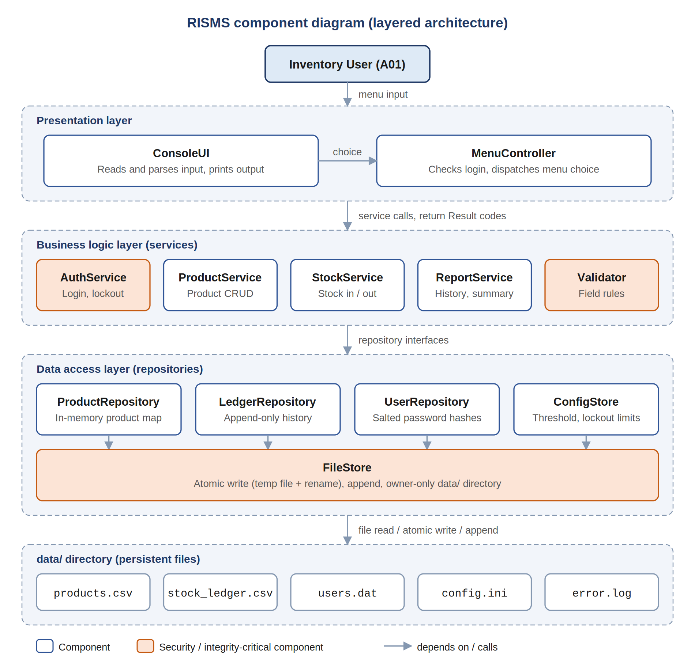

2.4 Component Descriptions
Component | Responsibility | Provided interface | Requirements
ConsoleUI | Prints menus, tables and messages; reads lines with std::getline; parses numbers safely. | readText(), readInt(), readDouble(), show() | NFR03, SR04
MenuController | Runs the login screen and main menu loop; blocks every command until a session exists; maps each choice to a service call. | run() | FR01, SR03
AuthService | Verifies credentials against salted hashes, counts failures, applies lockout, holds the current user. | login(), logout(), isAuthenticated(), currentUser() | FR01, SR01, SR02
ProductService | Add, update, remove, search and list products; rejects duplicate IDs. | addProduct(), updateProduct(), removeProduct(), findById(), searchByName(), listAll() | FR02–FR06, FR11, VFR01–VFR04
StockService | Stock-in and stock-out with arithmetic and availability checks; one ledger entry per successful change. | stockIn(), stockOut(), getQuantity() | FR07–FR09, VFR05–VFR07
ReportService | Stock history per product; inventory summary with totals and low-stock list. | historyFor(), inventorySummary() | FR10, FR12, VFR09
Validator | Single home for field rules: required fields, lengths, allowed characters, non-negative numbers. | validateProduct(), validateQty() | VFR02, SR04
ProductRepository | Loads products.csv into an unordered_map; saves the full file on change. | load(), get(), exists(), all(), put(), erase(), save() | FR13, FR14, NFR01
LedgerRepository | Appends movements to stock_ledger.csv; reads history for a product; no update or delete. | append(), forProduct(), nextId() | FR09, FR10, SR05
UserRepository | Reads and writes users.dat (user ID, salt, hash). | find(), create() | SR01
ConfigStore | Reads config.ini; falls back to defaults if a key is missing. | lowStockThreshold(), maxAttempts(), lockoutSeconds() | VFR09, SR02
FileStore | All file I/O: creates data/ with owner-only permissions, reads lines, atomic rewrite, append. | ensureDataDir(), readLines(), writeAtomic(), appendLine() | FR13, VFR08, NFR02, SR06, SR07

2.5 Deployment View
RISMS is deployed on a single node; there are no servers or network links:
- Store PC: Windows 10+ or Linux machine able to run a console program.
- Executable: risms (Linux) or risms.exe (Windows), containing all three layers, built with g++ -std=c++17 -O2 src/*.cpp -o risms or the equivalent CMake target.
- Data directory: data/ next to the executable, created on first run with owner-only permissions, holding products.csv, stock_ledger.csv, users.dat, config.ini and error.log.

2.6 Data Design
The principal persistent entities and their key attributes are shown below. Attributes marked (U) are unique, (I) are indexed in memory.

Entity (file) | Key attributes | Notes
Product (products.csv) | productId (U, I), name, category, unitPrice, quantity | ID 1–10 letters/digits; name 1–50 chars; price and quantity ≥ 0. Whole file rewritten atomically on change.
StockMovement (stock_ledger.csv) | movementId (U), productId, type {IN, OUT}, quantityChange, resultingQty, timestamp, userId, reason | Append-only (SR05). quantityChange > 0; direction given by type. History kept after a product is removed.
User (users.dat) | userId (U), saltHex, hashHex | Password never stored in plain text (SR01). Initial account created on first run.
Config (config.ini) | low_stock_threshold (default 10), max_login_attempts (3), lockout_seconds (60) | Defaults used if a key is missing.
ErrorLog (error.log) | timestamp, level {INFO, WARN, ERROR}, component, message | Security events and I/O errors; never shown to the user.

2.7 Traceability to Requirements
Table 2.7-a maps every functional and verifiable requirement in the SRS to the use case, the responsible component and the operation that realises it. Table 2.7-b does the same for non-functional and security requirements.
Table 2.7-a: Functional requirements
Requirement | Use case | Component(s) | Operation / design element
FR01 | UC01 | MenuController, AuthService | AuthService::login(); session check before every command
FR02, VFR01, VFR02 | UC02 | ProductService, Validator | addProduct() → DUPLICATE_ID / INVALID_INPUT
FR03 | UC03 | ProductService, Validator | updateProduct() (quantity not editable here)
FR04 | UC04 | ProductService | removeProduct() with Y/N confirmation
FR05, VFR03, VFR04 | UC05 | ProductService | findById(), searchByName() → NOT_FOUND
FR06 | UC06 | ProductService, ConsoleUI | findById() and detail view
FR07, VFR05, VFR06 | UC07 | StockService | stockIn(), stockOut() → INSUFFICIENT_STOCK
FR08 | UC08 | StockService | getQuantity()
FR09, VFR07 | UC07 | StockService, LedgerRepository | LedgerRepository::append() after every successful adjustment
FR10 | UC09 | ReportService | historyFor(), newest first
FR11 | UC10 | ProductService | listAll(), sorted by product ID
FR12, VFR09 | UC11 | ReportService, ConfigStore | inventorySummary(): quantity ≤ threshold
FR13 | UC02, UC07 | Repositories, FileStore | save(), append(), writeAtomic()
FR14, VFR08 | UC01 | ProductRepository, LedgerRepository | load() at start-up; atomic write guarantees intact files

Table 2.7-b: Non-functional and security requirements
Requirement | Design decision that satisfies it
NFR01 | Products cached in an unordered_map keyed on productId; the file is read once at start-up.
NFR02 | FileStore::writeAtomic() (temp file, flush, rename); product saved before ledger append with rollback on failure.
NFR03 | Numbered menu of 10 options; each operation asks for at most 5 fields; error catalogue gives one-line reasons.
NFR04 | Standard C++17 library only (plus header-only picosha2); std::filesystem for paths and permissions.
NFR05 | Services depend on repository interfaces injected through constructors; unit tests use in-memory fakes.
SR01 | UserRepository stores SHA-256(salt + password) with a 16-byte random salt; constant-time comparison.
SR02 | AuthService keeps failure count and lock-until time; values read from config.ini.
SR03 | MenuController calls isAuthenticated() before dispatching any option.
SR04 | std::getline into std::string (no fixed buffers); std::stoi/std::stod inside try/catch; Validator caps lengths and rejects commas and newlines.
SR05 | LedgerRepository exposes append and read methods only; entries carry userId and timestamp.
SR06 | writeAtomic() for products.csv and users.dat; appendLine() with flush for the ledger.
SR07 | FileStore::ensureDataDir() creates data/ with permissions 0700 (Linux) or current-user-only ACL (Windows).

2.8 Security Architecture

2.8.1 Security objectives
Objective | Description
SO1 Confidentiality and access control | Only an authenticated Inventory User can view or change inventory data; credentials are never stored or shown in plain text.
SO2 Integrity | Product quantities and history change only through validated service operations, and data files are never left half-written.
SO3 Accountability | Every stock change can be traced to a user, a time and a reason.

2.8.2 Security controls by layer
Layer | Control | Objective / SR
Presentation | Input read as whole lines into std::string; numeric parsing in try/catch; no raw file paths or exception text printed. | SO2 / SR04
Session | Login gate before the main menu; session cleared on logout and on exit. | SO1 / SR03
Authentication | Salted SHA-256 hashes, constant-time compare, 3-attempt lockout for 60 s, generic “incorrect user ID or password” message. | SO1 / SR01, SR02
Business logic | Every service re-validates arguments; quantity changed only via stockIn/stockOut; stock-out bounded by available quantity. | SO2 / SR04
Data access | Append-only ledger; atomic rewrite of products and users; malformed lines skipped and logged, never guessed. | SO2, SO3 / SR05, SR06
Storage | data/ directory restricted to the owning OS account. | SO1 / SR07
Audit | error.log records login success, failure, lockout, logout and I/O errors. | SO3

2.8.3 Access control matrix
The SRS defines a single actor, so access control distinguishes an authenticated Inventory User from an unauthenticated person at the console.
Operation | Authenticated Inventory User | Unauthenticated
Login / Exit | Yes | Yes
Create initial account | No | First run only
Add / update / remove product | Yes | No
Search / view product, list all | Yes | No
Stock in / stock out | Yes | No
Check stock | Yes | No
View stock history | Yes | No
Inventory summary | Yes | No

3. Detailed Design

3.1 UML Sequence Diagrams
Three interaction scenarios are modelled: SD1 – User Login (UC01), SD2 – Add Product (UC02) and SD3 – Stock-out with Ledger Entry (UC07). Solid arrows are calls, dashed arrows are returns and red arrows are error returns.

3.1.1 SD1 – User Login (UC01)
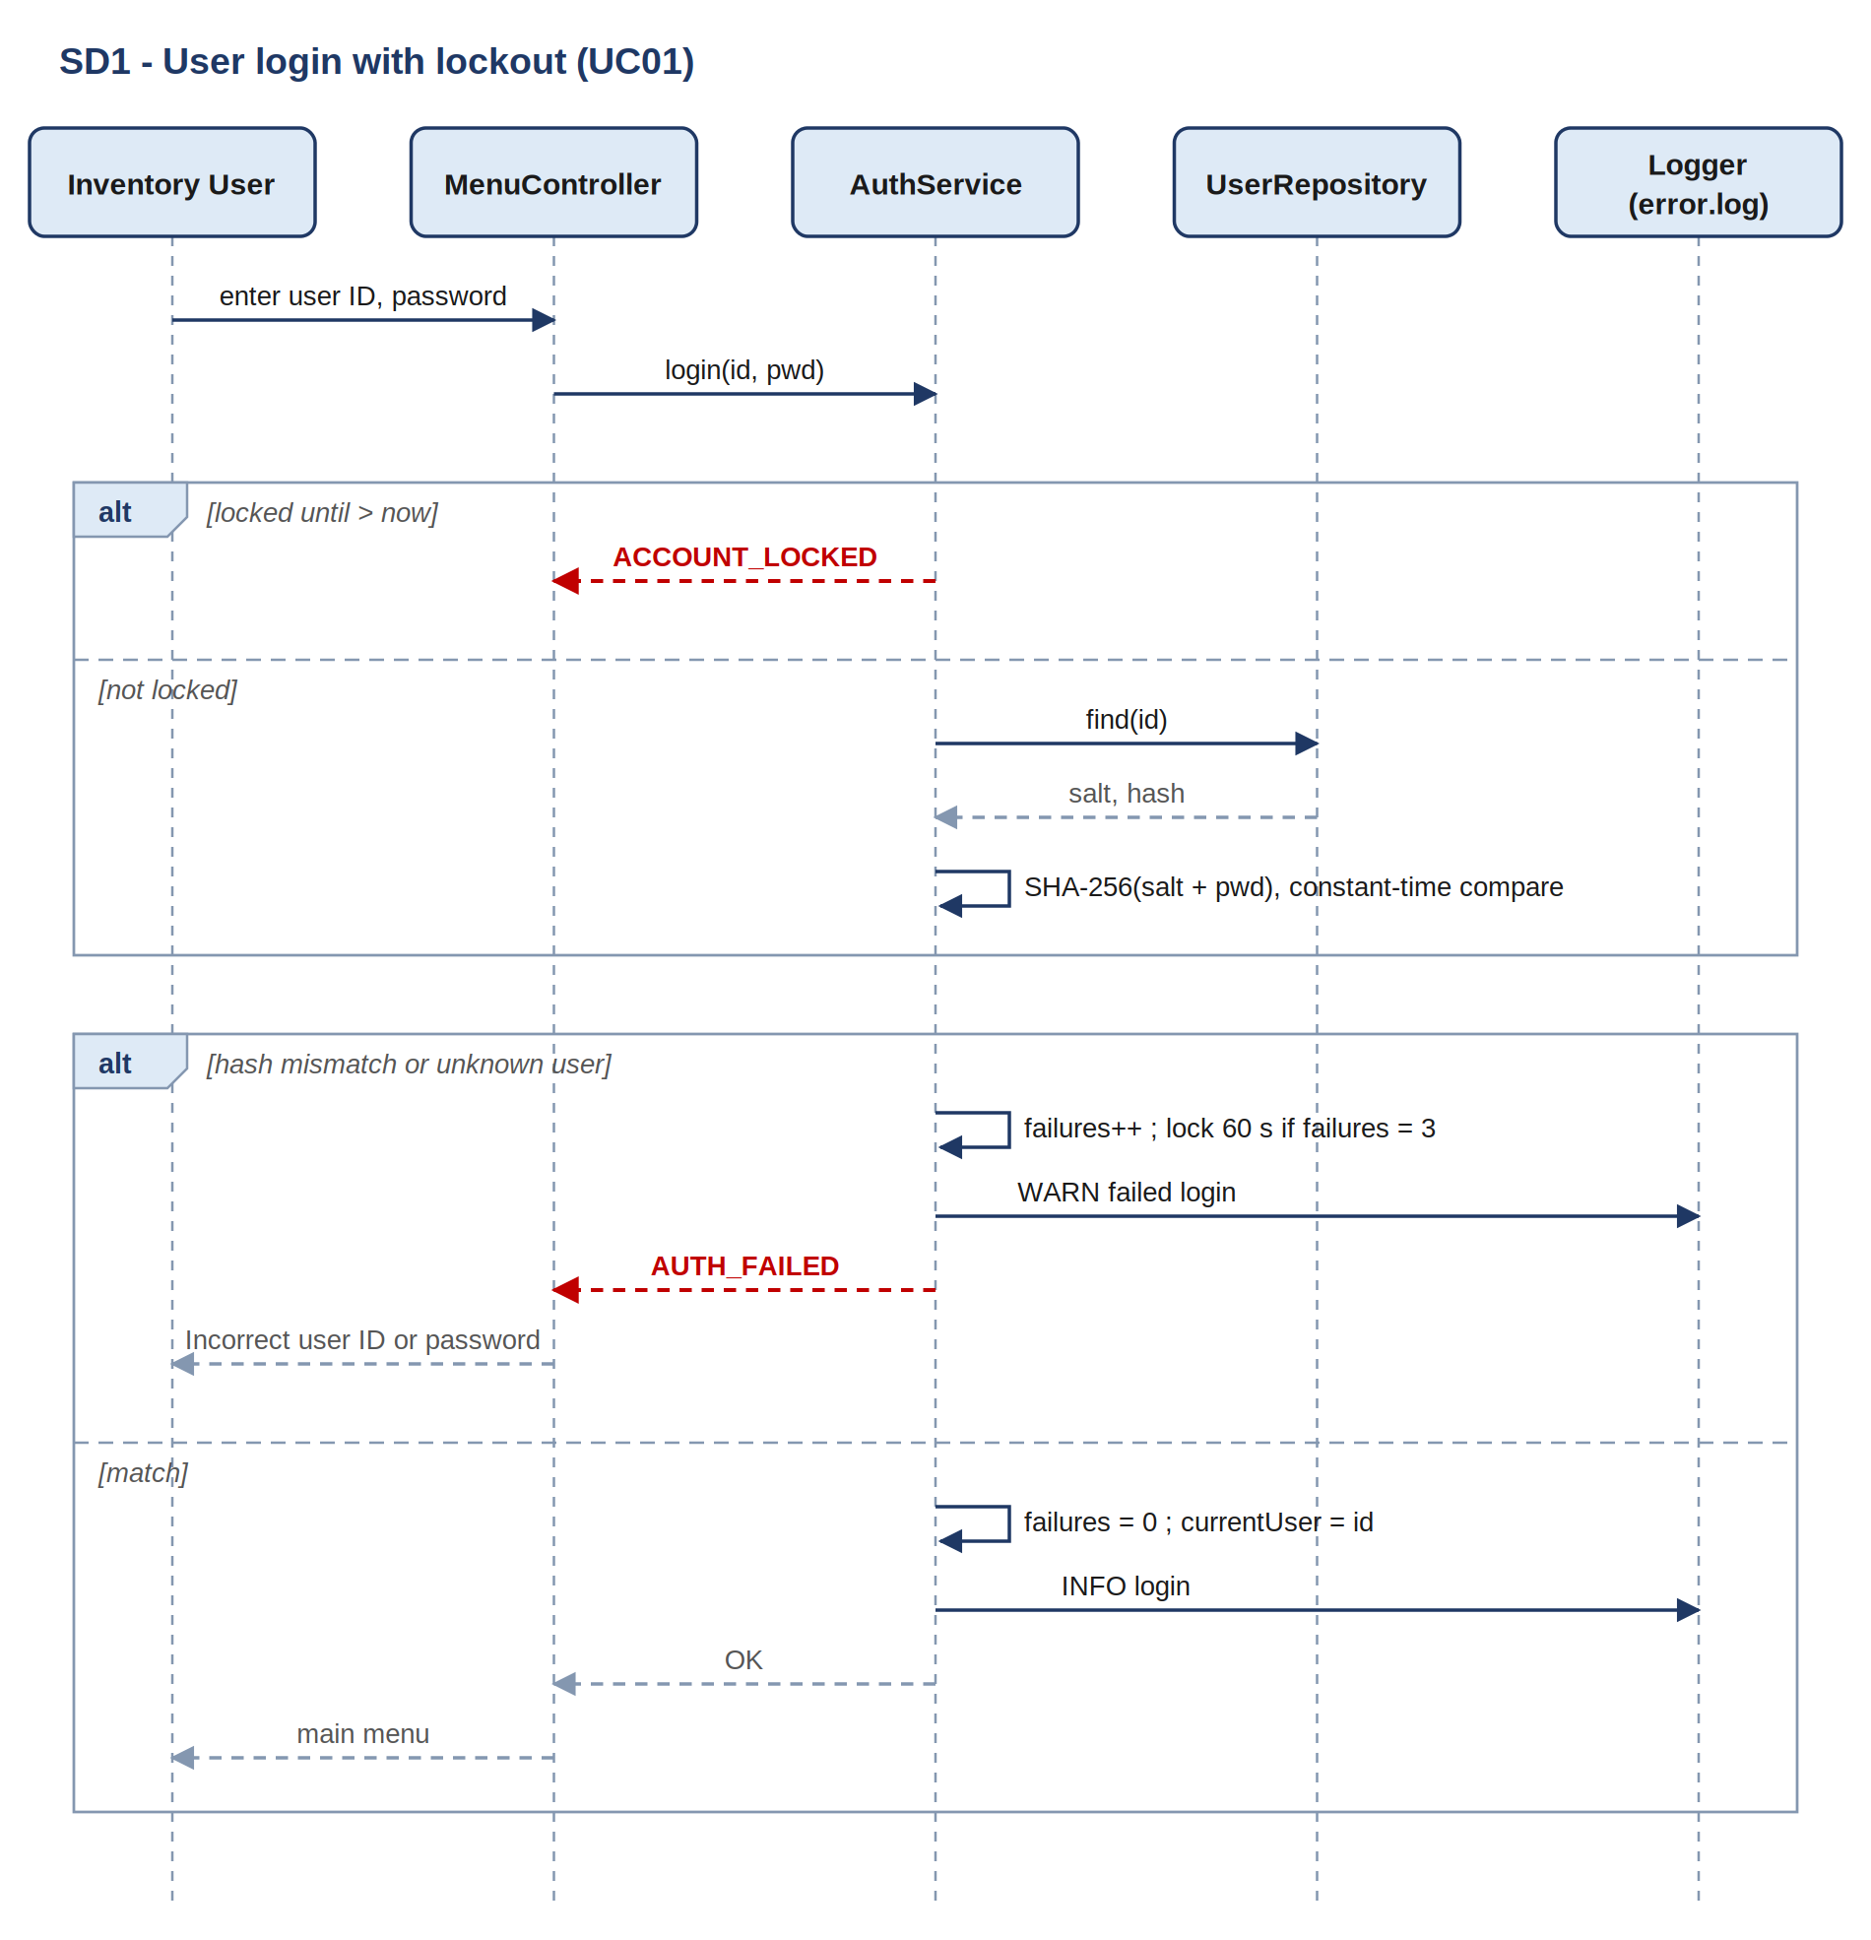

3.1.2 SD2 – Add Product (UC02)
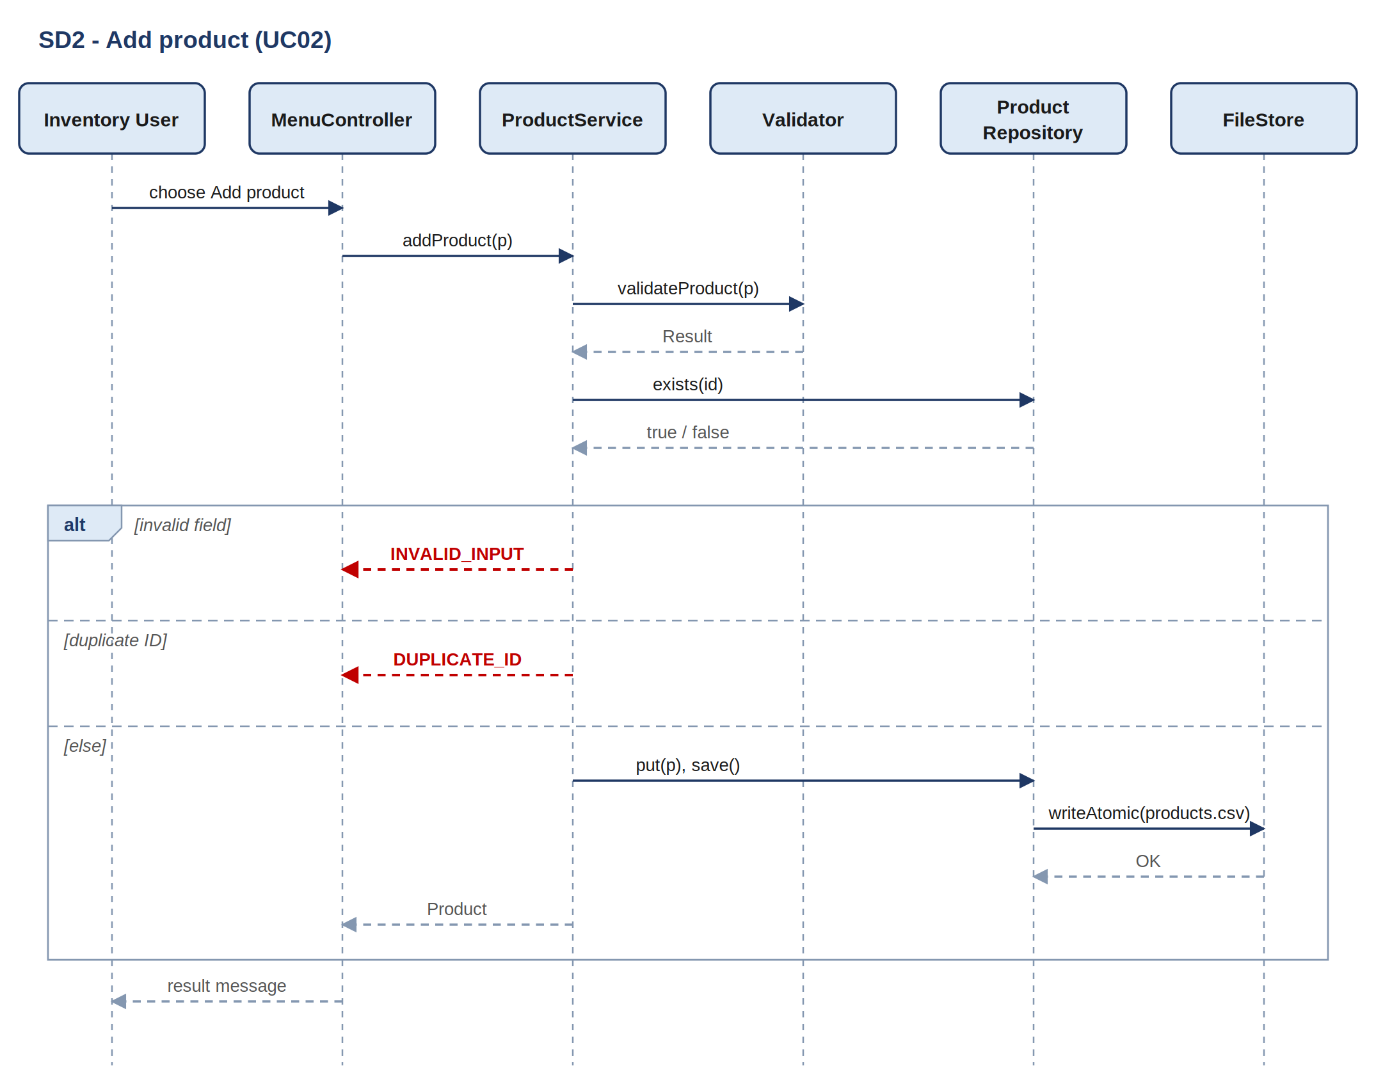

Validation runs first, then the duplicate check against the in-memory map. INVALID_INPUT (with the field name) takes precedence over DUPLICATE_ID. Only a valid, new product reaches save().

3.1.3 SD3 – Stock-out with Ledger Entry (UC07)
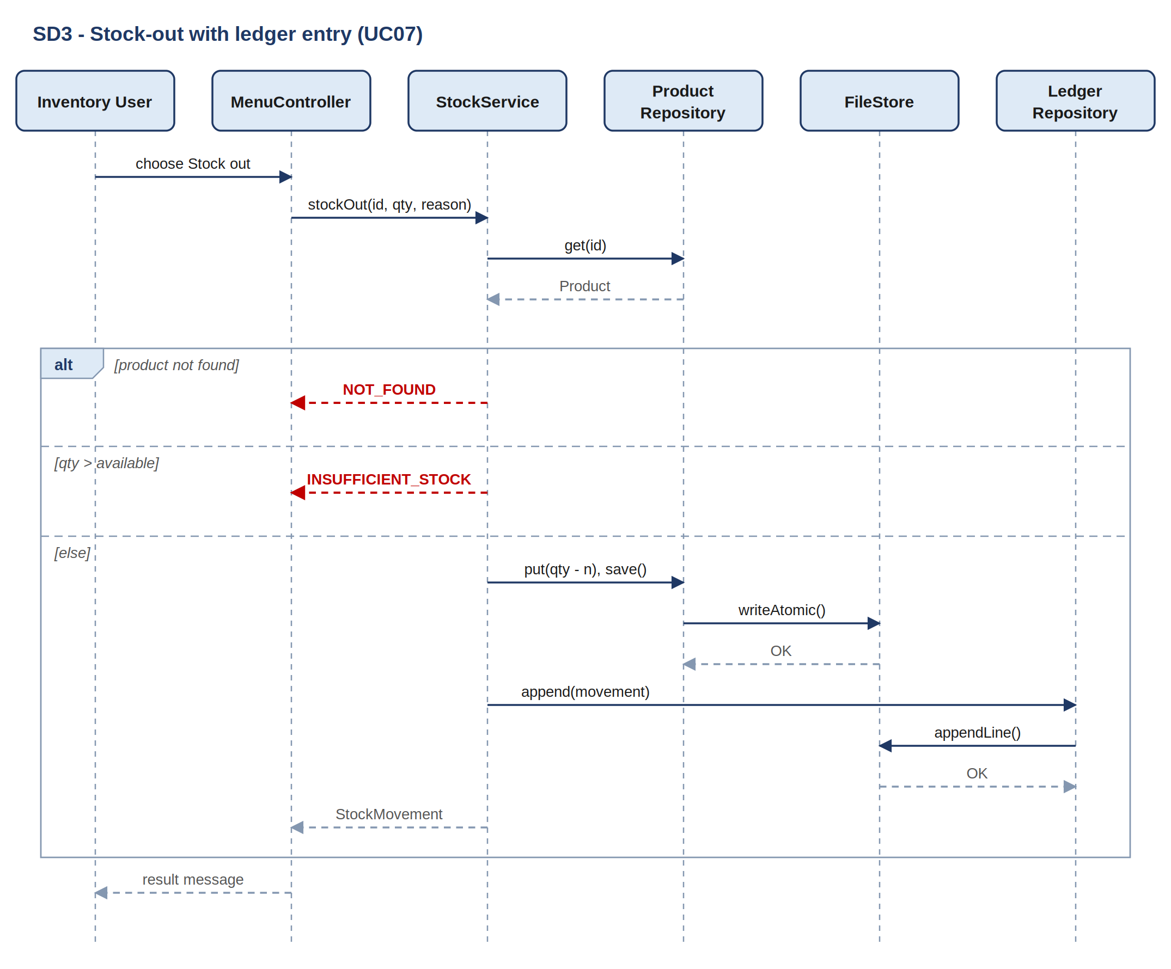
Figure 4: Sequence diagram for stock-out and ledger logging (FR07, FR09, VFR06, VFR07)
The product file is rewritten atomically before the movement is appended. If the append fails, the quantity is restored and the product file re-saved (Section 3.3.1).

3.2 API Design
RISMS has no network API. Its API is the set of C++ class interfaces between layers, plus the console menu that users interact with.

3.2.1 Conventions
- Every service operation returns Result<T>, carrying either a value or an ErrorCode with a human-readable message; expected failures never throw.
- Identifiers are std::string; quantities are int; prices are double rounded to two decimals; timestamps are ISO-8601 local time from the system clock.
- Services validate all arguments themselves, even when ConsoleUI has already checked them.
- Quantity is changed only through stockIn()/stockOut(), never through updateProduct(), so every change reaches the ledger.

3.2.2 Service operation summary
Operation | Purpose | Returns | Main errors
AuthService::login(id, pwd) | Authenticate and open a session | Result<void> | AUTH_FAILED, ACCOUNT_LOCKED
AuthService::logout() | End session, log event | void | —
ProductService::addProduct(p) | Create product record | Result<Product> | INVALID_INPUT, DUPLICATE_ID, FILE_IO_ERROR
ProductService::updateProduct(id, name, category, price) | Modify name, category or price | Result<Product> | NOT_FOUND, INVALID_INPUT, FILE_IO_ERROR
ProductService::removeProduct(id) | Remove product (history kept) | Result<void> | NOT_FOUND, FILE_IO_ERROR
ProductService::findById(id) | Exact lookup | Result<Product> | NOT_FOUND
ProductService::searchByName(text) | Case-insensitive substring search | Result<vector<Product>> | NOT_FOUND
ProductService::listAll() | All products sorted by ID | vector<Product> | —
StockService::stockIn(id, qty, reason) | Increase quantity, log movement | Result<StockMovement> | NOT_FOUND, INVALID_INPUT, FILE_IO_ERROR
StockService::stockOut(id, qty, reason) | Decrease quantity, log movement | Result<StockMovement> | NOT_FOUND, INVALID_INPUT, INSUFFICIENT_STOCK
StockService::getQuantity(id) | Current available quantity | Result<int> | NOT_FOUND
ReportService::historyFor(id) | Movements for a product, newest first | Result<vector<StockMovement>> | NOT_FOUND
ReportService::inventorySummary() | Totals and low-stock list | InventorySummary | —

3.2.3 Common types
enum class ErrorCode { OK, INVALID_INPUT, DUPLICATE_ID, NOT_FOUND, INSUFFICIENT_STOCK,
AUTH_FAILED, ACCOUNT_LOCKED, NOT_AUTHENTICATED,
FILE_IO_ERROR, DATA_CORRUPT };

template <typename T> struct Result {
ErrorCode code = ErrorCode::OK;
std::string message; // shown to the user by ConsoleUI
std::optional<T> value;
bool ok() const { return code == ErrorCode::OK; }
};

enum class AdjustType { IN, OUT };
struct Product { std::string id, name, category; double unitPrice; int quantity; };
struct StockMovement { long id; std::string productId; AdjustType type;
int change, resultingQty; std::string timestamp, userId, reason; };
struct InventorySummary { int totalProducts; long totalUnits; double totalValue;
std::vector<Product> lowStock; };

3.2.5 Console menu (user-facing interface)
Key | Menu option | Service call | Use case
1 | Add product | addProduct() | UC02
2 | Update product | updateProduct() | UC03
3 | Remove product (asks Y/N) | removeProduct() | UC04
4 | Search product (by ID or name) | findById() / searchByName() | UC05, UC06
5 | Stock in | stockIn() | UC07
6 | Stock out | stockOut() | UC07
7 | Check stock | getQuantity() | UC08
8 | Stock history | historyFor() | UC09
9 | List all products | listAll() | UC10
10 | Inventory summary | inventorySummary() | UC11
0 | Log out and exit | logout() | UC01

3.3 Error Handling

3.3.1 Strategy
- Validate before mutate: every service checks all arguments before changing any state (VFR02, SR04).
- Typed error codes: services return Result with an ErrorCode; they never print or exit themselves.
- One place for presentation: ConsoleUI turns each ErrorCode into the message in Section 3.3.3; details go only to error.log.
- Consistency on failure: a service updates the in-memory copy, calls save()/append(), and on failure restores the previous value before returning FILE_IO_ERROR. For stock adjustments the product file is saved first, then the ledger entry is appended; if the append fails the quantity is restored and the product file re-saved (VFR07, NFR02).
- Corrupt data at start-up: a line that fails to parse is skipped, its line number logged, and the user warned once; loading continues.
- Unexpected errors: a top-level try/catch in main() logs the exception and exits cleanly without writing partial data.

3.3.2 Standard error presentation
[ERROR] INSUFFICIENT_STOCK
Only 12 units of P0001 are available; cannot remove 20.
Press Enter to return to the menu.

error.log:
2026-09-28T14:07:40 WARN StockService stockOut P0001 qty=20 available=12 user=staff01

3.3.3 Error catalogue
Code | Raised when | User-facing message | Recovery | Related requirement
INVALID_INPUT | Empty field, negative price or quantity, non-numeric or over-length input | Invalid <field>: <reason>. | Re-prompt the field | VFR02, SR04
DUPLICATE_ID | Product ID already stored | Product ID <id> already exists. | Ask for another ID | VFR01
NOT_FOUND | No product matches the key | No product found for '<key>'. | Return to menu | VFR04
INSUFFICIENT_STOCK | Stock-out quantity exceeds available | Only <n> units available; cannot remove <m>. | Return to menu, quantity unchanged | VFR06
AUTH_FAILED | Wrong user ID or password | Incorrect user ID or password. | Re-prompt; count attempt | FR01, SR01
ACCOUNT_LOCKED | 3 consecutive failed logins | Too many attempts. Try again in 60 seconds. | Wait, then re-prompt | SR02
NOT_AUTHENTICATED | Command without a session | Please log in first. | Show login screen | SR03
FILE_IO_ERROR | File cannot be opened, written or renamed | Could not save data. Your last change was not applied. | Roll back, log, return to menu | NFR02, SR06
DATA_CORRUPT | A stored line fails to parse at load | Warning: <n> unreadable record(s) skipped (see error.log). | Skip line, keep loading | FR14, VFR08

3.4 Key Algorithms

3.4.1 Stock-out with ledger entry (FR07, FR09, VFR06, VFR07)
stockOut(id, qty, reason):
if qty <= 0: return INVALID_INPUT
p = products.get(id); if p is none: return NOT_FOUND
if qty > p.quantity: return INSUFFICIENT_STOCK
old = p.quantity
p.quantity = old - qty; products.put(p)
if products.save() fails: p.quantity = old; products.put(p); return FILE_IO_ERROR
m = StockMovement(ledger.nextId(), id, OUT, qty, p.quantity, now(), auth.currentUser(), reason)
if ledger.append(m) fails:
p.quantity = old; products.put(p); products.save(); return FILE_IO_ERROR
return m
stockIn() is identical except that it has no availability check and sets new quantity = old + qty (VFR05).
3.4.2 Atomic file write (NFR02, SR06)
writeAtomic(path, lines):
tmp = path + ".tmp"
write all lines to tmp; flush; close
if any stream error: delete tmp; return FILE_IO_ERROR
std::filesystem::rename(tmp, path) // replaces the original in one step

3.4.3 Login with lockout (FR01, SR01, SR02)
login(id, pwd):
if now() < lockUntil: return ACCOUNT_LOCKED
u = users.find(id)
ok = u exists and constantTimeEqual(sha256(u.salt + pwd), u.hash)
if not ok:
failures += 1; log WARN
if failures >= maxAttempts: lockUntil = now() + lockoutSeconds; failures = 0
return AUTH_FAILED
failures = 0; current = id; log INFO; return OK

4. Design Constraints and Assumptions
- The system is a single-user C++17 console application running on one store PC; only one instance runs against a data/ directory at a time.
- Persistence uses files only, as required by the SRS; no external database or network service is used.
- Only free tools are used (g++/MSVC Community, CMake), in line with the economic feasibility in the SRS.
- The SRS defines one actor, the Inventory User; there are no separate administrator privileges in Part-1.
- The system clock of the store PC is the single time source for ledger timestamps.
- The low-stock threshold is one store-wide value in config.ini (default 10 units).

