Spatial Informatics Project : Progress Review-1

Finding Potential locations in establishing a shopping center in Urban Areas.

Population data:

Aim : To find the high to moderately populated areas of hyderabad.

Source : http://www.ghmc.gov.in/tender%20pdfs/election_wards.pdf

Characteristics : csv file containing the ward number and the corresponding population (all 150 wards).

Description : The source provides the population of each ward. We will be creating a csv file from that data manually. The csv file will then be used to do a join with the ward-wise boundary map of hyderabad.

Limitation : Population density map of hyderabad city was unavailable and therefore we are using the ward-wise population.

Data Cleaning and Processing : Since, the data is being manually created, no further cleaning is needed.

Urban sprawl model:

Aim : To find out the directions in which the city is growing raidly

Source : http://bhuvan.nrsc.gov.in/bhuvan_links.php (data has been requested from bhuvan)

Characteristics : Raster data showing the direction of growing areas in terms of population

Description : This will be used to find out the potential areas where we can setup the new malls. This will give us an idea of potential marketplace.

Data Cleaning and Processing : N/A

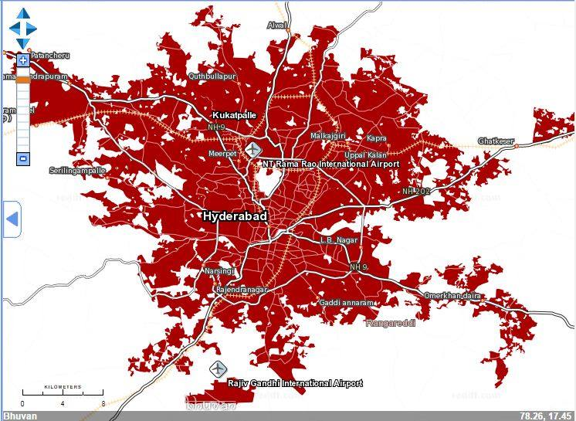
Urban Sprawl Map of Hyderabad (2011-12)

-

Road network:

Aim : Ease of accessibility

Source : https://mapzen.com/metro-extracts/ (OSM road map of hyderabad city)

Characteristics : Vector file (.shp) containing the geometry of the road network.

Description : Ensure the connectivity for local people and the frequent visitors. We are trying to make sure that the area is accessible to local people and the people working there.

Data Cleaning and Processing : The road network which is outside the boundary map of hyderabad will be removed.

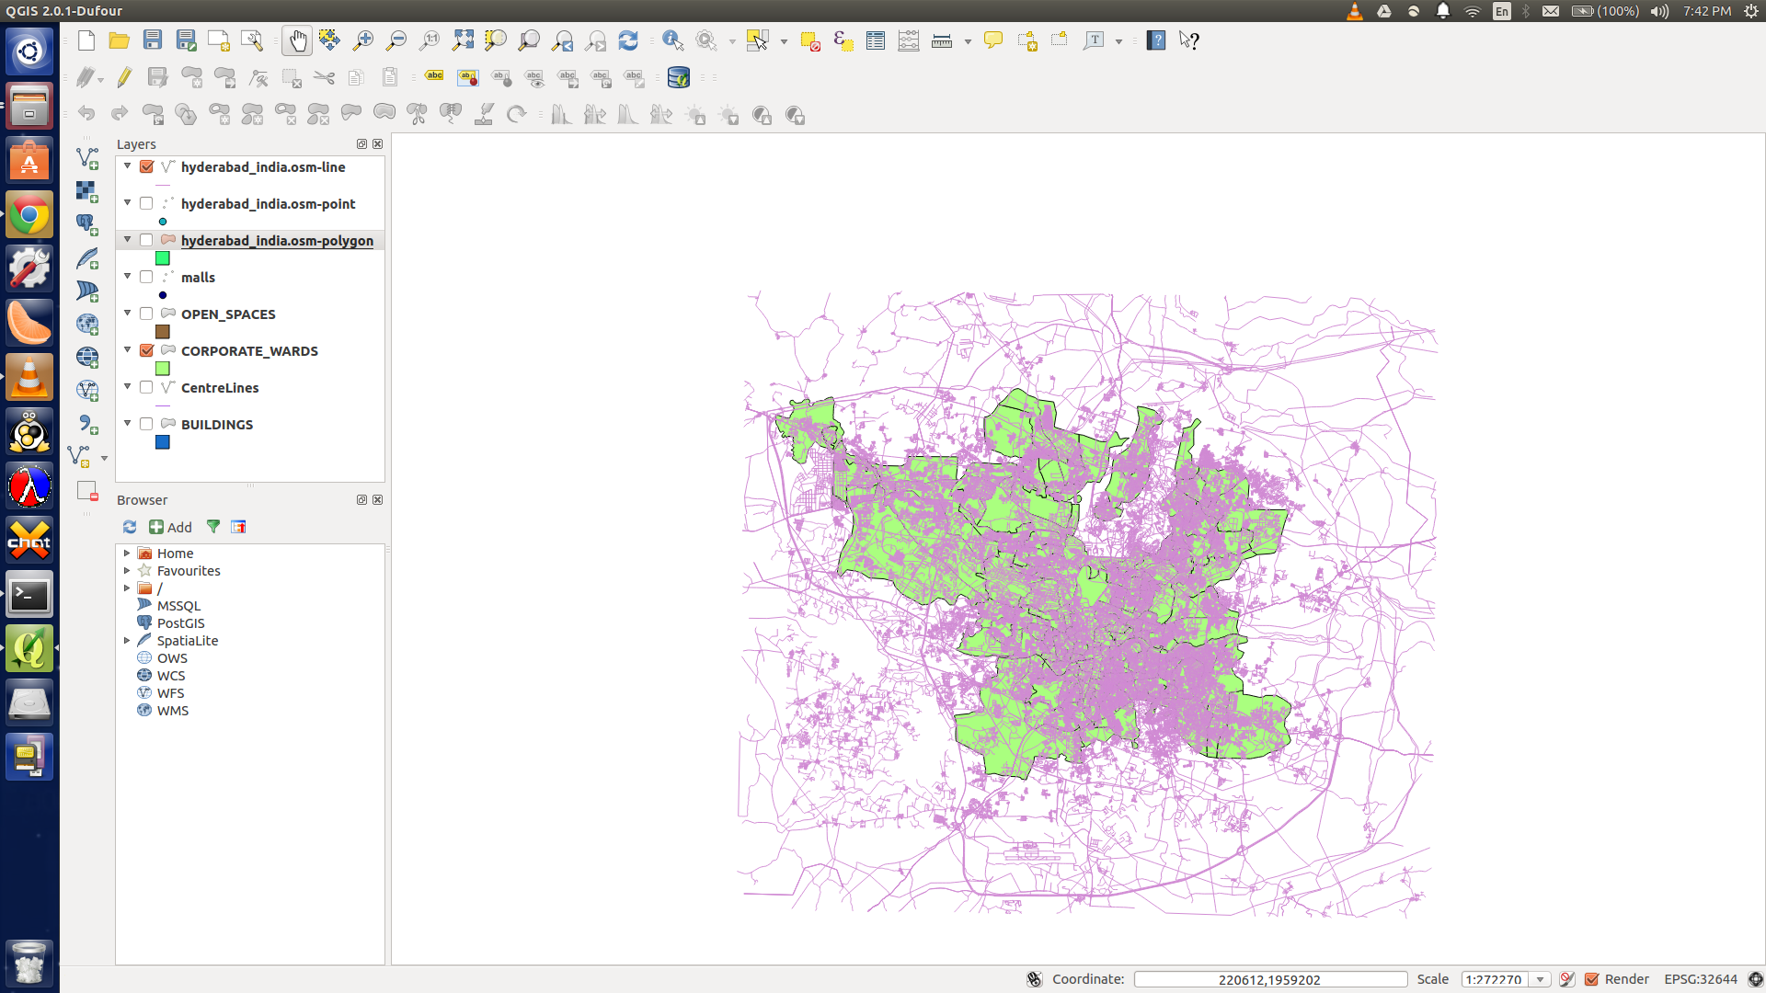
Unprocessed Map of Road Network of Hyderabad

Existing Malls in Hyderabad:

Aim : To find the malls present in Hyderabad, so that the malls won’t be conflicting in nature.

Source : Google earth.

Characteristics : Vector file (.kml) containing point data of the existing malls in Hyderabad.

Description : We will be assigning a buffer area to each mall. The excluded area is the potential area for the mall. We will also try to ensure no overlapping with the new buffer.

Limitation : The number of malls increase in number, as we zoom into the map and hence the number of malls actually present to that being considered will be different.

Data Cleaning and Processing : From Google Earth, we export the map given below into a kml file and then, this kml layer is being overlayed in QGis. The kml file being overlayed has many redundant and unnecessary details, that needs to be cleaned.

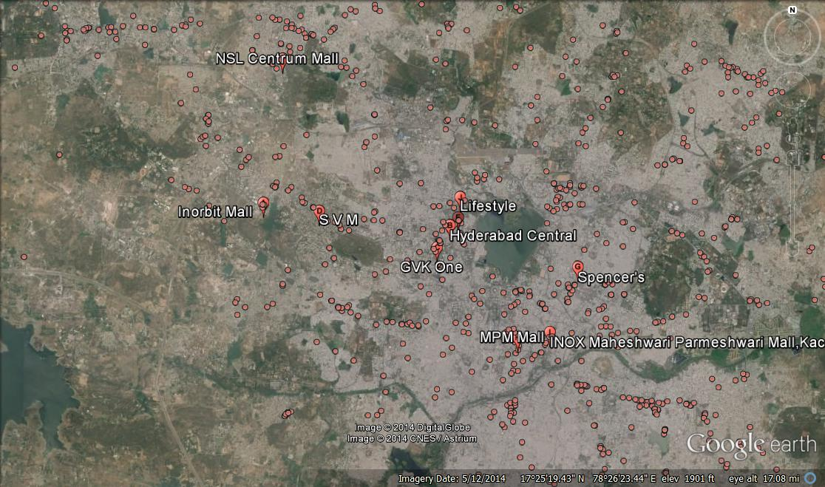
Unprocessed map of the malls in Hyderabad
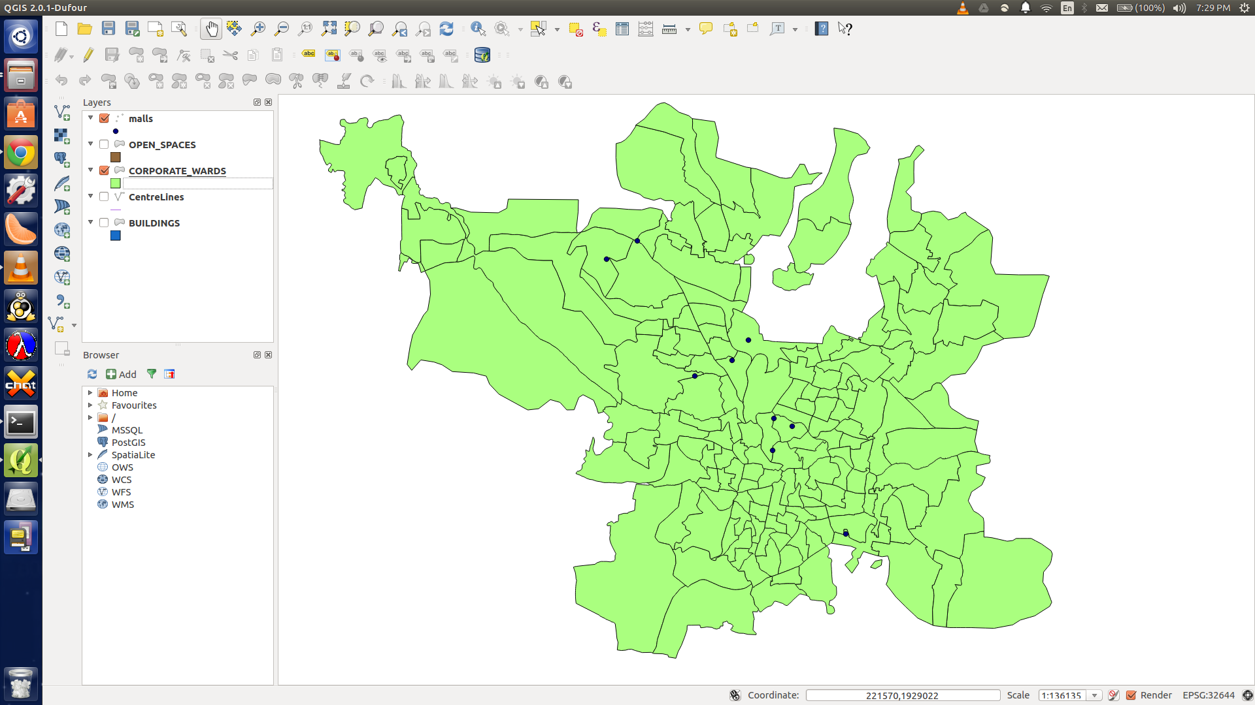
Processed Map of the malls in Hyderabad

Open Spaces in Hyderabad:

Aim : To find out the exact location of the mall in a selected area (by above methods).

Source :

Characteristics : Vector file (.shp) containing the different open spaces in hyderabad.

Description : Since, a given location being selected, may already have buildings on it. Thus, in order to get the correct location, we will choose only the open spaces in a given selected area, to get the exact locations.

Limitation:

Data Cleaning and Processing :

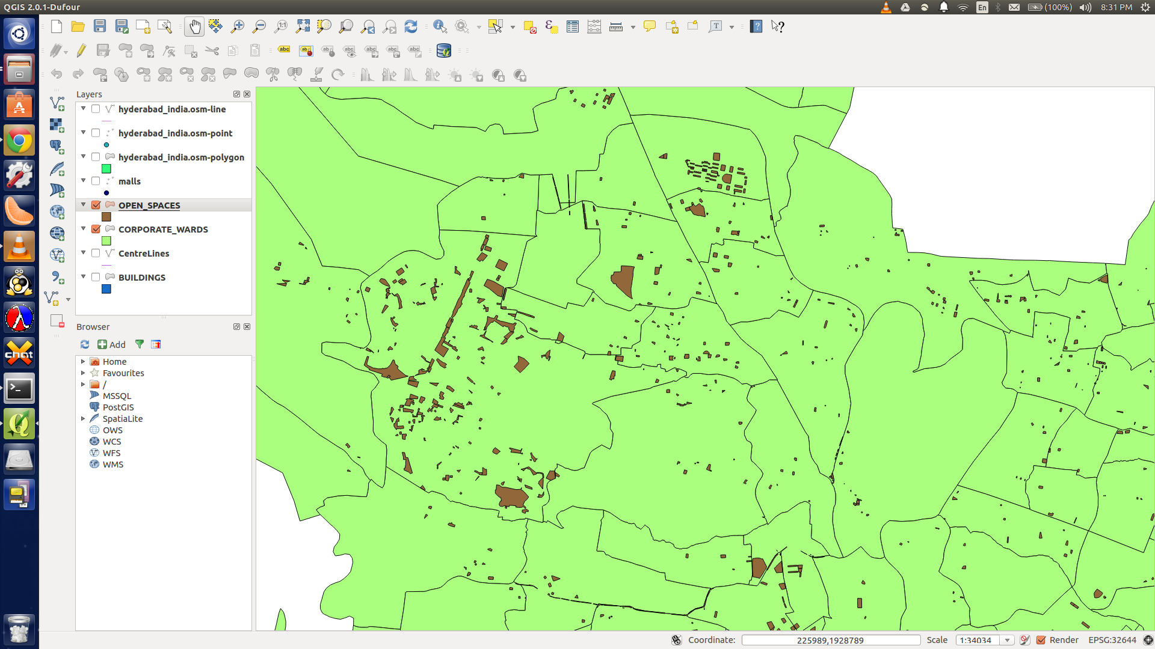
Open Spaces being shown in brown, in the ward wise boundary map of hyderabad.

