Spatial Informatics
Final Project Report

Objective/Problem Statement:

Find potential sites for the establishment of a shopping mall in Hyderabad. We will be creating different model to ascertain the location of the mall in the city and the results of the different model will be combined to give the final results **(There may be results where there will be no overlap between the any of the given models).

Data Preparation/Cleaning:

Ward-wise boundary map of Hyderabad:
File Format - Vector file (.shp)
Feature types - Polygon
Feature count - 160
Layer SRS - WGS 84 / UTM zone 44N
Source - Hyderabad Metropolitan Development Authority (HMDA)
Attributes - WARD_NUMBER, WARD_NAME, WARD_POPULATION,WARD_PERIMETER
Data preparation/Cleaning : A .csv file was created containing ward wise-population data. A join operation was done on the .shp map file and the .csv file.

Commercial Spaces of Hyderabad:
File Format - Vector file (.shp)
Feature types - Polygon
Feature count - 603
Layer SRS - WGS 84 / UTM zone 44N
Source - Open Street Maps
Attributes - Name, Type
Data preparation/Cleaning : N/A

Road network map:
File Format - Vector file (.shp) containing the geometry of the road network.
Feature Type - Line
Feature Count - 113461
Layer SRS - WGS 84 / UTM zone 44N
Source - Open Street Maps Metro Extracts (url - https://mapzen.com/metro-extracts/)
Attributes - LENGTH, ROADWIDTH, NAME,
Data preparation/cleaning - Not required.

Existing malls map:
File Format - Vector file (.kml) containing point data of the existing malls in Hyderabad
Feature Type - Point
Feature Count - 30
Layer SRS - WGS 84 / UTM zone 44N
Source -Google Earth
Attributes - NAME
Data preparation - Created a .kml file by copying KML features from Google Earth. Irrelevant entries were removed.

Open spaces map:
File Format - Vector file (.shp) containing the different open spaces in hyderabad.
Feature types - Polygon
Feature count - 2469
Layer SRS - WGS 84 / UTM zone 44N
Source - HMDA
Attributes - TYPE, AREA, PERIMETER
Data Cleaning- Removal of irrelevant attributes from the table.

Population Density map:
File Format - Vector file (.shp)
Feature types - Polygon
Feature count - 160
Layer SRS - WGS 84 / UTM zone 44N
Source - Hyderabad Metropolitan Development Authority (HMDA)
Attributes - WARD_NUMBER, WARD_POPULATION, WARD_AREA, DENSITY
Data preparation/Cleaning : A .csv file was created where the density of the ward was calculated by dividing ward population by ward area.

Methodology

In the project, we are using four models for classifying and filtering the different locations. The area of consideration is Hyderabad. Hyderabad is an urban city. Hyderabad is the capital and largest city of both the southern Indian states of Andhra Pradesh and Telangana. Occupying 650 square kilometres, along the banks of the Musi River, it has a population of about 6.8 million and a metropolitan population of about 7.75 million, making it the fourth most populous city and sixth most populous urban agglomeration in India. It is home to many commercial software companies who have set up their foreign offices, employing a lot of people.
"Stochastic" means being or having a random variable. A stochastic model is a tool for estimating probability distributions of potential outcomes by allowing for random variation in one or more inputs over time. The random variation is usually based on fluctuations observed in historical data for a selected period using standard time-series techniques. Distributions of potential outcomes are derived from a large number of simulations (stochastic projections) which reflect the random variation in the input(s).
In mathematics and physics, a deterministic system is a system in which no randomness is involved in the development of future states of the system. A deterministic model will thus always produce the same output from a given starting condition or initial state.

The project has been divided into 4 main models
- Deterministic Models
  - Population Density model
  - Commercial Spaces model
- Stochastic Models
  - Major Road model
  - Existing malls model

The deterministic models are used to pin point the locations, on the basis of solid facts and observations. While the stochastic models are used to filter those locations, which are classified on the basis of weighted stochastic model and thus ranked accordingly.
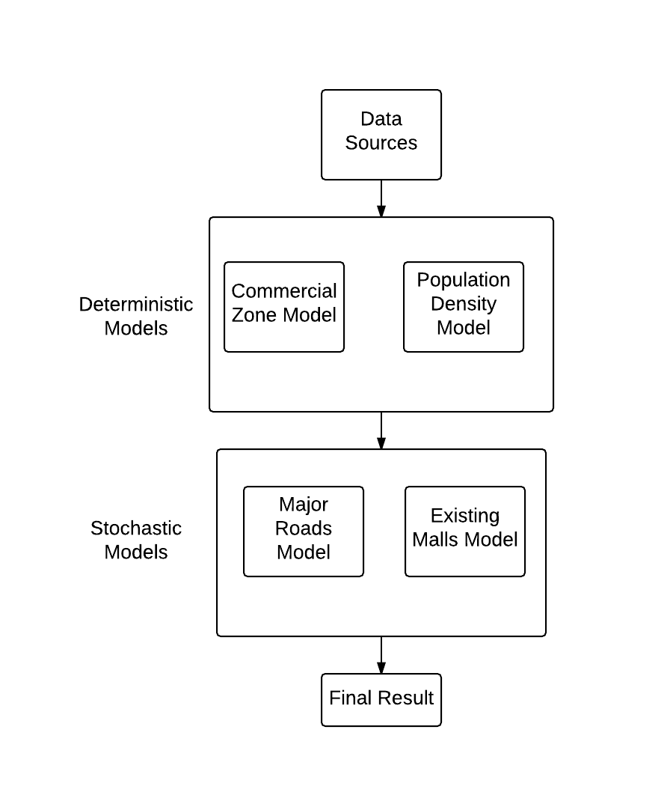
Block Diagram of the Process Used

Population Density Model

Population density of a region plays an important role in deciding the extent of demand and supply.

Assumption : Population density of a ward is assumed to be constant throughout the area of that ward.

Maps used for this model :
- Ward-wise boundary map
- Open spaces map
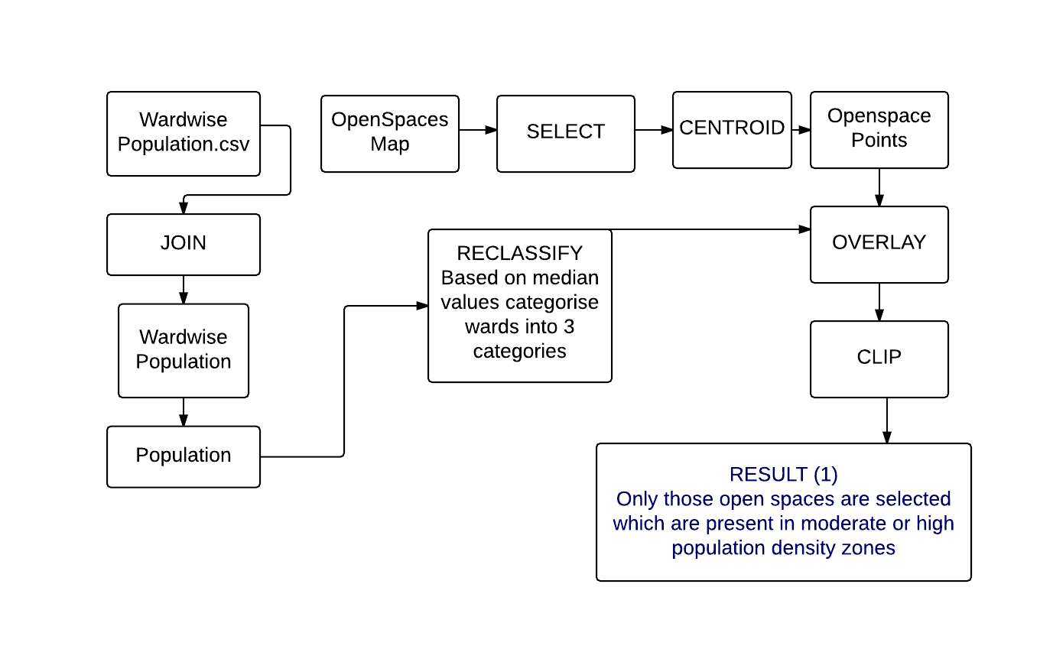
Flowchart of Population Density Model

Steps :
- Converted the non-spatial data of ward-wise population of Hyderabad into a spatial data by joining the csv file with wardwise boundary map.
- Reclassify wards according to population density into 3 categories - High, Medium and Low Population density areas.
Population density = Population / area
Median population density - 0.018693
  - High density areas - Population density > 0.028040
  - Medium density areas - 0.011226 < Population density < 0.028040
  - Low density areas - Population density < 0.011226
Only areas which lie in medium and high population density areas are being considered to filter out the points which will be favorable from business point of view in terms of sales.
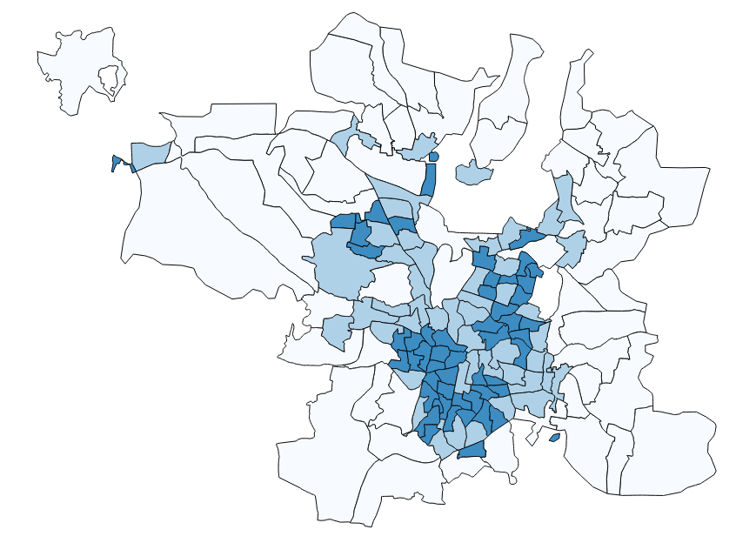
Corporate Wards map classified according to population density

- Select open space polygons which have an area greater than 14,000 m. sq. which is the area of smallest shopping malls that we could find in Hyderabad.

- Create polygon centroids for open space polygons from the open-spaces map.
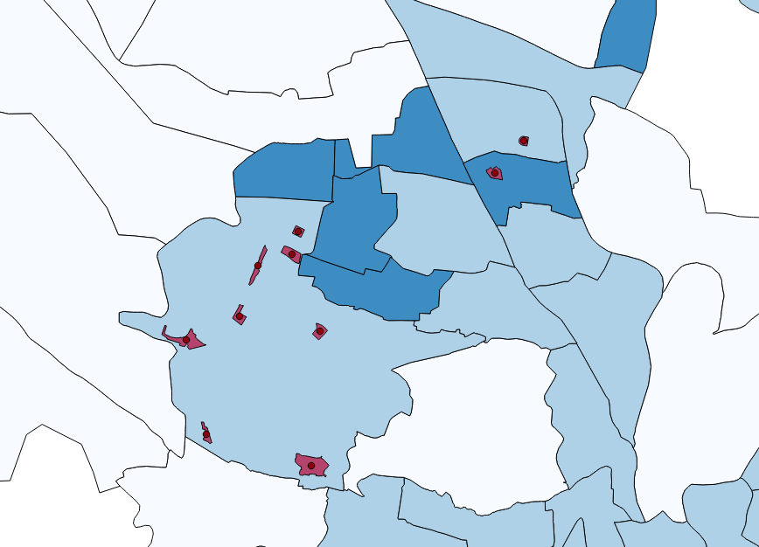
Polygon centroid for open spaces

- Clip polygon centroid map with the ward-wise boundary map to get the open spaces which lie in medium and high density wards.
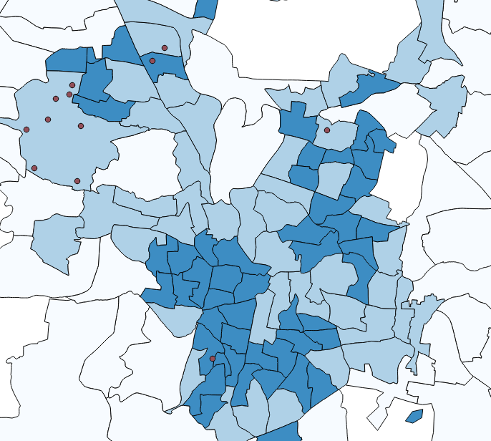
Open space centroids after applying the population density model
Commercial Space Model

The purpose of this model is to find out open spaces which are close to commercial activity areas.
Maps used for this model:
- Urban land use map from OSM metro extracts
- Open space centroid map from population density model
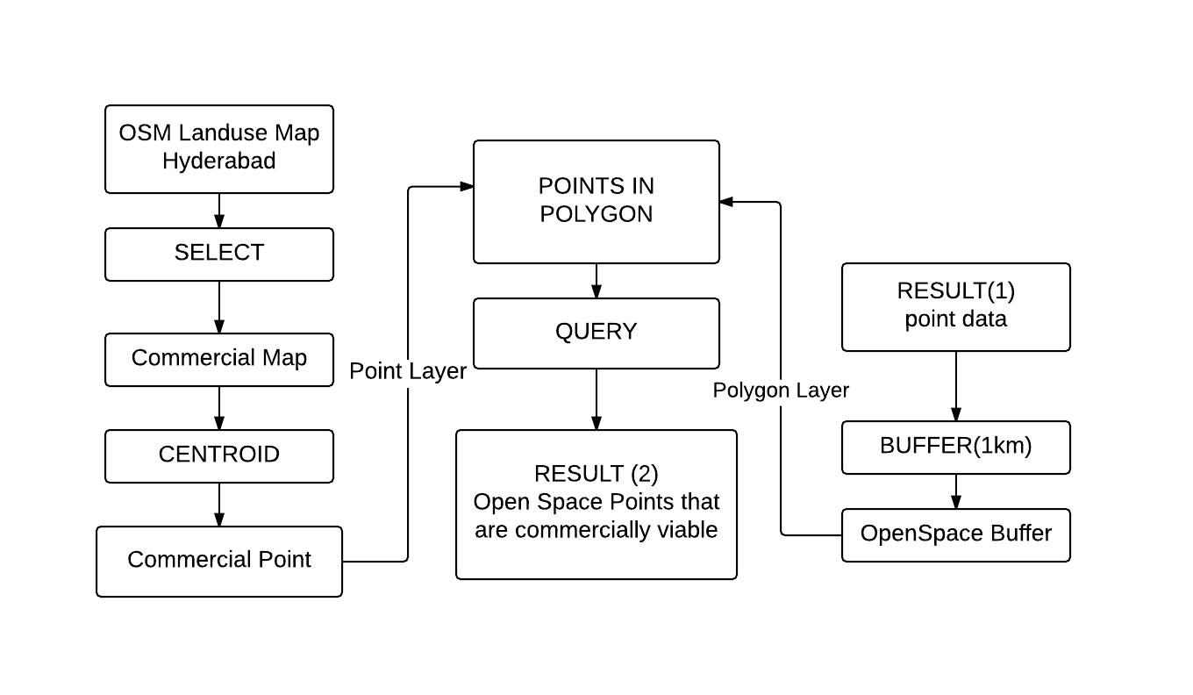
Flowchart of the Commercial Zones Model

Steps:
- Select the polygons which are of type - commercial, retail, park and recreational ground - from the land use map. OSM defines park and recreational ground as places of leisure activity. Therefore, These areas are also being considered commercial spaces.

- Take polygon centroids of the polygons in commercial areas Map.
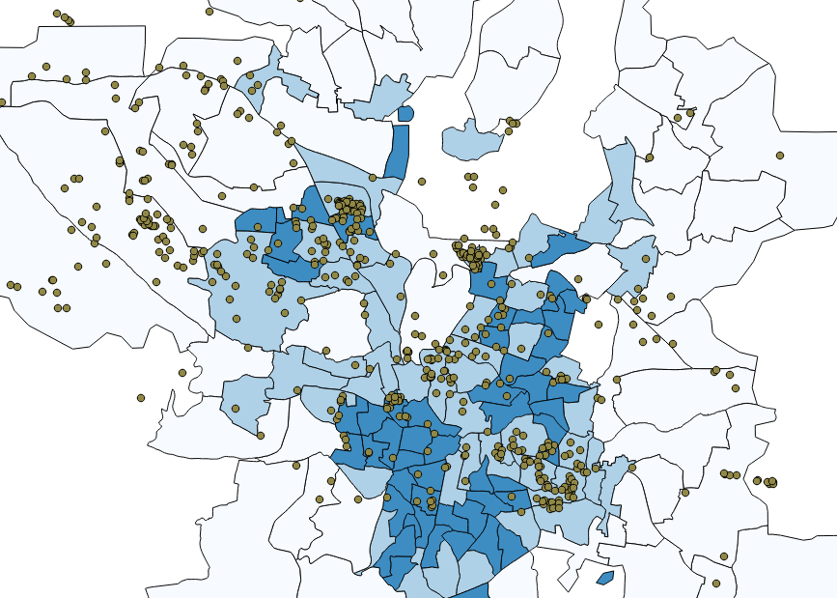
Polygon centroids of commercial spaces

- Create buffer around open space points from the centroid of the openspace map with a radius of 1 km. If a considerable number (assumed to be greater than 5) commercial space points lie within this area, it is safe to assume that area is commercially active.
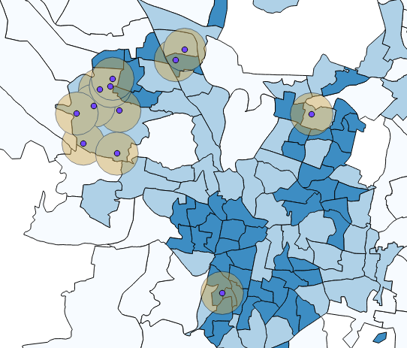
Buffer of 1 km around open space points

- Apply the points in polygon operation with the buffer layer as the polygon layer and commercial spaces as the point layer. The result is a map which contains for each buffer, the number of commercial space points in that buffer.
- Select only the buffers which have the threshold number of commercial space points. Get back the open space points from the buffers selected.
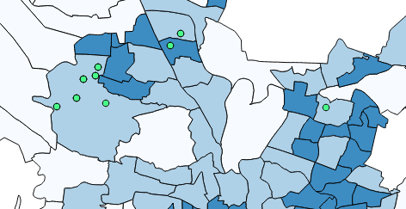
Open space points after applying commercial space model

Road Network Model
Road Network of an area decide the accessibility of a particular area. We try to find out the roads which lead to maximum traffic to the proposed area.

Assumption: A more wider road near mall leads to more traffic to the mall. A single lane road is about 3 m thus 4 lane road is 12 m. Source - Article from Hindu newspaper

Maps used for this model:
- Road Network OSM map
- Result from commercial space model

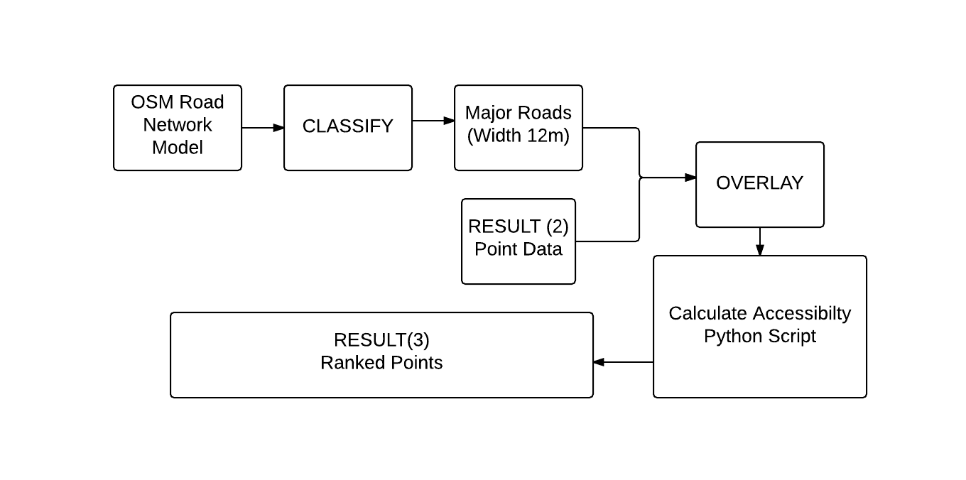
Flowchart of the Road Network Model
Steps:
- Road network map of OSM contains all roads of hyderabad city. Select roads which have a road width of 12m.
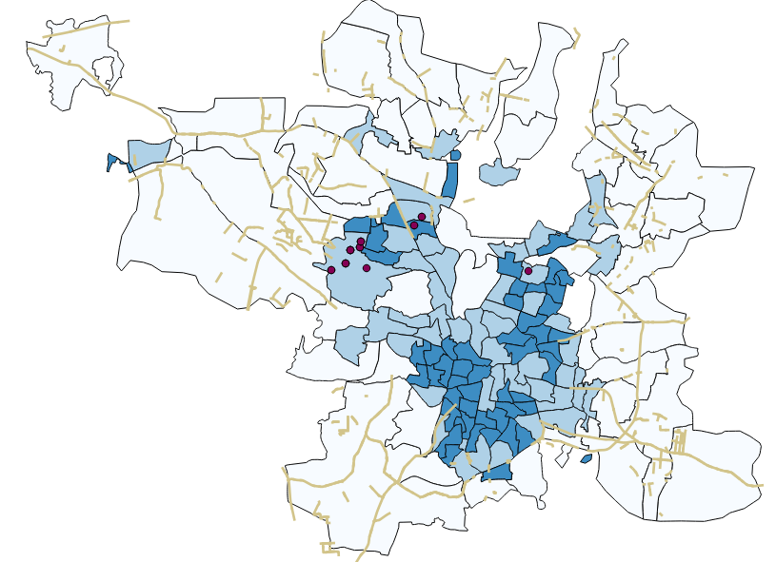
Roads with road width >= 12m

- Find the nearest road from each open space point and calculate that distance. This can be done by using the nearest Neighbour python module of QGIS.
- Rank the open space points according to the nearest road distance.

Existing Malls Model
Existing malls model will tell us the position the existing malls. This will give us the area where we don’t require mall. Thus these areas will be deducted from the existing area.

Assumption: A area of distance around the existing malls doesn’t require an another mall

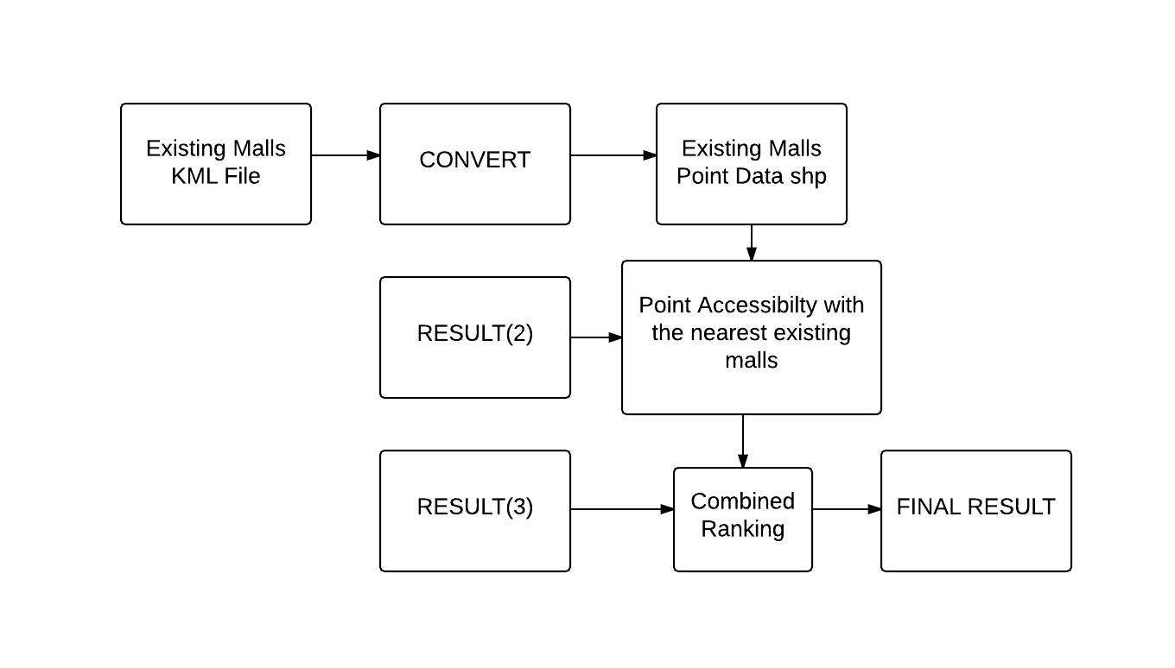
Flowchart of the Existing Malls Model
Maps used in this model:
- Existing malls in hyderabad
- Result from the Road Network Model

Steps:
- We created a kml file of the malls in the hyderabad from the google earth.
- We open it in QGIS and the save it in form of shp point file.
- Now we can either use a deterministic model or a probabillistic model to get further filtered results.
- Deterministic Model
  - Now we overlay that on the existing answer and then form a buffer of distance around them.
  - All the possible points lying within that area will be removed as those area are already covered by some existing malls. We used the clip operation.
  - Now this will give us the most deterministic answer.
- Stochastic Model
  - Calculate the distance of the given point from the nearest existing mall and then rank them accordingly to get the results.
  - The point which is farther from the existing mall will be more favorable than the point which is nearer to it.

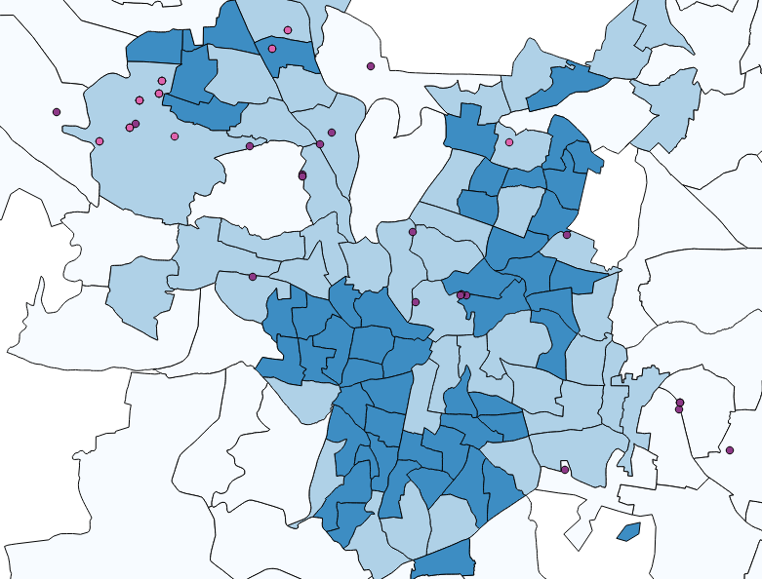
Existing malls are in violet and open space points are in pink

- We have used the Stochastic Model here, because suppose the whole city is full of malls, then there will be no suitable space left for the mall, hence deterministic model will rank the filtered points from Commercial Model to get ranked results

After all the models were applied, we combined the result from the Road Network Model and the Commercial Space Model and after all the above is done we can sum the ranks. The model with the least cumilative rank is the final result of the points that are suitable to set up a mall by our model.

Challenges Faced

- Each model is either classified as deterministic or stochastic. There were doubts in deciding what modelling category to give to each model.

- Population density map does not have continuous density variation. Therefore, we are working with the assumption that the population density of the entire ward is constant throughout the area of the ward. The same can be said about the commercial spaces map. Raster map with each pixel categorized would have been a better solutions in both the cases mentioned above.

- The assumption that a 12m road width gives us better accessibility may not be always correct.

