Assignment-1

Installed Minikube

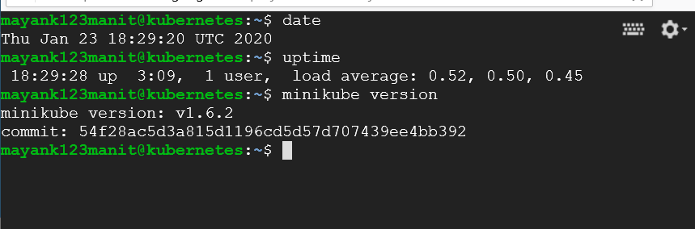

Download the sample.war file using wget

Created the dockerfile with COPY command to wrap the sample.war file. Dockerfile in repo.

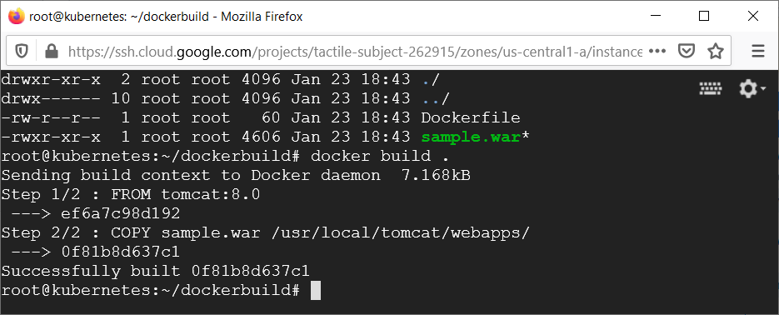

root@kubernetes:~/dockerbuild# docker tag 0f81b8d637c1 mayank123/tomcat:8.0

root@kubernetes:~/dockerbuild# docker login

fed my dockerhub credentials.

root@kubernetes:~/dockerbuild# docker push mayank123/tomcat

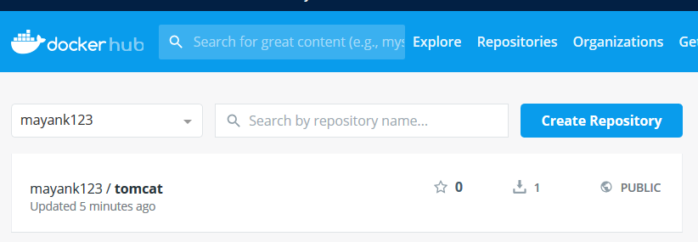

Created a namespace called assignment on the minikube cluster.

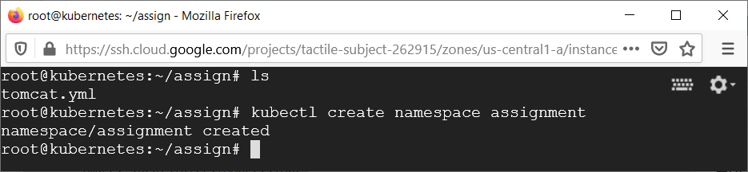

Created the deployment and service for tomcat.

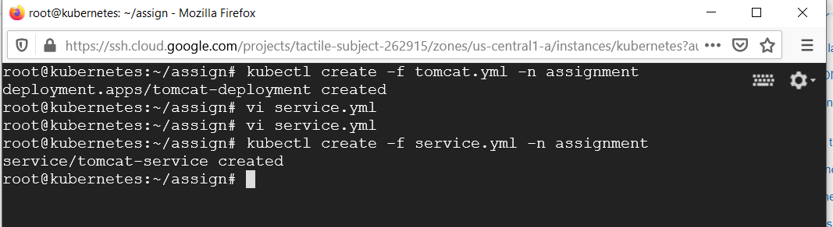

Service exposed.

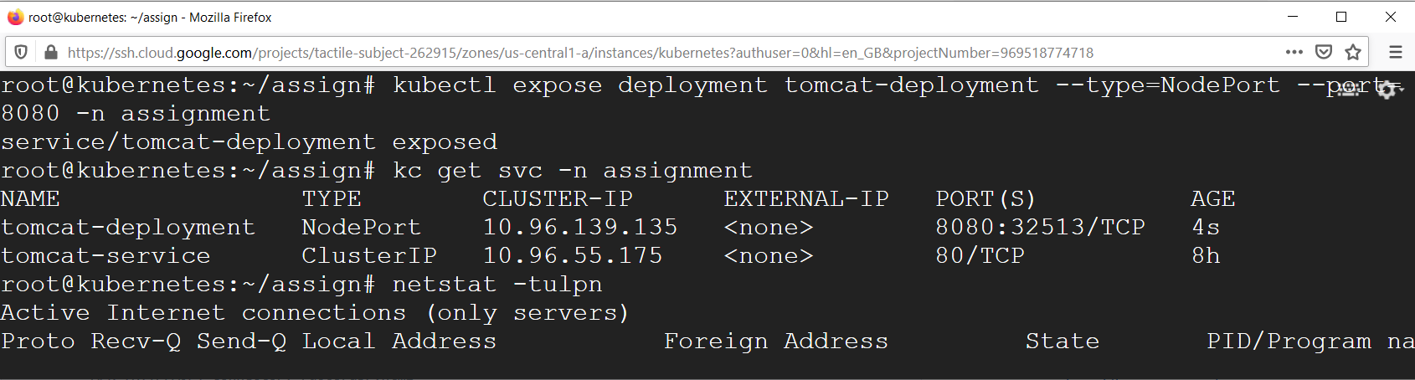

root@kubernetes:~/assign# kubectl expose deployment tomcat-deployment --type=NodePort --port=8080 -n assignment

Access Hello World with external IP of the VM and port 32513.

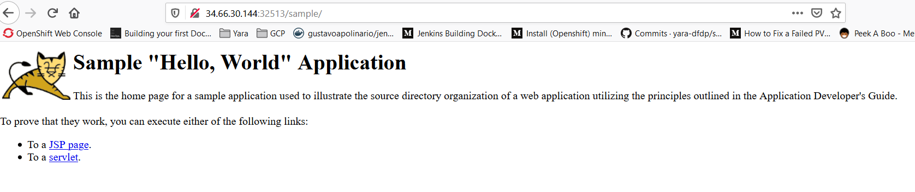

Nginx Task

Created DockerFile. Attached in repo. Also created index.html.Used “assign” namespace in minikube for nginx task.

Pushed the image to Dockerhub.

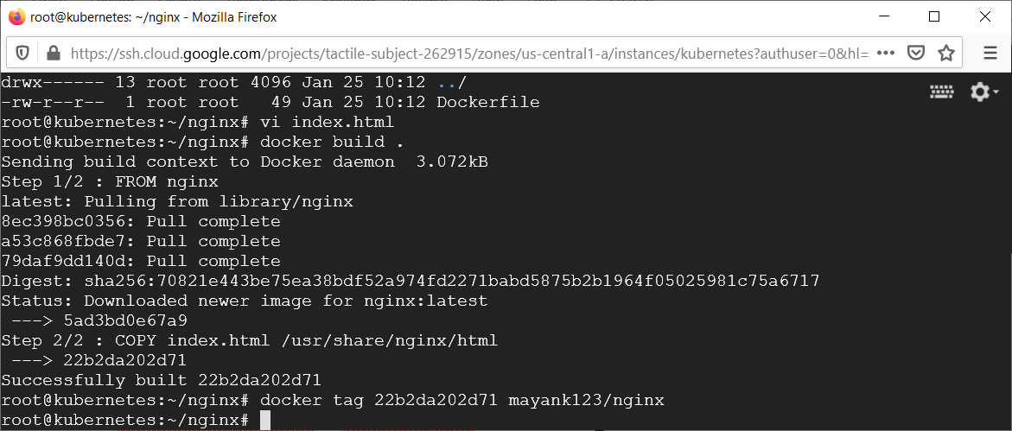

Created deployment and service for nginx.

Exposed the service.

root@kubernetes:~/assign# kubectl expose deployment nginx-deploy --type=LoadBalancer --port=80 -n assign

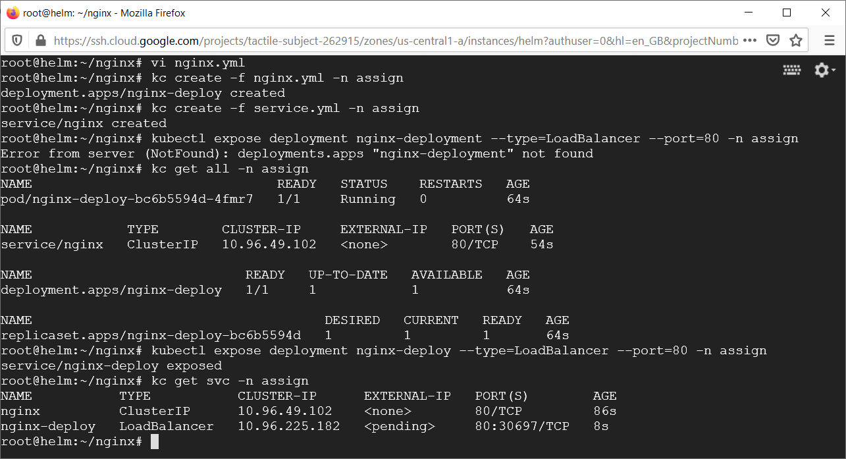

Access Hello World with external IP of the VM and port 30697.

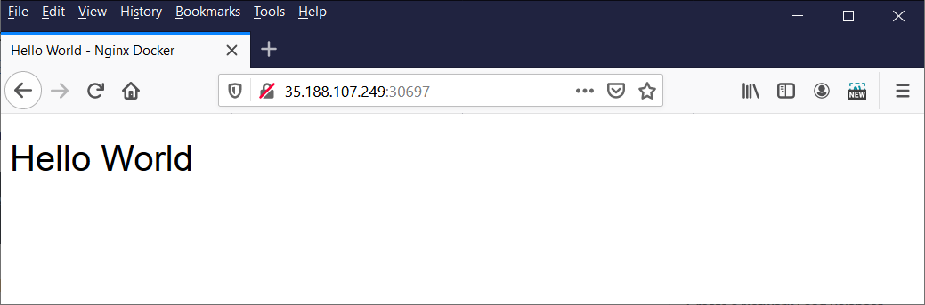

Terraform Task:

Defining the following resources in the vpc.tf

1. VPC
2. Subnet inside VPC
3. Internet gateway associated with VPC
4. Route Table inside VPC with a route that directs internet-bound traffic to the internet gateway
5. Route table association with our subnet to make it a public subnet
6. Security group inside VPC
7. EC2 instance inside our public subnet with an associated security group.
8. Used AMI image ID: ami-42a2532b which is Centos based Free Tier EC2 CentOS 5.5 GPU HVM AMI

Commands used:

terraform init : Initialize a Terraform working directory

terraform plan -out vpc.plan: Generate and show an execution plan

terraform apply vpc.plan: Build the VPC and EC2 instance with required AMI image.

terraform destroy : Destroy Terraform-managed infrastructure

Variables are read from variables.tf file. terraform.tfstate is also attached for reference.