OPERATING SYSTEMS PRACTICALS

RAMANUJAN COLLEGE, DELHI UNIVERSITY

Submitted to : Mr. Nikhil Rajput

Submitted by : Mr. Mayank Kharab

College Roll No. : 20201437

University Roll No. : 20020570021

Semester : 3rd

Year : 2nd

Course : B.Sc. Hons. CS

Q1. Implement SRTF. Compute waiting time and turnaround time.

Description:

This is the preemptive version of SJF scheduling. In SRTF, the execution of the process can be stopped after certain amount of time. At the arrival of every process, the short term scheduler schedules the process with the least remaining burst time among the list of available processes and the running process.

Once all the processes are available in the ready queue, No preemption will be done and the algorithm will work as SJF scheduling. The context of the process is saved in the Process Control Block when the process is removed from the execution and the next process is scheduled. This PCB is accessed on the next execution of this process.

**Output: -**

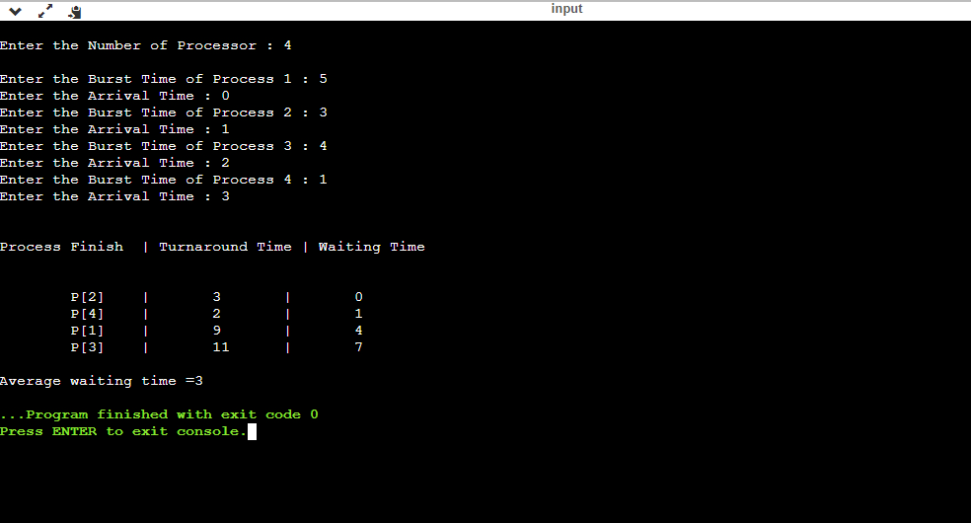

Gantt chart: -

|  |  |  |  |  |
| --- | --- | --- | --- | --- |
| P1 | P2 | P4 | P1 | P3 |

0 1 4 5 9 13

Q2. Write a program to demonstrate fork where parent and child run same codes and child process should run first.

Description:

In the code, a child process is created. fork() returns 0 in the child process and positive integer in the parent process.

Here, two outputs are possible because the parent process and child process are running concurrently. So we don’t know whether the OS will first give control to the parent process or the child process.

Parent process and child process are running the same program, but it does not mean they are identical. OS allocate different data and states for these two processes, and the control flow of these processes can be different.

**Output: -**

