Lesson 1:- JavaScript Basics (Exercise)
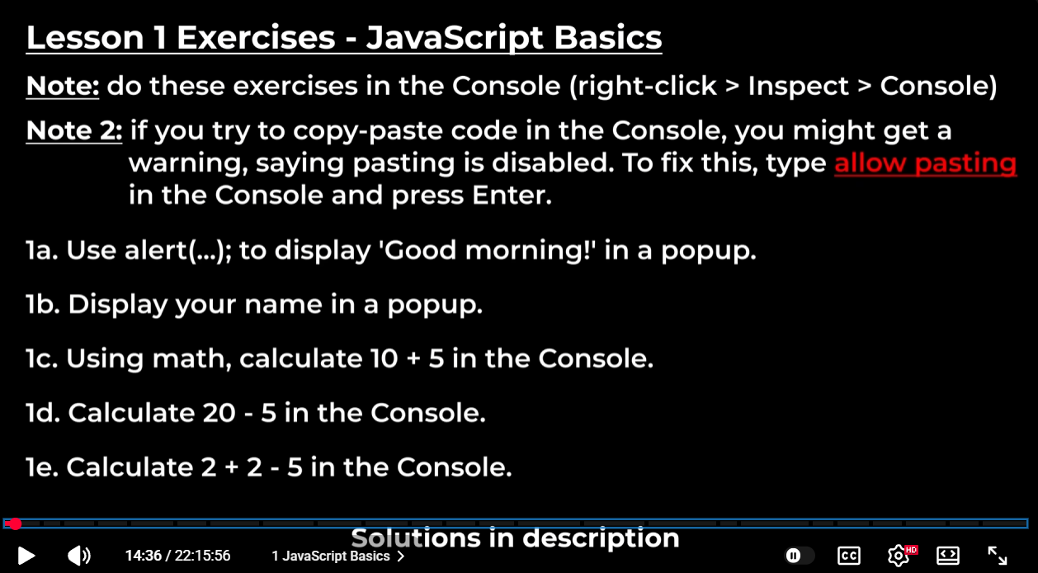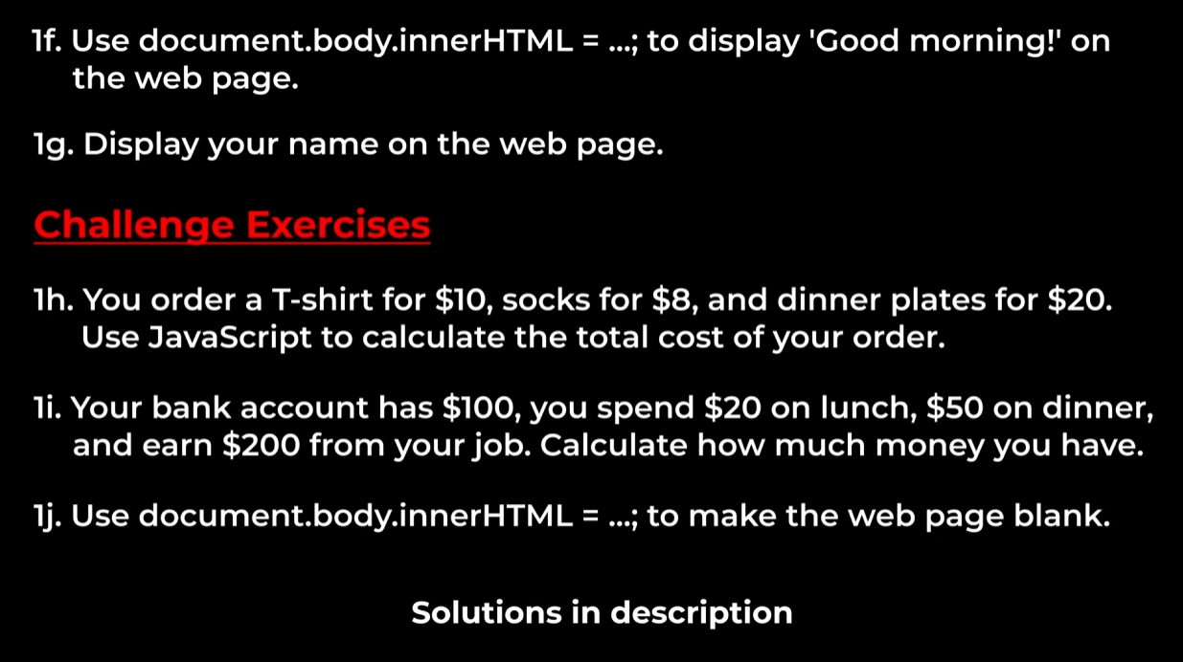

Sol_1a:- alert(’Good Morning’);
Sol_1b:- alert(’Mayank Singh’);
Sol_1c:- console.log(10+5);
Sol_1d:- console.log(20-5);
Sol_1e:- console.log(2+2-5);
Sol_1f:- document.body.innerHTML(’Good Morning’);
Sol_1h:- const Tshirt = 10;
const socks = 8;
const plate = 20;
let total = Tshirt+socks+plate;
console.log(total);
Sol_1i:- console.log(100+200-20-50);
Sol_1j:- document.body.innerHTML = “ ”;

