LESSON_2:- Numbers and Maths
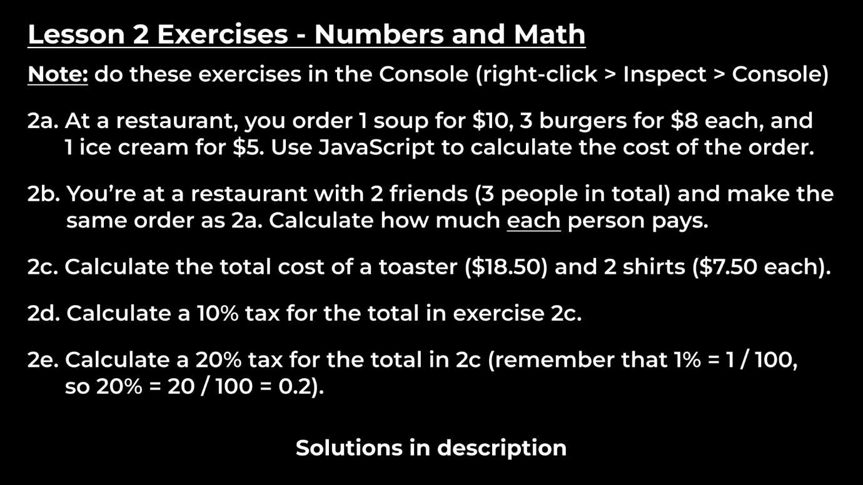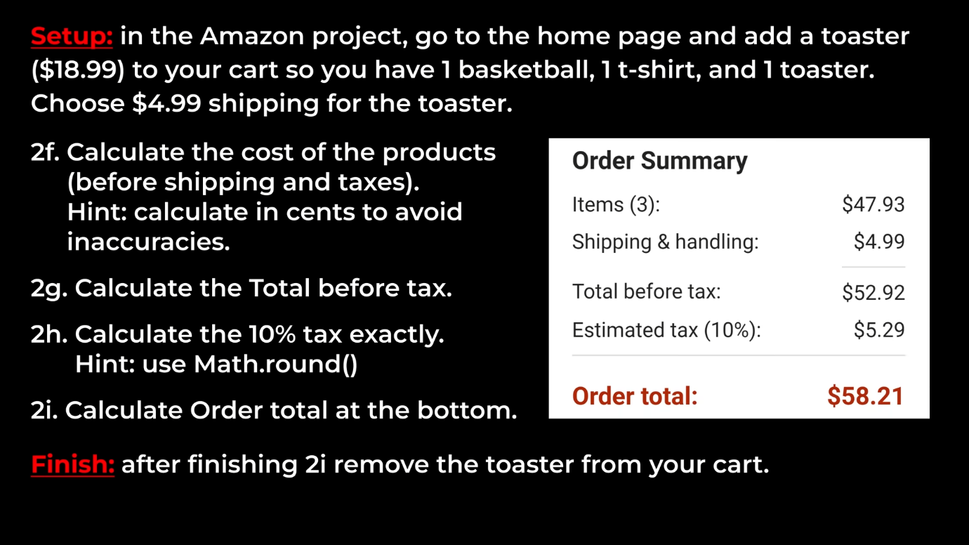
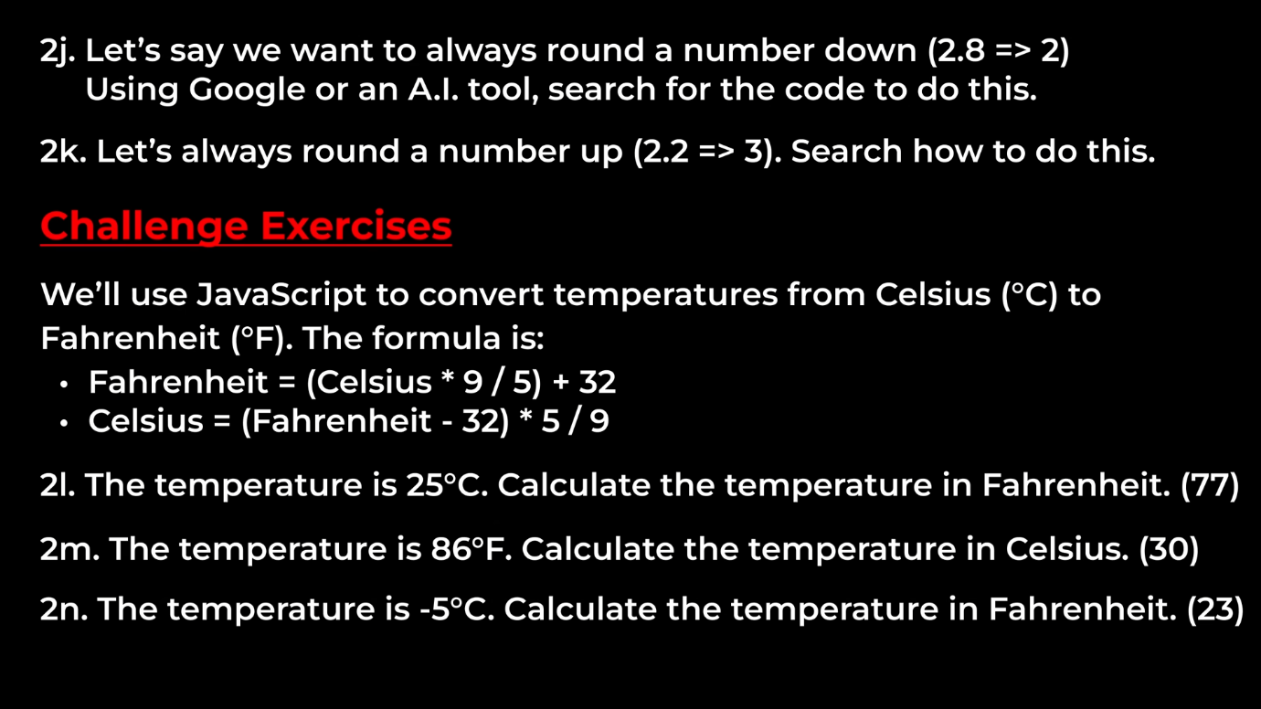
Sol_2a:- const soup = 10;
const burger = 3;
const ice_cream = 5;
let total = soup+burger+ice_cream;
console.log(total);

Sol_2b:- total = (total/3);
console.log(total);
Sol_2c:- let total = (18.50 + (7.50*2));
console.log(total);
Sol_2d:- console.log(total*01);
Sol_2e:- console.log(total*0.2);
Sol_2f:- 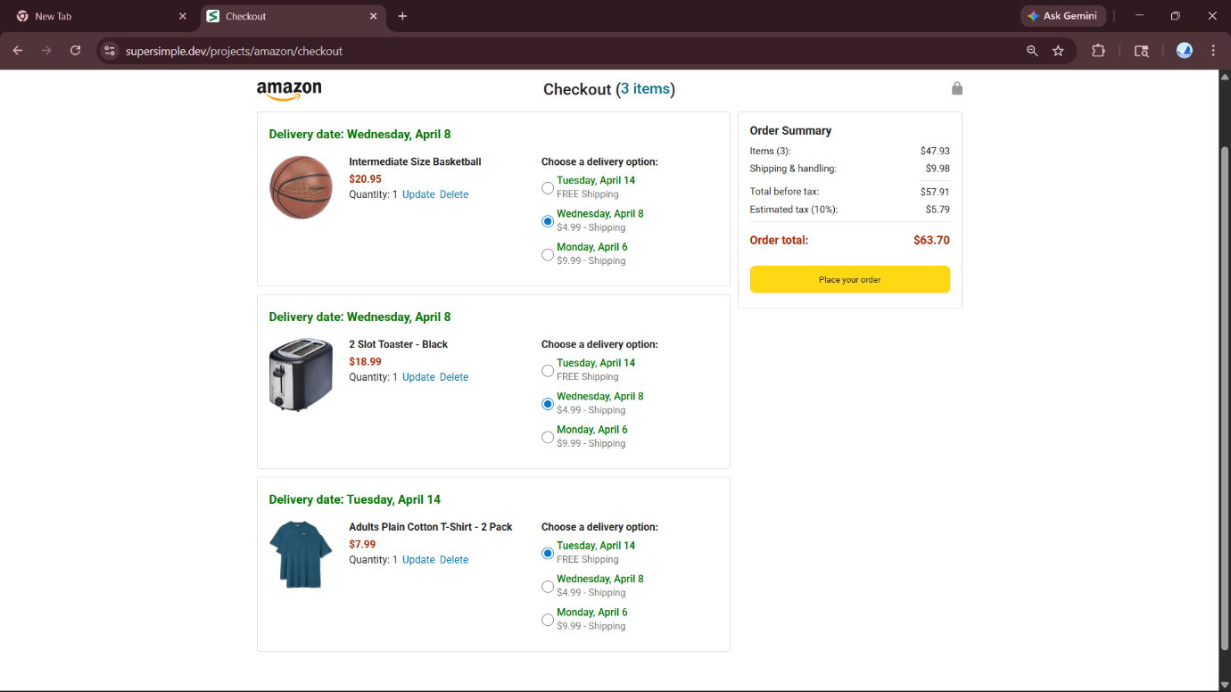
console.log(20.95+18.99+7.99);
Sol_2g;- console.log(2095+1899+799+998)/100;
Sol_2h:- console.log(Math.round(57.91*0.1);
Sol_2i:- console.log(47.93+9.98+5.79);
Sol_2j:- Math.floor(2.8);
Sol_2k:- Math.ceil(2.8);
Sol_2l:- let t1 = (25*9/5) + 32;
console.log(t1);
Sol_2m:- let t2 = (86-32) * 5 / 9;
Sol_2n:- let t3 = (-5*9/5) + 32;

