LESSON_3 – Strings (Notes)
- Ways to create string in JS:-
- ‘……’ -> single quotes
- “…..” -> double quotes.
- `…..` -> template string (by using backtick) -> it helps in interpolation (`${ }`). It also allow to create multi line string.
- typeof:- tells the type of input data.
- ’hello’ + 3;
‘hello3’ -> this is because of type coercion.
EXERCISE
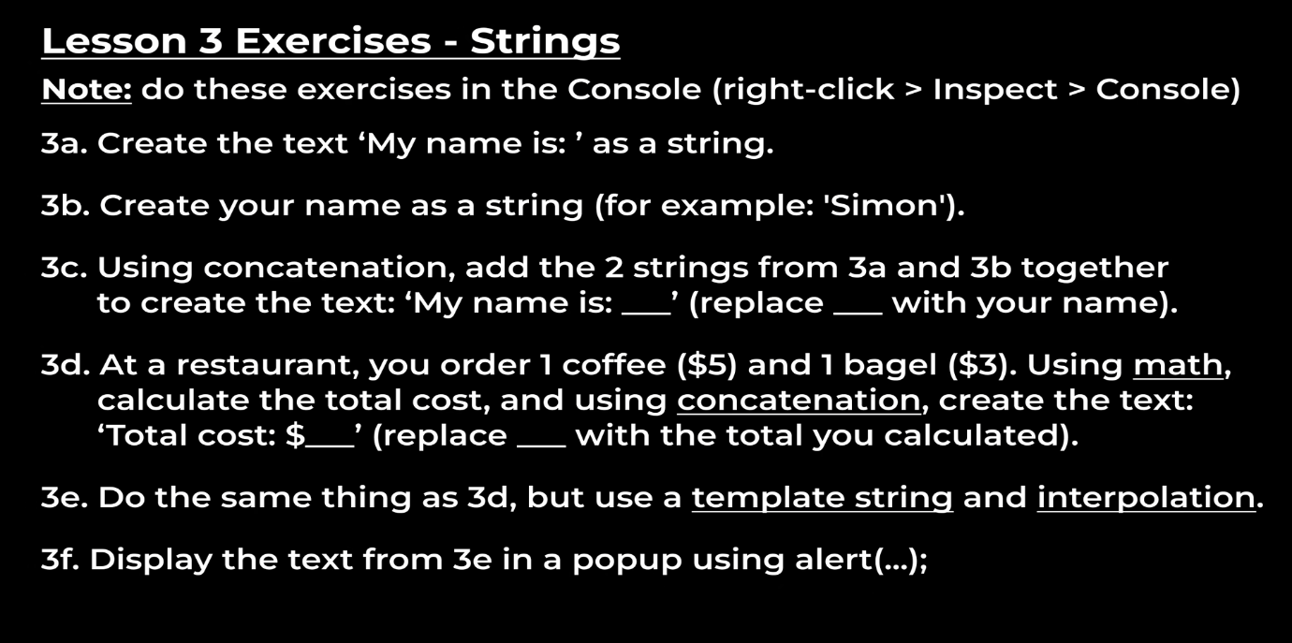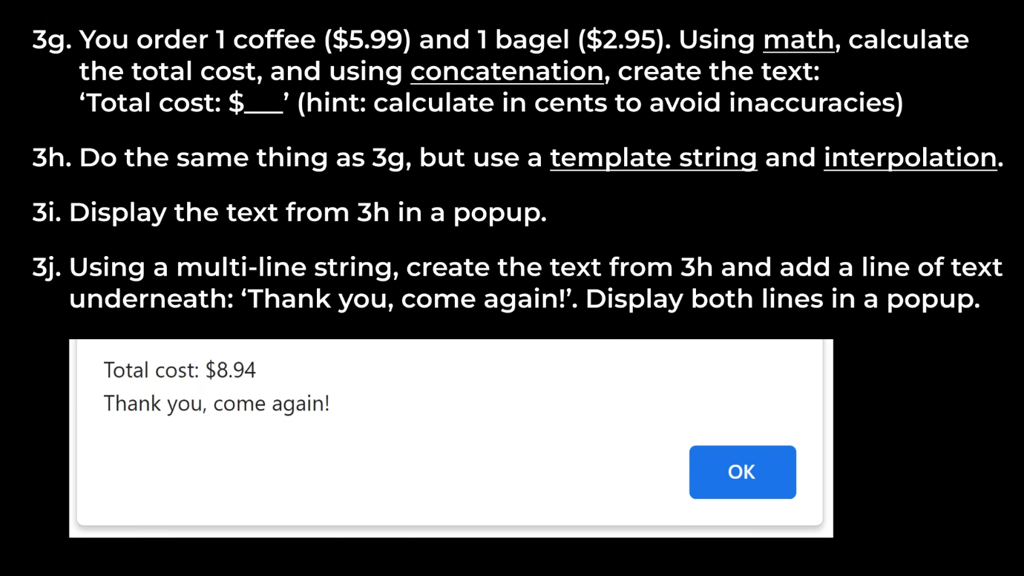
Sol_3a:- string s1 = ‘My name is’;
Sol_3b:- string s2 = ‘Mayank Singh’;
Sol_3c:- console.log(string1 + ‘ ’ + string2);
Sol_3(d&e):- const coffee = 5;
const bagel = 3;
let total = (coffee + bagel);
console.log(`Total cost: $${total}’);
Sol_3f:- alert(`Total cost: $${total}’);
Sol_3(g&h):- const coffee = 5.99;
const bagel = 2.95;
let total = (coffee + bagel);
console.log(`Total cost: $${total}’);
Sol_3i:- alert(`Total cost: $${total}’);
Sol_3j:-alert(`Total cost: $${total}\n Thank you, come again!`);

