LESSON 5:- Variables
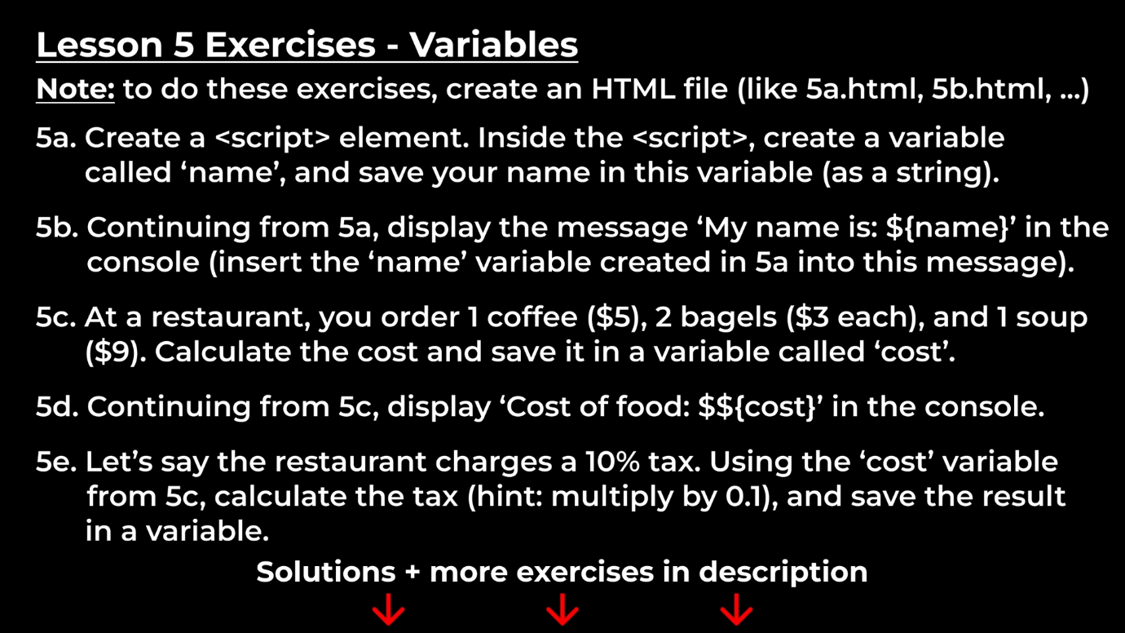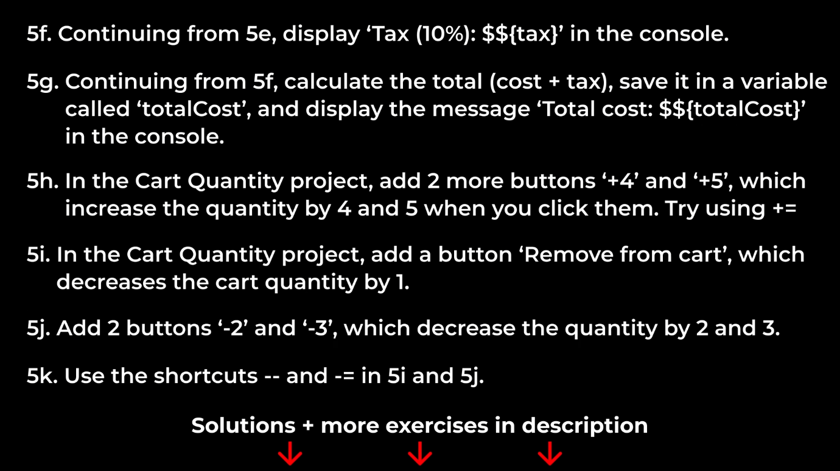
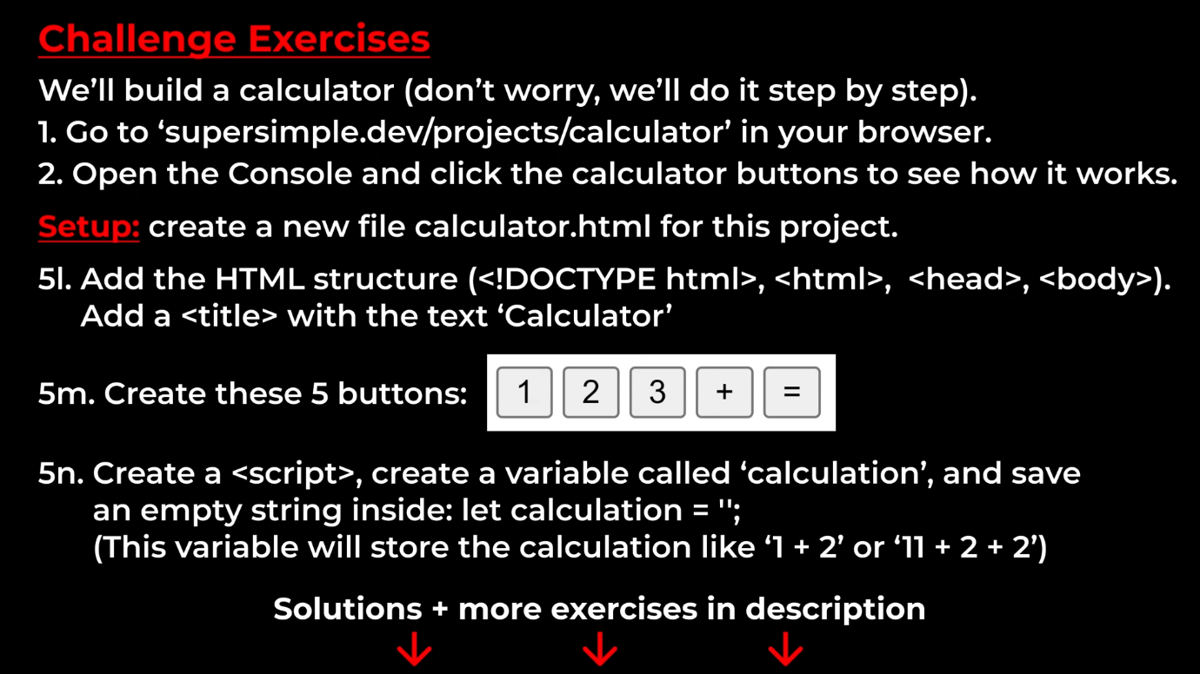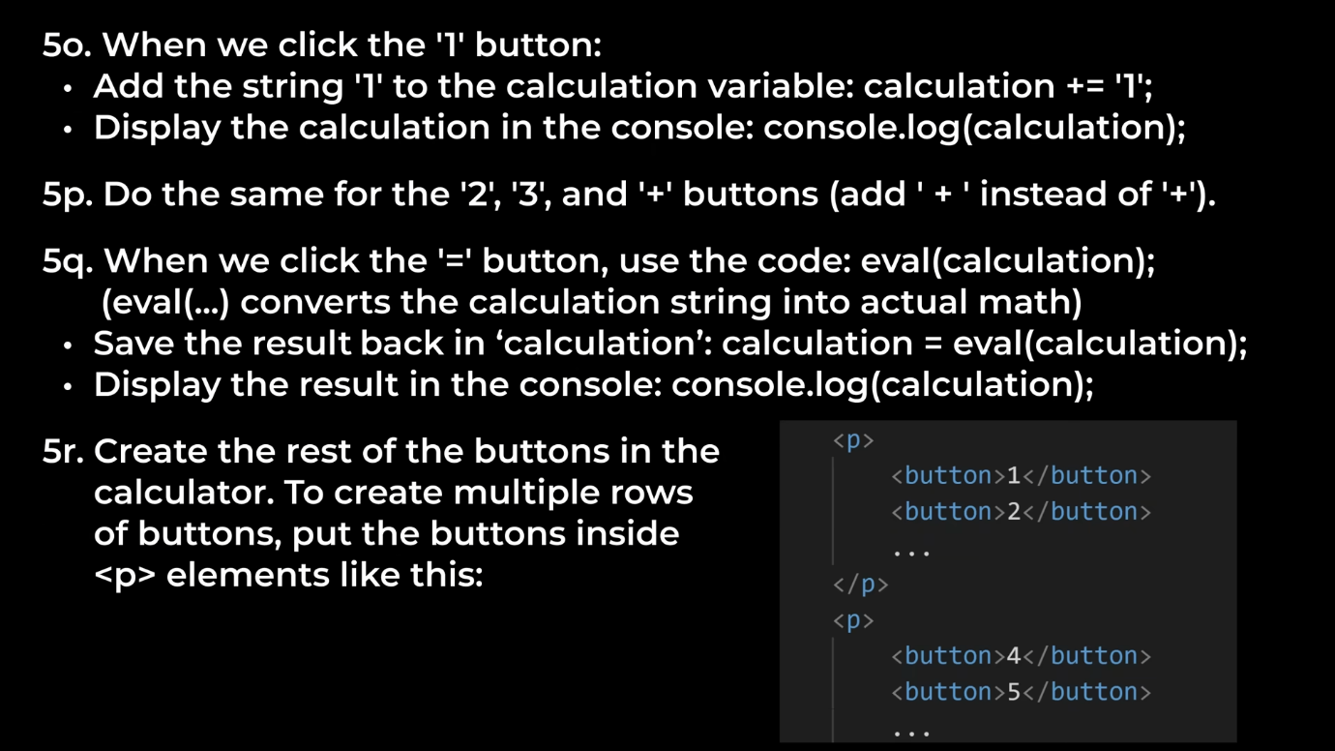

Sol_5(a&b):- <script>
let name = ‘Mayank Singh’;
console.log(`My name is ${name}`);
</script>

Sol_5(c to g):- <script>
const coffee = 5;
const bagel = 3;
const soup = 9;
let cost = (5 + (3*2) + 9);
console.log(`Cost of food: $${cost}`);
let tax = cost*0.1;
console.log(`Tax 10%: $${tax}`);
let totalCost = cost + tax;
console.log(`TotalCost: $${totalCost}`);
</script>

For the rest of the exercise I have uploded the project(i.e – Cart Quantity and Calculator).

