**IC-201P Design Practicum**

**GROUP-34**

**Development of Lab Scale Flume to Study Dynamics of Debris Flow**

**Group Members:**

|  |  |
| --- | --- |
| Aditya Kumar | B22029 |
| Sravya Kumbha | B22112 |
| R. Lohit Vardhan | B22122 |
| Om Litoriya | B22226 |
| Mayank Goel | B22306 |
| Ritik Kumar | B22316 |

**Faculty Mentors Student Mentor**

Dr. Mousumi Mukherjee GovindKant Misra

Dr. K.V. Uday

**MOTIVATION AND INTRODUCTION**

Debris flow is a natural process characterized by the rapid movement of a mixture of water, sediment, and organic material down steep slopes, typically occurring in mountainous regions with loose soil and steep gradients.

The velocity of debris flows can range from slow-moving slurries to rapidly flowing torrents, influenced by factors such as slope gradient, rainfall intensity, and sediment concentration. Intense rainfall events, snowmelt, or rapid thawing of glaciers can trigger debris flows by saturating the soil and mobilizing loose sediment, posing a significant risk, especially with increasing frequency and severity of extreme weather events due to climate change.

We are embarking on a project to construct a small-scale version of a flume in a laboratory. This setup will enable us to study the behaviour of debris flows, which is crucial for understanding and managing these natural hazards.

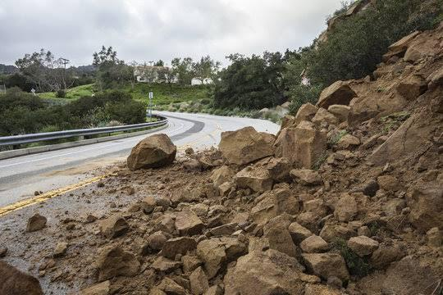

Our project aims to replicate key aspects of debris flow dynamics through the design and construction of a flume experimental setup. By studying factors such as flow behaviour, flow height, and planar velocity, we hope to develop early warning systems, effective mitigation measures, and inform land use planning decisions in debris flow-prone areas to improve hazard mapping, emergency preparedness, and infrastructure resilience.

Our objective is to deepen our understanding of debris flow dynamics and contribute to future research efforts in finding effective solutions to mitigate landslides.

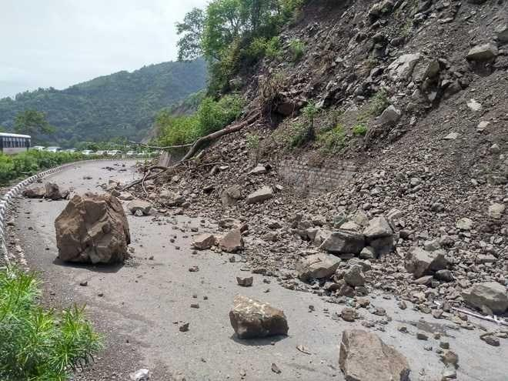

**EXPERIMENTAL SETUP**

The experimental setup comprises several key components designed to facilitate comprehensive data collection and analysis:

Flume and Flume Stand: The flume is supported by a specially designed flume stand that allows for the adjustment of inclination angles. This feature enables precise control over the slope of the flume, which is crucial for studying flow dynamics under varying conditions. Additionally, the inclusion of wheels on the flume stand enhances mobility, making it easier to position the flume for experiments and research activities.

Gate Mechanism: The flume is equipped with two gates strategically placed to regulate the flow of materials. These gates are securely held in place by grooves integrated into the flume structure, ensuring stability during experiments involving different flow rates and conditions.

Pulley Stand for Gate Lifting: A pulley stand is incorporated into the setup to provide an efficient mechanism for lifting and adjusting the gates. This mechanism not only streamlines the process of controlling flow but also enhances the accuracy and repeatability of experiments by enabling precise gate positioning.

Ring Light and Camera Setup: To capture detailed data for analysis, a cost-effective ring light is utilized in conjunction with a high-resolution camera. The ring light serves as a backlighting source, during video recording of the flow processes within the flume. The camera records high-quality videos that are segmented into individual frames or photos, facilitating data analysis for computing velocity profiles and other relevant parameters.

|  |
| --- |
| picture of experimental setup |

**DESIGN OF PULLEY STAND**

The initial design considerations, challenges faced, and the final optimized design are discussed below in detail.

**Initial Design Considerations:**

Tripod Pulley Stand: The initial concept was to construct a pulley stand resembling a tripod, with sufficient height to accommodate the gate mechanism. This design was chosen for its simplicity and ease of construction, providing a basic support structure for the gate.

Challenges Encountered

* Instability: Upon further analysis, it was identified that a tripod design might lead to instability when lifting the gate with a significant amount of force.
* Reasoning: The limited contact points with the ground in a tripod stand could result in wobbling or tipping when subjected to force during gate lifting.

**Revised Design Approach:**

Horizontal Rod with Vertical Supports: To address the instability issue, the design approach was revised to incorporate a horizontal rod supported by two vertical rods, forming an 'L' shape.This configuration aimed to provide better stability by distributing the force vertically along the two support rods.

**Further Enhancements:**

Adding Perpendicular Support Rods: Despite the improvement in stability, concerns remained about lateral forces exerted on the gate during lifting. The addition of two perpendicular rods (along the z-axis) further reinforced the structure, minimizing lateral movement and ensuring smoother gate operation.

Increased Vertical Support: To enhance overall stability and load-bearing capacity, the number of vertical support rods was increased from two to four. This adjustment was crucial in distributing the load evenly and preventing any structural deformation or failure during gate operation.

**Final Design Description:**

The optimized pulley stand design comprises:

* A horizontal rod (along the x-axis) supported by two perpendicular rods (along the z-axis), forming a stable 'T' shape.
* Four vertical rods provide robust support and ensure structural integrity by adding a rectangular frame of 4 rods at bottom to support vertical rods.
* A rope and pulley system integrated with the gate mechanism for controlled lifting and release of debris flow.

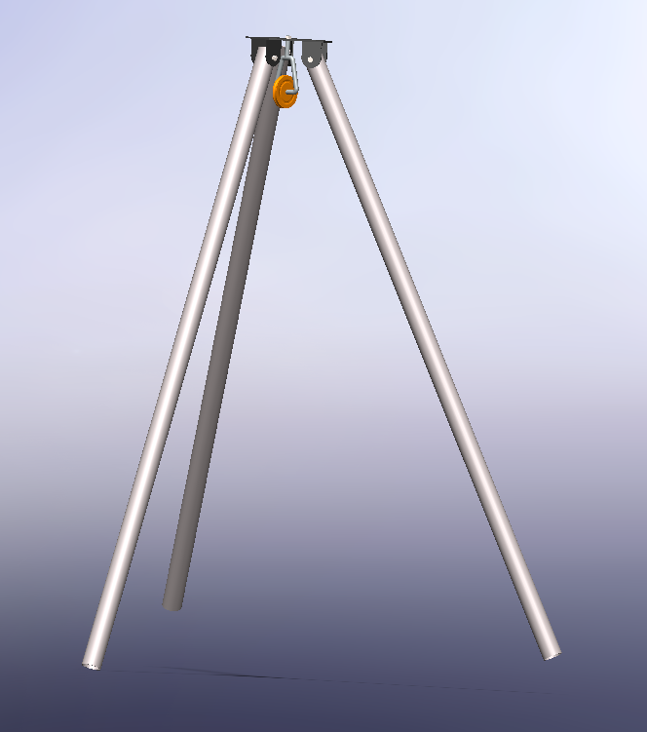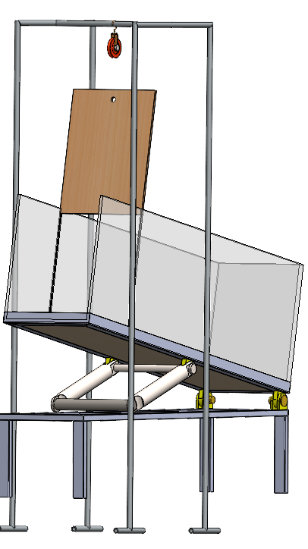

*Initial structural consideration of pulley stand     CAD model of finalized experimental setup*

**FABRICATION OF PULLEY STAND**

Design Specifications:

Length of Vertical Iron Rods: 1.3 meters

Distance Between Two Pairs of Vertical Iron Rods (along y-axis) and Length of Horizontal Iron Rod (along x-axis): 0.8 meters

Length of Two Perpendicular Iron Rods (along z-axis) and Distance Between Two Other Pairs of Vertical Rods: 0.5 meters

Materials Used:

* Iron rods:

Vertical rods: 1.3m x 4 (Quantity)

Horizontal rod: 0.8m x 1 (Quantity)

Perpendicular rods: 0.5m x 2 (Quantity)

* Pulleys and rope suitable for the load requirements.
* Welding electrodes compatible with iron welding.
* Protective coating or paint for finishing.

Fabrication Steps:

Preparation:

Verified design specifications and gathered required materials and tools.

Metal Cutting:

Cut the iron rods to the following lengths:

Vertical rods: 1.3m each x 4

Horizontal rod: 0.8m

Perpendicular rods: 0.5m each x 2

Welding Assembly:

Perpendicular rods were welded at the midpoint of the horizontal rod (0.4m from centre).

Welded the two perpendicular rods onto the horizontal rod to form the 'T' shape.

Welded the vertical support rods at the ends of the perpendicular rods:

Vertical rods were evenly spaced with a distance of 0.8m between two pairs.

Pulley System Installation:

Installed pulley on the horizontal rod at a suitable position (centre) for smooth rope movement.

Threaded the rope through the pulley and attached it to the gate mechanism.

Quality Check and Finishing:

Inspected welded joints for strength and stability, ensuring proper penetration and absence of defects. Applied a protective coating or paint to the fabricated pulley stand for corrosion resistance and aesthetic appeal.

Testing and Calibration:

Tested the pulley stand by lifting and lowering the gate mechanism with varying loads to ensure functionality and stability. Calibrated the pulley system to optimize rope tension for smooth operation.

Summary:

Design specifications were adhered to, with precise measurements and weld placements. Welding techniques such as fillet welds were used for strong and durable joints. Pulley system installation and rope threading were done accurately to enable controlled gate lifting. Quality checks were performed to ensure structural integrity and safety. The finished pulley stand underwent testing and calibration to verify performance under operational conditions.

|  |  |
| --- | --- |
| *picture of pulley stand* | *illustration of flume,flume stand and pulley stand* |

**CONSTRUCTION OF FLUME STAND**

Specifications:

* Length of 4 support rods above the ground: 0.3m.
* Length of rectangular base: 2m.
* Width of rectangular base: 0.4m (0.5 square meter area left open for debris collection).
* Rectangular base divided into four sections, each 0.375m long.
* Solid base for the flume: 1.5m length, 0.4m width.
* Vertical square frame attached to the solid base at 0.75m from one end.
* Length of stoppers attached to solid base:0.1m
* Wheels to facilitate the movement.
* Vertical square frame supports the flume and allows for changing the inclination angle.
* Vertical square frame supported by four divisions of the bottom rectangular frame.

Manufacturing Steps:

1. Construct the rectangular base with the specified dimensions and divisions.
2. Weld the vertical support rods to the rectangular base and fix wheels at the bottom of the stand.
3. Build the solid base for the flume with the vertical square frame attached at the designated distance.
4. Ensure that the vertical square frame is sturdy and allows for easy adjustment of the inclination angle.
5. Fix the edge of the solid base to the bottom rectangular frame and stoppers for additional support.
6. Test the flume stand for stability and functionality, adjusting the inclination angles to ensure smooth operation.

This setup allows for precise control over the inclination angles of the flume, essential for controlled experimentation and simulation in debris flow analysis.

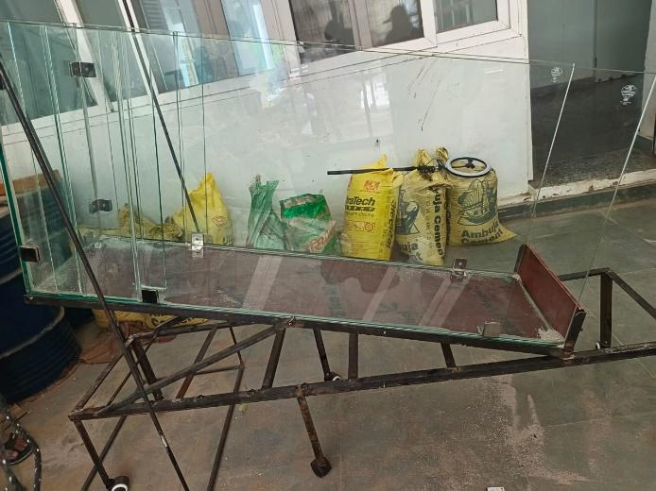

*picture of flume when inclined CAD model of flume stand*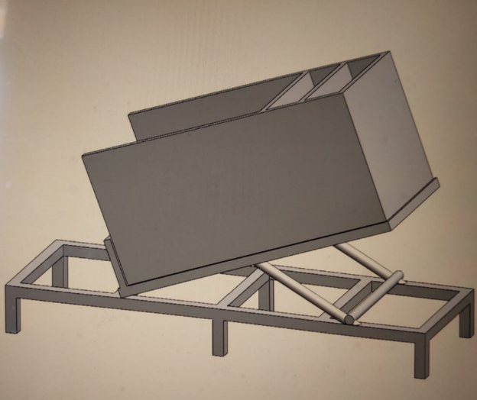

**MANUFACTURE OF LAB SCALE FLUME**

Material Procurement and Preparation:

* Toughened glass sheets with a thickness of 10mm were acquired, meeting the required dimensions for the flume (1.5m length, 0.4m width).
* L Holders for joining the toughened glass walls with the base were purchased.
* Silicone sealing material suitable for creating an airtight seal was obtained.

Cutting and Shaping Glass:

* Precision cutting tools were used to cut the toughened glass sheets to the specified dimensions for the flume (1.5m length, 0.4m width).
* Additional pieces were cut for the side walls to a height of 0.7m.

Assembling the Flume:

* L Holders were attached to the base of the flume at regular intervals along the length and width, ensuring they were securely fixed.
* The toughened glass sheets were placed upright on the base, following the flume's design (rectangular shape with a height of 0.7m).

Joining the Walls:

* Silicone sealing was applied along the edges of the toughened glass sheets to create an airtight seal between the walls and the base.
* The glass sheets were pressed firmly onto the silicone to ensure a strong bond and seal.

Installing Grooves for Gates:

* Precision cutting tools were used to create grooves in the glass walls at specified distances from one end (0.15m and 0.3m) to hold the gates.
* The grooves were ensured to be smooth and precise to accommodate the gates without any obstruction.

Quality Check and Testing:

* A thorough quality check of the assembled flume was conducted, inspecting for any leaks or weak joints.
* The flume was tested by pouring a small amount of sand to ensure it was airtight and functioned as intended.
* The gates were verified to fit properly into the grooves and could be opened and closed without issues.

Finalizing:

* Once the flume passed quality checks and testing, the construction was finalized by securing all components and making necessary adjustments.

Following these detailed steps, our team successfully manufactured a flume for debris flow analysis that met all design specifications and quality standards.

**EXPERIMENTATION**

The experimentation phase comprised four distinct sets of experiments, each designed to explore specific configurations and parameters related to the flow of fine sand and coarse sand within the flume setup.

Fine Sand - 0.15m Gate:

Aspect Ratios Tested: 0.5, 1.5, 2, 3

Fine Sand - 0.30m Gate:

Aspect Ratios Tested: 0.5, 1, 1.5

Coarse Sand - 0.15m Gate:

Aspect Ratios Tested: 0.5, 1.5, 2, 3

Coarse Sand - 0.30m Gate:

Aspect Ratios Tested: 0.5, 1, 1.5

Experimental Configurations:

Fine Sand vs. Coarse Sand: A comparative analysis was conducted between the flow behaviours of fine sand and coarse sand, exploring how particle size influences flow dynamics.

Gate Position Variation: Two different gate positions, 0.15m and 0.30m from the closed end of the flume, were utilized to assess the impact of gate placement on flow characteristics.

Aspect Ratio Variations: Each set of experiments involved testing with varying aspect ratios to capture a range of flow conditions and geometric configurations.

Precaution:

Throughout the experiments, a consistent setup was maintained, including uniform lighting conditions, camera positioning, ensuring reliable and comparable data across all sets of experiments.

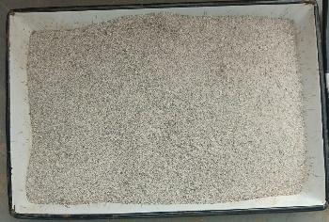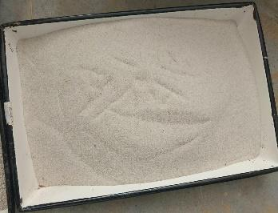

*Coarse sand Fine sand* 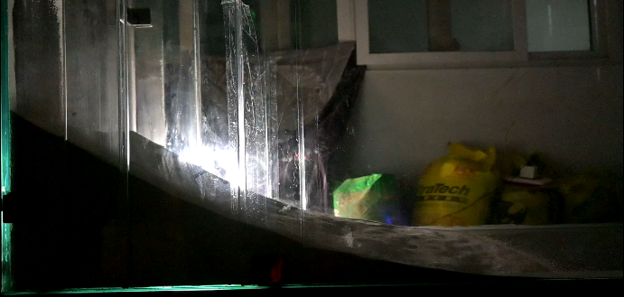

*resultant of fine sand, aspect ratio=3*

**IMAGE PROCESSING**

Camera Setup for Particle Analysis in the Flume:

* To capture clear images of the particles in the flume, a camera will be mounted on a stand to ensure stability and prevent any movement during photography.
* This stationary setup allows for precise focusing on specific areas of the flume without any disturbances, enabling detailed analysis of particle movements.
* Maintaining the camera in a fixed position is essential for accurate examination and interpretation of sediment transport dynamics within the flume, offering valuable insights into erosion processes and flow behaviour.

Utilizing Backlighting Technique for Analysis:

* The backlighting technique will be employed to determine the speed of sand movement and the height of sand accumulation in targeted areas.
* A ring light will be positioned behind the flume structure,while the camera will be situated on the opposite side.
* Prior to sand introduction, a reference image of the empty flume alongside a 30-centimeter ruler will be captured to establish the spatial calibration of the subsequent images.
* Analysing the number of zero-intensity pixels due to the ruler obstruction will aid in determining the pixels per meter, facilitating precise measurements during analysis.

Methodology for Soil Movement Study:

* Video recording will be conducted while soil is flowing through the flume, documenting every stage of movement.
* The recorded video will then be segmented into individual frames for thorough examination of soil behaviour over time.
* By tracking changes in soil height and velocity across frames, the progression and speed of soil movement can be meticulously analysed.

Analysis of Brightness Changes for Speed Calculation:

* Brightness variations in pixels of each frame will be examined to ascertain the distance travelled by the soil and its velocity.
* The time interval between frames, typically around 1/60th of a second with a recording rate of 60 frames per second, will be utilized to calculate the speed of the soil movement accurately.

Comprehensive Experimentation for Insights:

* Multiple repetitions of the experiment will be conducted across various sections of the 1.5-meter-long flume to encompass the entire length and observe soil flow dynamics comprehensively.
* Different types of soil with varying textures, particle sizes, and compositions will be utilized to observe how these factors influence soil behaviour within the flume.

**RESULTS**

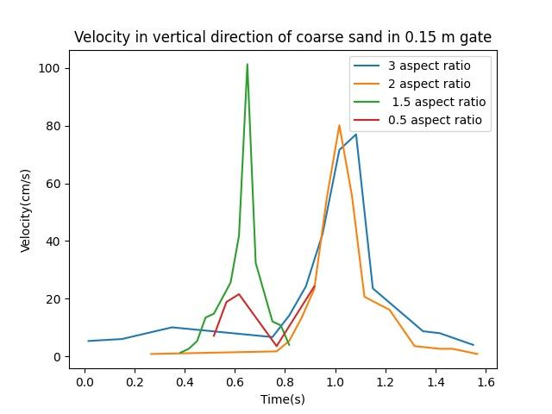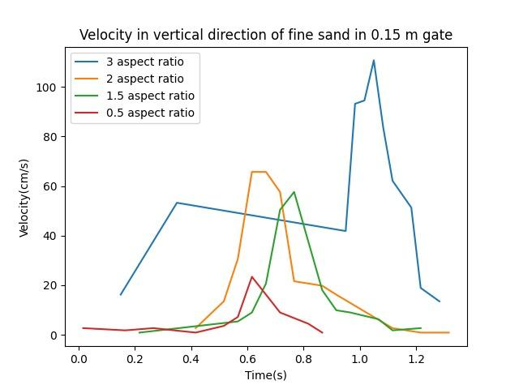

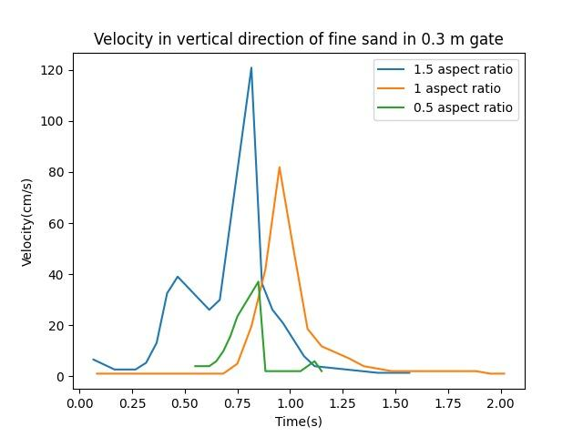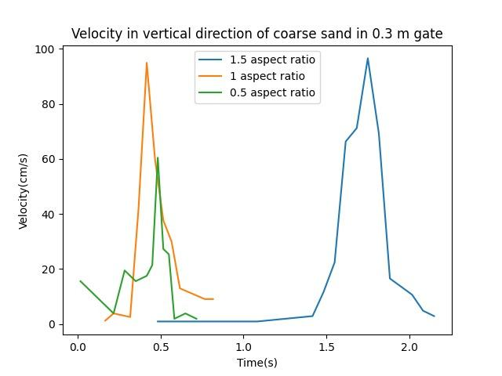

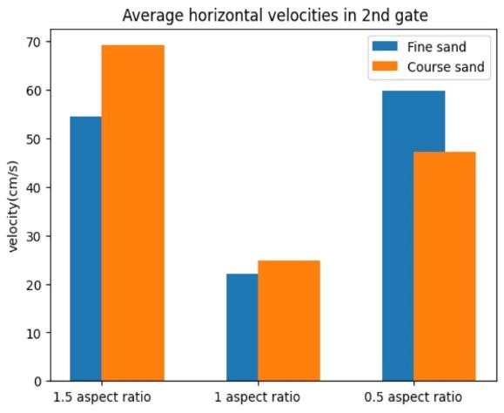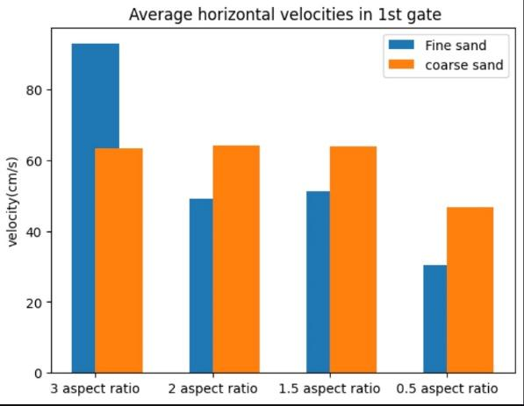

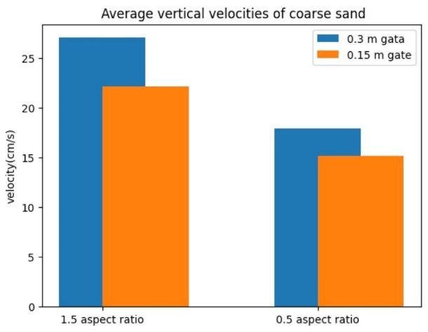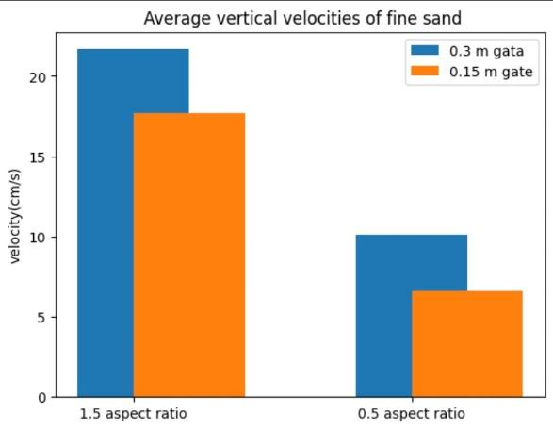

**OBSERVATIONS**

* There is a noticeable trend of increase in vertical velocity of fine sand and coarse sand initially, attains a peak point and then decreases.
* The peak values obtained from experiments with fine sand increase with increase in aspect ratio.
* From the results of experiments, it can be observed that average vertical velocities increase with increase in aspect ratios.
* Average velocity of sand when experiment is done with the groove at 0.3m is higher than that obtained from experiments done with 0.15m grooved gate.
* We can also observe that average horizontal velocities of sand from 0.15m gate had less change with varying aspect ratio than that of sand released from 0.3m gate.
* It can also be observed that vertical and horizontal velocities of fine sand were greater than that of coarse sand.

**ADVANTAGES**

Our lab-scale flume setup for studying debris flow dynamics provides distinct advantages.

* By scaling down natural phenomena, we can accurately simulate various scenarios, controlling variables like flow rate and sediment size. This precision allows for in-depth analysis and understanding of debris flow behaviour.
* Additionally, the cost-effectiveness of lab-scale experiments enables us to conduct a higher number of tests, facilitating rapid iteration and exploration of diverse conditions.
* The reproducibility of results in a controlled environment enhances the reliability of our findings.
* Integrated technology such as sensors and data acquisition systems further enhance the experimental process, providing precise data for efficient analysis and enabling sensitivity analysis to understand the impact of small changes on debris flow dynamics.

**FUTURE ASPECTS**

1. Slope Angle Impact on Debris Flow: Investigate the relationship between slope angles and debris flow dynamics to further understand the acceleration and destructive potential of debris flows under varying slope conditions.

2. Water Content's Effect on Debris Behaviour: Explore the influence of different water content levels on debris behavior to enhance insights into flow initiation, viscosity changes, and the overall movement characteristics of debris flows in controlled laboratory conditions.

3. Pressure's Role in Obstacle Interaction: Research the role of pressure fluctuations during debris flow interactions with obstacles to better comprehend obstacle displacement, flow redirection patterns, and erosion dynamics, simulating real-world scenarios within the lab-scale flume.

4. Precision Flow Measurement with PIV: Utilize Particle Image Velocimetry (PIV) for precise flow velocity measurements to analyze flow patterns, turbulence characteristics, and energy distribution, enhancing the accuracy of flow dynamics assessment in the lab-scale flume experiments.

5. Particle Size Influence on Flow Dynamics: Explore the impact of varying particle sizes on flow dynamics to examine flow resistance, sediment transport patterns.

6. Channel Roughness's Impact on Debris Movement: Study the effects of channel roughness on debris flow movement to analyze velocity distribution, energy dissipation, and stability alterations.

7. Segregation Analysis Based on Particle Size: Conduct segregation analysis according to particle size categories to study sediment settling, transport patterns, and deposition behaviors.

8. Vegetation's Influence on Debris Flow Mitigation: Investigate the role of vegetation in mitigating debris flow impacts by assessing its effectiveness in reducing flow speed, stabilizing slopes, and enhancing sediment retention, offering insights into nature-based solutions for erosion control within the lab-scale flume setup.

**CONCLUSION**

Selection of material and finalising dimensions of flume were as important as the experimentation part. After some research work, toughened glass stood out for its transparency, scratch resistance and durability. Iterative process of designing flume stand and pulley stand was required in order to meet the requirements. Aspect ratios had a vital role in deciding the flow parameters like velocity and spread.

**REFERENCES**

Yung Ming Cheng, Wing Hong Ivan Fung, Liang Li and Na Li, “Laboratory and field tests and distinct element analysis of dry granular flows and segregation processes”

0. HUNGR* and N. R. MORGENSTERN, “Experiments on the flow behaviour of granular materials at high velocity in an open channel”

Marcel Hurlimann, Brian W. McArdell, Christian Rickli, “Field and laboratory analysis of the runout characteristics of hillslope debris flows in Switzerland”

Kun Li, Yufeng Wang, Qiangong Cheng, Qiwen Lin1, Yue Wu and Yanmei Long, “Insight into Granular Flow Dynamics Relying on Basal Stress Measurements: From Experimental Flume Tests”

Ivo Baselt, Gustavo Q. de Oliveira, Jan-Thomas Fischer, Shiva P. Pudasaini, “Evolution of stony debris flows in laboratory experiments”