Shri Ram Shiksha Mandir

Jindpur, Delhi

CBSE CS Project

(Subject code - 083)

Session – 2022 – 23

Name - Mayank Garg

Class – 12th – 1

Adm. No. – 2925

Acknowledgement

This project is made under the guidance of Mr. Ankur (Computer Science Teacher),

I would like to thank him as without his precious guidance I would not be able to complete this project.

Also, I would like to thank my parents, who made the resources available to me.

I would like to thank all those people who contributed in my interviews and gave me an idea for my project.

Last but not the least, I would like to thank my friends without whose support I would not be able to complete this project.

* Mayank Garg

Certificate of originality

This is to certify that this

Project is made by

Mayank Garg,

of class 12th – 1 (Science)

and adm. No. – 2925,

under the valuable guidance of

Mr. Ankur,

in session 2022 – 23.

Teacher’s signature

Index

1. Acknowledgement
2. Certificate of Originality
3. Content
   1. Introduction
   2. Main Documentation
   3. Requirements
   4. Code
   5. Output
4. Bibliography

Introduction

In our daily life, around us we see many vendors, shopkeepers, and other people selling something. I got to know various problems faced by them and by taking an initiative and contributing my part as a programmer, I designed a simple program which will help any person who is associated with shop managing task or similar work. This program makes it easy for a person to manage shop. There are many tasks to be done while managing a shop out of which many tasks wastes a huge amount of time, decreasing their productivity. They have to spend their time in various necessary works at shop resulting the loss of time and may be the person appoint someone for that task then there will be a loss of money as well. Let’s take an example, there is a shopkeeper who have a grocery shop. His shop has high demand in the locality as it is the shop with best quality products. Now let’s understand the work he has to do on regular basis. He has to keep track on available products and order the items which are not in suitable amount, or we can say he need to manage his inventory. Next, he has to make bills for all the customers he attends. And also, these bills are handwritten, so there is no well record of bills for future. Further, as he is a local shopkeeper there is always due system or in local language we say ‘***Udhari system’***. For that, he uses a notebook where he manages the dues of all. Again, this method of pen and paper in not good for future need. Now you saw the work of the shopkeeper and got to know the problems and the need of this program.

Main Documentation

Till now you might have got an idea of what is my program all about. If not, you will get to know in this section.

We all have seen shopkeeper’s working and tasks he/she need to do regularly. Now let’s come to real life and have a look at what the shopkeepers have to do in their business period.

As I am a student not a shopkeeper, so I decided to talk to the local shopkeepers about how they work and what problems they actually face in their daily life.

It took me about 2 or 3 weeks to interview shopkeepers, and get the data compiled with me to examine the things more effectively and efficiently. I interviewed at grocery shops, general stores, dairy stores, stationary shops,

sweets and snacks shops, etc., and compiled the problems they have to face during doing their jobs.

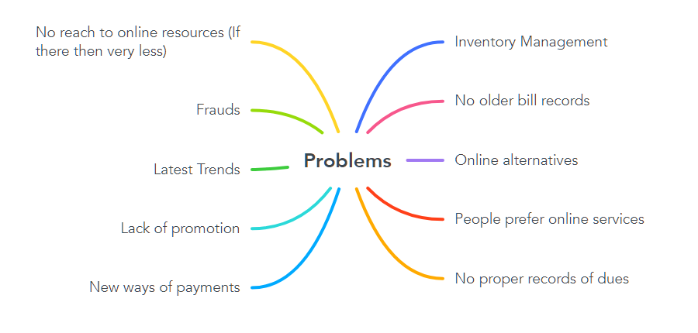

Figure – problems

The above figure shows the problems faced by shopkeepers during doing their jobs. Let me elaborate them for you.

Inventory management – It is the most common problem faced by shopkeepers associated with any category of the shop. Most of the shopkeeper face problem while managing their shop inventories. They spend reasonable part of their earnings in employing someone to manage inventories.

No older bill records – It is also one of the most common issues that shopkeepers have to face. Most of the shopkeepers uses handwritten bills which are single use or prefer to say they are one time bills which shopkeeper prepares and give to customer without taking any copy with him/her, and also there may be overwriting over it which may cause future disputes.

Online Alternatives – Most of the shopkeepers whom I interviewed mention this problem of online alternatives. They say that there are many websites and apps coming in front of us during this changing era which are making it easier to order things and get it delivered to their homes.

People prefer online services – As mentioned in above point, people choose online services over going to shop and purchasing.

No proper records of dues – It is the most common problem among those shopkeepers who used to manage due account for the customer, or we can say “***Udhar khata***”. In that case shopkeepers may sometime create mistakes. Overall this is not the best way to manage this task as it contains a huge scope of human error.

No reach to online resources – This is the problem faced by most of the local shopkeepers. They lack the excess to online resources which makes it a down point for small shopkeepers.

Frauds – This happens with everyone in this world one or another day. But local shopkeepers are more prone to it. They can be a victim of a fraud, in terms of finance, or may be in terms quality or quantity of the goods purchased by them.

Latest trends – Latest trends also contribute in problems to a shopkeeper. Every day some or other new things come into market but this very difficult for a shopkeeper to keep a regular track of it and order the new items every day.

Lack of promotion – one more reason why shopkeeper is not feeling comfortable in the market is lack of promotion. These shopkeepers are not even promoted in their locality, people promote online services’ websites but they hesitate to promote these shopkeepers, because of which less people come to the shop to purchase items.

New ways of payments – This is also one of the most common issue faced by them as they are not aware of latest mode of payments. Some says that when one mode of payment comes then it becomes the headache for them to get their account in it as a business account as sometime the servers are flooded with numerous requests.

Now when I got the major problems listed with me I started thinking of the solutions.

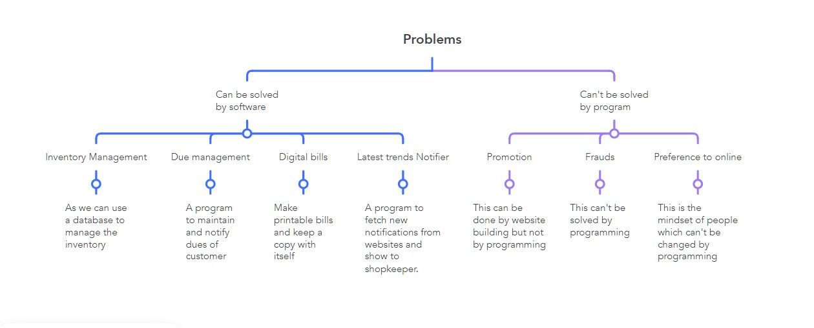

Figure – classification of problems and solutions

Now I separated my problems on the basis if that problem can be solved by any software or program that I can code. Finally, I found some problems that can be solved by using the program that I can code. These problems are –

1. Inventory management

2. Due management

3. Digital bills

4. Latest trends notifier

Now when I have listed my problems and their solutions, so now I can start planning my work.

Now if we talk about inventory management we have to maintain a database which will have all products name and their quantity available to shopkeeper. For making a python program for this purpose I have to think of the way to maintain the database. In this I opt for csv files as they are easy to maintain, display organized data, can be used in python easily and moreover I am more comfortable in using it.

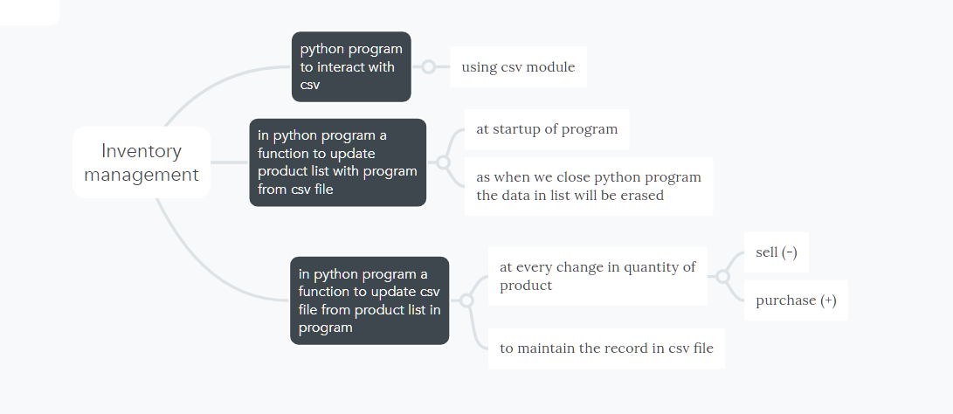

Figure – mind map for inventory management program

As you can see in above flowchart, our program for inventory management must complete these three objectives.

In our program we need to deal with csv files that’s why we are using csv module. In our program we have to make two major functions – (I) to update csv file from product list in program.

(II) to update product list in program from csv file.

Reason of doing so is that our python program on startup will start with a fresh empty product list and not for first time only, it will do so at every single run. To solve this issue, we need to make a function that will access the csv file and fill the product list in python program with the products and quantity available in it. This will refresh the product list at every startup. Now we have solved one problem but another problem left to be solved that is the problem in updating the data in csv file after every sell or every incoming supply of product.

This can be solved by using another function which will add or subtract the change in quantity of a product in product list and then update the data of that product in csv file by using the freshly updated product list.

When we use this program, it will solve our first problem that is inventory management. Benefits of this program are –

* Easy to add or subtract products in inventory.
* Easy to excess
* Reduce human error
* Clear displaying of list as the csv file will open in any of the available spreadsheet software.

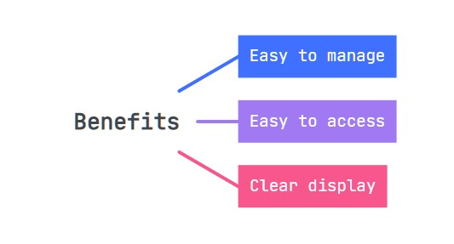

Figure – benefits of inventory management program

After we solved our first problem, we can head towards our next problem, that is – due management.

Here also we have to maintain a database for maintaining dues. This database will contain names and dues pending of a customer. Python program.

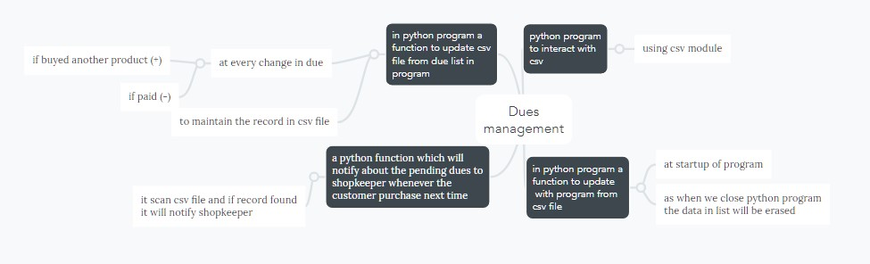

Figure – mind map for due management program

As we can see in above flowchart, we have three major objectives to make due management python program.

First is same as that of inventory management, that is using csv module to manage the database.

Again, we will make two functions in python program that are –

(I) Function to update due list in python program at the startup from csv file.

(II) Function to update csv file from python program after every transaction either addition in due amount or reduction in due amount.

But here we need one more function

Benefits of the program –

* This program will make it easy to add or subtract the dues.
* Reduce human error.
* Easy to excess
* Clear displaying of list as the csv file will open in any of the available spreadsheet software.

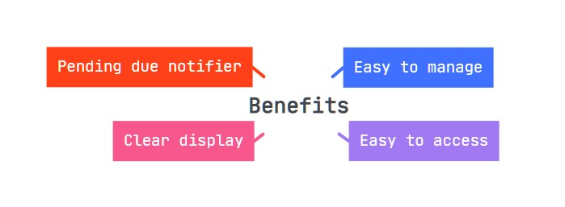

Figure – benefits of due management program

Now we come across our third problem that is making printable digital bills.

To tackle this problem, we can use basic file input – output basis. We can make a function that will manage the whole bill making process.

Let’s have a look at the processes to be done by this program.

Figure – cyclic events in our bill maker program

From above chart we can see that we have a cycle of processes that have to be done in continuation. Here we can use either concept of loops or method of recursion.

I will use recursion here as recursion is 3000+ times faster than the loop. Recursion adds clarity, reduces time complexity and perform better in solving problems based on tree structures.

(Note – the above details are as per real life experimentation and various reports available online)

Now let’s take a look at the action plan for making this program.

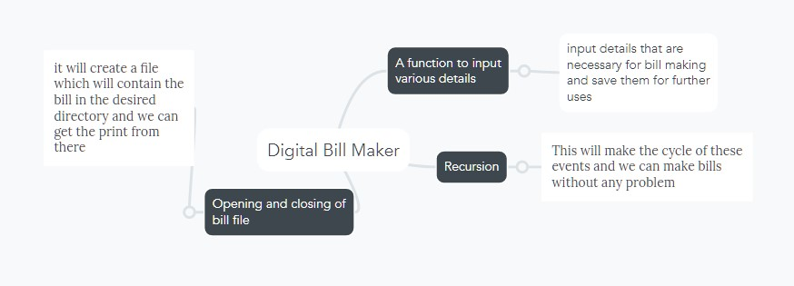

Figure – mind map for bill maker program

From above flowchart you can see the tasks listed. To fulfill our goals, we have to work on the above mentioned things.

We need a function which will ask for the various necessary details like – date, customer name, etc.

Next, we need to open a file for making bill. When we open the file, we can use another function for making bill, which will input products and various other details regarding the same which will be helpful in bill making. When the bill is over the file will close itself and get ready to be taken out as print. As the bill fill is stored in computer directory that’s why it will be helpful to us in two ways – first it will be an original copy of bill, and second, we can search any name from thousands of bills by search bar.

Now finally we can use recursion and do the above processes again and again.

Benefits of the program –

* Easy to access
* Reduce human errors
* Original copy is always present
* Can be searched from numerous other files in the same directory
* Printable

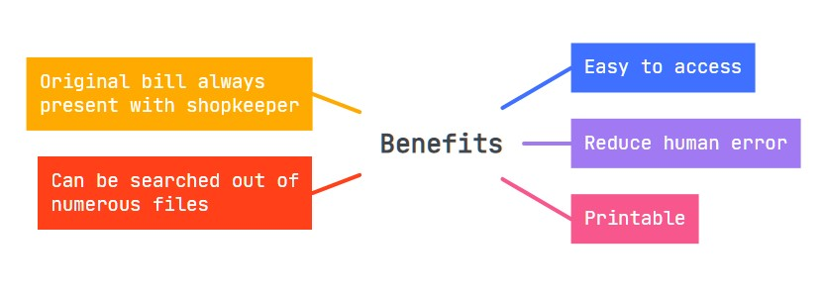

Figure – benefits of bill maker program

Now let’s have a look at what we can do for our fourth problem. Solution to our fourth problem is latest trend notifier. This will help in getting the shopkeeper up – to – date regarding latest things or products.

This can be done by using the concepts of web scraping where we can use beautiful soup module to scrap some useful data from various websites and later we can use module named plyer to send notification on the desktop of the shopkeeper. As this is a problem, involving web – scrapping, desktop notifier, a program combining both and other related things, due to which our final program to solve this problem is getting more complex and chances of errors are increasing. Resulting errors in my program so I would request you to please skip this part of program.

Rest of the problems that I classified as problems that cannot be solved by using programming.

So now we have three goals successfully achieved and one goal left due to problem discussed already.

Now we can compile these three programs together and make our final program which will serve our purpose.

Let’s now plan how we can compile them and get our desired output from our programs.

First let’s list our problems –

1. Inventory management
2. Dues management
3. Digital bill maker
4. Compiling all the three programs

Possible ways to go forward –

* We can make two lists –
  1. Product list
  2. Due list
* Now we can make two files –
  1. Products csv file
  2. Dues csv file
* Next, we can make various functions –
  1. Update csv files from lists
  2. Update lists from csv files
  3. Startup function containing starting point of the program
  4. Enter supplies
  5. Bill maker
  6. Payment manager
  7. Dues manager

Now we are all set and we can start coding….

Code

First, we can import modules for our program.

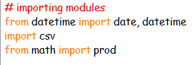

Figure – modules

Let’s define some presets.

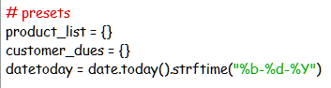

Figure – presets

Now let’s define the pre – planned functions in our program.

1. list refresher –

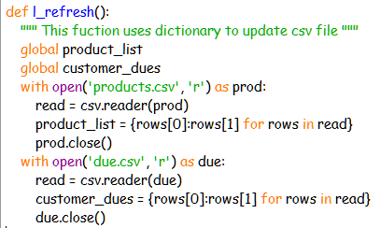

Figure – list refresher

This function refreshes the lists using csv file.

2. CSV refresher –

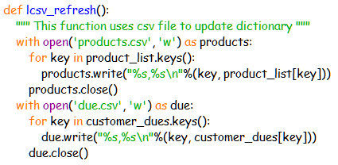

Figure – csv refresher

This function refreshes the csv file using lists in program.

3. Startup function –

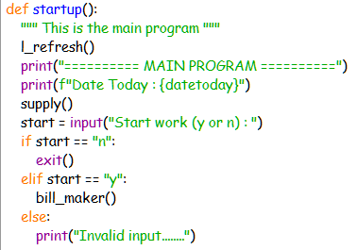

Figure – startup function

This function starts the events of our programs. Here we are calling three functions that are – list refresher, supply manager, and bill maker.

4. Supply manager –

These two functions manage the whole supply process. It increases the quantity of products in csv file for each supply.

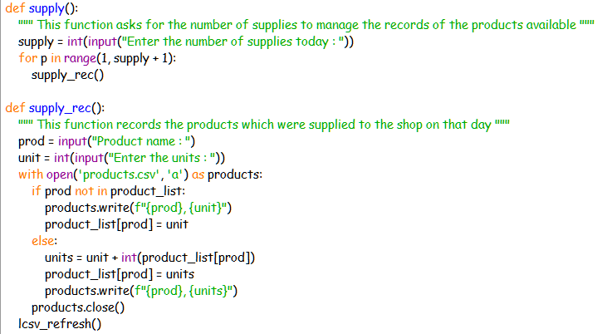

Figure – supply manager

In this we have two functions defined –

1. supply () – asks for the number of supplies present.
2. supply_rec () – this records the supplies by asking product name and units supplied to shopkeeper. Then this data is added in the csv file.

5. Bill maker –

This function manages all about bills. This function will show some required details, input various necessary details, next it will open the bill file and make bill in it, finally it will close the file and trigger our next function to ask type of payment.

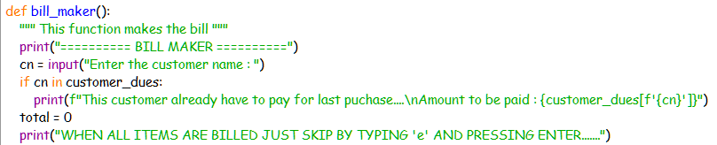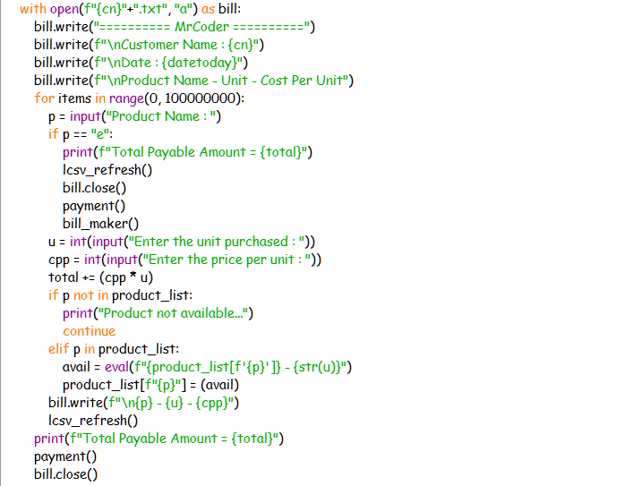



Figure – bill maker

6. Payment manager –

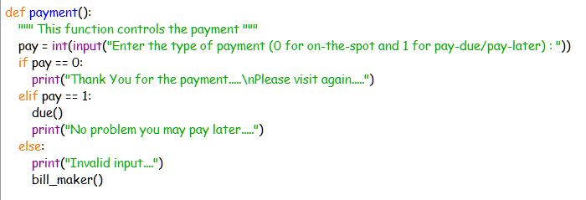

Figure – payment handler

This function will manage the way of payment. It will ask the user to choose the way of payment that are “on the spot” payment or to manage due record.

If we choose “on the spot” payment then it will go to bill maker again for new bills.

But if we choose to maintain due record, then it will trigger our new function which will manage dues.

7. Due management –

This function manages the due records. If we choose “manage dues” when asked for the way of payment, then our program will jump into this section of code.

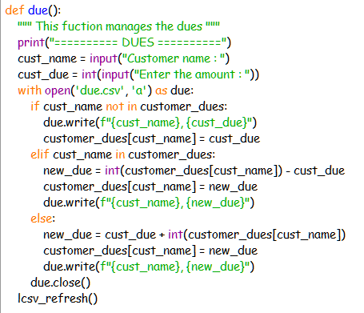

Figure – due manager

Here the user has to input the customer name by which the customer wants to create a due record and then user have to input the amount to be added in the due record.

Output

Now after discussing the coding part of the program let’s have a look at its execution.

First let’s have a look at the folder of this program.



When we open this folder, we get few files with us –



First is due.csv which is our due record database, second is products.csv which is our inventory database, and finally we have our main.py which is our main program.

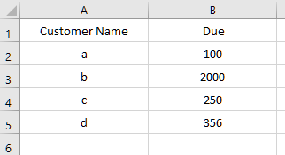

Figure – due.csv

Let’s have a look at due.csv (the above image shows us the due.csv). We can see how the data is arranged which makes it very easy to understand.

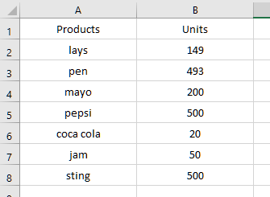

Figure – products.csv

This is the image showing us the product.csv. Again, we can see the benefit of our program, how the data is arranged in order which makes it very clear to keep record of quantity of products.

Before proceeding further, once have an initial look at both the csv files.

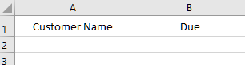

Figure – due.csv (initially)

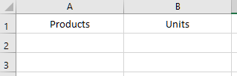

Figure – product.csv (initially)

We can see that both the files are initially blank.

Now let’s move on to the main program. We can run our program by just double clicking main.py file.

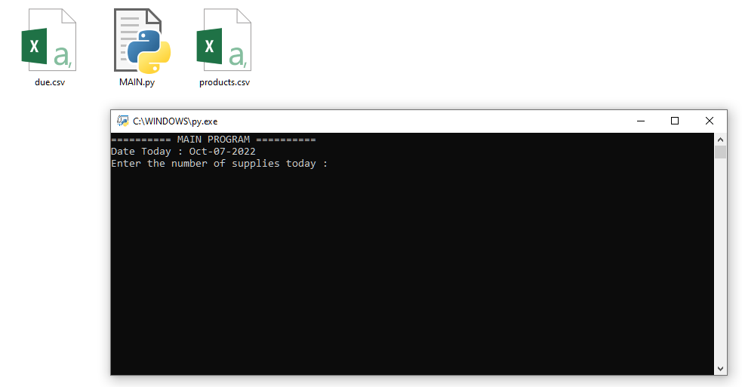

Figure – main.py (displaying date and asking number of supplies)

You can see that when we run our program it shows us the date and asks us for the number of supplies.

Here user can enter the number of supplies he/she received on that day.

Let’s enter 2 here for demonstration. It means we got supplied 2 products to our shop.

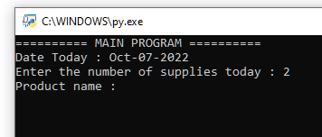

Figure – main.py (asking details regarding supplies)

Now when we enter 2, we are asked to enter the product name.

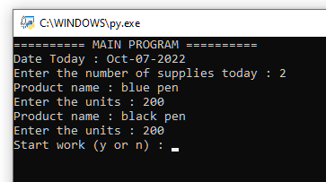

Figure – main.py (asking to start the work or not)

Now we can see how our program asked us to enter the product name and units that number of time that we entered earlier.

After that we got a new prompt asking us to tell whether to start work or not.

If entered “n” the program will close, while if pressed “y” the program will continue forward.

Before proceeding further let’s have a look at how this introduced the change in our inventory. For that purpose, we have to check our inventory database or we can say products.csv file.

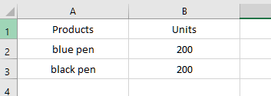

Figure – products.csv (after entering supplies)

We can see that two products’ supply that we entered are recorded here.

Let’s now start our work by pressing “y”.

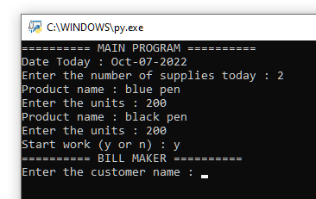

Figure – main.py (bill maker)

We can see here that when we press “y” we get started by our bill maker. In bill maker we are asked to enter the customer name first. Let’s take the customer name as “mrcoder”.

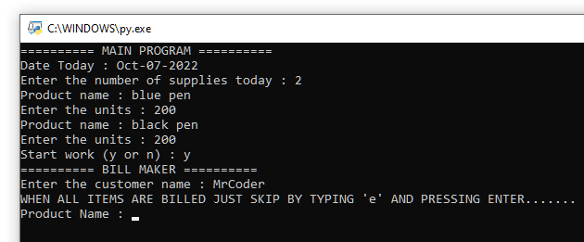

Figure – main.py (entering customer name in bill maker)

Now our bill maker has started making the bill and displayed that we can press “e” to stop the bill maker.

Now let’s enter some items purchased. For example, let’s say that the person purchased 2 blue pens of 20 rupees each and 2 black pens of 15 rupees each. Also, let’s say the person need 2 red pens of 20 rupees each, but the shopkeeper doesn’t have it in stock.

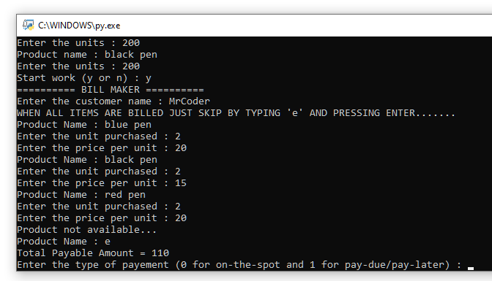

Figure – main.py (bill making)

We can see that as red pens are out of stock, so the program showed that “product not available…” message.

Also, our program on pressing “e” stopped making bill and showed user the total payable amount. And asked to choose the way of payment.

Before proceeding further let’s have a look at the contents in the folder.



Figure – new file formed

We can see a new file with the name of customer is created in the folder. This is our printable bill for the customer.

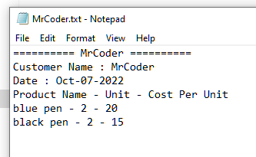

Figure – bill fill content

We can see that the bill is formed with customer name date and all items purchased.

Note – here I have two problems with my program that are –

1. Lack of proper display of bill in bill file.
2. Unable to add the total payable amount in the bill file. Yes, but getting it in the program.

Also, we should once have a look at our products.csv, to check if our program deducted the number of products sold from the inventory database.

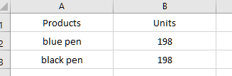

Figure – products.csv (quantity of products after some of them are sold)

Now let’s go back to our main.py and enter the way of payment.

If we enter –

* “0” then it means that the customer paid for the items on the spot. Hence, the program will move on to bill maker again for making new bill.
* “1” then it means that the customer didn’t paid at that time and want to maintain a due record for him. Hence, the program will trigger due manager section of our code.

Let’s enter “1” to check how our due manager is working.

We can see in figure below that how when we enter “1” when way of payment is asked, our program automatically starts due manager.

In this we are asked to enter the customer name. User can enter any name here, or I can say that name can be any as per his/her convenience that he/she might enter the customer name or the name by which customer want to create due record or may be customer don’t purchase anything but just came to pay due of someone else.

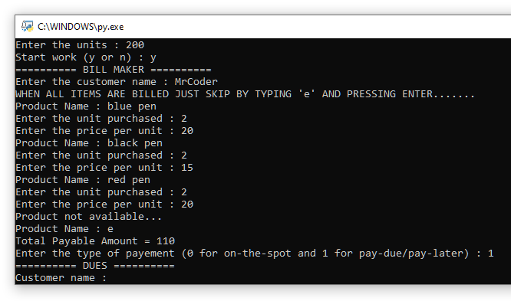

Figure – main.py (due manager)

Now let’s enter the customer name same as earlier.

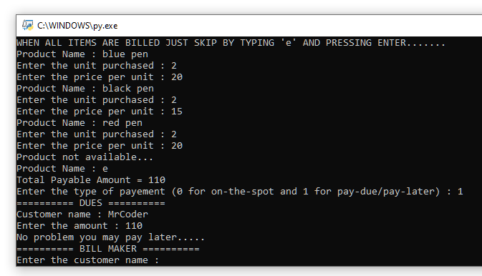

Figure – entering details in due manager

Now we have attended one customer successfully. And we can see that how the program again started bill maker to attend next customer without any wastage of time.

Before heading forward let’s have a look at our dues database or dues.csv to check out the changes in it.

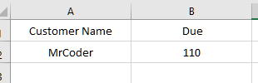

Figure – due.csv (after adding customers due record)

Let’s make one more bill. Suppose another customer came to shop to buy 1 blue pen of 20 rupees and 2 black pens of 15 rupees. And choose to pay later.

I have entered all the details already to show you the different changes.

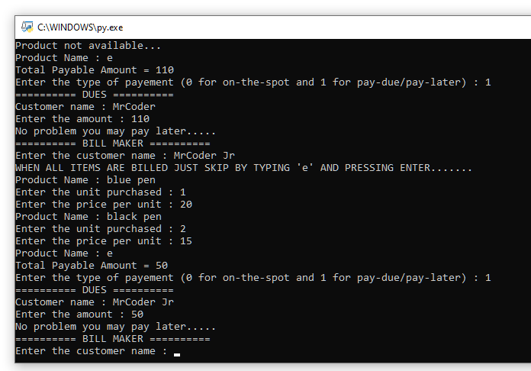

Figure – main.py (Second customer)

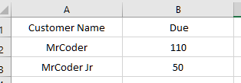

Figure – due.csv (after adding second due record)

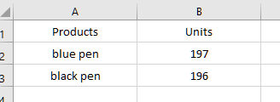

Figure – products.csv (after attending second customer)

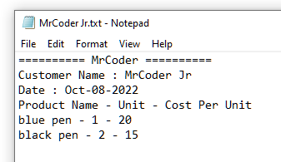

Figure – bill for second customer

Now let’s close the program and run it for second time.

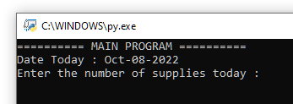

Figure – main.py (second run)

If 3 supplies came, then let’s enter 3 and record blue pen, black pen, and red pen supplies. And start the work again.

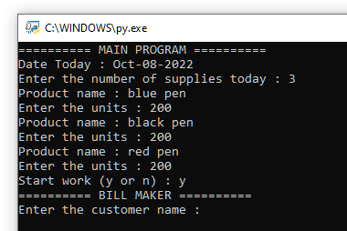

Figure – main.py (recording supplies for second time)

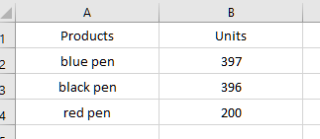

Figure – products.csv (after recording new supplies)

let’s suppose both the earlier customers came again and paid the dues.

Customer whose name was “MrCoder” came to pay dues of “MrCoder Jr”, and “MrCoder Jr” came to pay dues of “MrCoder”. We can see that when they came again the earlier dues were displayed at the top.

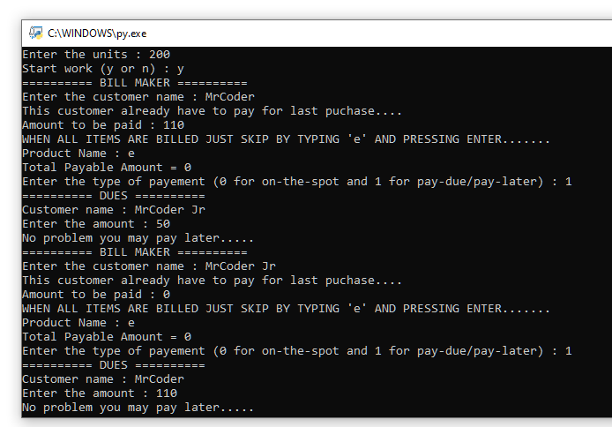

Figure – main.py (paying dues)

Also, we can see that the pending dues of both are cleared in due.csv file.

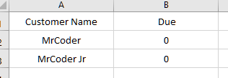

Figure – due.csv (after nulling the dues by customers)

By this we saw the working of whole program.

Important points

There are some important points to keep in mind while using this program.

* Never delete any of the csv file (either products.csv or dues.csv).
* To add due use “–” sign in front of the amount and to reduce the due no need to use any sign just enter the amount.

For example:

To add due –

Amount: -100

To reduce due –

Amount: 100

Businesses it will help

This program will help be useful in many of the businesses. This program is basically made for all those businesses which include bill making, inventory management, and due management. But if asked to use in some other business this program can be modified accordingly.

System requirements

* RAM – less than even 1gb
* Display – any basic display
* Video card – not required
* Hard disk – about I or 2 MB

User Requirements

* Person must now English
* Person must be able to use a simple computer.
* Person must know basic computer details like opening. closing, printing of a file, etc.

Bibliography

* <https://wikipedia.org>
* <https://retail.economictimes.indiatimes.com/news/e-commerce/e-tailing/10-challenges-plaguing-small-sellers-in-the-indian-e-commerce-market/76995711>
* <https://quora.com/What-are-the-problems-faced-by-local-and-small-retailers>

Github link for the program

I am attaching my GitHub link for my program but it is not allowed to download the program without my consent to do so as per the license.

<https://github.com/mayank785/ShopManager.git>