

MDS507C-4 — Natural Language Processing
NLP Project Report
Lexicon-Based vs. Machine Learning Approaches for
Financial Sentiment Classification

A Project Report Submitted by
Mayank Sahu (2548029)
Course: MDS507C-4 — Natural Language Processing

Abstract
Sentiment analysis is widely used to gauge market perception from financial news, yet most publicly available sentiment tools (e.g., VADER) are trained on general-purpose or social media text and often misinterpret domain-specific financial vocabulary — terms such as “liability,” “volatile,” or “write-down” that carry different connotations in financial contexts than in everyday language. This creates a gap between generic sentiment tools and the specialized language of financial reporting.
This project investigates whether domain adaptation improves sentiment classification accuracy on financial text by comparing three approaches: (1) a general-purpose lexicon-based method (VADER), (2) a finance-specific lexicon (Loughran-McDonald), and (3) a supervised machine learning approach using TF-IDF features with a Logistic Regression/SVM classifier trained directly on labeled financial sentences. A pretrained transformer-based model (FinBERT) is additionally evaluated for reference.
The Financial PhraseBank dataset, comprising financial news sentences annotated by finance professionals as positive, negative, or neutral, is used for training and evaluation. Standard text preprocessing steps — tokenization, stopword removal, and lemmatization — are applied, with care taken to preserve negation cues relevant to sentiment. Model performance is evaluated using accuracy, precision, recall, and macro-averaged F1-score, with particular attention to the neutral class, which is known to be challenging in financial text due to hedged and non-committal language.
The study aims to critically examine the strengths and limitations of lexicon-based versus learned approaches in a specialized domain, providing insight into when simple, interpretable methods suffice versus when supervised learning is warranted. All four approaches are evaluated on the same held-out test split, differences are checked for statistical significance with McNemar's exact test, and systematic error analysis is used to characterize where and why each approach fails.

Table of Contents
Abstract 2
Table of Contents 3
1. Introduction 5
2. Literature Survey 5
2.1 Hutto & Gilbert (2014) — VADER 5
2.2 Loughran & McDonald (2011) — Finance-Specific Lexicons 6
2.3 Malo et al. (2014) — The Financial PhraseBank Dataset 6
2.4 Araci (2019) — FinBERT 6
2.5 Karanikola et al. (2023) — Classic Methods vs. Deep Learning 6
3. Research Gap and Problem Statement 7
4. Dataset 7
5. Methodology 8
5.1 Text Preprocessing 8
5.2 Model Implementations 9
5.2.1 VADER (General-Purpose Lexicon) 9
5.2.2 Loughran-McDonald (Finance-Specific Lexicon) 9
5.2.3 TF-IDF + Machine Learning (Supervised) 9
5.2.4 FinBERT (Pretrained Transformer, Zero-Shot Reference) 9
5.3 Evaluation Methodology 9
6. System Implementation 10
7. Results 11
7.1 Overall Comparison 11
7.2 Per-Class Performance 11
7.3 Statistical Significance 12
7.4 Confusion Matrices 13
8. Error Analysis 16
8.1 Hedged, procedural language mistaken for sentiment 16
8.2 Positive investor sentiment with no sentiment-bearing words 16
8.3 Lexical false positives from stale trigger words 16
9. Critical Discussion: Strengths and Limitations 18
9.1 Strengths 18
9.2 Limitations 18
10. Dashboard Demonstration 20
10.1 Live Demo 20
10.2 Results Dashboard 22
11. Conclusion and Future Work 26
References 27

1. Introduction
Sentiment analysis — automatically determining whether a piece of text expresses a positive, negative, or neutral attitude — is one of the most widely deployed applications of NLP. In finance specifically, sentiment extracted from news articles, earnings-call transcripts, analyst reports, and regulatory filings is used as a signal for trading strategies, risk assessment, and market-perception monitoring. Because financial markets react quickly to information, automated sentiment extraction at scale has direct practical value.
However, financial text has vocabulary and conventions that differ sharply from the general-purpose or social-media text most sentiment tools are built and validated on. Words such as “liability,” “tax,” “cost,” and “volatile” are often flagged as negative by general-purpose sentiment dictionaries, yet in a 10-K filing or an earnings report these words are frequently neutral, expected terminology rather than expressions of sentiment. This mismatch is well documented in the finance-NLP literature (see Section 2) and motivates the central question of this project: does adapting the sentiment method to the financial domain — through a domain-specific lexicon, a supervised model trained on financial text, or a domain-pretrained transformer — actually improve classification quality over an out-of-the-box general-purpose tool, and if so, by how much, and where specifically does the improvement come from?
To answer this, the project implements and evaluates four sentiment-classification approaches, spanning a spectrum from fully rule-based to fully learned, on the same dataset and the same held-out test split, and analyzes the results both quantitatively (metrics and statistical significance testing) and qualitatively (error analysis on specific misclassified sentences).

2. Literature Survey
Five papers were reviewed to ground the project's methodology and to identify the research gap addressed in Section 3. Each directly underlies a component of the implemented system.

2.1 Hutto & Gilbert (2014) — VADER
Hutto and Gilbert [1] introduced VADER (Valence Aware Dictionary and sEntiment Reasoner), a lexicon- and rule-based model built from roughly 7,500 lexical features, each rated for sentiment valence on a −4 to +4 scale by ten independent human raters. On top of the lexicon, VADER applies heuristic rules for intensifiers, negation, punctuation emphasis, and capitalization to compute a normalized “compound” sentiment score. The model was validated primarily on social-media text (tweets), along with movie reviews, product reviews, and NYT editorials, where it matched or exceeded individual human raters' agreement. VADER is used in this project as the general-purpose baseline (Section 5.2.1) — its documented tuning toward social-media conventions rather than financial-reporting language is exactly the mismatch this project measures.

2.2 Loughran & McDonald (2011) — Finance-Specific Lexicons
Loughran and McDonald [2] showed empirically that roughly three-quarters of the words a general-purpose dictionary (Harvard IV-4) marks as “negative” are not actually negative in the context of 10-K filings — words like “tax,” “cost,” “liability,” and “capital” are ordinary, expected financial-reporting vocabulary rather than sentiment signals. To correct this, the authors built the Loughran-McDonald Master Dictionary: a set of finance-specific word lists spanning several sentiment-relevant categories (including positive, negative, uncertainty, and litigious language), derived directly from the actual word usage in a large corpus of 10-K filings rather than general English text. This dictionary is the direct basis for the Loughran-McDonald model implemented in Section 5.2.2, and its central finding — that domain vocabulary systematically breaks general-purpose sentiment tools — is the empirical motivation for this entire project.

2.3 Malo et al. (2014) — The Financial PhraseBank Dataset
Malo, Sinha, Korhonen, Wallenius, and Takala [3] constructed the Financial PhraseBank: 4,846 sentences drawn from English-language financial news and press releases (via the LexisNexis database), each annotated as positive, negative, or neutral by a panel of 16 annotators with finance and business-education backgrounds. Critically, annotators were instructed to label sentiment from an investor's perspective — a sentence is positive or negative if the information would plausibly benefit or hurt an investor, not merely if it contains positive- or negative-sounding words. The dataset ships in four subsets by annotator-agreement threshold (50%, 66%, 75%, and 100% agreement). This is the dataset used for training and evaluation throughout this project (Section 4), and its investor-perspective annotation guideline is directly relevant to several of the error cases discussed in Section 8.

2.4 Araci (2019) — FinBERT
Araci [4] fine-tuned BERT on a financial corpus (1.8 million Reuters news stories, combined with the Financial PhraseBank itself) to produce FinBERT, a transformer-based sentiment classifier for financial text. FinBERT improved on prior state-of-the-art results by roughly 14 percentage points on financial sentiment benchmarks, demonstrating that contextual, pretrained language representations capture financial sentiment far better than static lexicons or bag-of-words features. The publicly released checkpoint from this work (ProsusAI/finbert) is used in this project as a zero-shot reference model (Section 5.2.4) — evaluated as-is, with no further fine-tuning on this project's own train split.

2.5 Karanikola et al. (2023) — Classic Methods vs. Deep Learning
Karanikola, Davrazos, Liapis, and Kotsiantis [5] published a recent comparative study directly surveying the same question this project asks: how do classic (lexicon and classical ML) methods compare against deep-learning approaches for financial sentiment analysis. Their review confirms that this comparison remains an active, unsettled area of research, and that most published comparisons report only aggregate accuracy or F1 scores. Notably, the survey does not report significance testing between methods, nor does it isolate performance on the neutral class specifically — both of which this project addresses directly (Sections 7.3 and 8).

3. Research Gap and Problem Statement
The literature establishes two things clearly: (1) general-purpose sentiment lexicons are known to misfire on financial vocabulary [1, 2], and (2) domain adaptation — whether through a finance-specific lexicon, a supervised model trained on financial text, or a domain-pretrained transformer — consistently improves results [2, 4, 5]. What the literature does not consistently provide is:
- A controlled comparison of all four paradigms (general lexicon, domain lexicon, classical supervised ML, and pretrained transformer) evaluated on the exact same held-out test set, so that differences are attributable to the method and not to different data splits.
- Statistical confirmation that observed differences between methods are significant rather than sampling noise — most comparative studies, including the recent survey by Karanikola et al. [5], report point estimates of accuracy/F1 without a significance test.
- A systematic, qualitative account of where and why each method fails, particularly on the neutral class, which financial-domain literature repeatedly identifies as the hardest category due to hedged, non-committal reporting language, but which is rarely examined at the level of individual sentences.
This project's problem statement is therefore: quantify, with statistical rigor and qualitative evidence, how much sentiment-classification quality improves as a financial sentiment system moves from a general-purpose lexicon, to a finance-specific lexicon, to a supervised model trained on financial text, to a pretrained financial-domain transformer — with particular attention to the neutral class — and to characterize the specific linguistic patterns (hedging, purely factual reporting, investor-perspective framing) that remain difficult across all four approaches.

4. Dataset
The Financial PhraseBank dataset [3] is used for both training (the supervised TF-IDF+ML model) and evaluation (all four models). Sentences are labeled positive, negative, or neutral from an investor's perspective by finance-domain annotators.
The canonical distribution (“takala/financial_phrasebank” on the Hugging Face Hub) is packaged using a legacy loading-script format that current versions of the `datasets` library no longer execute. This project therefore sources the dataset from a script-free parquet mirror (“warwickai/financial_phrasebank_mirror”) containing the full 4,846-sentence set (all annotator-agreement levels merged, corresponding to the original “50% agreement” configuration), with a documented manual-download fallback path for the cleaner, higher-agreement subsets if needed. This substitution is a methodological deviation from the original plan and is discussed as a limitation in Section 9.
Split | Sentences | Negative | Neutral | Positive
Full dataset | 4846 | 604 | 2879 | 1363
Train | 3392 | 423 | 2015 | 954
Validation | 727 | 90 | 432 | 205
Test | 727 | 91 | 432 | 204

The dataset is split 70% / 15% / 15% into train / validation / test, stratified by label so the class distribution is preserved across splits, with a fixed random seed for reproducibility. The dataset is neutral-majority — neutral sentences make up roughly 59% of the test split, positive about 28%, and negative only about 13% — which is itself a source of difficulty discussed in Section 9. All four models are evaluated on the identical test split for a fair, apples-to-apples comparison.
As an auxiliary resource, the Loughran-McDonald Master Dictionary [2] (downloaded separately from the University of Notre Dame's Software Repository for Accounting and Finance, as it is not distributed via any package manager) supplies the finance-specific positive/negative word lists used by the Loughran-McDonald model.

5. Methodology

5.1 Text Preprocessing
A shared preprocessing pipeline (tokenization → negation-safe stopword removal → lemmatization) is applied using NLTK. Sentences are lowercased and tokenized with NLTK's word tokenizer, which correctly splits contractions such as “n't” into their own token. Stopwords are removed using NLTK's standard English stopword list, with one deliberate modification: a curated set of negation cues (“no,” “not,” “nor,” “n't,” “never,” “none,” “nobody,” “nothing,” “neither,” “nowhere,” “cannot,” “without,” “hardly,” “scarcely,” “barely”) is excluded from the stopword list so these tokens survive filtering, since negation is directly relevant to sentiment and removing it as a generic stopword would discard useful signal. Remaining tokens are lemmatized with NLTK's WordNet lemmatizer.
Not every model consumes the same text form. VADER and FinBERT are designed to interpret natural, minimally altered language directly (VADER's rules use punctuation and capitalization cues; FinBERT performs its own subword tokenization and contextual normalization), so both receive the raw sentence. The Loughran-McDonald scorer and the TF-IDF+ML model, which both depend on exact word-form matching against a fixed vocabulary, receive the fully preprocessed (tokenized, negation-safe stopword-filtered, lemmatized) form.

5.2 Model Implementations
All four models implement a common interface — fit(texts, labels) and predict(texts) → label, plus an optional predict_proba(texts) for confidence scores — so the evaluation harness (Section 5.3) treats them uniformly despite very different underlying mechanisms.

5.2.1 VADER (General-Purpose Lexicon)
VADER [1] is used out of the box via the vaderSentiment package. Its compound sentiment score is mapped to a label using the package's own standard convention: compound ≥ 0.05 → positive, compound ≤ −0.05 → negative, otherwise neutral. No training is performed; VADER requires no labeled data.

5.2.2 Loughran-McDonald (Finance-Specific Lexicon)
The Loughran-McDonald Master Dictionary [2] is parsed into lemmatized positive and negative word sets. For each sentence, positive and negative word hits are counted in the preprocessed token list; the majority count determines the predicted label, and a tie (including zero hits in both categories) is classified as neutral. Like VADER, this model requires no training.

5.2.3 TF-IDF + Machine Learning (Supervised)
A scikit-learn pipeline combines a TF-IDF vectorizer (unigrams and bigrams, minimum document frequency of 2) with a classifier trained directly on the labeled training split. A light hyperparameter sweep is performed over classifier type (Logistic Regression vs. Linear SVM) and the regularization strength C ∈ {0.1, 1.0, 10.0}, selecting the configuration with the best macro-F1 on the validation split. This run selected a Linear SVM with C = 1.0. This is the only one of the four models that is actually trained on labeled financial sentences from this dataset.

5.2.4 FinBERT (Pretrained Transformer, Zero-Shot Reference)
The publicly released ProsusAI/finbert checkpoint [4] is loaded via Hugging Face Transformers and run as a batched CPU inference pipeline, with no further fine-tuning on this project's training split. Its own id-to-label mapping is used directly rather than assuming a fixed class order, since this can differ between checkpoints. FinBERT is included “for reference” per the project's original scope, not as a fully controlled experimental arm — see the discussion of this caveat in Section 9.

5.3 Evaluation Methodology
All four models are evaluated on the same held-out test split. Because the dataset is neutral-majority (Section 4), macro-averaged precision, recall, and F1 are used as the primary metrics rather than raw accuracy alone, alongside a full per-class breakdown (with particular attention to the neutral class) and a confusion matrix per model. Beyond standard metrics, two additional analyses are performed that are not typically found in comparable published studies (Section 3):
- Statistical significance testing: McNemar's exact test is run pairwise between every pair of models on their paired correct/incorrect outcomes over the identical test set, to determine whether observed accuracy differences are statistically significant rather than sampling noise.
- Qualitative error analysis: per-model misclassification tables, a neutral-class-specific slice of each, and a cross-model “hardest sentences” table listing sentences misclassified by two or more models simultaneously, used to characterize recurring failure patterns (Section 8).

6. System Implementation
The project is implemented as a modular Python package (`finsent`) rather than a single monolithic script or notebook, so that each stage of the pipeline — data loading, preprocessing, each of the four models, and evaluation/reporting — is independently reusable and testable. Key implementation points:
- Runs entirely on a standard laptop CPU — no GPU or cloud compute is required, since three of the four models are non-neural and FinBERT is used for inference only (no fine-tuning). FinBERT inference over the full test split completes in under a minute on CPU.
- A shared SentimentModel interface (fit / predict / predict_proba) lets the evaluation harness treat lexicon rules, a trained scikit-learn pipeline, and a pretrained transformer uniformly.
- Configuration (dataset source, split ratios, model hyperparameters, random seed) is centralized in a single config.yaml rather than hardcoded, and datasets/lexicons/artifacts are cached to disk after first load so repeated runs are fast.
- A pytest suite (14 tests) covers the negation-preserving preprocessing logic, the Loughran-McDonald scorer, the McNemar's-test implementation, the error-analysis table builders, and the common model interface — all passing at the time of this report.
- Results (metrics, comparison tables, confusion-matrix figures, significance tests, error-analysis tables) are generated by a report notebook (notebooks/report.ipynb) and written to results/, which both this report and the interactive dashboard (Section 10) read from.
- An interactive Streamlit dashboard (app.py) provides a live multi-model demo and a visual results walkthrough, described in Section 10.

7. Results

7.1 Overall Comparison
Model | Accuracy | Macro-Precision | Macro-Recall | Macro-F1 | Neutral-Class F1
VADER | 53.2% | 0.495 | 0.484 | 0.469 | 0.615
Loughran-McDonald | 63.3% | 0.571 | 0.515 | 0.518 | 0.750
TFIDF+ML | 71.9% | 0.676 | 0.642 | 0.656 | 0.803
FinBERT (zero-shot) | 87.8% | 0.838 | 0.905 | 0.865 | 0.897

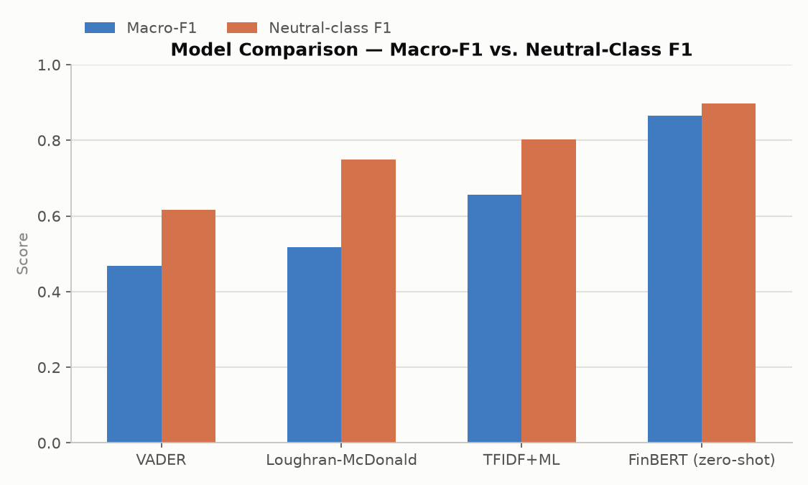
Figure 7.1 — Macro-F1 and neutral-class F1 across all four models.

Every metric improves monotonically along the same ordering — VADER < Loughran-McDonald < TF-IDF+ML < FinBERT — for accuracy, macro-F1, and neutral-class F1 alike. The improvement is large: accuracy rises from 53.2% (VADER) to 87.8% (FinBERT), and macro-F1 nearly doubles, from 0.469 to 0.865.

7.2 Per-Class Performance
Model | Class | Precision | Recall | F1-score | Support
VADER | negative | 0.364 | 0.264 | 0.306 | 91
VADER | neutral | 0.738 | 0.528 | 0.615 | 432
VADER | positive | 0.384 | 0.662 | 0.486 | 204
Loughran-McDonald | negative | 0.500 | 0.451 | 0.474 | 91
Loughran-McDonald | neutral | 0.666 | 0.859 | 0.750 | 432
Loughran-McDonald | positive | 0.545 | 0.235 | 0.329 | 204
TFIDF+ML | negative | 0.640 | 0.527 | 0.578 | 91
TFIDF+ML | neutral | 0.774 | 0.833 | 0.803 | 432
TFIDF+ML | positive | 0.615 | 0.564 | 0.588 | 204
FinBERT (zero-shot) | negative | 0.739 | 0.967 | 0.838 | 91
FinBERT (zero-shot) | neutral | 0.953 | 0.847 | 0.897 | 432
FinBERT (zero-shot) | positive | 0.821 | 0.902 | 0.860 | 204

The neutral class is where the four models diverge most sharply. VADER recalls only 52.8% of true neutral sentences (it over-predicts positive/negative based on any sentiment-bearing word present), while Loughran-McDonald over-predicts neutral (85.9% neutral recall but only 23.5% positive recall) because its counting rule defaults to neutral whenever too few finance-specific sentiment words are present. FinBERT is the only model with high precision and recall simultaneously across all three classes, consistent with its ability to use contextual, not just lexical, information.

7.3 Statistical Significance
Model A | Model B | Both correct | A only correct | B only correct | Both wrong | p-value | Significant (α=0.05)
VADER | Loughran-McDonald | 266 | 121 | 194 | 146 | 4.63e-05 | Yes
VADER | TFIDF+ML | 280 | 107 | 243 | 97 | 2.69e-13 | Yes
VADER | FinBERT (zero-shot) | 352 | 35 | 286 | 54 | 4.02e-50 | Yes
Loughran-McDonald | TFIDF+ML | 356 | 104 | 167 | 100 | 1.56e-04 | Yes
Loughran-McDonald | FinBERT (zero-shot) | 411 | 49 | 227 | 40 | 1.49e-28 | Yes
TFIDF+ML | FinBERT (zero-shot) | 482 | 41 | 156 | 48 | 5.38e-17 | Yes

McNemar's exact test was run on every pair of models over their paired correct/incorrect outcomes on the identical test set. All 6 of 6 pairwise comparisons are statistically significant at p < 0.05 — most by an overwhelming margin (e.g., VADER vs. FinBERT: p ≈ 4.0 × 10⁻⁵⁰). This confirms that the accuracy differences reported in Section 7.1 reflect genuine differences in classification quality rather than sampling variation in the test split.

7.4 Confusion Matrices
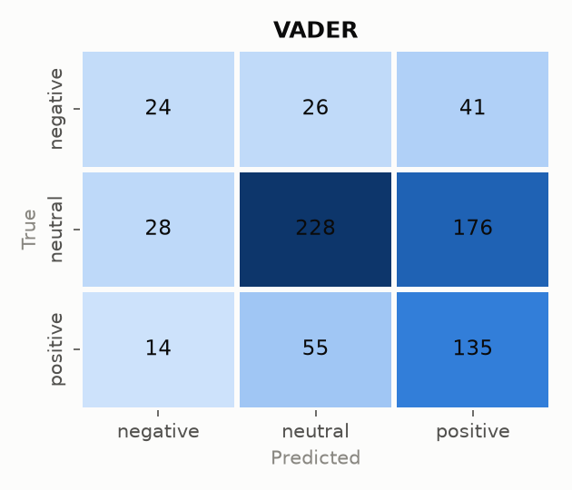
Figure 7.2 — VADER confusion matrix.

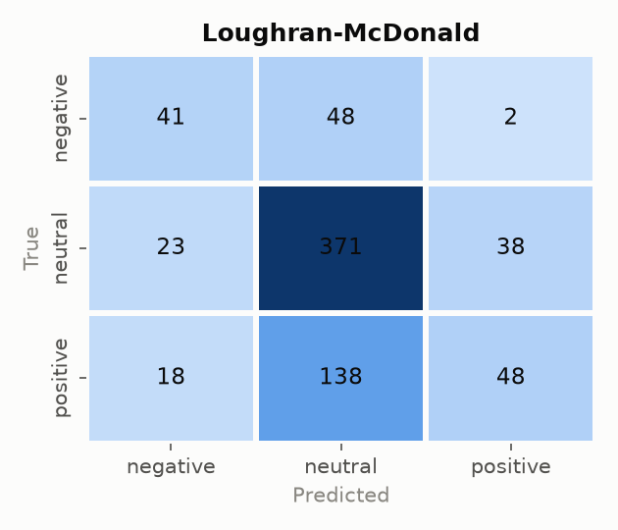
Figure 7.3 — Loughran-McDonald confusion matrix.

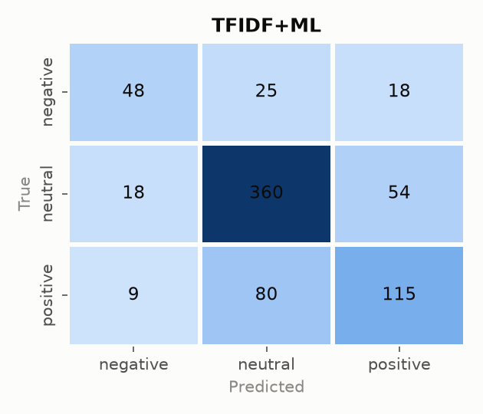
Figure 7.4 — TF-IDF+ML confusion matrix.

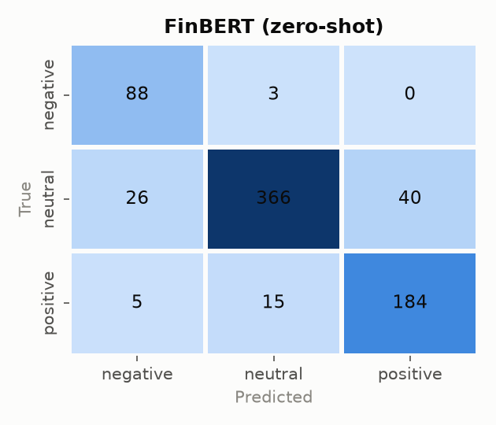
Figure 7.5 — FinBERT (zero-shot) confusion matrix.

VADER's confusion matrix shows heavy leakage from neutral into positive (176 of 432 true-neutral sentences predicted positive) — consistent with its tendency to flag any positive-sounding word regardless of financial context. Loughran-McDonald shows the opposite tendency for the positive class (138 of 204 true-positive sentences predicted neutral), consistent with its more conservative, finance-specific vocabulary rarely triggering on subtler positive language. FinBERT's matrix is by far the most diagonal (concentrated on the correct-prediction cells), with only 3 false negatives and 0 false positives out of 91 true-negative sentences.

8. Error Analysis
Beyond aggregate metrics, sentences that were misclassified by two or more models simultaneously were examined directly to identify recurring, interpretable failure patterns. Three representative examples:

8.1 Hedged, procedural language mistaken for sentiment
“The company plans to spend the proceeds from the rights offering for strengthening its balance sheet.” — true label: neutral; predicted positive by all four models.
This sentence describes a routine, forward-looking financial plan. It contains no evaluative claim about company performance, yet the word “strengthening” carries enough positive lexical charge to mislead every model, including FinBERT, into predicting positive. This is a textbook case of the hedged, non-committal financial language the original project abstract identified as the central difficulty of the neutral class — and it shows that even a contextual transformer is not immune to it.

8.2 Positive investor sentiment with no sentiment-bearing words
“The company said that it will supply the WCDMA 3G-HSPA radio network, including the modular, high capacity Nokia Flexi WCDMA base station in East Java, Bali, Sumatra and Batam.” — true label: positive; predicted neutral by all four models.
This sentence is purely factual — a company announcing a new supply contract — with no lexical sentiment cues whatsoever. It is labeled positive only because, from an investor's perspective, winning a new contract is good news [3]. No model in this study can recover sentiment that is implied by business facts rather than expressed in words, because all four rely, directly or indirectly, on the language of the sentence itself. This reveals a limit not of any one model, but of purely text-based sentiment classification against this annotation guideline (see Section 9).

8.3 Lexical false positives from stale trigger words
“The last job losses related to these reductions will take place during 2010.” — true label: neutral; predicted negative by all four models.
The word “losses” is a strong negative cue for every model, including the finance-specific Loughran-McDonald lexicon. But the sentence is not reporting new bad news — it is a neutral, administrative statement that a previously announced reduction plan is being completed. Distinguishing “new negative event” from “finalization of an already-known event” requires discourse-level context beyond any single sentence, which none of the four approaches models.
Across the full “hardest sentences” table (sentences wrong on 2 or more models), a clear pattern holds: VADER, Loughran-McDonald, and TF-IDF+ML agree with each other far more often than any of them agrees with FinBERT, including when they agree on the wrong answer — reflecting that the first three methods all ultimately rely on surface lexical cues (word presence or n-gram weights), while FinBERT's contextual representation gives it a qualitatively different, and generally more accurate, error profile.

9. Critical Discussion: Strengths and Limitations

9.1 Strengths
- Controlled, fair comparison: all four models are evaluated on the identical held-out test split, which is not guaranteed in many published comparisons and is essential for the differences reported in Section 7 to be meaningful.
- Statistically validated results: all six pairwise differences in Section 7.3 are significant under McNemar's exact test, several overwhelmingly so — the observed accuracy/F1 ordering is not an artifact of test-set sampling.
- Explicit, quantified focus on the neutral class, as the project's own problem statement demands: neutral-class F1 is tracked separately at every stage (Section 7.1–7.2) and is shown to be the primary axis along which the four methods actually differ.
- Reproducible and lightweight: the entire pipeline runs on a CPU-only laptop with no external services beyond a one-time dataset/model download, is covered by a 14-test automated test suite, and caches intermediate artifacts for fast re-runs.
- Goes beyond aggregate metrics with both statistical significance testing and sentence-level qualitative error analysis (Section 8), which most comparable studies in the literature reviewed in Section 2 do not report.
- A working interactive demonstration (Section 10) makes the results inspectable on new, user-provided sentences, not just the fixed test set.

9.2 Limitations
- FinBERT's “zero-shot” framing is optimistic: the ProsusAI/finbert checkpoint [4] was originally fine-tuned in part on the Financial PhraseBank dataset itself, so its strong result here (87.8% accuracy) is not a clean out-of-domain evaluation in the way the TF-IDF+ML model's held-out test performance is. This is a caveat on the FinBERT vs. other-models comparison, not a flaw in the evaluation methodology, and should be stated explicitly rather than implied.
- Dataset substitution: the originally intended, cleaner sentences_66agree subset of Financial PhraseBank could not be loaded programmatically because the canonical Hugging Face dataset repository uses a loading-script format no longer supported by current library versions. The project instead defaults to a mirror containing the full, noisier 50%-agreement-equivalent set (Section 4), which may modestly depress all four models' scores relative to what the cleaner subset would show.
- Single fixed train/validation/test split: hyperparameter selection and final evaluation rely on one stratified split rather than k-fold cross-validation, so reported numbers carry unquantified sampling variance at the point-estimate level, though McNemar's test does correct for this in the pairwise comparisons that matter most.
- No fine-tuning arm for FinBERT: because FinBERT is evaluated zero-shot only, by design, for compute and scope reasons, this project cannot separate “how good is a domain-pretrained transformer out-of-the-box” from “how good could a transformer be if fine-tuned on this exact training split, the way the TF-IDF+ML model was.” The FinBERT vs. TF-IDF+ML comparison is therefore not fully matched in training exposure.
- The Loughran-McDonald scorer has no negation-scope handling: negation tokens are deliberately preserved through preprocessing (Section 5.1), but the scorer never uses them to flip polarity, so a phrase like “not profitable” still counts “profitable” as a positive hit. This is a scoped, acknowledged design limitation rather than an oversight.
- Class imbalance: the test split is 59% neutral, 28% positive, and 13% negative, which makes raw accuracy a weak headline metric on its own — mitigated in this project by leading with macro-F1 and reporting full per-class metrics, but worth stating explicitly as the reason those metrics, not accuracy, are the primary basis for comparison.
- Task-inherent difficulty, not just model failure: the dataset's investor-perspective annotation guideline [3] means some “positive” or “negative” sentences carry no lexical sentiment cues at all (Section 8.2). No purely text-based model, however sophisticated, can be expected to recover sentiment that depends on domain knowledge about what business events matter to investors — this reframes some of the observed errors as a property of the task, not a deficiency of any one method.

10. Dashboard Demonstration
An interactive Streamlit dashboard (app.py) was built to make the project demonstrable, both for live exploration and for the project viva. It has two views: a Live Demo, where any financial sentence can be classified by all four models at once, and a Results Dashboard, presenting the same figures and tables as this report in an interactive, walkthrough-friendly form.

10.1 Live Demo
The landing view lets a user type a sentence or choose from a set of built-in examples, then classify it with all four models simultaneously.
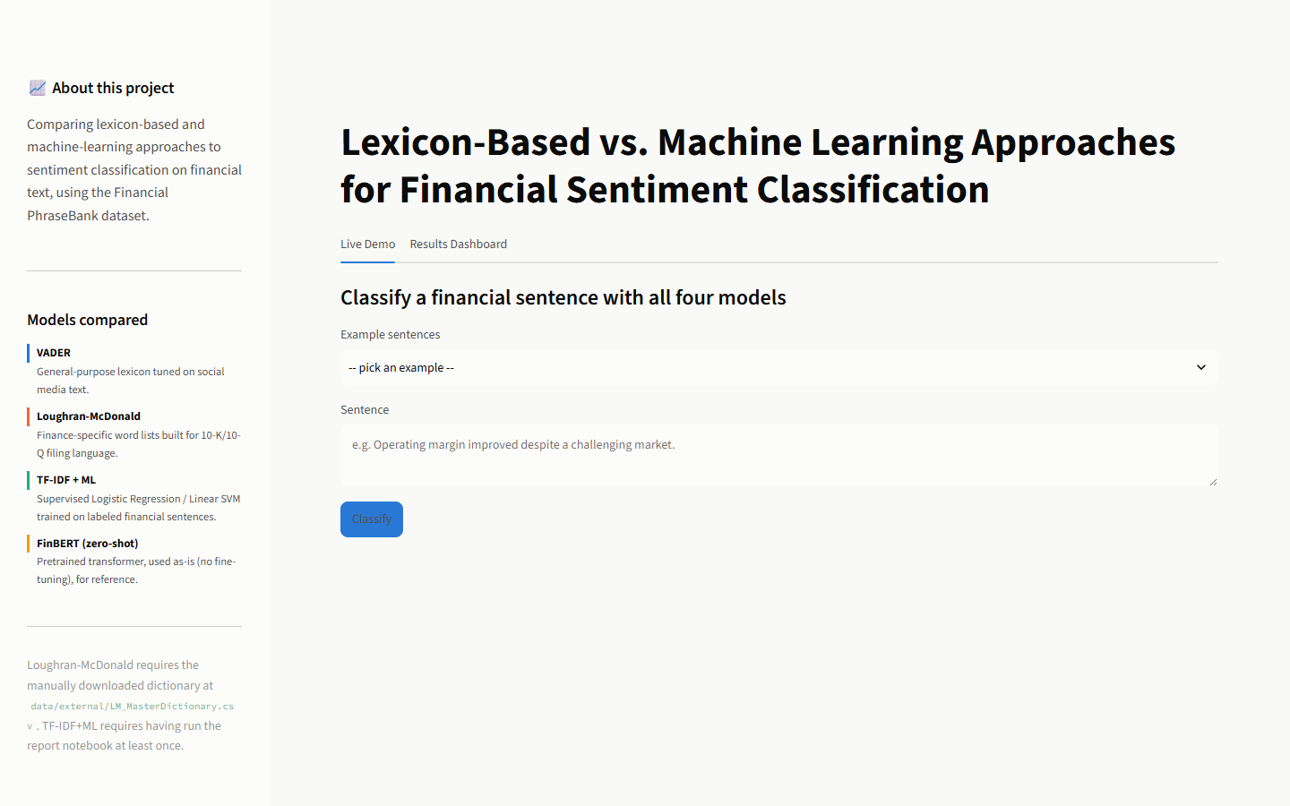
Figure 10.1 — Live Demo tab, landing state, with the sidebar model glossary.

A clearly positive example, where all four models agree:
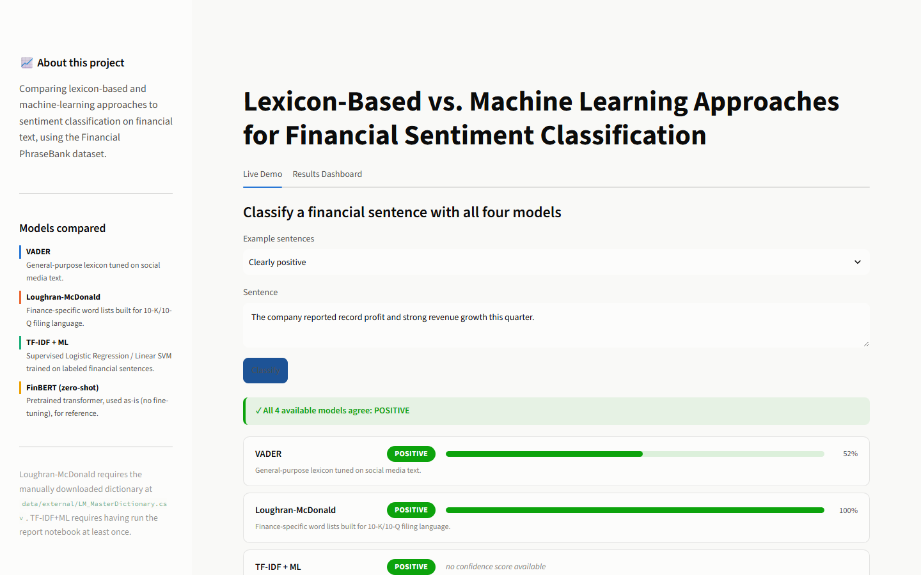
Figure 10.2 — All four models classify a clearly positive sentence, with confidence meters.

The hedged/neutral “hard case” discussed in Section 8.1, reproduced live in the dashboard — all four models incorrectly agree on positive, which is itself a useful demonstration of the project's central finding:
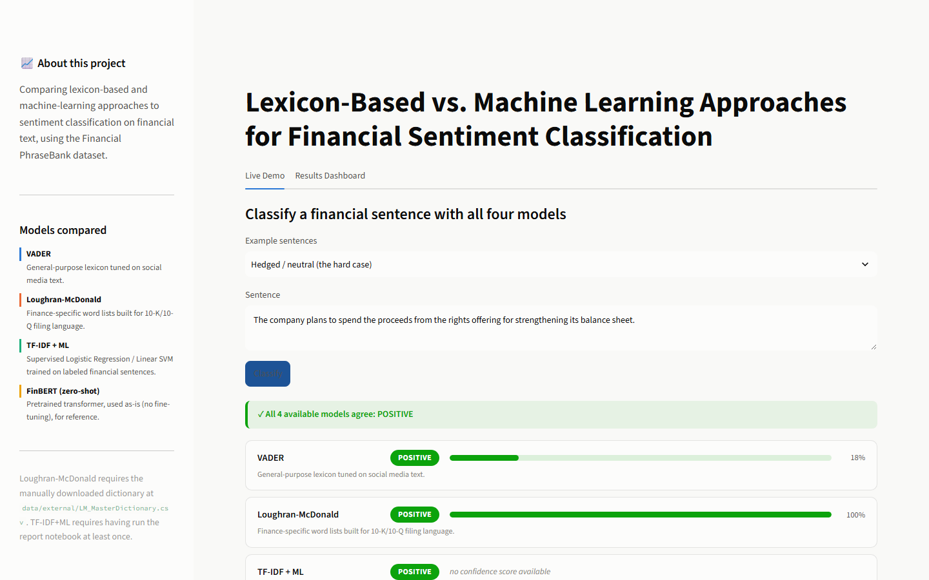
Figure 10.3 — The hedged-language example: every model misreads procedural language as positive sentiment.

10.2 Results Dashboard
The Results Dashboard opens with summary statistic tiles (best accuracy, best macro-F1, best neutral-class F1, macro-F1 lift from weakest to strongest model, and the significance-test summary) computed live from the results in Section 7, followed by the full comparison table:
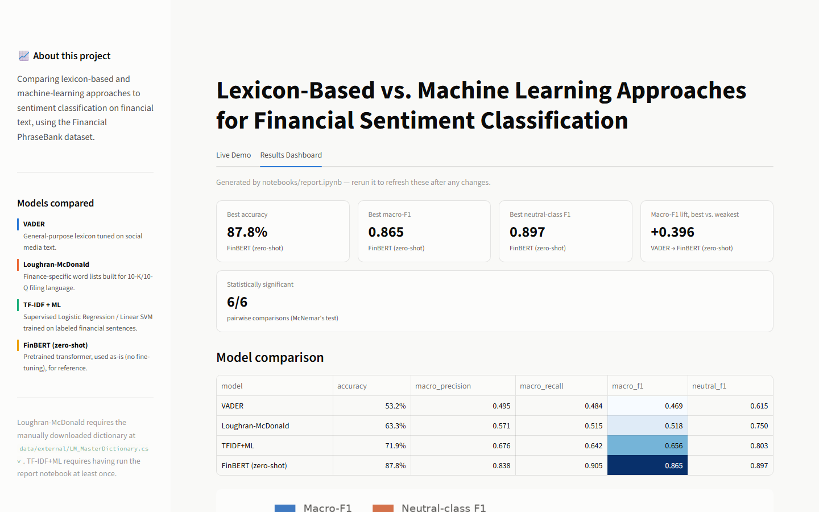
Figure 10.4 — Results Dashboard overview: stat tiles and the model comparison table.

Scrolling down surfaces the comparison chart and the full statistical-significance table from Section 7.3:
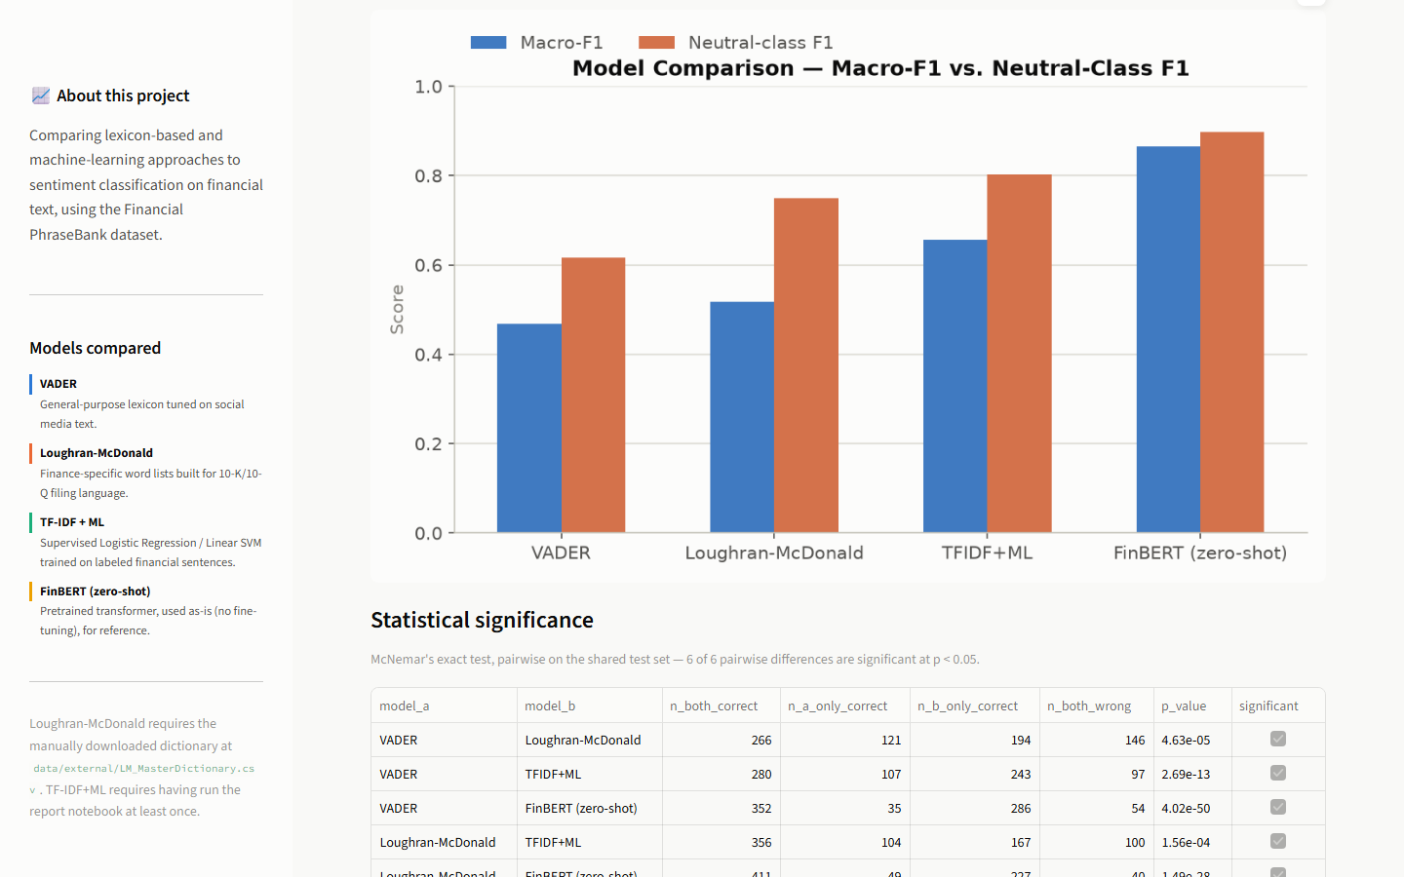
Figure 10.5 — Comparison chart and McNemar's-test significance table.

All four confusion matrices are shown together as a grid rather than one at a time:
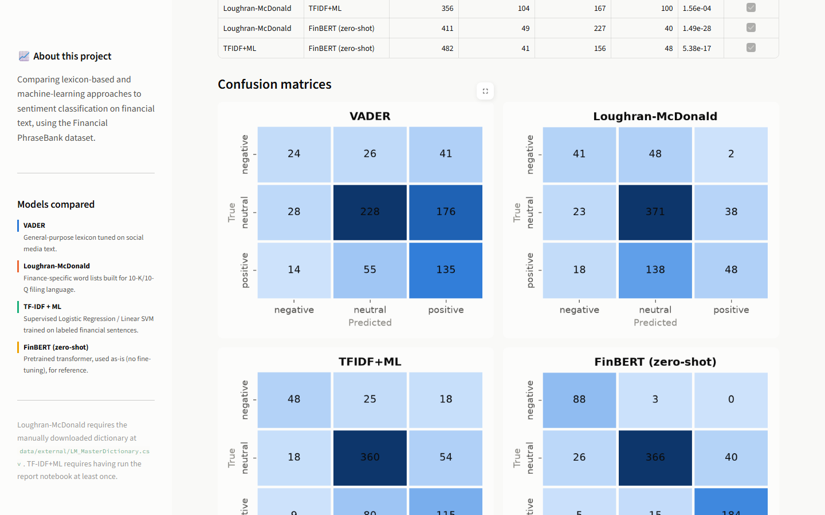
Figure 10.6 — Confusion matrices for all four models, shown together.

The dashboard also surfaces the cross-model “hardest sentences” table used for the error analysis in Section 8:
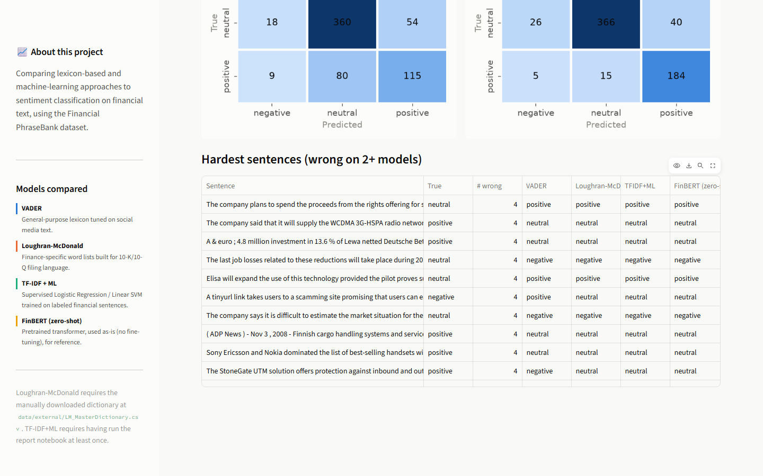
Figure 10.7 — Sentences misclassified by two or more models, with every model's prediction shown side by side.

11. Conclusion and Future Work
This project set out to measure whether domain adaptation improves sentiment classification on financial text, and if so, where the improvement actually comes from. The answer, based on a controlled comparison across four paradigms on the identical Financial PhraseBank test split, is unambiguous: accuracy rises monotonically from 53.2% (a general-purpose lexicon) to 63.3% (a finance-specific lexicon) to 71.9% (a supervised model trained on financial text) to 87.8% (a financial-domain pretrained transformer), with every pairwise difference statistically significant under McNemar's exact test. The gap is concentrated in the neutral class — neutral-class F1 rises from 0.615 to 0.897 across the same progression — confirming the project's original hypothesis that hedged, non-committal financial language is the primary source of difficulty that domain adaptation must overcome.
At the same time, the qualitative error analysis in Section 8 shows that no method, including the domain-pretrained transformer, is immune to this difficulty, and that some errors reflect the inherent difficulty of investor-perspective sentiment annotation rather than a deficiency of any one model. Simple, interpretable lexicon methods remain useful where transparency and zero training cost matter more than peak accuracy; supervised learning is clearly warranted once labeled financial text is available; and a domain-pretrained transformer provides the strongest results but at the cost of interpretability and (in a fully fair setup) additional fine-tuning effort.
Future work suggested directly by the limitations in Section 9 includes:
- Fine-tuning FinBERT on this project's own training split, to make the FinBERT vs. TF-IDF+ML comparison fully matched in training exposure.
- Re-running the full pipeline on the cleaner sentences_66agree and sentences_allagree subsets of Financial PhraseBank, to check whether the reported results are sensitive to annotation-agreement noise in the current dataset source.
- Extending the Loughran-McDonald scorer with negation-scope flipping, using the negation tokens already preserved through preprocessing but currently unused by the scoring rule.
- Cross-validating the TF-IDF+ML hyperparameter selection instead of relying on a single fixed validation split.

References
[1] Hutto, C., & Gilbert, E. (2014). VADER: A Parsimonious Rule-Based Model for Sentiment Analysis of Social Media Text. Proceedings of the International AAAI Conference on Web and Social Media, 8(1), 216–225. https://doi.org/10.1609/icwsm.v8i1.14550
[2] Loughran, T., & McDonald, B. (2011). When Is a Liability Not a Liability? Textual Analysis, Dictionaries, and 10-Ks. The Journal of Finance, 66(1), 35–65. https://doi.org/10.1111/j.1540-6261.2010.01625.x
[3] Malo, P., Sinha, A., Korhonen, P., Wallenius, J., & Takala, P. (2014). Good debt or bad debt: Detecting semantic orientations in economic texts. Journal of the Association for Information Science and Technology, 65(4), 782–796. https://doi.org/10.1002/asi.23062
[4] Araci, D. (2019). FinBERT: Financial Sentiment Analysis with Pre-trained Language Models. arXiv preprint arXiv:1908.10063.
[5] Karanikola, A., Davrazos, G., Liapis, C. M., & Kotsiantis, S. (2023). Financial sentiment analysis: Classic methods vs. deep learning models. Intelligent Decision Technologies, 17(4), 893–915. https://doi.org/10.3233/IDT-230478

