QA Automation Multi-Agent System
Design Document: FastMCP + CrewAI Implementation
Automated failure analysis, root-cause reporting, and self-healing test fixes
Prepared for: Engineering / QA Automation Team
Version 1.0

Table of Contents

1. Overview
This document describes the design of a multi-agent QA automation system that monitors Jenkins test runs, retrieves execution artifacts via a FastMCP server (instead of calling the Jenkins REST API directly), performs automated root-cause analysis on failures, generates failure and fix reports, and attempts automated code fixes through a CrewAI-orchestrated agent crew.
The system is intended to be implemented using Claude Code inside this workspace, with CrewAI as the agent orchestration framework and a FastMCP server as the abstraction layer over Jenkins.

1.1 Goals
- Eliminate manual triage of failed automated test runs.
- Standardize root-cause classification across flaky, environment, and genuine regression failures.
- Auto-generate structured failure and fix reports for stakeholders.
- Auto-patch common, low-risk failure patterns and raise a PR for review.
- Decouple the agent system from Jenkins' REST API specifics by using FastMCP as a tool layer, making the integration swappable and reusable across other CI systems.

1.2 Why FastMCP instead of direct Jenkins API calls
- FastMCP exposes Jenkins operations (build status, artifacts, console logs, test reports) as typed MCP tools that any MCP-compatible agent framework can call, instead of agents needing custom REST client code.
- CrewAI's MCPServerAdapter can connect to a FastMCP server (over stdio or streamable-HTTP) and automatically convert its tools into CrewAI Tool objects — no manual wrapper code per endpoint.
- Swapping or upgrading the CI backend later (e.g. GitLab CI, GitHub Actions) only requires a new MCP server; agent logic stays the same.
- Centralizes auth, retries, and rate-limiting for Jenkins access in one place (the MCP server) rather than scattering it across agents.

2. Architecture
The architecture has three zones: the Jenkins + FastMCP layer (data source), the CrewAI multi-agent system (processing), and the outputs layer (reports, PRs, notifications, and storage).
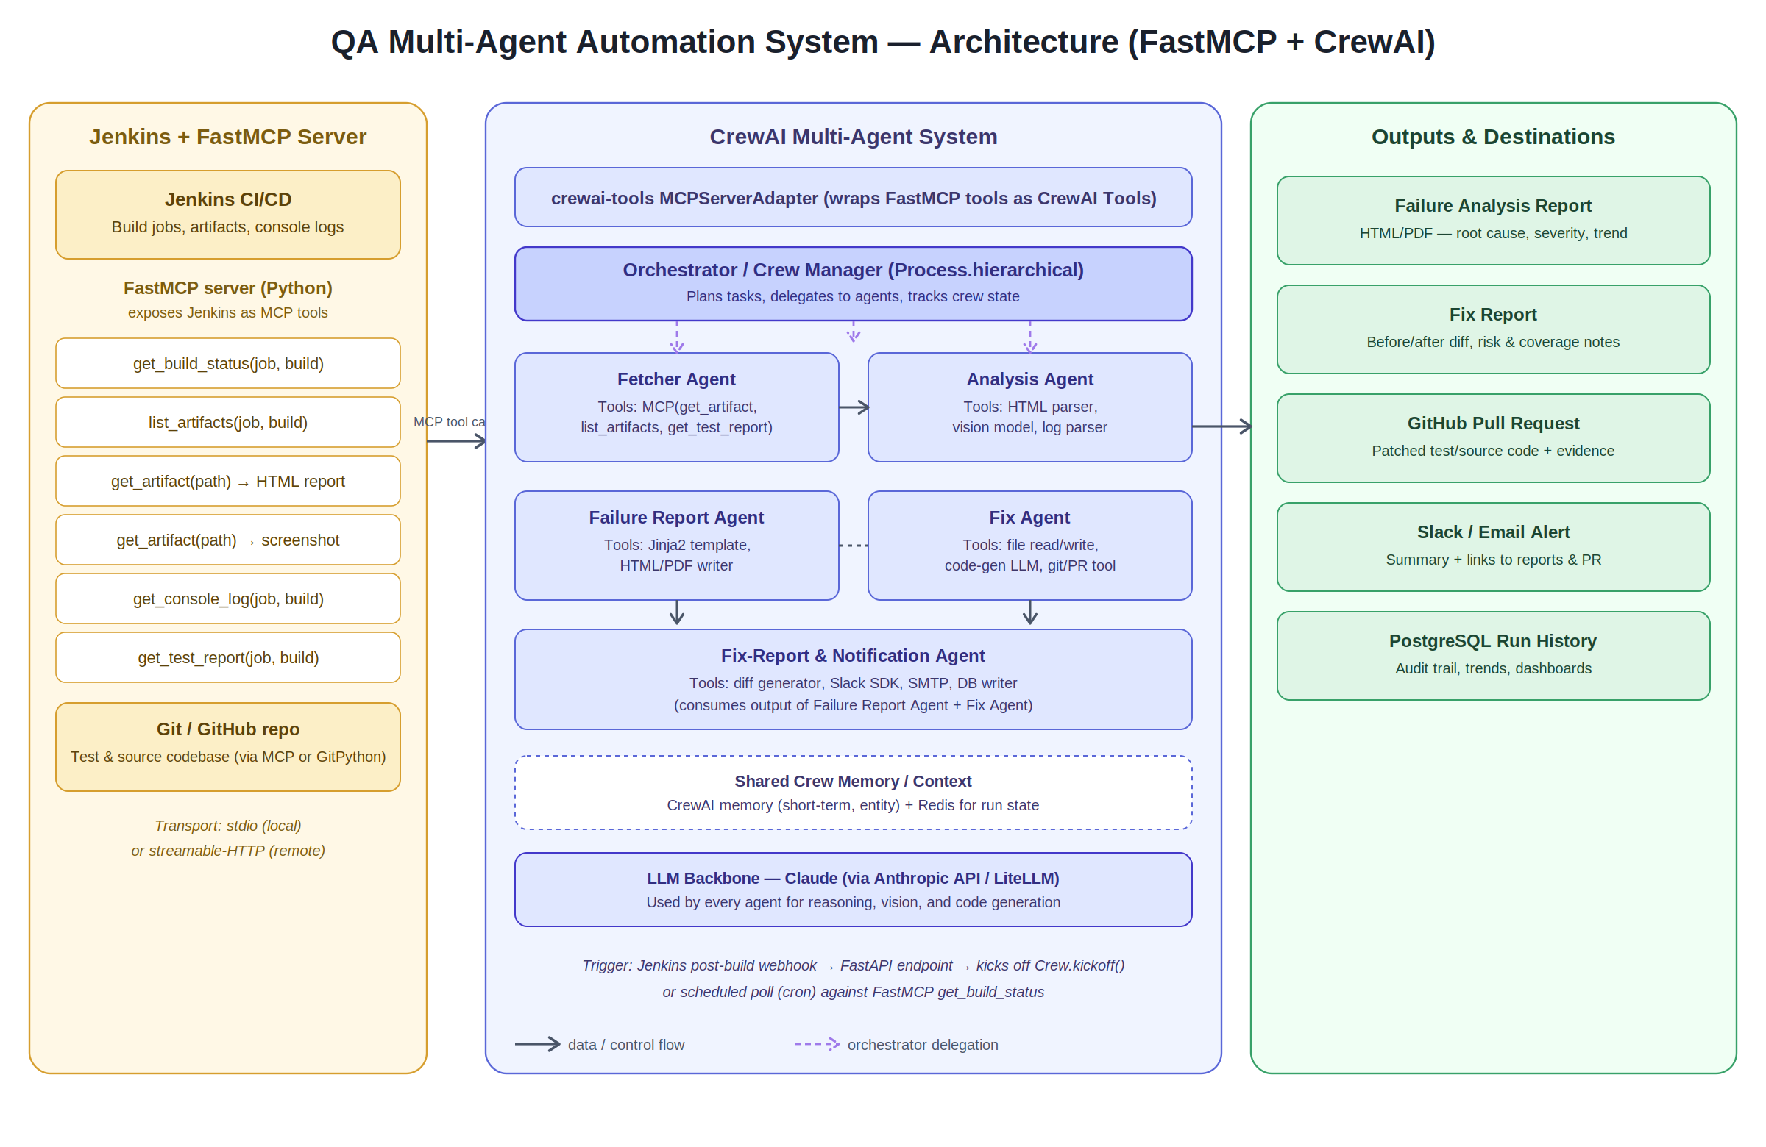
Figure 1 — System architecture: FastMCP server fronting Jenkins, CrewAI agent crew, and output destinations.

2.1 Component summary
Component | Responsibility | Key technology
FastMCP server | Exposes Jenkins build status, artifacts, console logs, and test reports as MCP tools | Python, FastMCP, python-jenkins or requests
MCPServerAdapter | Connects CrewAI to the FastMCP server and converts MCP tools into CrewAI Tools | crewai-tools
Orchestrator / Crew Manager | Plans and delegates tasks across agents; tracks run state | CrewAI Process.hierarchical
Fetcher Agent | Pulls HTML reports, screenshots, logs, and code via MCP tools | CrewAI Agent + MCP tools
Analysis Agent | Classifies and clusters root causes using text + vision | Claude (text + vision)
Failure Report Agent | Produces the structured failure report | Jinja2, WeasyPrint
Fix Agent | Generates and validates code patches, opens PRs | Claude code-gen, GitPython, GitHub API
Fix Report & Notify Agent | Diff summary, Slack/email alerts, DB persistence | Slack SDK, SMTP, SQLAlchemy

3. End-to-End Flow
The diagram below shows the sequential flow triggered by a Jenkins build completion, through analysis, reporting, fixing, and notification.
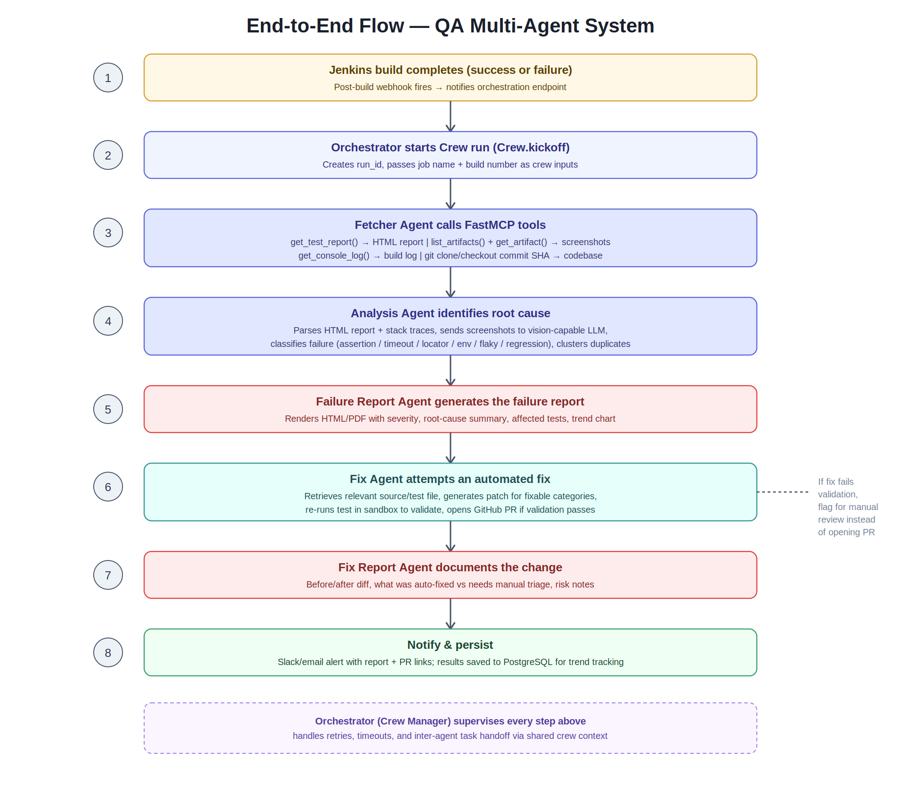
Figure 2 — End-to-end execution flow across all agents.

4. FastMCP Server Design
The FastMCP server is a thin, typed wrapper around Jenkins. It should be a standalone Python project, runnable independently of the agent crew, so it can be tested and versioned separately.

4.1 Proposed tools
Tool | Parameters | Returns
get_build_status | job_name, build_number | status, duration, timestamp, result
list_artifacts | job_name, build_number | list of artifact paths and types
get_artifact | job_name, build_number, artifact_path | raw bytes or base64 (HTML report / screenshot)
get_test_report | job_name, build_number | parsed JSON test report (pass/fail per test case)
get_console_log | job_name, build_number | plain-text console output
trigger_rebuild | job_name, params (optional) | new build number (used after a fix is merged)

4.2 Minimal server skeleton
# jenkins_mcp_server.py
from fastmcp import FastMCP
import jenkins
mcp = FastMCP("jenkins-qa-server")
client = jenkins.Jenkins(JENKINS_URL, username=USER, password=TOKEN)
@mcp.tool()
def get_build_status(job_name: str, build_number: int) -> dict:
info = client.get_build_info(job_name, build_number)
return {"result": info["result"], "duration": info["duration"]}
@mcp.tool()
def list_artifacts(job_name: str, build_number: int) -> list[dict]:
info = client.get_build_info(job_name, build_number)
return info.get("artifacts", [])
@mcp.tool()
def get_artifact(job_name: str, build_number: int, artifact_path: str) -> str:
# fetch via Jenkins artifact URL, return base64-encoded content
...
if __name__ == "__main__":
mcp.run(transport="stdio") # or transport="streamable-http"

4.3 Transport choice
- stdio — simplest, runs the MCP server as a local subprocess of the CrewAI process. Best for a single-machine setup or local Claude Code development.
- streamable-HTTP — run the FastMCP server as a separate persistent service (e.g. inside the Jenkins network) and have CrewAI connect over HTTP. Best when Jenkins is not reachable from where the agents run.

5. CrewAI Implementation Design

5.1 Project structure
qa-multiagent/
├── mcp_server/
│ └── jenkins_mcp_server.py
├── src/
│ ├── crew.py # Crew + agent + task definitions
│ ├── agents/
│ │ ├── fetcher.py
│ │ ├── analyzer.py
│ │ ├── failure_reporter.py
│ │ ├── fixer.py
│ │ └── fix_reporter.py
│ ├── tools/
│ │ └── mcp_adapter.py # wraps MCPServerAdapter config
│ ├── templates/
│ │ ├── failure_report.html.j2
│ │ └── fix_report.html.j2
│ └── main.py # FastAPI webhook receiver
├── tests/
├── pyproject.toml
└── .env

5.2 Connecting CrewAI to the FastMCP server
from crewai_tools import MCPServerAdapter
server_params = {
"command": "python",
"args": ["mcp_server/jenkins_mcp_server.py"],
}
with MCPServerAdapter(server_params) as mcp_tools:
fetcher_agent = Agent(
role="Jenkins Artifact Fetcher",
goal="Retrieve test reports, screenshots, logs and code for a failed build",
backstory="Expert at navigating CI artifacts via MCP tools",
tools=mcp_tools,
verbose=True,
)

5.3 Agent and task definitions (summary)
- Fetcher Agent — task: "Fetch the HTML report, screenshots, console log and code for job {job_name} build {build_number}."
- Analysis Agent — task: "Analyze the fetched artifacts and classify each failing test's root cause with confidence and evidence."
- Failure Report Agent — task: "Generate a structured failure report from the analysis output."
- Fix Agent — task: "For each fixable root cause, generate a patch, validate it, and open a PR."
- Fix Report & Notify Agent — task: "Summarize fixes vs. unresolved issues, notify the team, and persist the run."

5.4 Process type
Use Process.hierarchical with a manager LLM acting as the orchestrator, so the manager can dynamically decide whether to skip the Fix Agent (e.g., when root cause confidence is low) and re-route to manual triage instead of forcing every failure through the same fixed sequence.

5.5 Trigger mechanism
- A lightweight FastAPI endpoint receives the Jenkins post-build webhook and calls crew.kickoff(inputs={...}) asynchronously.
- Alternative: a scheduled poller calls the get_build_status MCP tool periodically and kicks off the crew when a new failed build is detected.

6. Implementation Plan
Phase | Duration | Deliverable
1. FastMCP server | Week 1 | Working MCP server exposing all 6 tools, tested standalone with MCP Inspector
2. CrewAI skeleton | Week 2 | Crew wired to MCP server; Fetcher Agent retrieving real artifacts
3. Analysis Agent | Weeks 3–4 | Root-cause classification + vision-based screenshot analysis
4. Reporting | Week 5 | Failure report template + generator
5. Fix Agent | Weeks 6–7 | Patch generation, sandbox validation, PR creation
6. Fix reporting & rollout | Week 8 | Diff reports, Slack/email notifications, DB persistence, webhook trigger live

6.1 Suggested Claude Code workflow
- Scaffold the repo structure shown in section 5.1 using Claude Code in this workspace.
- Implement and unit-test the FastMCP server in isolation first (mock Jenkins responses).
- Implement the CrewAI crew with the Fetcher Agent only; verify it can call the MCP tools end-to-end against a real or staging Jenkins.
- Add the Analysis Agent and validate classification quality on a sample of historical failed builds.
- Add reporting, then the Fix Agent behind a feature flag that defaults to "suggest only" (no auto-merge) until trusted.
- Wire the webhook trigger and notifications last, once the pipeline is validated manually.

7. Risks & Mitigations
Risk | Mitigation
Fix Agent introduces a bad patch | Sandbox re-run of the affected test before opening a PR; never auto-merge, always require human review
Root-cause misclassification on flaky tests | Track historical flakiness score per test; downweight confidence for known-flaky tests
FastMCP server becomes a bottleneck for large artifact downloads | Stream large artifacts, cache by build number, paginate console logs
Jenkins credentials exposure | Store credentials only in the MCP server's environment, never pass through agent prompts or logs

8. Next Steps
- Confirm Jenkins job naming conventions and artifact paths to finalize the get_artifact tool signature.
- Decide stdio vs streamable-HTTP transport based on where the crew will run relative to the Jenkins network.
- Set the initial scope of "auto-fixable" failure categories (recommend starting with stale-locator and wait-condition failures only).

