Bank Loan Report SQL Document

BANK LOAN REPORT | SUMMARY
KPI’s :
Total Loan Applications
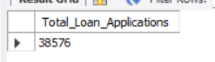
MTD(month to date)
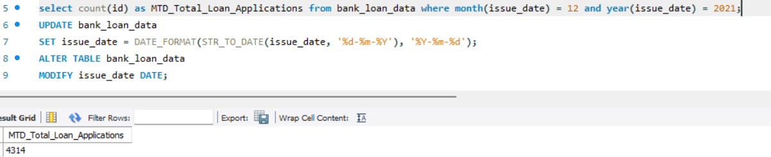
MOM(month on month)
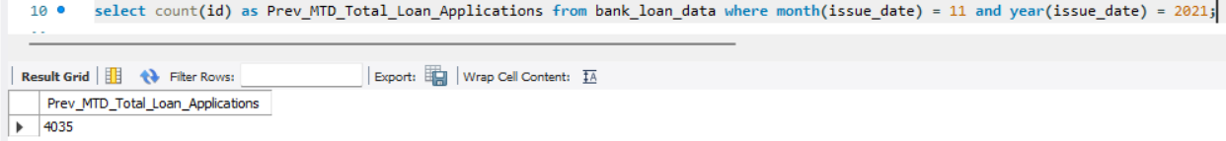
MOM= MTD - Prev_MTD / Prev_MTD
Total funded amount
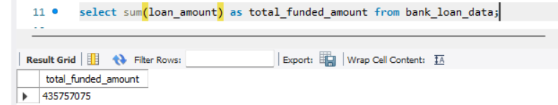
MTD
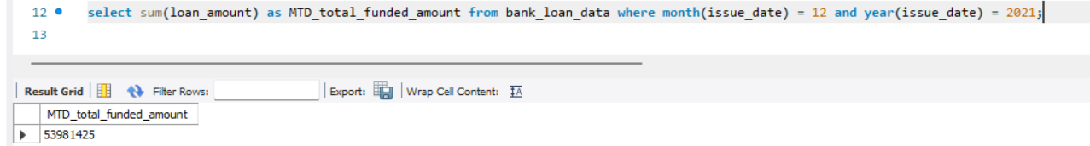
MOM(month on month)
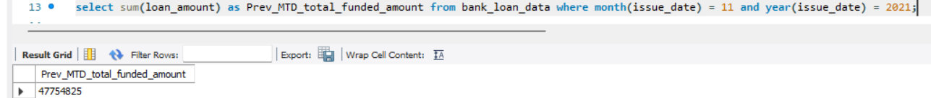
Total amount Received
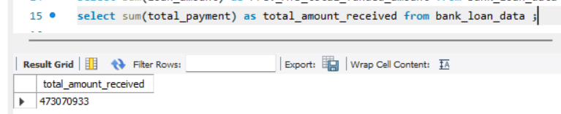
MTD
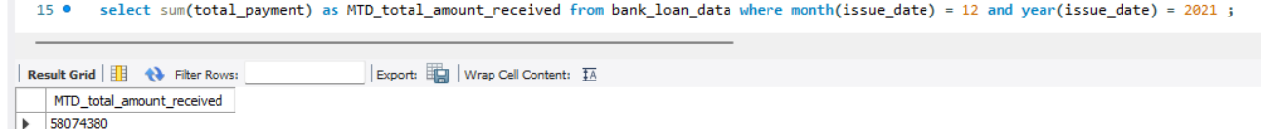
MOM
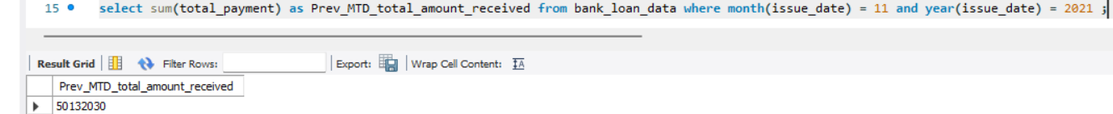
Average Interest Rate
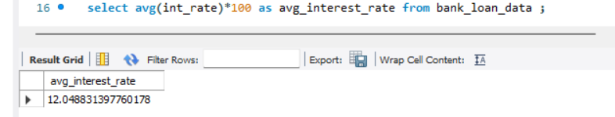
MTD
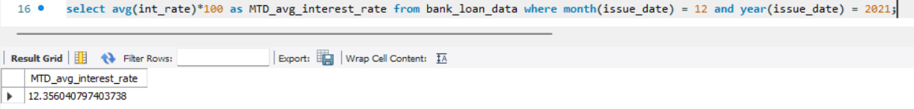
MOM
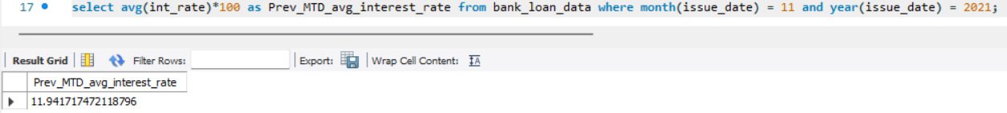
Average DTI(Debt to income Ratio)
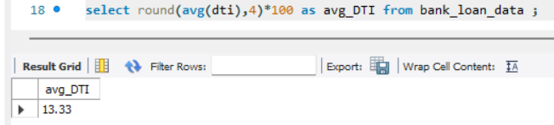
MTD
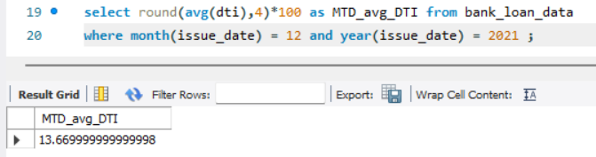
MOM
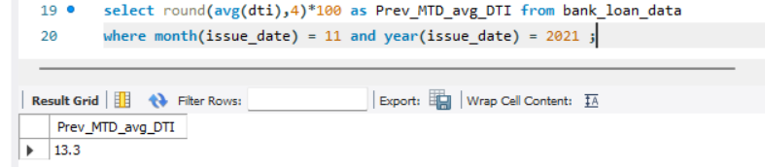
GOOD LOAN KPI’s
Good loan Percentage
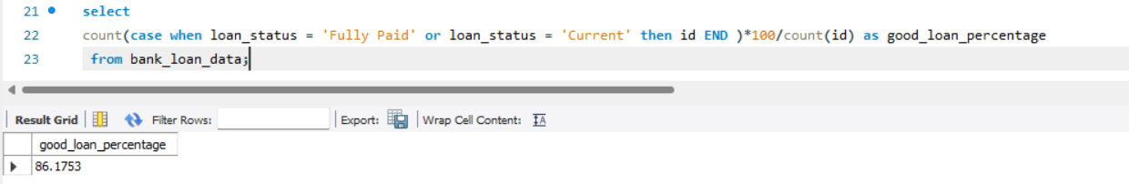
Good loan applications
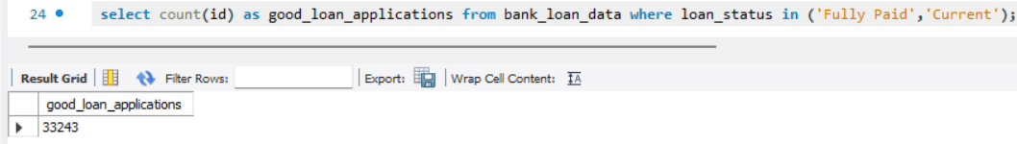
Good Loan Funded Amount
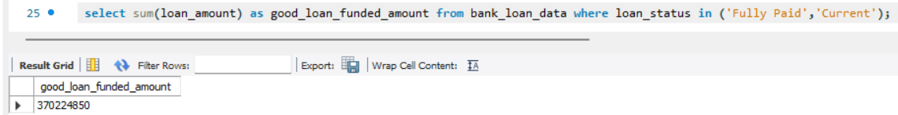
Good Loan Received amount
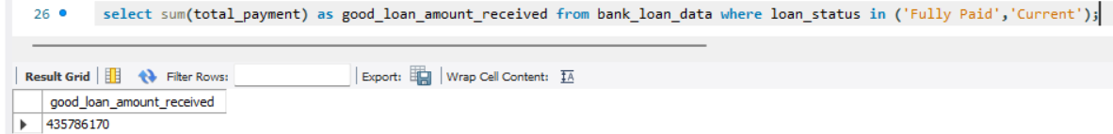
BAD LOANS
BAD LOAN PERCENTAGE
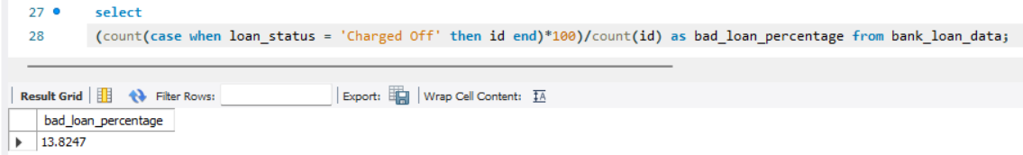
Bad loan applications
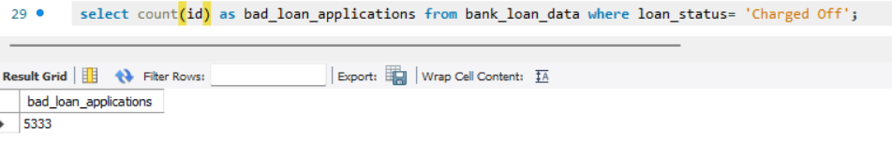

Bad loan funded amount
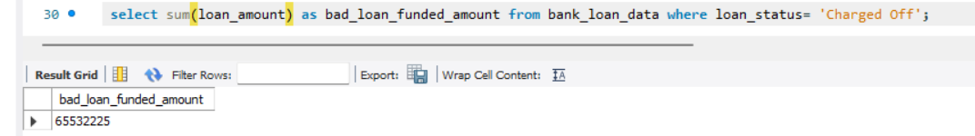
Bad loan received amount
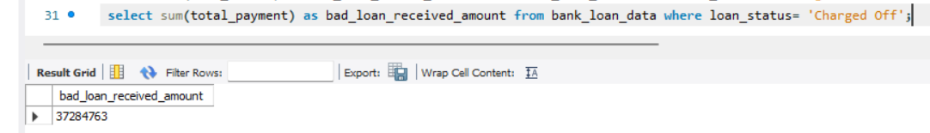
LOAN STATUS GRID VIEW
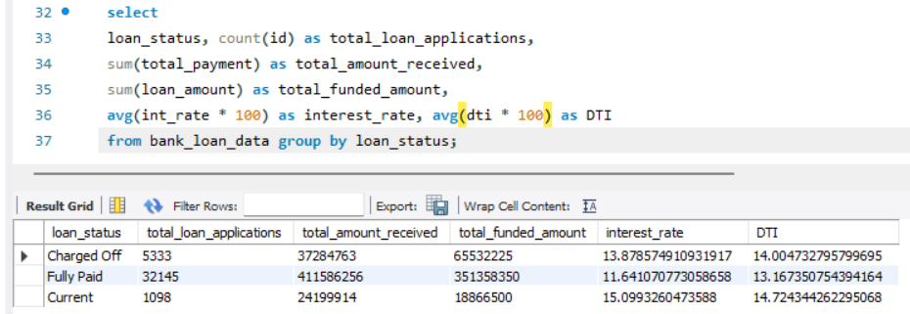
MTD
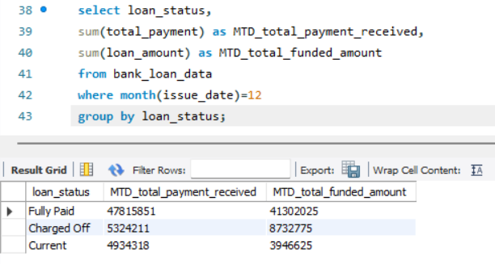

DASHBOARD-2 : OVERVIEW
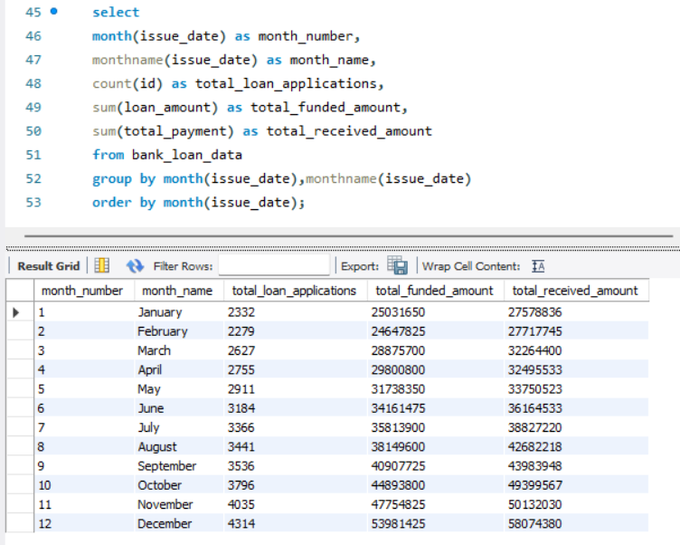
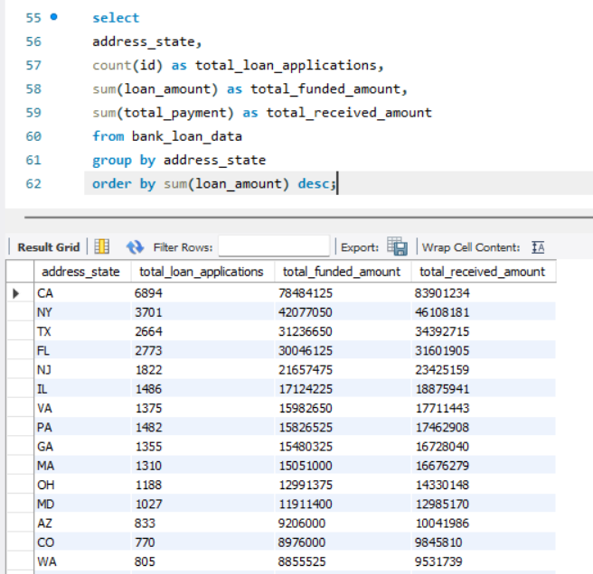
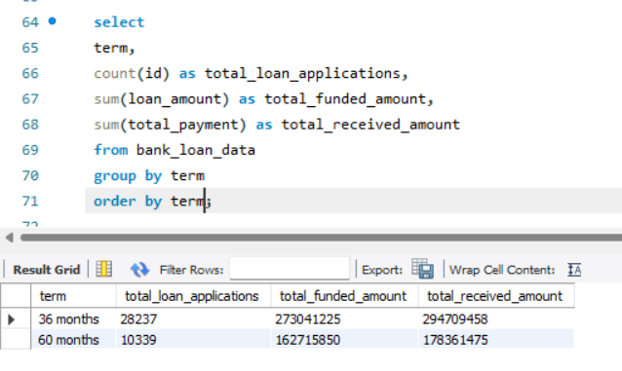

Emp work exp length
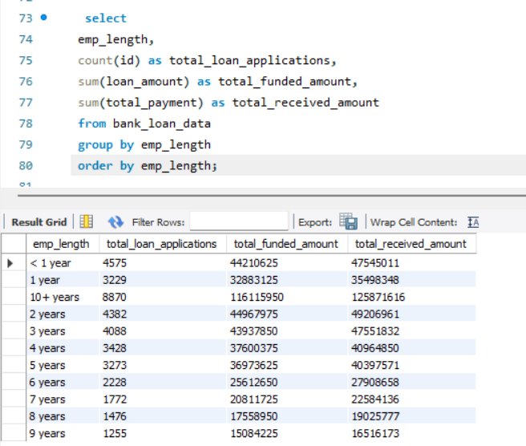
Purpose of loan
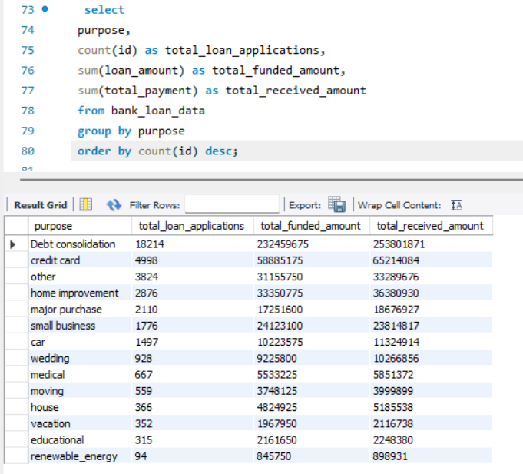
Home ownership status
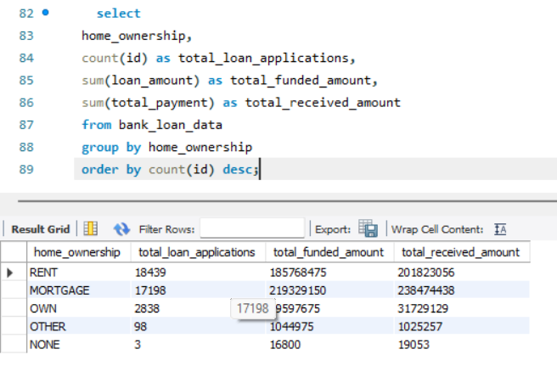
Applying some filters
for example
