INTERNSHIP REPORT
ON
MOMENTUM – PERSONAL PRODUCTIVITY DASHBOARD
Submitted to
School of Computer Science and Engineering
IILM University, Greater Noida, U.P.
In partial fulfillment of the requirement of degree of
B.Tech CSE

BY
NAME OF STUDENT: MAYANK PANDEY
ROLL NUMBER: 25scs1003002626
BATCH: 2025-29
Internship Role: Web Developer Intern
Organization: Codec Technologies Pvt. Ltd.
Internship Duration: 13/06/2026 to 16/07/2026

CANDIDATE’S DECLARATION
I, MAYANK PANDEY, do hereby declare that the internship report titled “Momentum – Personal Productivity Dashboard” has been completed by me to fulfil the requirement for the award of the degree of Bachelor of Technology in CSE. The report presents the work and learning undertaken during my internship as a Web Developer Intern at Codec Technologies Pvt. Ltd. I have quoted references wherever required and have not knowingly taken material from any other source without acknowledgement. I affirm that this report is my own work and has not been submitted to any other institute for any degree or diploma requirement. I shall be solely responsible for any copyright violation in this regard.
Signature
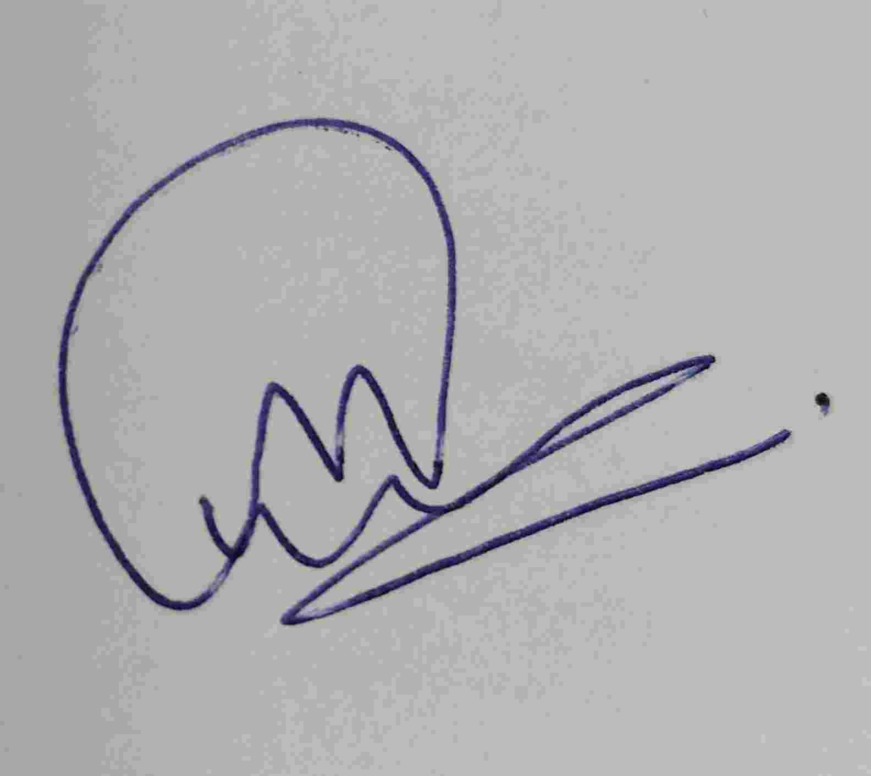
MAYANK PANDEY
Roll No.: 25scs1003002626

ACKNOWLEDGEMENT
I am using this opportunity to express my gratitude to everyone who supported me throughout the Internship Program. I am thankful for their guidance, constructive feedback and encouragement during the completion of the internship and the associated project work.
I sincerely thank Codec Technologies Pvt. Ltd. for providing me the opportunity to undertake a Web Developer Internship and for allowing me to gain practical exposure to web development concepts and project implementation. The internship helped me understand how a web application moves from planning and interface design to implementation, testing and deployment.
I am also grateful to the faculty and the School of Computer Science and Engineering, IILM University, Greater Noida, for their academic support and guidance. I express my gratitude to my parents for their blessings and continuous encouragement.
Signature

MAYANK PANDEY
Roll No.: 25scs1003002626

INTERNSHIP COMPLETION CERTIFICATE
Copy of the certificate issued by the organization
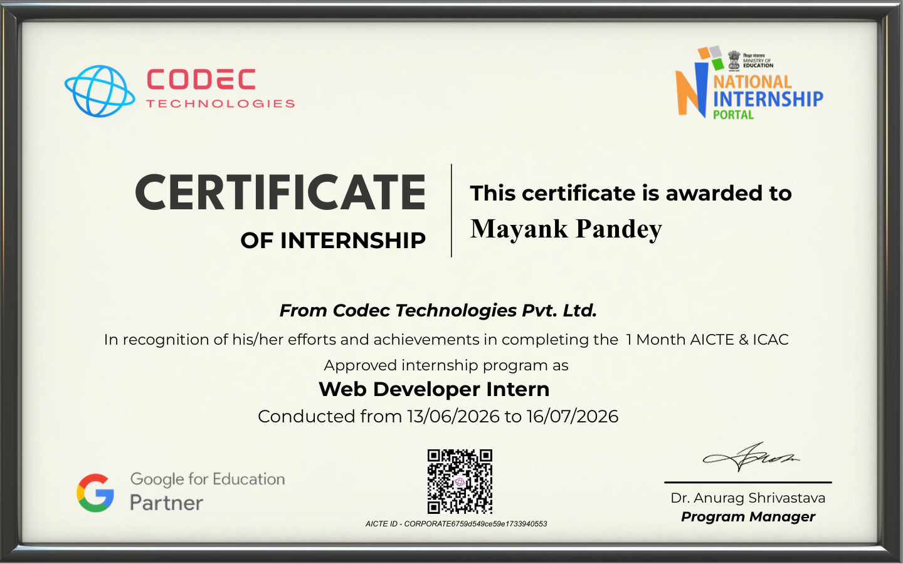

TABLE OF CONTENTS
Chapter No. | Chapter Name | Page No.
1. | Candidate’s Declaration | i
2. | Acknowledgement | ii
3. | Internship Completion Certificate | —
4. | Project Description | 2
4.1 | Introduction | 2
4.2 | Organization Profile | 3
4.3 | Problem Statement | 3
4.4 | Project Objectives | 5
4.5 | Scope of the Project | 5
4.6 | Technologies and Tools Used | 7
4.7 | System Architecture | 8
4.8 | Methodology | 10
4.9 | Expected Outcomes | 12
4.10 | Certificates of Completion and Other Communication Proof | 13
5. | Bibliography/References | 15

4. PROJECT DESCRIPTION

4.1 Introduction
Momentum – Personal Productivity Dashboard is a browser-based productivity application developed as the project component of the internship. The application brings common productivity activities into one interface, including task management, focus sessions, goals, notes and progress tracking. The project was implemented as a lightweight client-side web application using HTML, CSS and vanilla JavaScript, without a separate backend or build system.
The primary design objective was to create an interface that is simple to understand while still demonstrating practical web-development skills. The dashboard provides a central view of daily activity, while the individual sections allow users to manage tasks and goals, run focus sessions, maintain notes and observe progress. Data is persisted in the browser using localStorage so that the application can retain user state between sessions.
The project also emphasizes responsive interface design and accessibility-conscious interaction. Semantic HTML, visible focus states, keyboard-friendly controls and reduced-motion support are included in the implementation. The application provides light and dark themes and uses responsive navigation for smaller screens.
Project Snapshot
Item | Details
Project Title | Momentum – Personal Productivity Dashboard
Project Type | Client-side web application
Role | Web Developer Intern
Primary Technologies | HTML5, CSS3, JavaScript
Data Persistence | Browser localStorage
Deployment | GitHub Pages

4.2 Organization Profile
According to the internship offer letter, Codec Technologies is described as a global platform dedicated to empowering learners and connecting diverse talent to create meaningful career opportunities worldwide. The offer letter states that the organization delivers dedicated IT and business consultancy services across 27+ countries, with a focus on global innovation and strategic growth. The internship was offered in a hybrid, Pan-India mode and the candidate was assigned the designation of Web Developer Intern.
The offer letter specifies the internship duration as 13/06/2026 to 16/07/2026 and states that interns were expected to complete assigned projects and training tasks through the organization’s platform and email. The internship therefore provided a context for applying web-development concepts in a structured project environment.

4.3 Problem Statement
Managing personal productivity often involves switching between separate applications for tasks, notes, goals and time-management activities. This fragmentation can make it difficult to maintain a clear view of daily priorities and progress. The problem addressed by Momentum is to design a single, simple web interface where these activities can be organized and tracked without requiring a complex setup or external backend.
The application should provide an understandable dashboard, allow users to create and complete tasks, support focused work sessions, manage goals and notes, calculate simple productivity indicators and preserve information locally in the browser. The solution should also remain responsive and usable across common desktop and mobile screen sizes.
Figure 4.2 Project interface
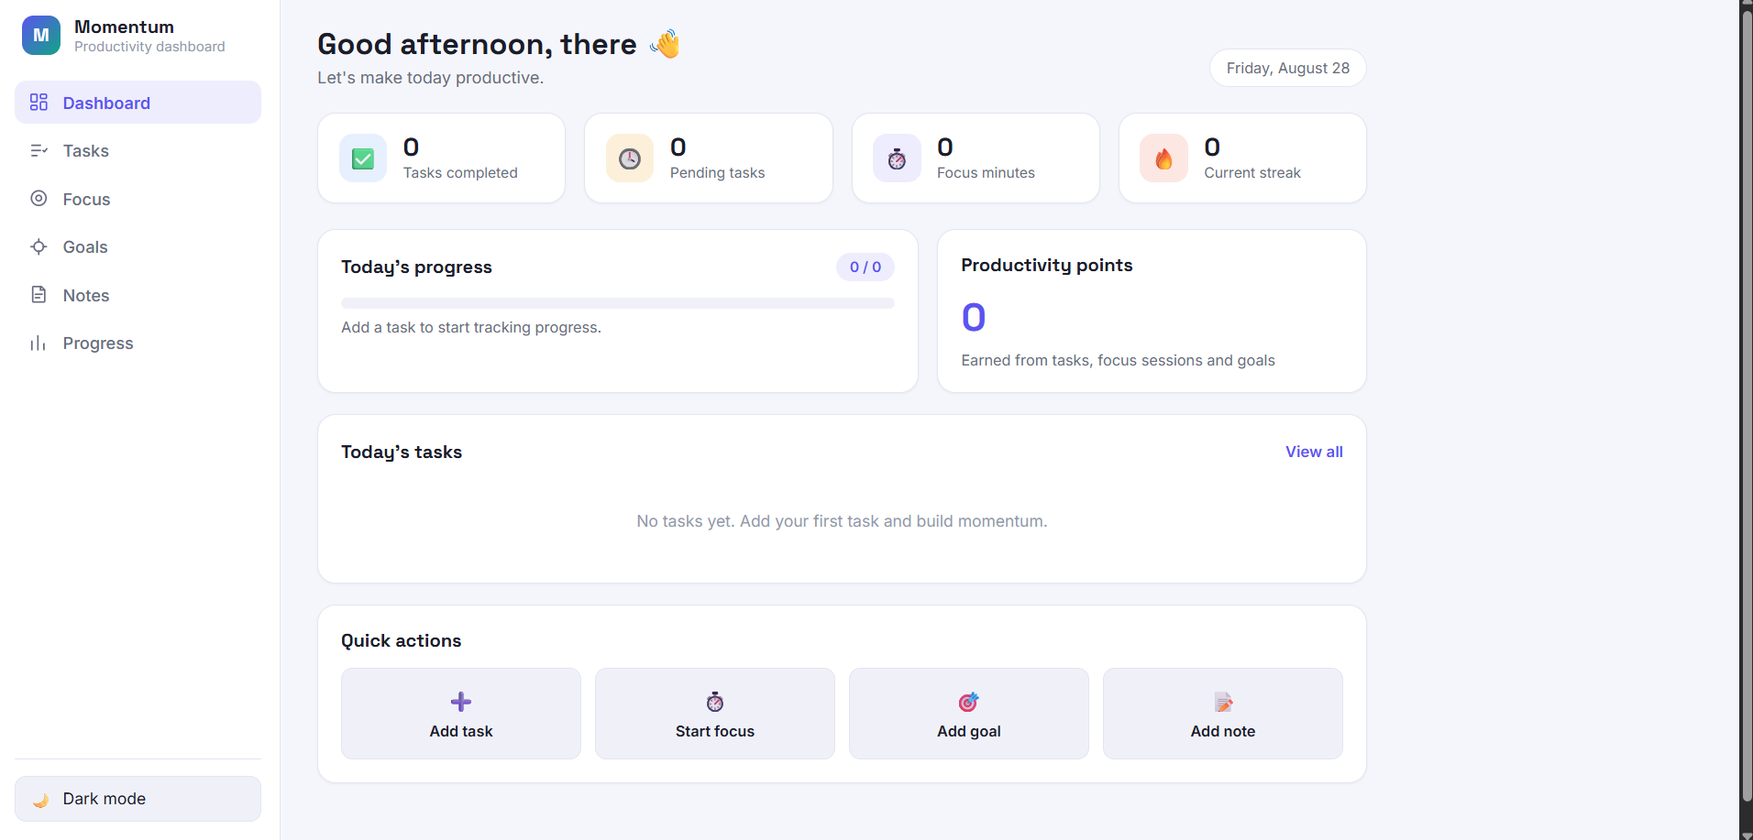
Figure 4.2 Momentum dashboard interface

4.4 Project Objectives
- Design and develop a clean, responsive productivity dashboard using standard web technologies.
- Implement task creation, completion, filtering and daily progress tracking.
- Provide a focus-session timer with session statistics and productivity points.
- Provide goal and note management features within the same application.
- Use browser localStorage to persist application state without a server-side database.
- Implement a light/dark theme and responsive navigation for different screen sizes.
- Apply basic accessibility practices such as semantic controls, focus indicators and reduced-motion support.
- Deploy the completed static web application using GitHub Pages and maintain its source code in a GitHub repository.

4.5 Scope of the Project
The current scope covers a front-end productivity dashboard that runs entirely in the browser. It includes a dashboard overview, task management, focus timer, goals, notes, progress indicators, achievements, productivity points and theme switching. The application stores data locally using the browser’s localStorage API.
The project does not include a user authentication system, cloud synchronization, a server-side database, multi-user collaboration or a separate REST API. These areas can be considered future extensions if the application is developed further. Keeping the current implementation client-side makes the project lightweight and suitable for static deployment.
Figure 4.3 Development environment
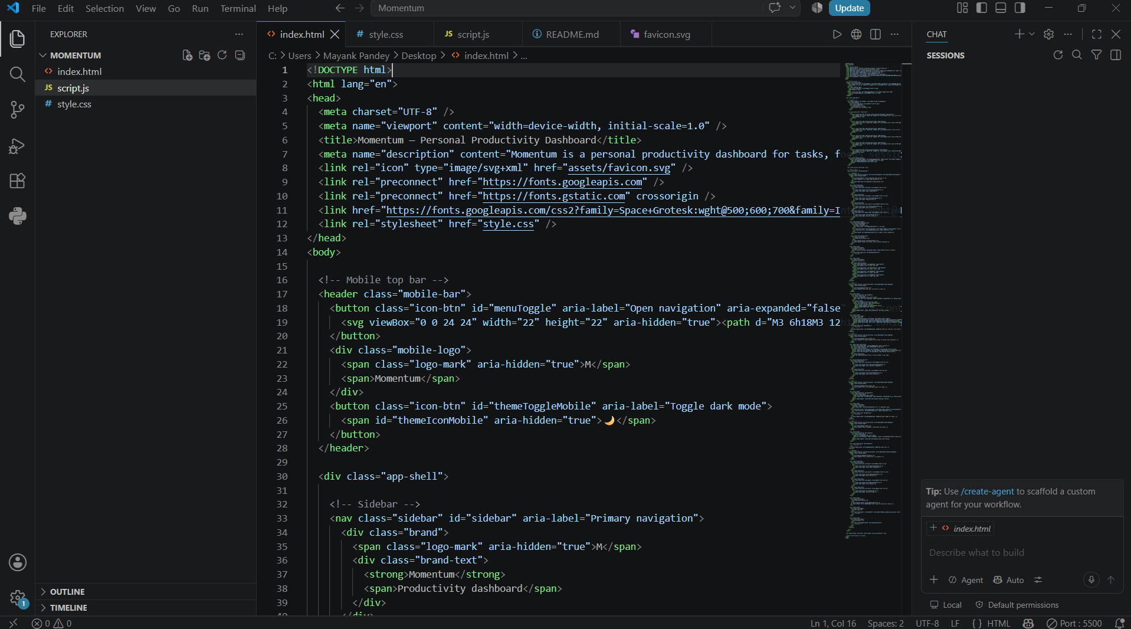
Figure 4.3 Implementation and testing in Visual Studio Code

4.6 Technologies and Tools Used
Technology / Tool | Purpose | Application in Project
HTML5 | Structure and semantics | Defines the application shell, navigation, sections, forms and content.
CSS3 | Presentation and responsive design | Controls layout, themes, cards, buttons, responsive behavior and visual states.
JavaScript (Vanilla) | Application logic | Handles events, navigation, state updates, timers, calculations and UI rendering.
localStorage API | Client-side persistence | Stores tasks, goals, notes, theme, focus data, points and progress-related state.
Visual Studio Code | Development environment | Used to create, edit, organize and test the project files.
Live Server | Local testing | Used to serve the static application locally during development.
Git & GitHub | Version control and hosting | Repository management and source-code hosting.
GitHub Pages | Deployment | Publishes the static web application as a public website.
The project deliberately avoids frameworks and a build step. This keeps the implementation easy to inspect and demonstrates understanding of core front-end technologies. External Google Fonts are referenced by the HTML document for typography, while the functional application logic remains local to the project.
Repository and deployment
The project source is maintained in the internship GitHub repository. The application is deployed through GitHub Pages from the main branch and the root directory. This makes the final project accessible through a public browser URL while preserving the source files and documentation in the same repository.
GitHubRepository:https://github.com/mayank87pandey-netizen/2025-29_MayankPandey_25scs1003002626_3rdsem_2CSE15

4.7 System Architecture
Momentum follows a simple client-side architecture. The browser loads the HTML document, applies the CSS presentation layer and executes the JavaScript application logic. User interactions are handled through JavaScript event listeners. Application data is maintained in an in-memory state object and persisted to localStorage using JSON serialization.
The architecture is intentionally lightweight. There is no application server or database in the current version. This reduces deployment complexity and allows the application to be hosted as a static site. The same architecture also makes the project suitable for demonstrating the fundamentals of front-end web development.
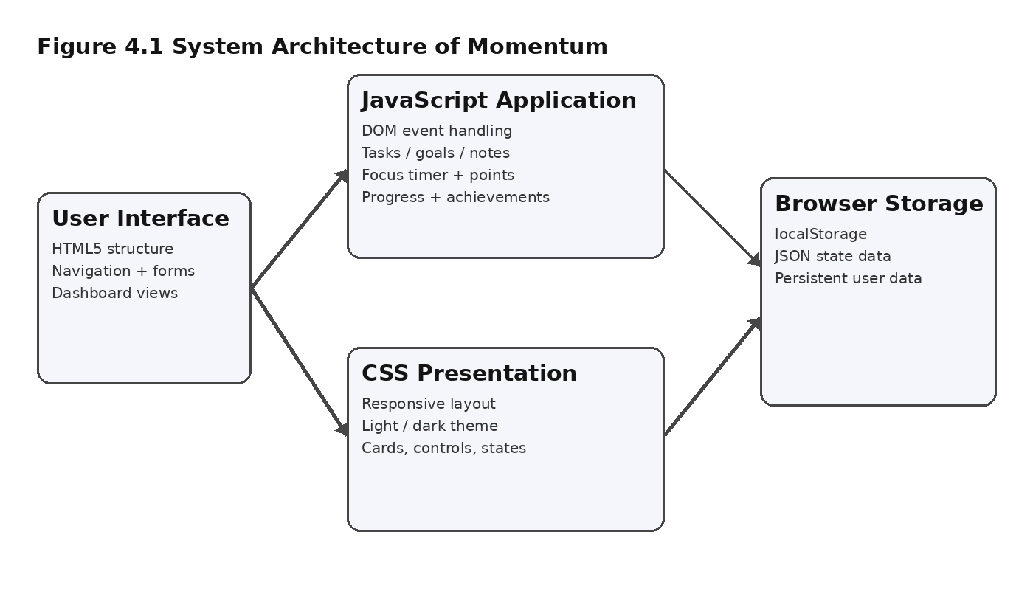
Figure 4.1 System Architecture of Momentum
Major modules
- Dashboard Module – summarizes tasks completed, pending tasks, focus minutes, streak and productivity points.
- Task Module – supports adding tasks, assigning priority, completing tasks and filtering task views.
- Focus Module – provides timed focus sessions and records completed focus activity.
- Goal Module – manages user goals and completion status.
- Notes Module – provides a simple space for storing personal notes.
- Progress Module – presents productivity history, achievements and related indicators.
- Theme and Navigation Module – controls section navigation, responsive sidebar behavior and light/dark theme state.

4.8 Methodology
Stage | Description
Requirement Identification | The project requirements were translated into a small set of productivity modules: tasks, focus sessions, goals, notes and progress. The objective was to keep the interface useful without adding unnecessary backend complexity.
Interface Planning | A dashboard-first layout was selected with a persistent sidebar on larger screens and a mobile navigation bar on smaller screens. Cards and sections were used to make important information visually scannable.
HTML Structure | The application was organized with semantic HTML elements for navigation, buttons, headings, sections and forms. Accessibility attributes and labels were included where appropriate.
CSS Implementation | CSS custom properties were used for design tokens such as colors, spacing, borders and typography. Separate theme values support light and dark modes. Media queries provide responsive behavior.
JavaScript Implementation | Vanilla JavaScript manages application state, user events, navigation, form submission, timer behavior, points, achievements and dynamic rendering. The code is organized into logical sections for configuration, storage, state and UI behavior.
Data Persistence | A small localStorage wrapper saves and loads JSON data. This allows tasks, goals, notes, theme settings, focus information and productivity state to persist after refresh.
Testing | The application was run locally using a browser-based development server. Each major module was tested through normal user interactions, including adding and completing tasks, using the focus controls, creating goals and notes, switching themes and refreshing the page.
Deployment | The completed files were uploaded to the GitHub internship repository and configured for GitHub Pages. The public deployment was then checked in the browser.
Figure 4.4 Development workflow
Requirements → UI Planning → HTML/CSS → JavaScript Logic → Local Persistence → Testing → GitHub Deployment

4.9 Expected Outcomes
The expected outcome of the internship project is a functional, responsive and maintainable productivity dashboard that demonstrates practical front-end web-development skills. The completed implementation meets the core objective of providing a single interface for managing everyday productivity activities.
- Functional task management with completion status, priorities and dashboard statistics.
- Working focus-session timer with stored focus statistics and productivity points.
- Goal and note management within the same application interface.
- Persistent browser-side data using localStorage.
- Responsive layout that adapts the navigation and content for smaller screens.
- Light and dark theme support.
- Achievement and streak concepts that provide simple motivation and progress feedback.
- Public deployment through GitHub Pages, making the project accessible for demonstration.
- Documented source code and README content maintained in the GitHub repository.
Learning outcomes
Through the implementation, practical understanding was developed in semantic HTML, CSS layout and responsive design, JavaScript event handling, DOM manipulation, state management, browser storage, basic accessibility considerations, local testing and static web deployment. The project also provided experience in organizing a small web application into reusable conceptual modules and documenting the work for portfolio and academic purposes.
Limitations and future enhancement
Because the current version is intentionally client-side, data is tied to the browser in which it is stored. Future versions could add authentication, cloud synchronization, a backend database, cross-device access, richer analytics and optional integrations such as calendar or notification services. These enhancements are outside the present project scope.

4.10 Certificates of Completion and Other Communication Proof
The internship completion certificate issued by Codec Technologies Pvt. Ltd. is attached immediately after the Acknowledgement section as required by the report format. The certificate identifies MAYANK PANDEY as a Web Developer Intern and records the internship period from 13/06/2026 to 16/07/2026.
Figure 4.5 Internship Completion Certificate

Figure 4.5 Internship Completion Certificate issued by Codec Technologies Pvt. Ltd.
The internship offer letter is also included as supporting communication proof. It states the designation as Web Developer Intern, the Pan-India hybrid mode, the internship duration and the assigned-project/training expectations.
Figure 4.6 Internship Offer Letter
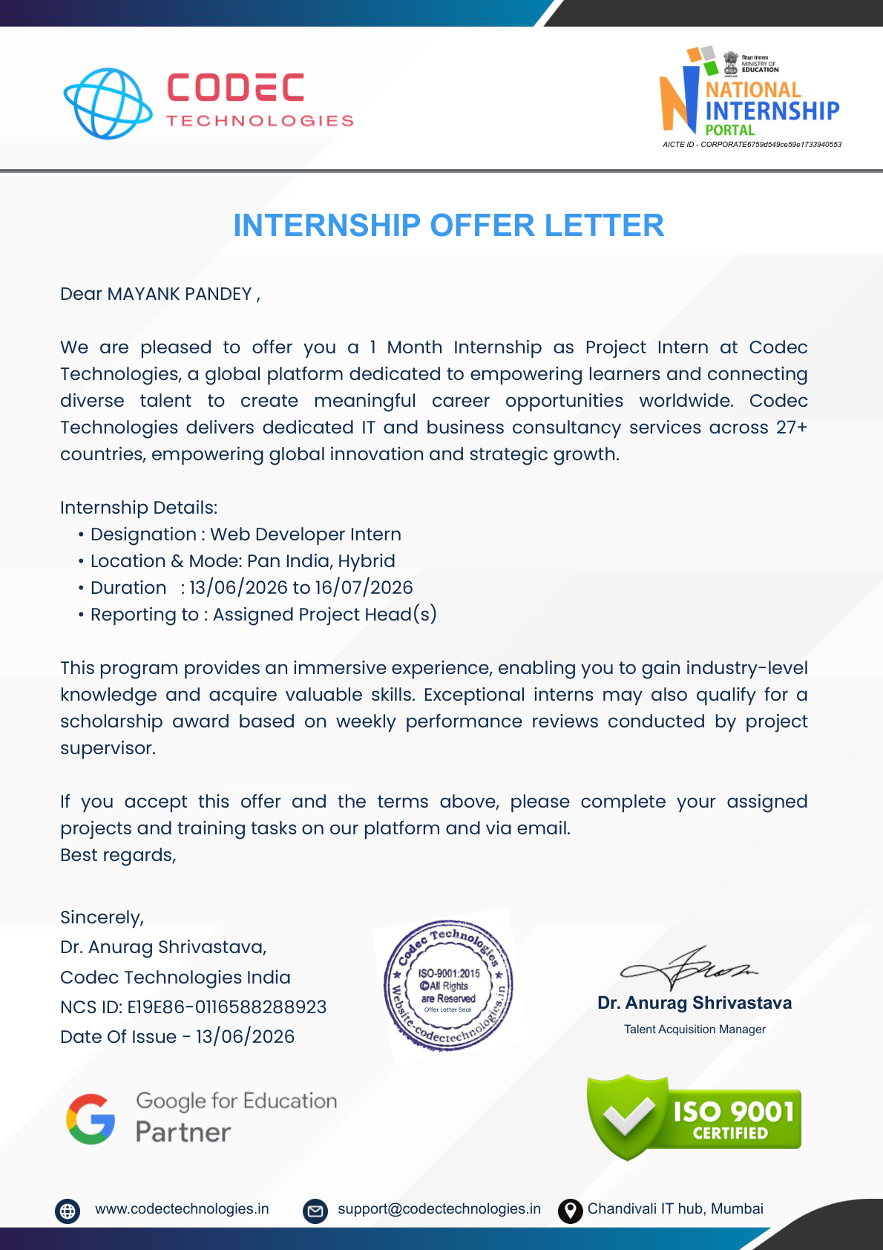
Figure 4.6 Internship Offer Letter from Codec Technologies

5. BIBLIOGRAPHY / REFERENCES
Codec Technologies Pvt. Ltd. (2026). Internship Offer Letter issued to MAYANK PANDEY, dated 13/06/2026.
Codec Technologies Pvt. Ltd. (2026). Internship Completion Certificate for the Web Developer Intern program, covering 13/06/2026 to 16/07/2026.
Mozilla Developer Network (MDN). HTML, CSS, JavaScript and Web Storage API documentation used as general technical references.
GitHub Documentation. GitHub Pages documentation for publishing static websites.
W3C Web Accessibility Initiative (WAI). General accessibility guidance for web content and user interface development.
ProjectRepository:https://github.com/mayank87pandey-netizen/2025-29_MayankPandey_25scs1003002626_3rdsem_2CSE15
Live Project: Momentum – GitHub Pages

