DHT11 Azure IOT Data

Monitoring

Hardware components

- Raspberry Pi 3

- DHT11 Temperature & Humidity Sensor (3 pins)
Overview of DHT11 Sensor:

- The DHT11 sensor can measure relative humidity and temperature with the following specifications:

- Temperature Range: 0-50°C

- Temperature Accuracy: ±2 °C

- Humidity Range: 20-90% RH

- Humidity Accuracy: ±5 %
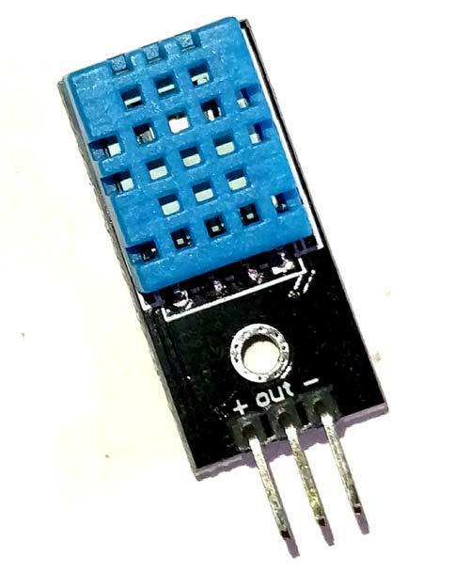
How DHT11 Sensor works:

- The DHT11 sensor comes with a blue or white colour casing. Inside this casing we have two important componentswhich help us to sense the relative humidity and temperature. The first component is a pair of electrodes; the electrical resistance between these two electrodes is decided by a moisture holding substrate. So the measured resistance is inversely proportional to the relative humidity of the environment. Higher the relative humidity lower will be the value of resistance and vice versa. Also note that Relative humidity is different from actual humidity. Relative humidity measures the water content in air relative to the temperature in the air.

- The other component is a surface mounted NTC Thermistor. The term NTC stands for Negative temperature coefficient, for increase in temperature the value of resistance will decrease
Installing the Adafruit DHT11 library on Raspberry Pi:

- Enter the four command lines one by one on the terminal to install the DHT library:

>>git clone https://github.com/adafruit/Adafruit_Python_DHT.git >>cd Adafruit_Python_DHT

>>sudo apt-get install build-essential python-dev >>sudo python setup.py install
End-to-end communication

- To get started with Azure IoT, we need to have an Azure account. If you do not have an Azure account, you can create one by navigating to this URL: https://azure.microsoft.com/en-in/free/.

- Once you have created your account, you can log in and navigate to the Azure portal or you can visit https://portal.azure.com to reach the required page.
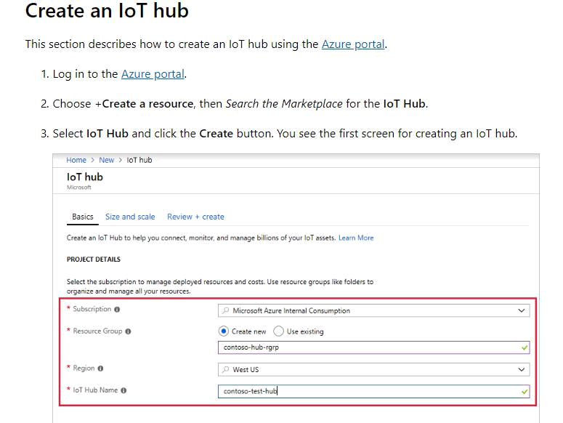
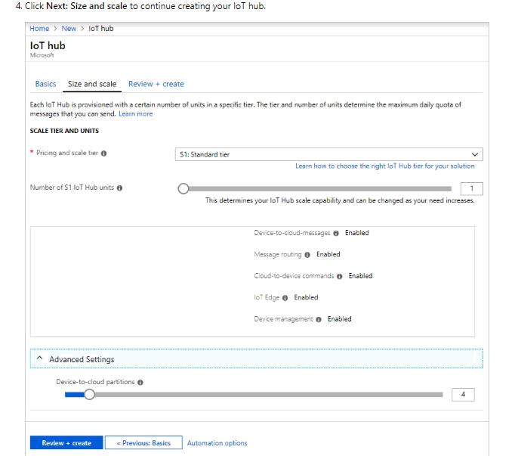
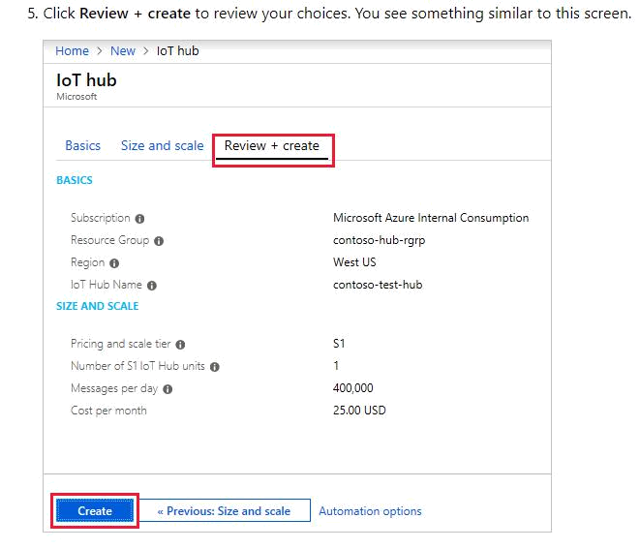
Setting up Raspberry Pi on the DHT11 node
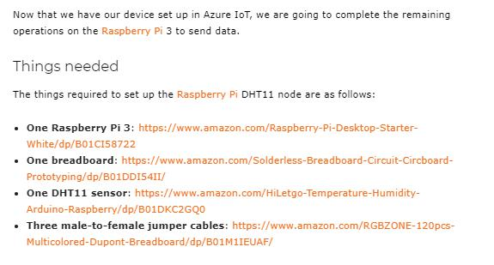
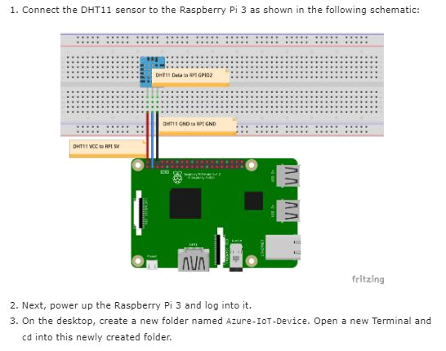
Send simulated telemetry

- The simulated device application connects to a device-specific endpoint on your IoT hub and sends simulated temperature and humidity telemetry.

- In a local terminal window, navigate to the root folder of the sample Python project.

- Open the SimulatedDevice.py file in a text editor of your choice.

- Replace the value of the CONNECTION_STRING variable with the device connection string you made a note of previously. Then save your changes to <Filename>.py file.

- In the local terminal window, run the following commands to install the required libraries for the simulated device application:

>>pip install azure-iothub-device-client

- In the local terminal window, run the following commands to run the simulated device application:

>>python SimulatedDevice.py
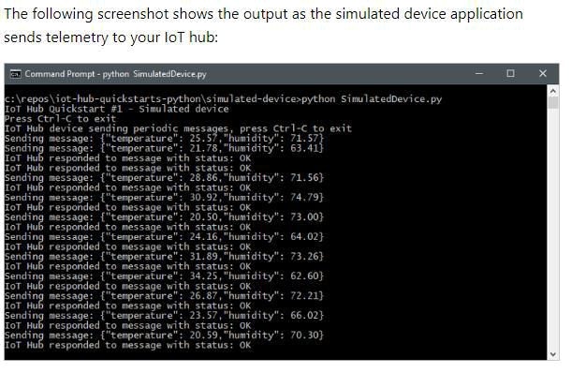
Read the telemetry from your hub

- The IoT Hub CLI extension can connect to the service-side Events endpoint on your IoT Hub. The extension receives the device-to-cloud messages sent from your simulated device. An IoT Hub back-end application typically runs in the cloud to receive and process device-to-cloud messages.

- Run the following commands in Azure Cloud Shell, replacing YourIoTHubName with the name of your IoT hub:

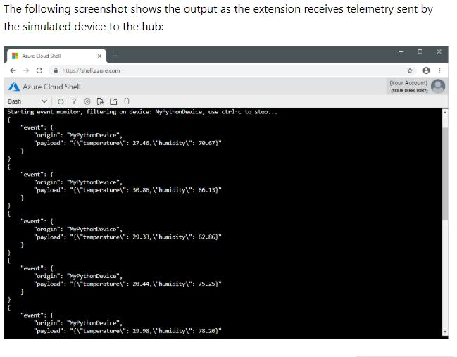
>>az iot hub monitor-events --hub-name YourIoTHubName --device-id <urdevicename>

