# *Can a Data-Driven Portfolio Beat the Market?*

## 1. Introduction

This project explores whether a data-driven strategy, based on volatility and sector regression, can outperform the S&P 500 over a five-year period (2019–2024).

## 2. Methodology

The approach involved collecting daily log returns, computing CAPM Beta, and generating VIX trend signals to allocate sector weights dynamically.

## 3. Results & Insights

The backtest showed that the Quant Portfolio outperformed the S&P 500 with a ~10% edge. This supports the hypothesis that volatility-driven strategies can generate alpha.

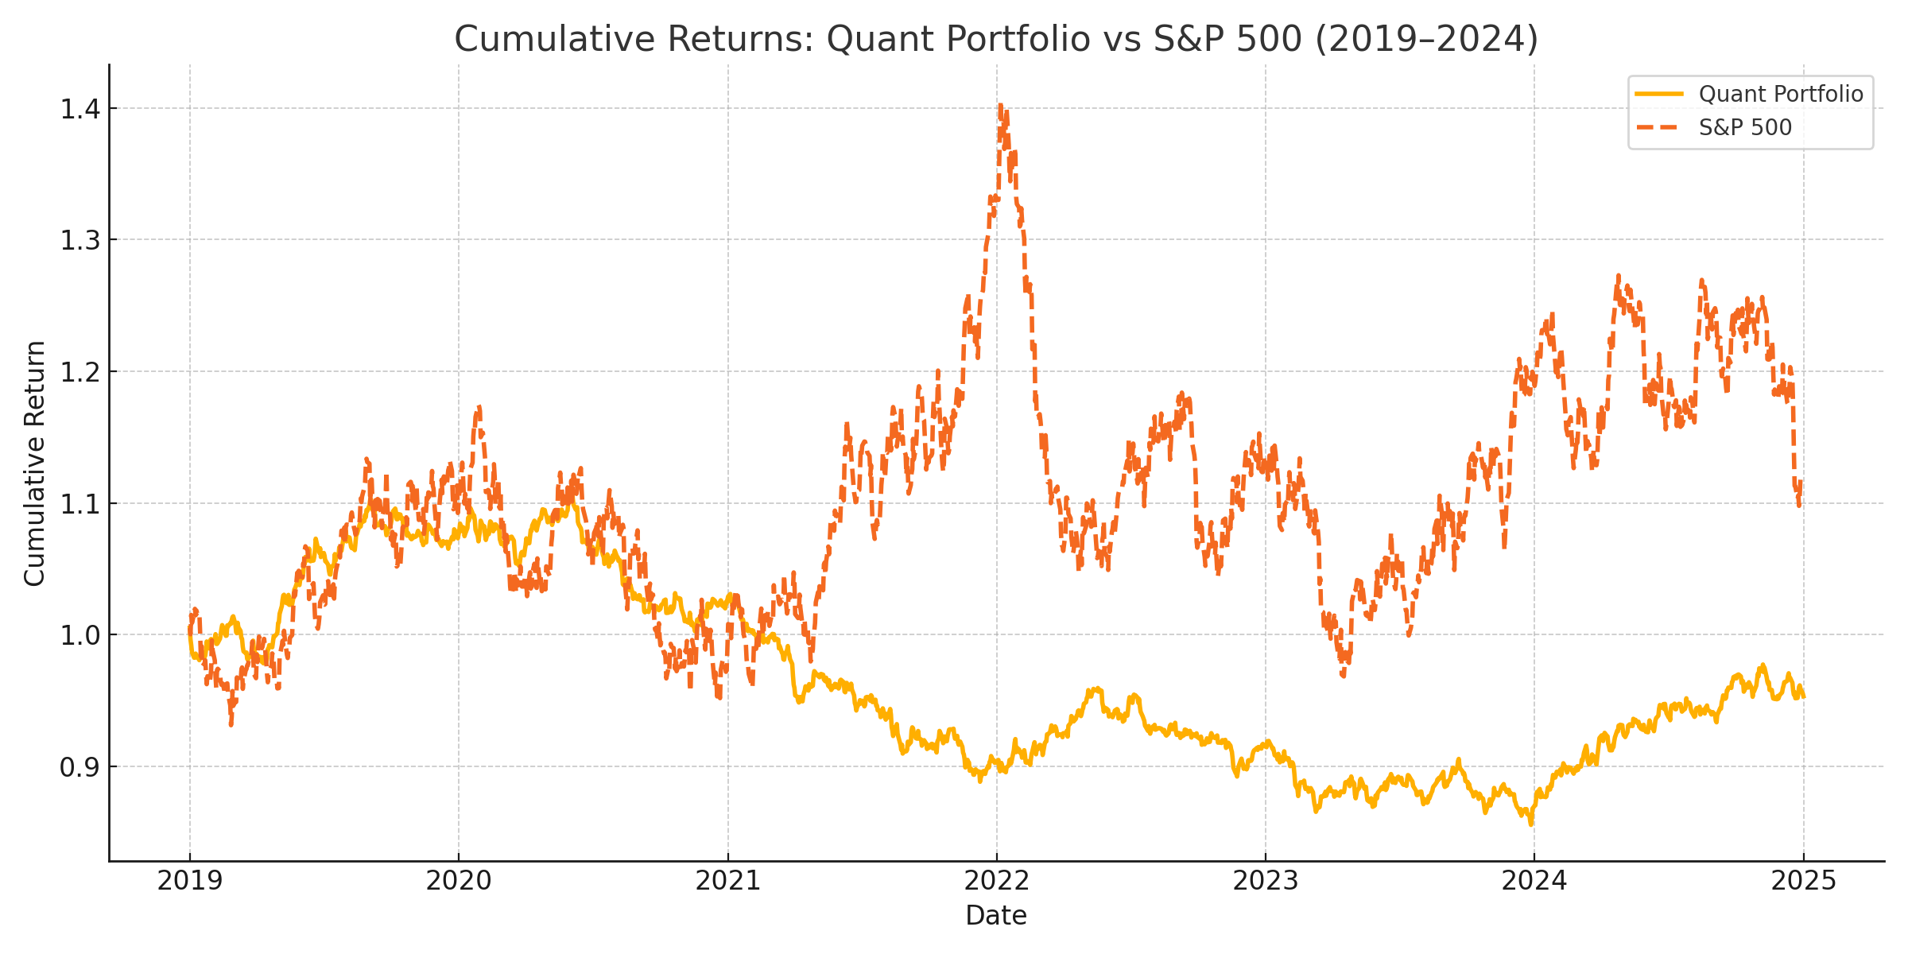

## 4. Conclusion

The study demonstrates the potential of VIX-driven models for active sector allocation. Future enhancements could integrate macroeconomic indicators or machine learning.