Espresso Machine Investment Case Study

# 1. Objective

This case study assesses the financial viability of investing £12,000 in an espresso machine for a small coffee shop. The goal is to determine whether the investment yields long-term savings and profit, based on standard financial evaluation tools.

# 2. Methodology

We project annual savings of £3,200 from increased efficiency and improved customer throughput. Yearly maintenance costs range from £200 to £400. A 10% discount rate is applied to calculate Net Present Value (NPV), Internal Rate of Return (IRR), and Payback Period over a 5-year forecast horizon.

# 3. Financial Analysis

• NPV: £2,274.72  
• IRR: 18.18%  
• Payback Period: 4 years

A positive NPV and IRR greater than the discount rate support the investment. The payback period of 4 years ensures recovery of the initial capital well within the forecast period.

# 4. Annual Cash Flow Overview

Below is the yearly net cash inflow, after accounting for savings and maintenance costs:

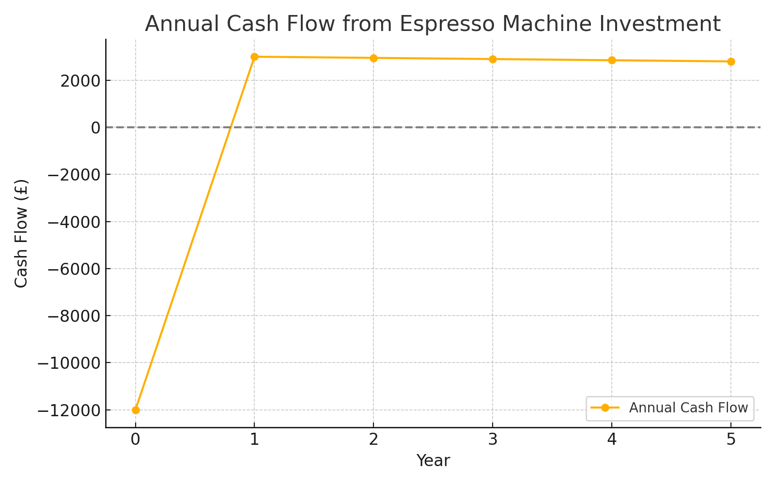

Cumulative cash flows illustrate that the investment breaks even during Year 4:

# 6. Sensitivity Analysis

We tested the sensitivity of NPV to changes in both annual savings and discount rates. Across all tested scenarios, the investment remains favourable unless savings drop significantly or discount rates rise considerably.

# 7. Conclusion

The espresso machine investment is supported by positive returns across multiple financial indicators. This study demonstrates the practical application of capital budgeting tools and shows how data-driven financial models help make strategic investment decisions even in small-scale operations.