**What Are Graphs in Data Structure?**

A graph is a non-linear kind of data structure made up of nodes or vertices and edges. The edges connect any two nodes in the graph, and the nodes are also known as vertices.

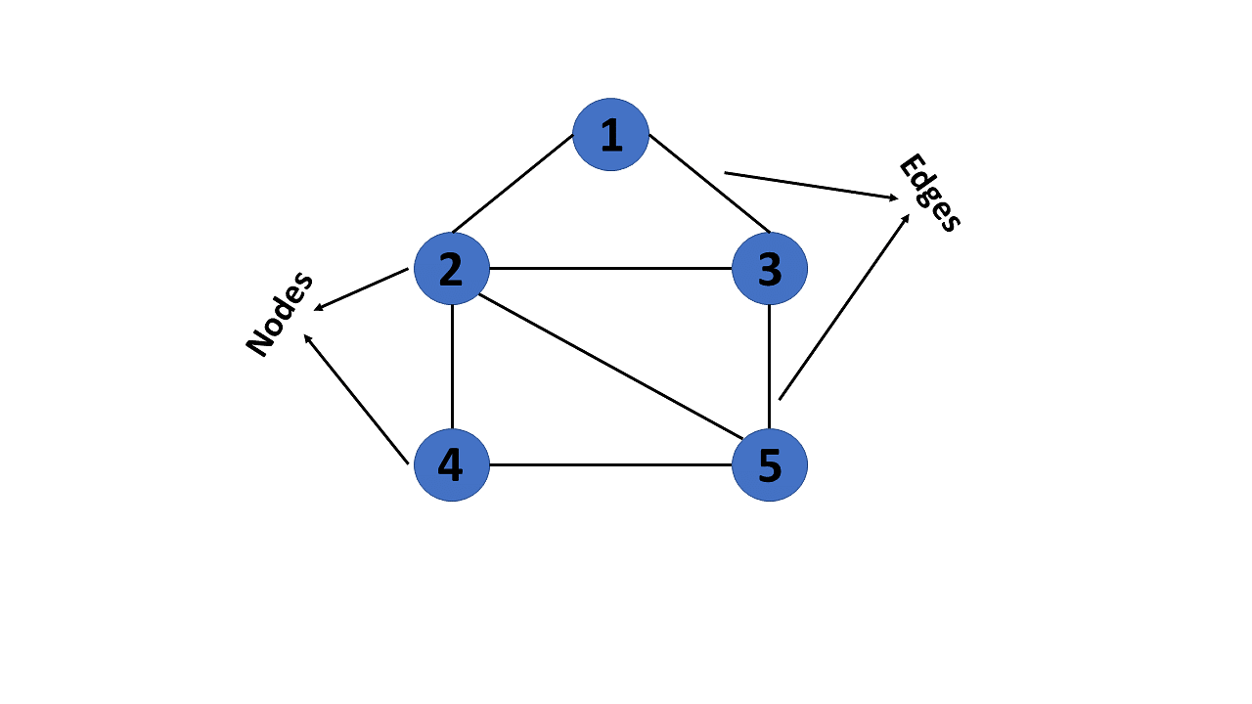

This graph has a set of vertices V= { 1,2,3,4,5} and a set of edges E= { (1,2),(1,3),(2,3),(2,4),(2,5),(3,5),(4,50 }.

Now that you’ve learned about the definition of graphs in data structures, you will learn about their various types.

**Types of Graphs in Data Structures**

There are different types of graphs in data structures, each of which is detailed below.

**1. Finite Graph**

The graph G=(V, E) is called a finite graph if the number of vertices and edges in the graph is limited in number

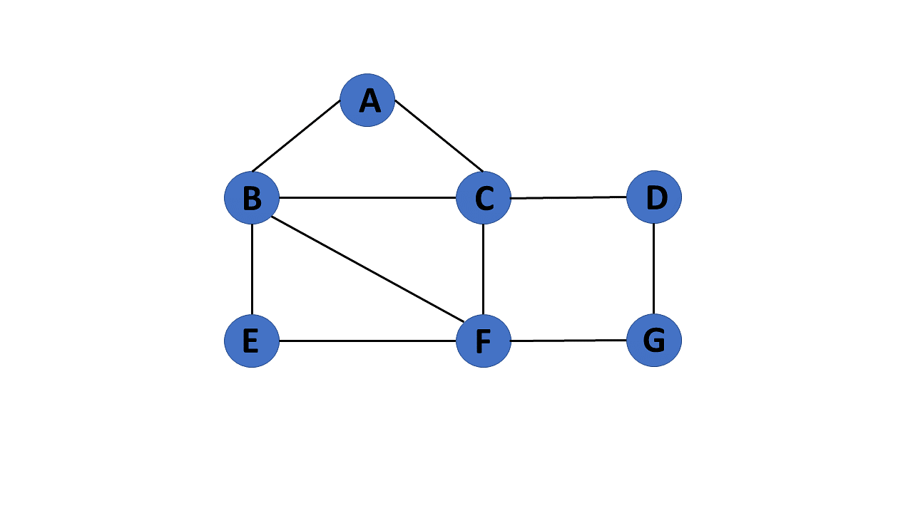

**2. Infinite Graph**

The graph G=(V, E) is called a finite graph if the number of vertices and edges in the graph is interminable.

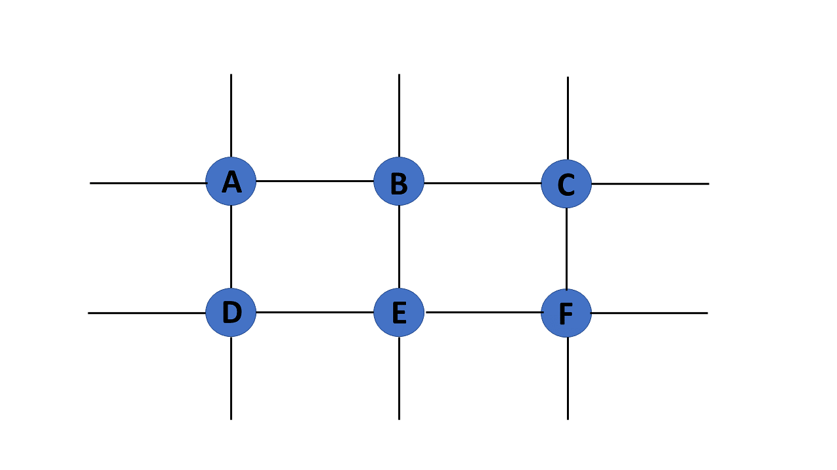

**3. Trivial Graph**

A graph G= (V, E) is trivial if it contains only a single vertex and no edges.

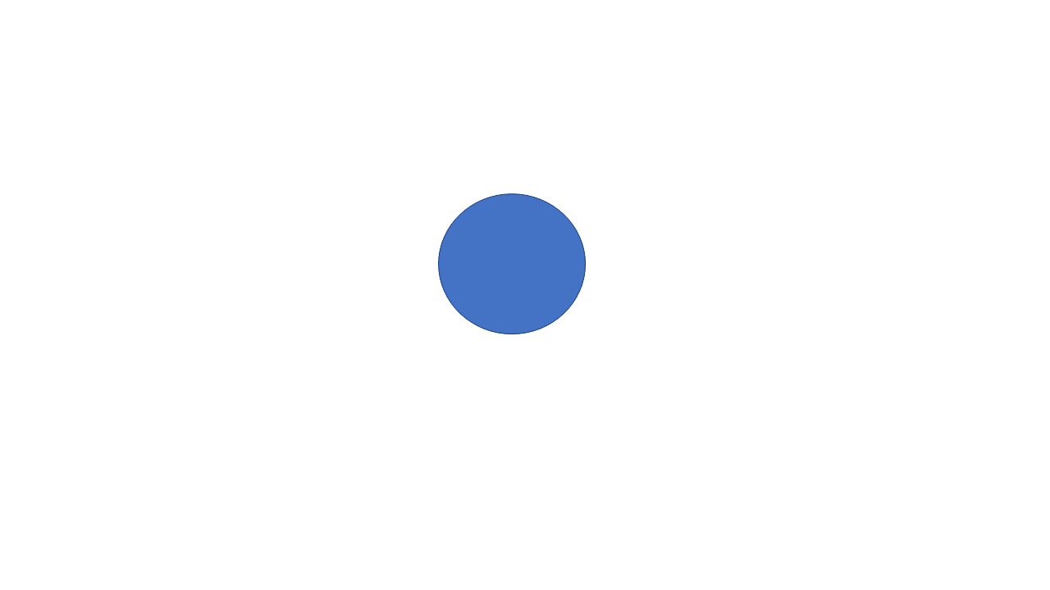

**4. Simple Graph**

If each pair of nodes or vertices in a graph G=(V, E) has only one edge, it is a simple graph. As a result, there is just one edge linking two vertices, depicting one-to-one interactions between two elements.

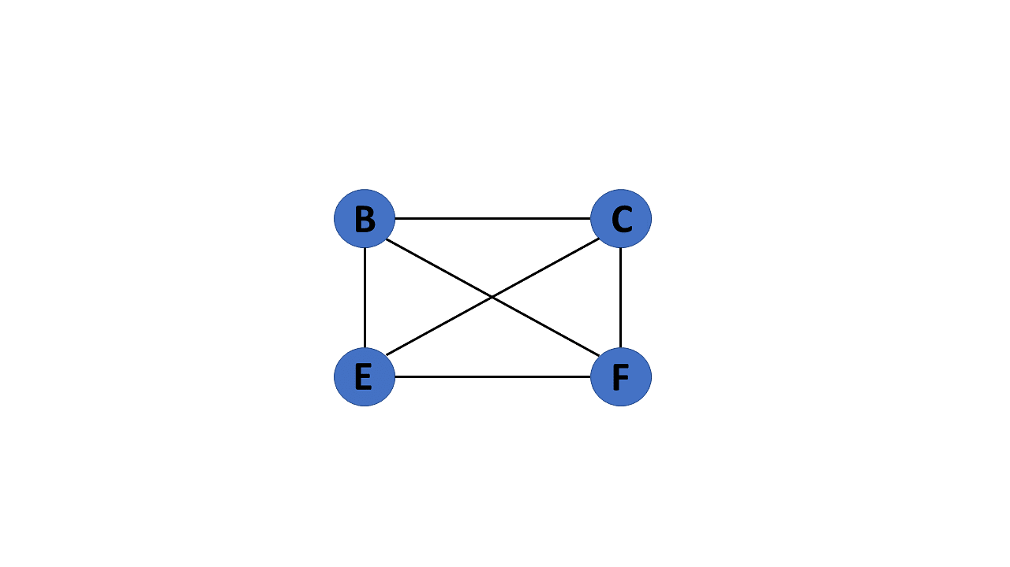

**Learn from the Best in the Industry!**

Caltech PGP Full Stack Development[Explore Program](https://www.simplilearn.com/pgp-full-stack-web-development-certification-training-course?source=GhPreviewCTABanner)

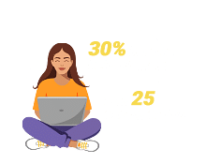

**5. Multi Graph**

If there are numerous edges between a pair of vertices in a graph G= (V, E), the graph is referred to as a multigraph. There are no self-loops in a Multigraph.

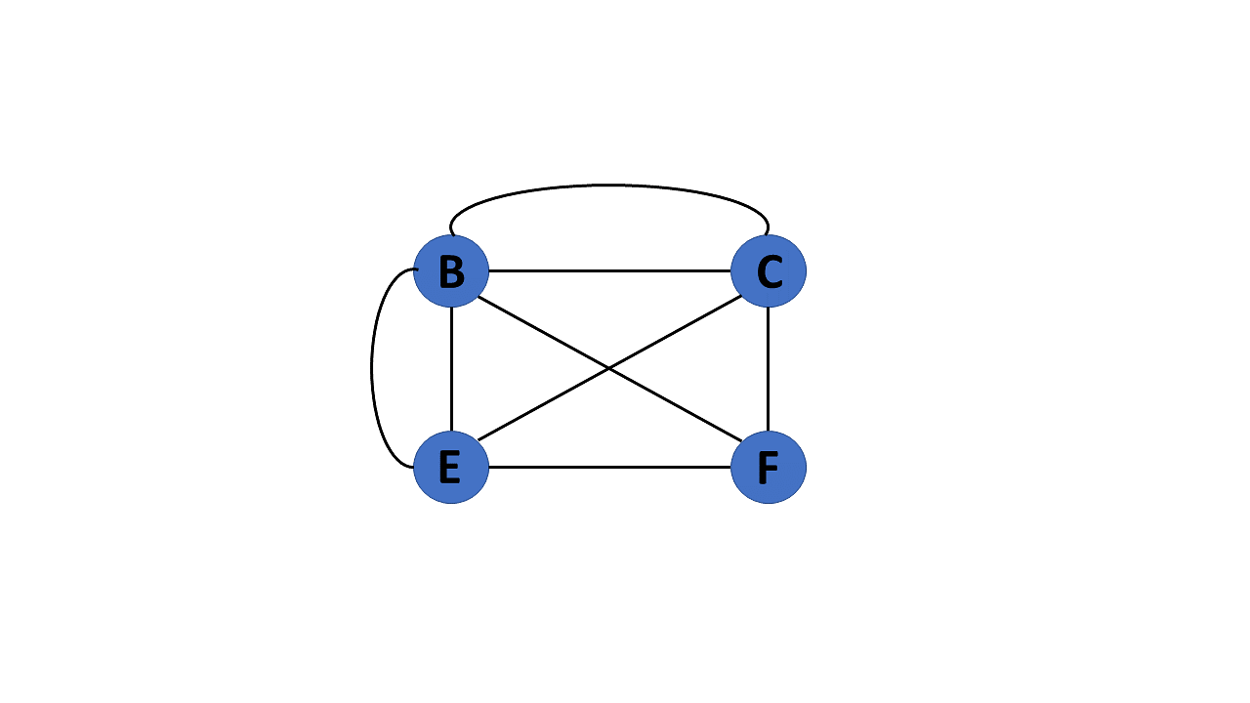

**6. Null Graph**

It's a reworked version of a trivial graph. If several vertices but no edges connect them, a graph G= (V, E) is a null graph.

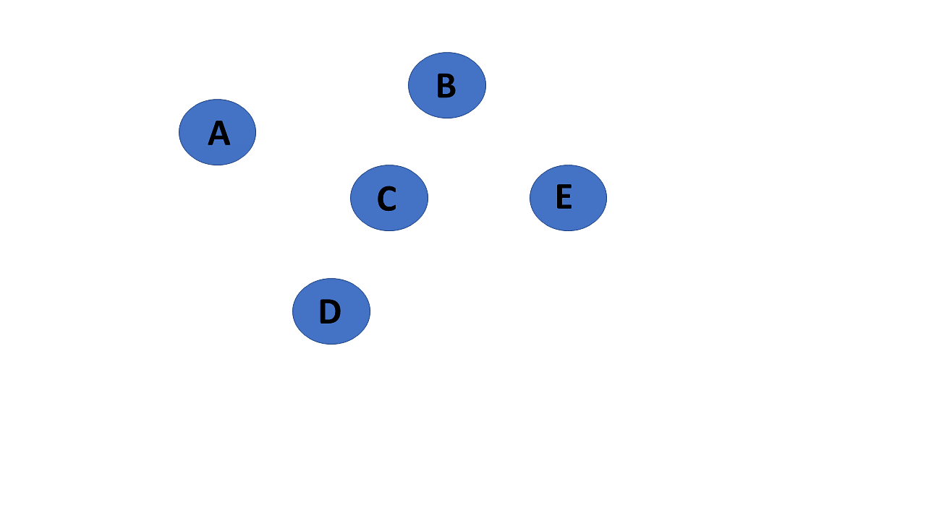

**7. Complete Graph**

If a graph G= (V, E) is also a simple graph, it is complete. Using the edges, with n number of vertices must be connected. It's also known as a full graph because each vertex's degree must be n-1.

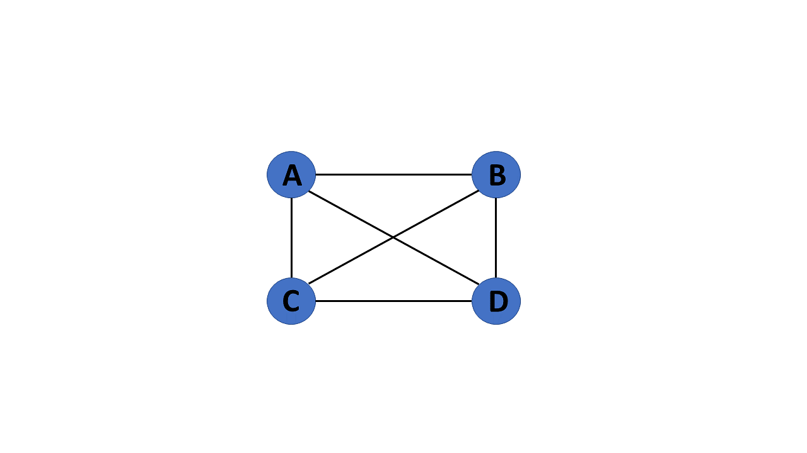

**8. Pseudo Graph**

If a graph G= (V, E) contains a self-loop besides other edges, it is a pseudograph.

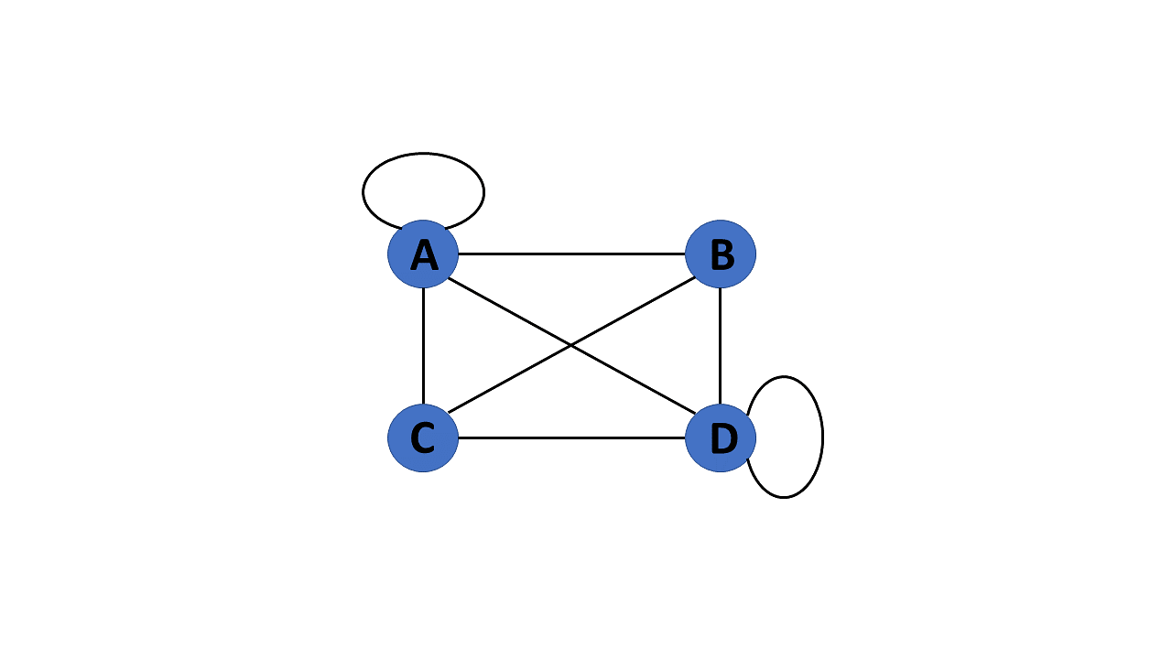

**9. Regular Graph**

If a graph G= (V, E) is a simple graph with the same degree at each vertex, it is a regular graph. As a result, every whole graph is a regular graph.

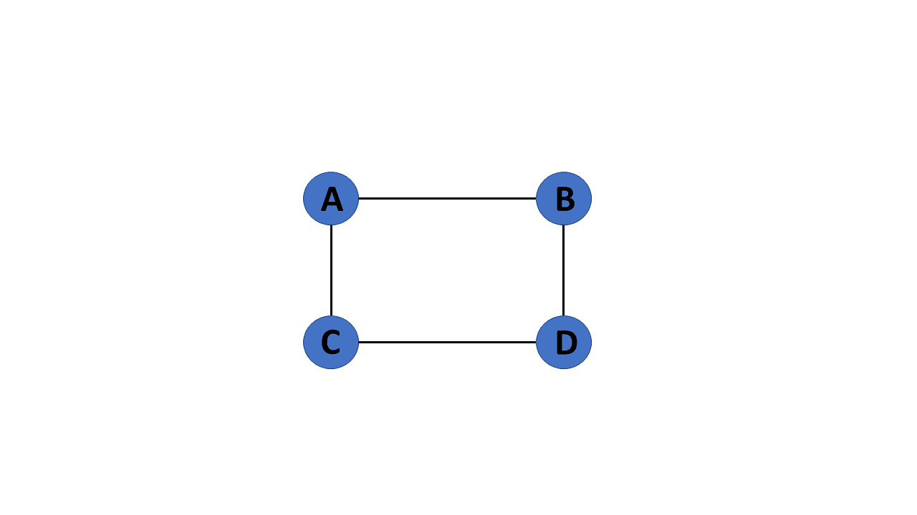

**10. Weighted Graph**

A graph G= (V, E) is called a labeled or weighted graph because each edge has a value or weight representing the cost of traversing that edge.

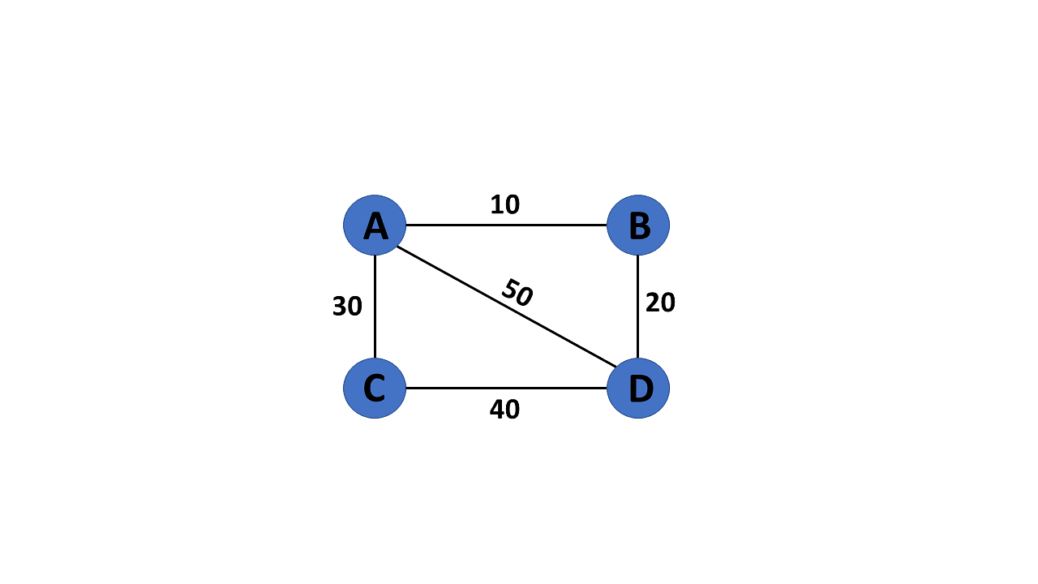

**11. Directed Graph**

A directed graph also referred to as a digraph, is a set of nodes connected by edges, each with a direction.

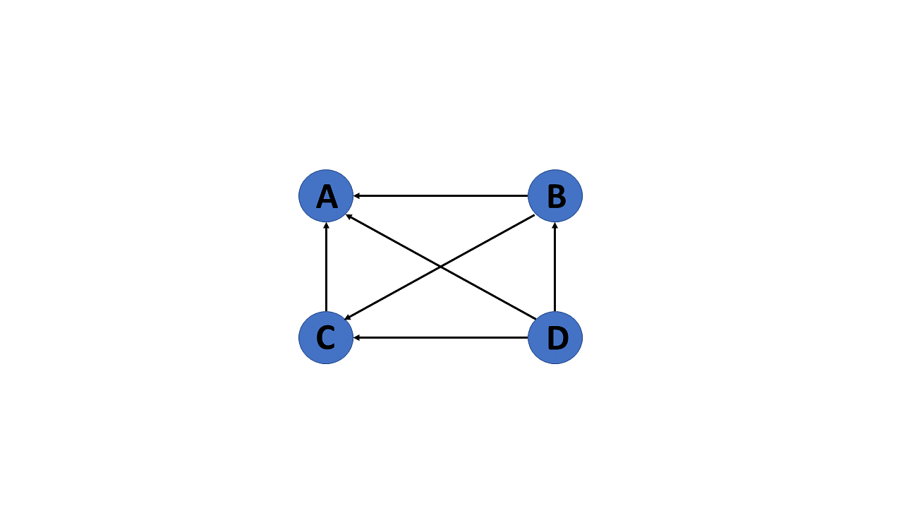

**12. Undirected Graph**

An undirected graph comprises a set of nodes and links connecting them. The order of the two connected vertices is irrelevant and has no direction. You can form an undirected graph with a finite number of vertices and edges.

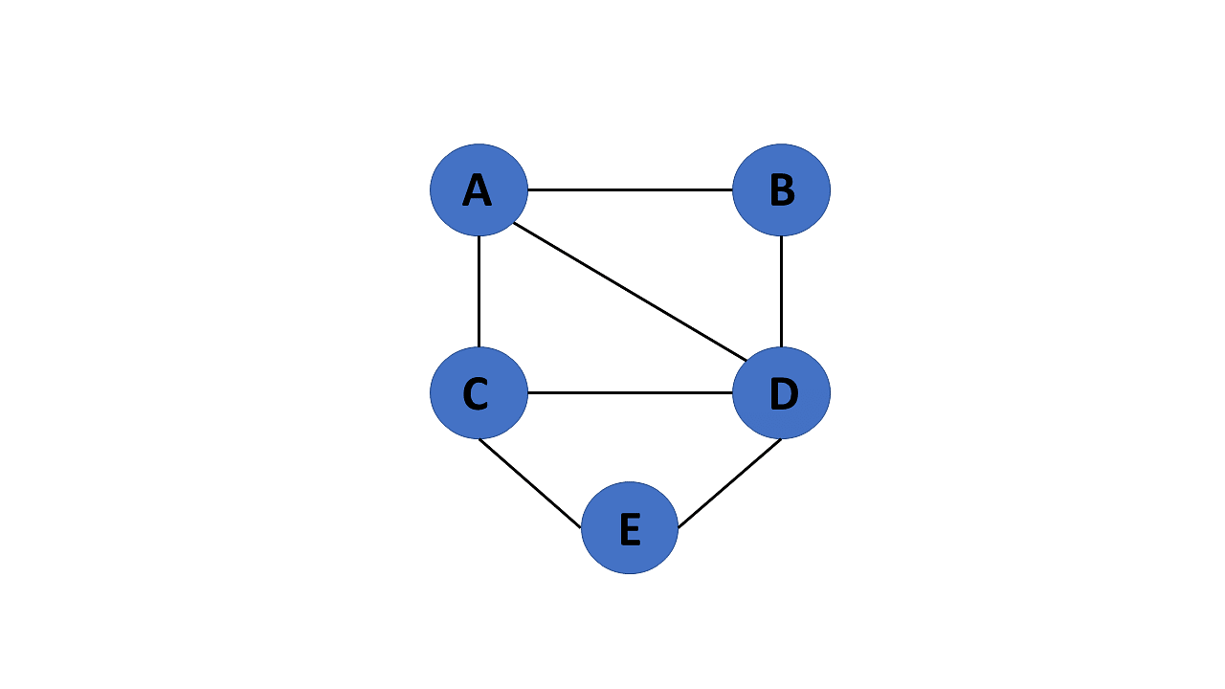

**13. Connected Graph**

If there is a path between one vertex of a graph data structure and any other vertex, the graph is connected.

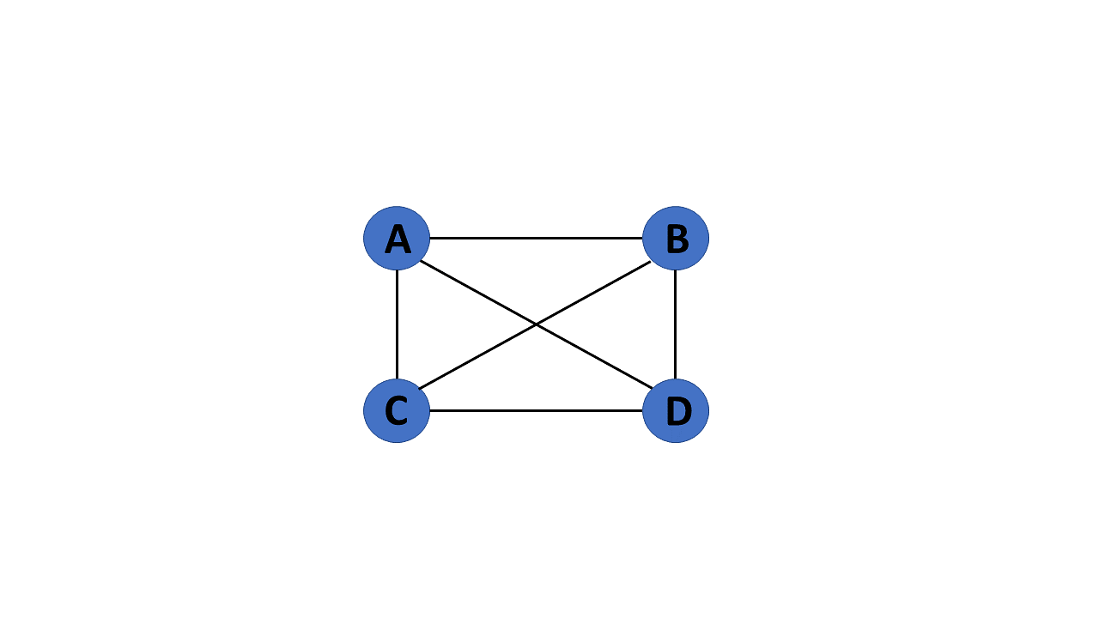

**14. Disconnected Graph**

When there is no edge linking the vertices, you refer to the null graph as a disconnected graph.

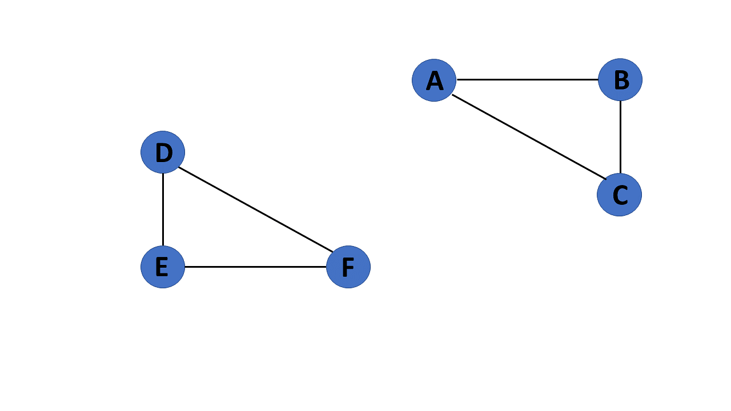

**Learn from the Best in the Industry!**

Caltech PGP Full Stack Development[Explore Program](https://www.simplilearn.com/pgp-full-stack-web-development-certification-training-course?source=GhPreviewCTABanner)



**15. Cyclic Graph**

If a graph contains at least one graph cycle, it is considered to be cyclic.

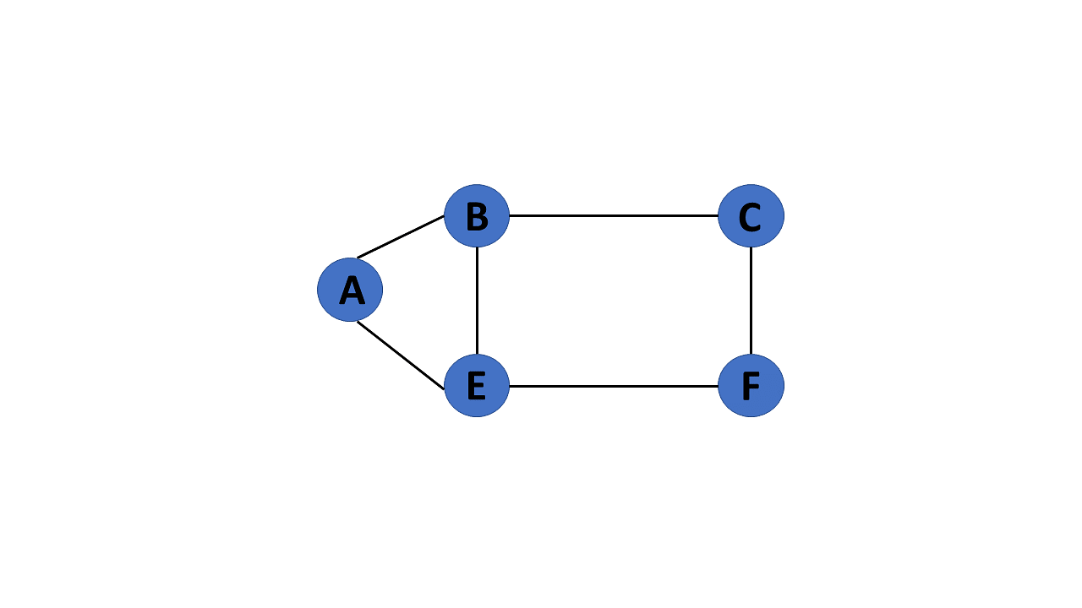

**16. Acyclic Graph**

When there are no cycles in a graph, it is called an acyclic graph.

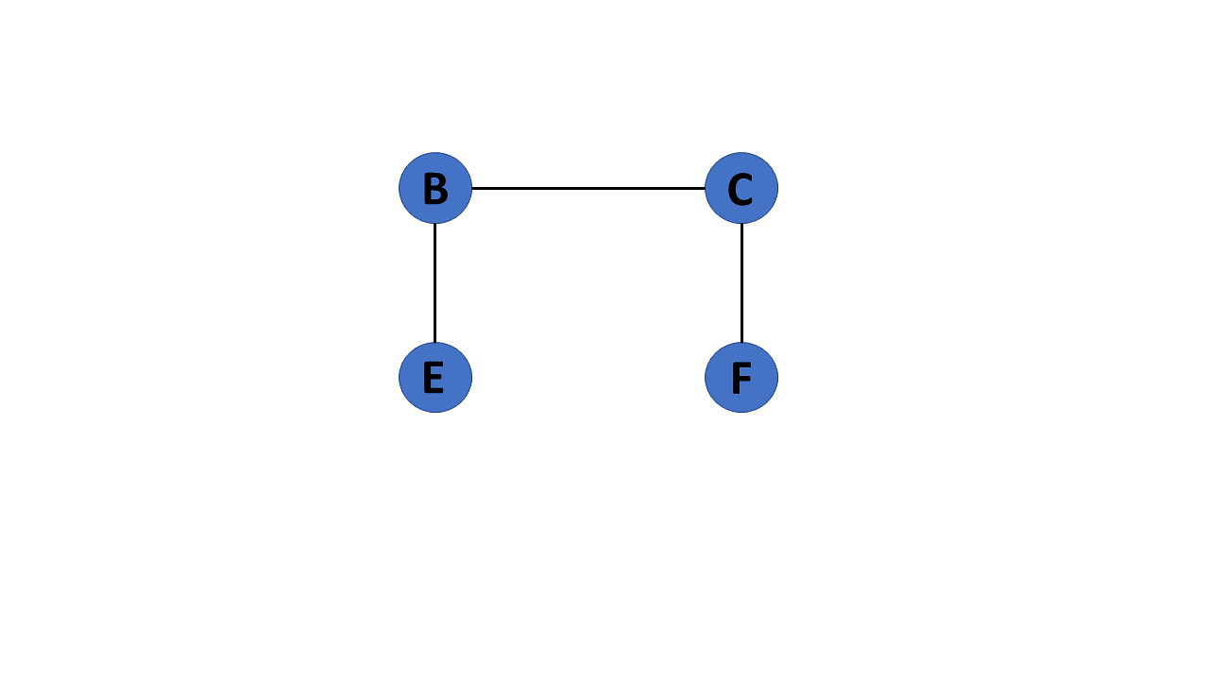

**17. Directed Acyclic Graph**

It's also known as a directed acyclic graph (DAG), and it's a graph with directed edges but no cycle. It represents the edges using an ordered pair of vertices since it directs the vertices and stores some data.

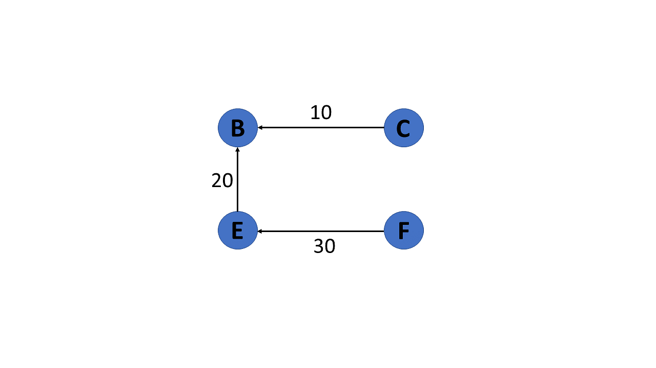

**18. Subgraph**

The vertices and edges of a graph that are subsets of another graph are known as a subgraph.

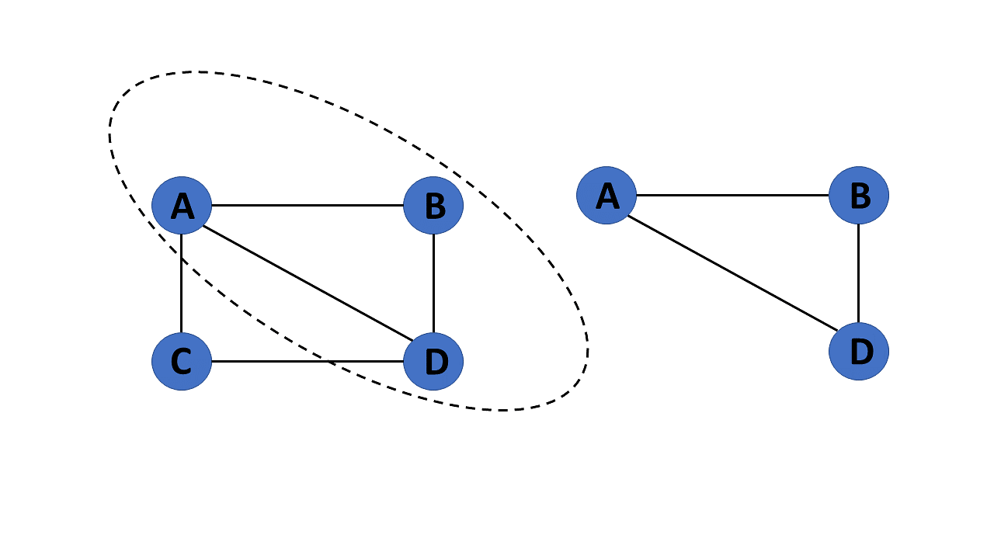

After you learn about the many types of graphs in graphs in data structures, you will move on to graph terminologies.

**Terminologies of Graphs in Data Structures**

Following are the basic terminologies of graphs in data structures:

* An edge is one of the two primary units used to form graphs. Each edge has two ends, which are vertices to which it is attached.
* If two vertices are endpoints of the same edge, they are adjacent.
* A vertex's outgoing edges are directed edges that point to the origin.
* A vertex's incoming edges are directed edges that point to the vertex's destination.
* The total number of edges occurring to a vertex in a graph is its degree.
* The out-degree of a vertex in a directed graph is the total number of outgoing edges, whereas the in-degree is the total number of incoming edges.
* A vertex with an in-degree of zero is referred to as a source vertex, while one with an out-degree of zero is known as sink vertex.
* An isolated vertex is a zero-degree vertex that is not an edge's endpoint.
* A path is a set of alternating vertices and edges, with each vertex connected by an edge.
* The path that starts and finishes at the same vertex is known as a cycle.
* A path with unique vertices is called a simple path.
* For each pair of vertices x, y, a graph is strongly connected if it contains a directed path from x to y and a directed path from y to x.
* A directed graph is weakly connected if all of its directed edges are replaced with undirected edges, resulting in a connected graph. A weakly linked graph's vertices have at least one out-degree or in-degree.
* A tree is a connected forest. The primary form of the tree is called a rooted tree, which is a free tree.
* A spanning subgraph that is also a tree is known as a [spanning tree.](https://www.simplilearn.com/tutorials/data-structure-tutorial/spanning-tree-in-data-structure)
* A connected component is the unconnected graph's most connected subgraph.
* A bridge, which is an edge of removal, would sever the graph.
* Forest is a graph without a cycle.

Following that, you will look at the graph representation in this data structures tutorial.

**Learn from the Best in the Industry!**

Caltech PGP Full Stack Development[Explore Program](https://www.simplilearn.com/pgp-full-stack-web-development-certification-training-course?source=GhPreviewCTABanner)



**Representation of Graphs in Data Structures**

Graphs in data structures are used to represent the relationships between objects. Every graph consists of a set of points known as vertices or nodes connected by lines known as edges. The vertices in a network represent entities.

The most frequent graph representations are the two that follow:

* Adjacency matrix
* Adjacency list

You’ll look at these two representations of graphs in data structures in more detail:

**Adjacency Matrix**

* A sequential representation is an adjacency matrix.
* It's used to show which nodes are next to one another. I.e., is there any connection between nodes in a graph?
* You create an MXM matrix G for this representation. If an edge exists between vertex a and vertex b, the corresponding element of G, gi,j = 1, otherwise gi,j = 0.
* If there is a weighted graph, you can record the edge's weight instead of 1s and 0s.

**Undirected Graph Representation**

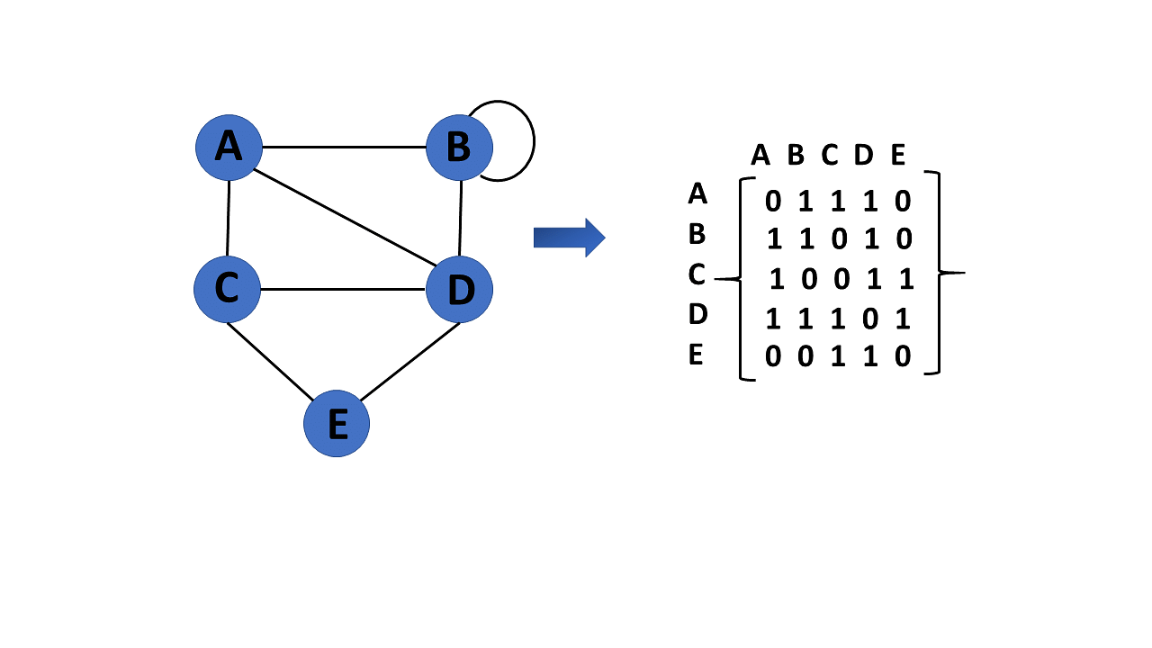

**Directed Graph Representation**

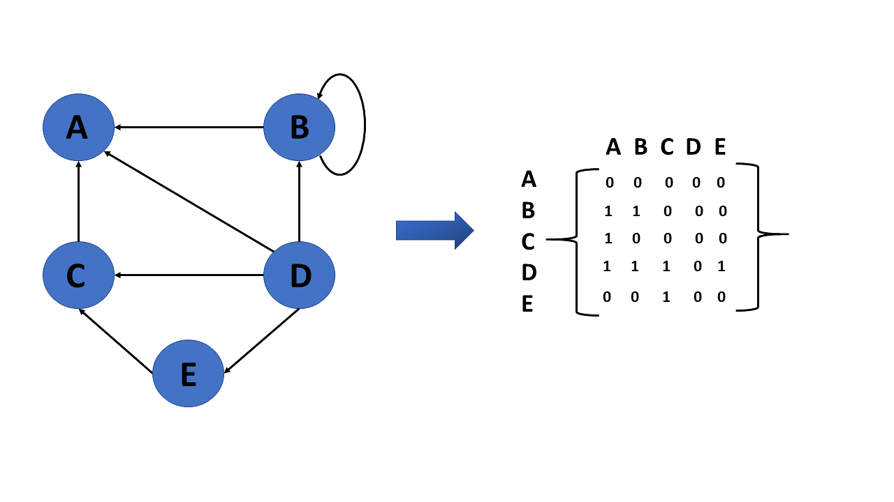

**Weighted Undirected Graph Representation**

Weight or cost is indicated at the graph's edge, a weighted graph representing these values in the matrix.

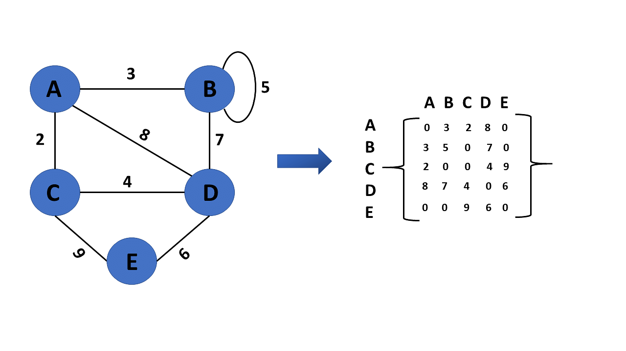

**Learn from the Best in the Industry!**

Caltech PGP Full Stack Development[Explore Program](https://www.simplilearn.com/pgp-full-stack-web-development-certification-training-course?source=GhPreviewCTABanner)



**Adjacency List**

* A linked representation is an adjacency list.
* You keep a list of neighbors for each vertex in the graph in this representation. It means that each vertex in the graph has a list of its neighboring vertices.
* You have an arra of vertices indexed by the vertex number, and the corresponding [array](https://www.simplilearn.com/tutorials/data-structure-tutorial/arrays-in-data-structure) member for each vertex x points to a [singly linked list](https://www.simplilearn.com/tutorials/data-structure-tutorial/singly-linked-list) of x's neighbors.

**Weighted Undirected Graph Representation Using Linked-List**

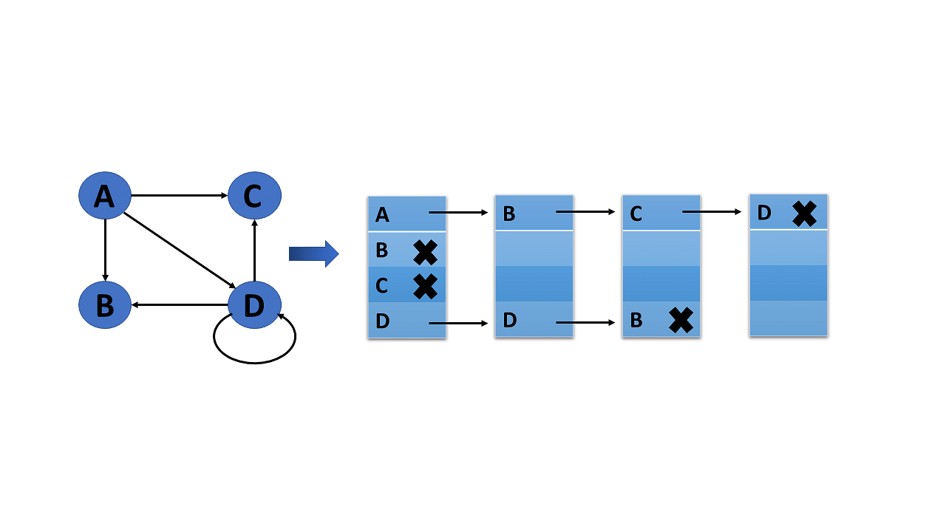

**Weighted Undirected Graph Representation Using an Array**

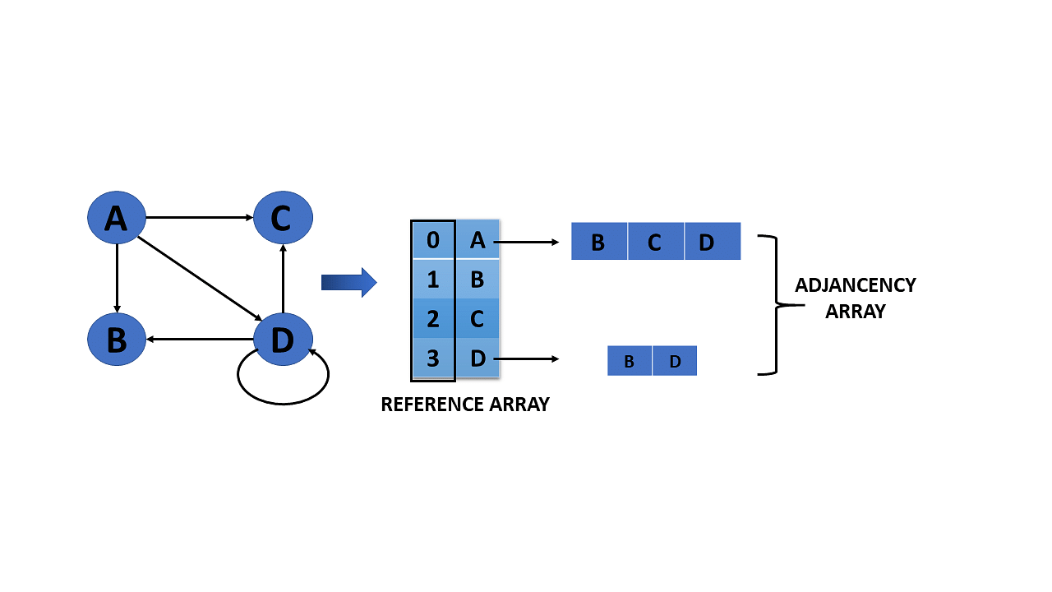

You will now see which all operations are conducted in graphs data structure after understanding the representation of graphs in the data structure.

**Also Read:** [**Linked List in A Data Structure**](https://www.simplilearn.com/tutorials/data-structure-tutorial/linked-list-in-data-structure)

**Operations on Graphs in Data Structures**

The operations you perform on the graphs in data structures are listed below:

* Creating graphs
* Insert vertex
* Delete vertex
* Insert edge
* Delete edge

You will go over each operation in detail one by one:

**Creating Graphs**

There are two techniques to make a graph:

**1. Adjacency Matrix**

The adjacency matrix of a simple labeled graph, also known as the connection matrix, is a matrix with rows and columns labeled by graph vertices and a 1 or 0 in position depending on whether they are adjacent or not.

**2. Adjacency List**

A finite graph is represented by an adjacency list, which is a collection of unordered lists. Each unordered list describes the set of neighbors of a particular vertex in the graph within an adjacency list.

**Learn from the Best in the Industry!**

Caltech PGP Full Stack Development[Explore Program](https://www.simplilearn.com/pgp-full-stack-web-development-certification-training-course?source=GhPreviewCTABanner)



**Insert Vertex**

When you add a vertex that after introducing one or more vertices or nodes, the graph's size grows by one, increasing the matrix's size by one at the row and column levels.

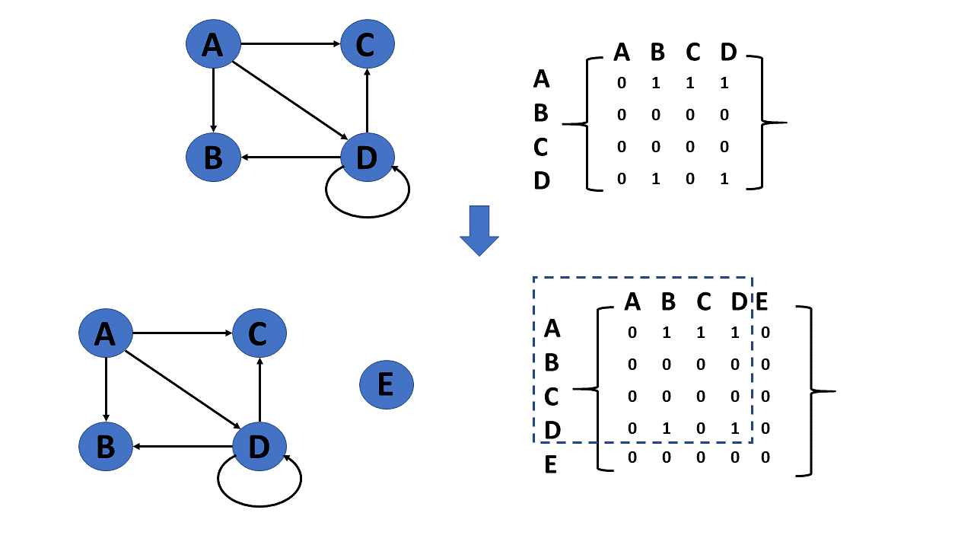

**Delete Vertex**

* Deleting a vertex refers to removing a specific node or vertex from a graph that has been saved.
* If a removed node appears in the graph, the matrix returns that node. If a deleted node does not appear in the graph, the matrix returns the node not available.

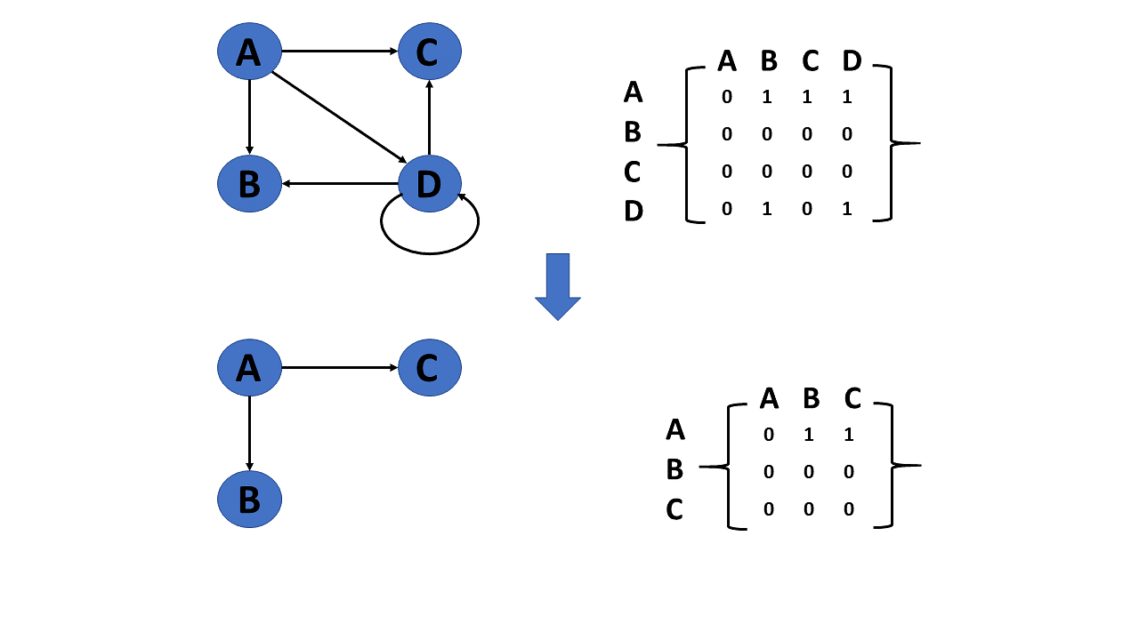

**Learn from the Best in the Industry!**

Caltech PGP Full Stack Development[Explore Program](https://www.simplilearn.com/pgp-full-stack-web-development-certification-training-course?source=GhPreviewCTABanner)



**Insert Edge**

Connecting two provided vertices can be used to add an edge to a graph.

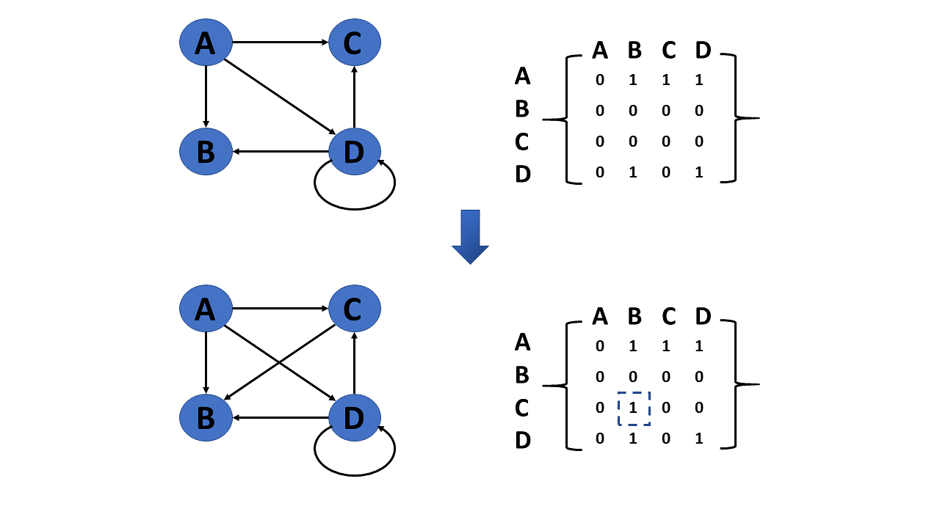

**Delete Edge**

The connection between the vertices or nodes can be removed to delete an edge.

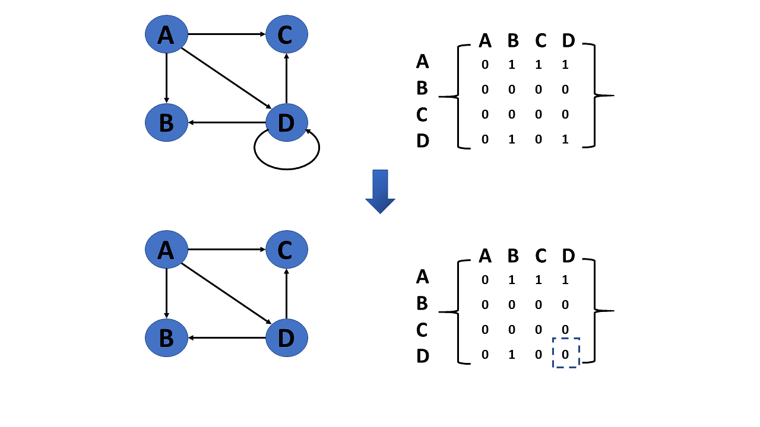

The types of graph traversal algorithms will be discussed next in the graphs in this data structures tutorial.

**Graph Traversal Algorithm**

The process of visiting or updating each vertex in a graph is known as graph traversal. The sequence in which they visit the vertices is used to classify such traversals. Graph traversal is a subset of tree traversal.

There are two techniques to implement a graph traversal algorithm:

* Breadth-first search
* Depth-first search

**Breadth-First Search or BFS**

[BFS](https://www.simplilearn.com/tutorials/data-structure-tutorial/bfs-algorithm) is a search technique for finding a node in a graph data structure that meets a set of criteria.

* It begins at the root of the graph and investigates all nodes at the current depth level before moving on to nodes at the next depth level.
* To maintain track of the child nodes that have been encountered but not yet inspected, more memory, generally you require a [queue.](https://www.simplilearn.com/tutorials/data-structure-tutorial/queue-in-data-structure)

Algorithm of breadth-first search

Step 1: Consider the graph you want to navigate.

Step 2: Select any vertex in your graph, say v1, from which you want to traverse the graph.

Step 3: Examine any two data structures for traversing the graph.

* Visited array (size of the graph)
* Queue data structure

Step 4: Starting from the vertex, you will add to the visited array, and afterward, you will v1's adjacent vertices to the queue data structure.

Step 5: Now, using the FIFO concept, you must remove the element from the queue, put it into the visited array, and then return to the queue to add the adjacent vertices of the removed element.

Step 6: Repeat step 5 until the queue is not empty and no vertex is left to be visited.

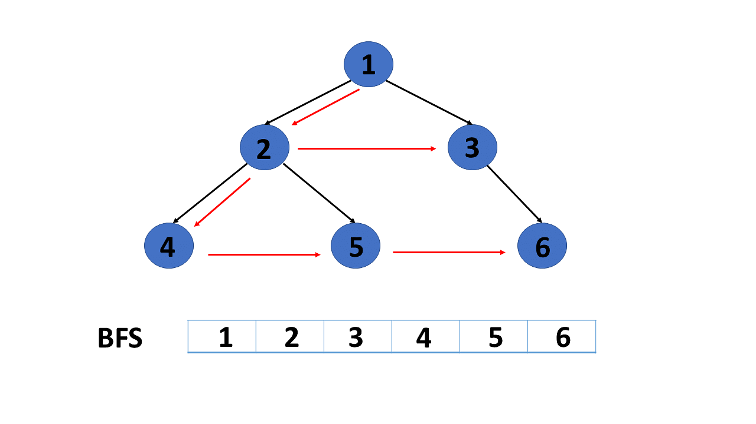

**Depth-First Search or DFS**

[DFS](https://www.simplilearn.com/tutorials/data-structure-tutorial/dfs-algorithm) is a search technique for finding a node in a graph data structure that meets a set of criteria.

* The depth-first search (DFS) algorithm traverses or explores data structures such as trees and graphs. The DFS algorithm begins at the root node and examines each branch as far as feasible before backtracking.
* To maintain track of the child nodes that have been encountered but not yet inspected, more memory, [generally a stack](https://www.simplilearn.com/tutorials/data-structure-tutorial/stacks-in-data-structures), is required.

Algorithm of depth-first search

Step 1: Consider the graph you want to navigate.

Step 2: Select any vertex in our graph, say v1, from which you want to begin traversing the graph.

Step 3: Examine any two data structures for traversing the graph.

* Visited array (size of the graph)
* Stack data structure

Step 4: Insert v1 into the array's first block and push all the adjacent nodes or vertices of vertex v1 into the stack.

Step 5: Now, using the FIFO principle, pop the topmost element and put it into the visited array, pushing all of the popped element's nearby nodes into it.

Step 6: If the topmost element of the stack is already present in the array, discard it instead of inserting it into the visited array.

Step 7: Repeat step 6 until the stack data structure isn't empty.

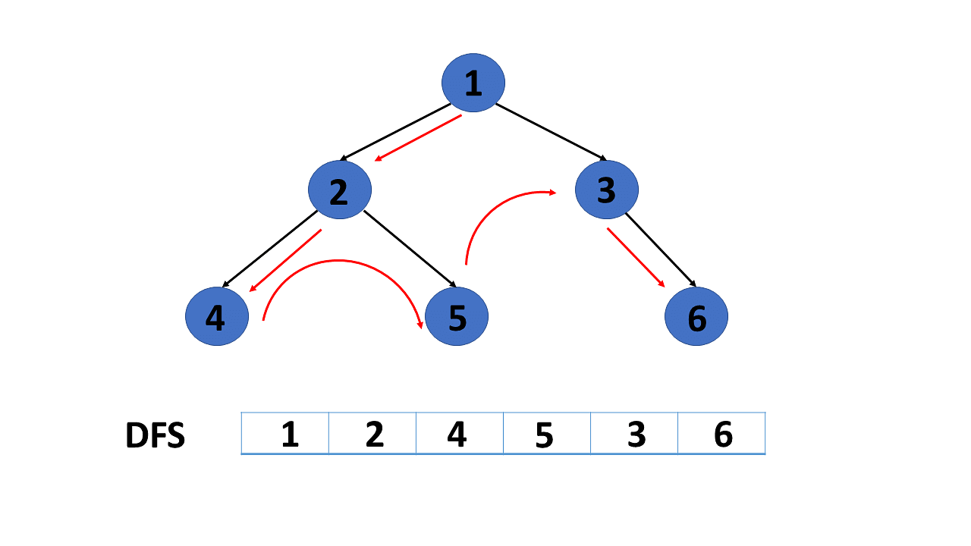

You will now look at applications of graph data structures after understanding the graph traversal algorithm in this tutorial.

**Application of Graphs in Data Structures**

Following  are some applications of graphs in data structures:

* Graphs are used in computer science to depict the flow of computation.
* Users on Facebook are referred to as vertices, and if they are friends, there is an edge connecting them. The Friend Suggestion system on Facebook is based on graph theory.
* You come across the Resource Allocation Graph in the Operating System, where each process and resource are regarded vertically. Edges are drawn from resources to assigned functions or from the requesting process to the desired resource. A stalemate will develop if this results in the establishment of a cycle.
* Web pages are referred to as vertices on the World Wide Web. Suppose there is a link from page A to page B that can represent an edge. This application is an illustration of a directed graph.
* Graph transformation systems manipulate graphs in memory using rules. Graph databases store and query graph-structured data in a transaction-safe, permanent manner.