### *Musico*

P ro je ct O u tli ne

Showcasing your Music Talent Made Easy Web App

P re p are d b y: L aksh K alra, ke shav S harm a

##### A MINI PROJECT REPORT

##### On Musico

##### In Partial Fulfillment of Requirement for the Degree Of

##### Bachelor of Technology In

##### COMPUTER SCIENCE

##### Submitted by Laksh Kalra Keshav Sharma

##### Under the Supervision of Mrs. Krista Chaudhary Assistant Prof., CS Dept.

##### KRISHNA ENGINEERING COLLEGE GHAZIABAD



##### DR. A.P.J. ABDUL KALAM TECHNICAL UNIVERSITY, LUCKNOW

2020-2021

**03**

# D ECLARATION

We hereby declare that this submission is our own work and that, to the best of our knowledge and belief, it contains no material previously published or written by another person nor material which to a substantial extent has been accepted for the award of any other degree or diploma of the university or other institute of higher learning except where due acknowledgment has been made in the text.

**04**

# C ERTIFICATE

Certified that **Laksh Kalra and Keshav Sharma** has carried out the project work presented in this report entitled **“Musico Social Media for all the musicians”** for the award of Bachelor of Technology from Dr. A.P.J. Abdul Kalam Technical University, Lucknow under my supervision. The report embodies the result of original work, and studies, as are carried out by the student themselves, and the contents of the report, do not form the basis for the award of any other degree to the candidate or to anybody else from this or any other university/institution.

Supervisor Name:

Mrs. Krista Chaudhary Dr. PramodKumar (Asst. Prof. C.S.) (H.O.D C.S.)

**05**

# A BSTRACT

Social media application for all the music enthusiasts, you can collab with nearby musicians, create your own band and perform your concert live on the app.

The audience (other users) can join the concert, enjoy live concerts, and can even hire musicians.

**06**

# A CKNOWLEDGEMENT

I would like to express my sincere gratitude to my project guide “Mrs. Krista Chaudhary” for giving me the opportunity to work on this topic. It would never be possible for us to take this project to this level without her innovative ideas and her relentless support and encouragement.

I have to appreciate the guidance given by other supervisors as well as the panels especially in our project presentation that has improved our presentation skills, thanks to their comments and advice. A special thanks to all our teammates and last but not least our parents for their encouragement and every possible support.

Name:

Laksh Kalra Keshav Sharma

(Signature) (Signature)

**07**

**C ONTENTS**

DECLARATION 03

CERTIFICATE 04

ABSTRACT 05

ACKNOWLEDGEMENT 06

INTRODUCTION 08

TECHNOLOGY USED 09

CODE 10

UI SNAPSHOTS 14

CONCLUSION 18

FUTURE SCOPE 19

REFERENCE 20

**08**

# INTRODUCTION

## Ab o u t the ap p

The “Musico Social Media for all the musicians” is basically a web application that helps musicians to stay connected with other musicians nearby them and schedule online/offline concerts together.

Other people can hire musicians by this platform as all musicians are logged in to the app with a proper profile.

## O b je cti ve s and p u rp o se o f the ap p

The main purpose of our app is to create a small community for musicians so that they can collaborate with other musicians.

Beginner Musicians can showcase their talent and can be hired by other people.

Professional musicians can plan concerts.

As everyone is working from the home cause of the pandemic then why not musicians. They can plan live concerts online for their fans.

**09**

# TECHNOLOGY USED

FRONTEND :

HTML CSS

JAVASCRIPT REACT JS

BACKEND :

MONGO DB EXPRESS JS NODE JS

**10**

# C ODE

#### F R O N T E N D C O D E :

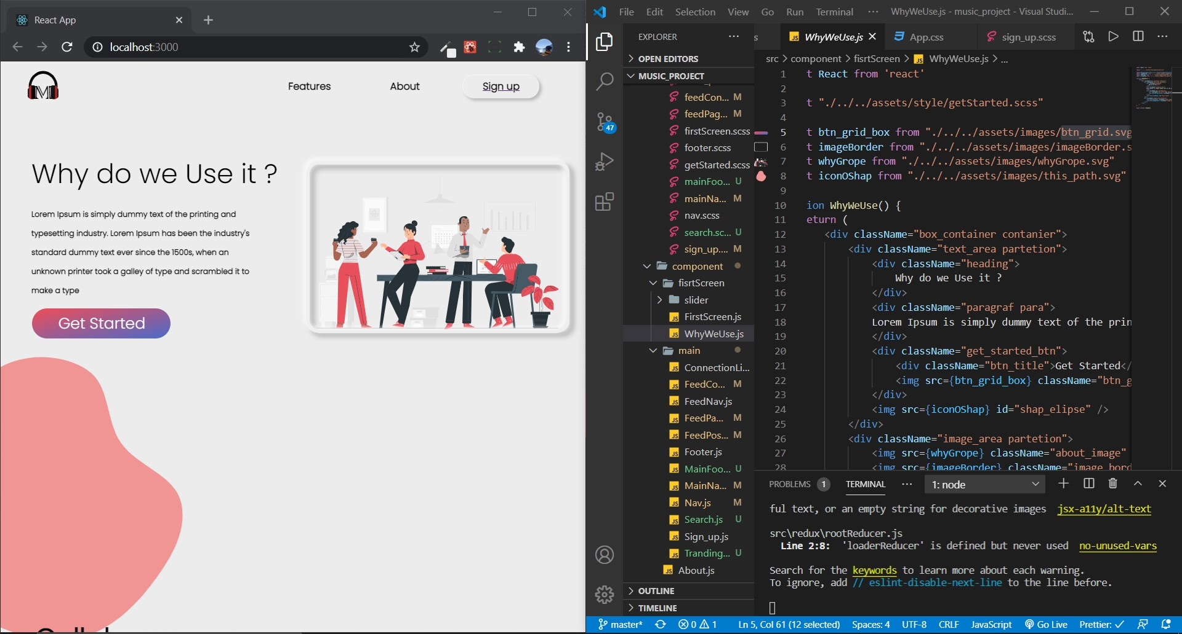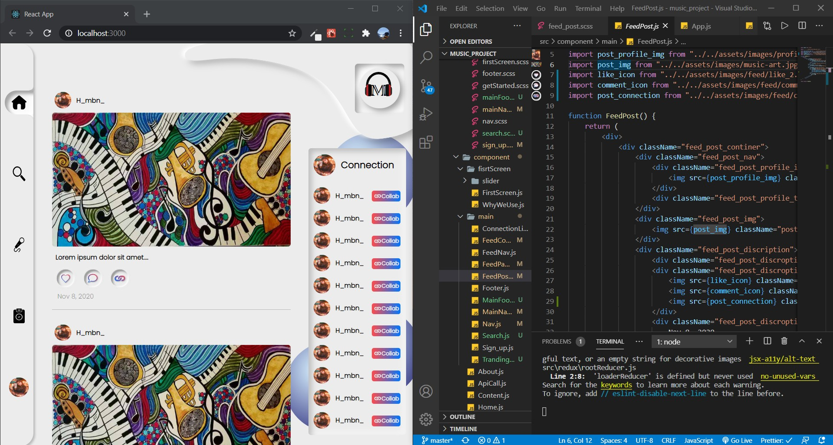

**11**

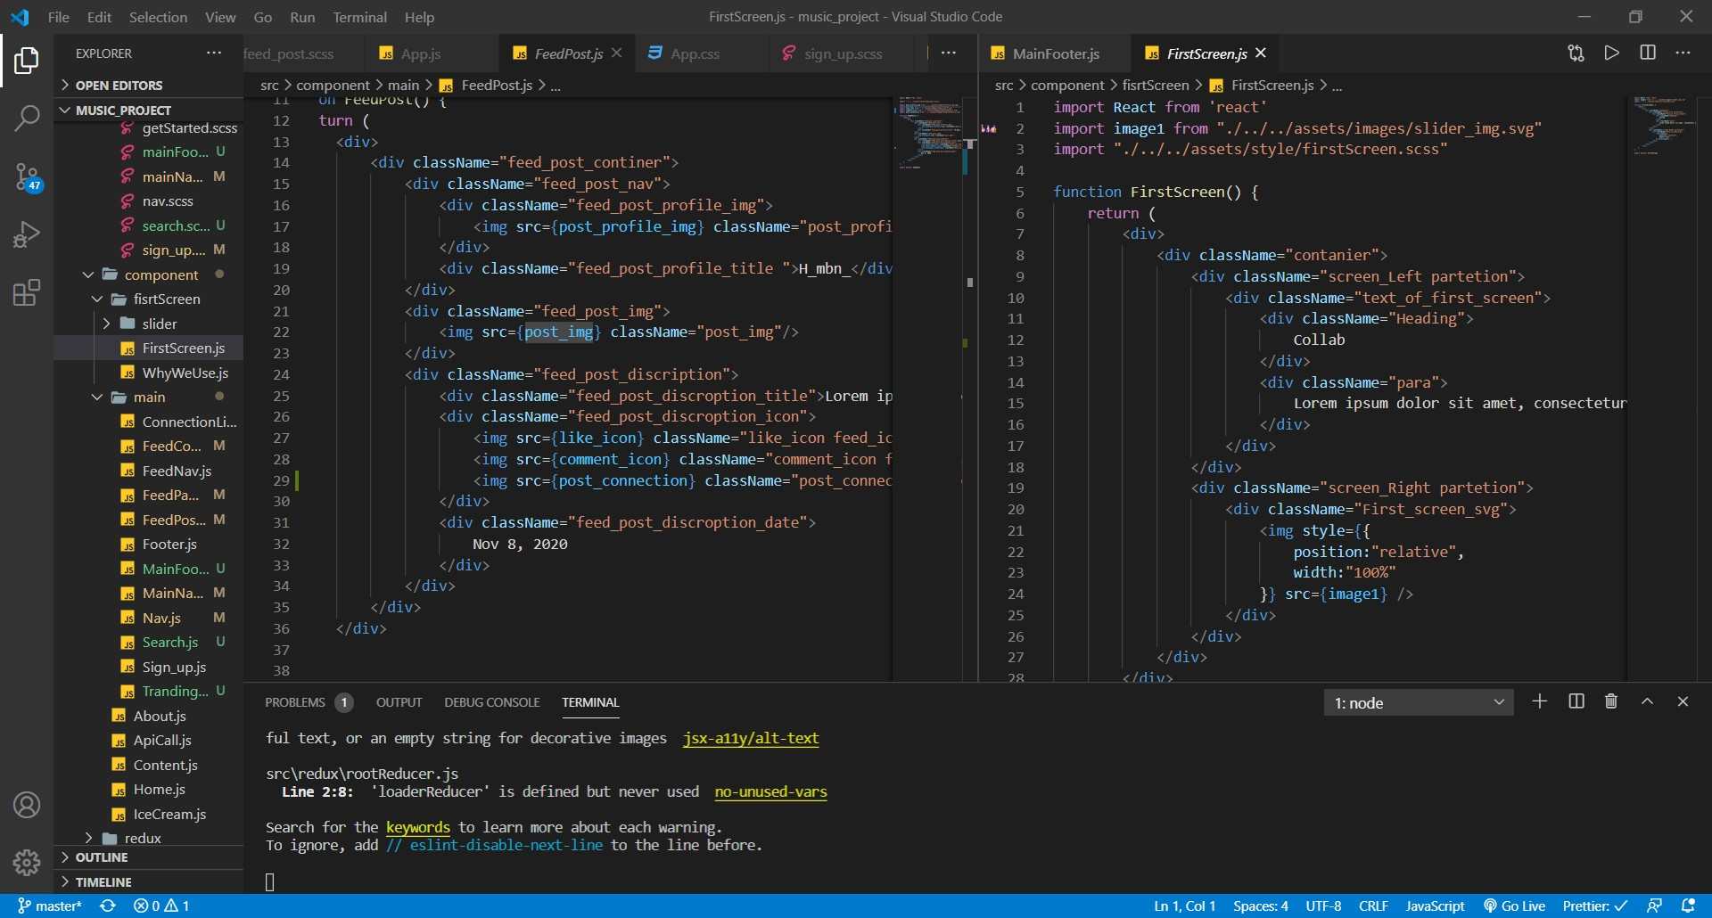

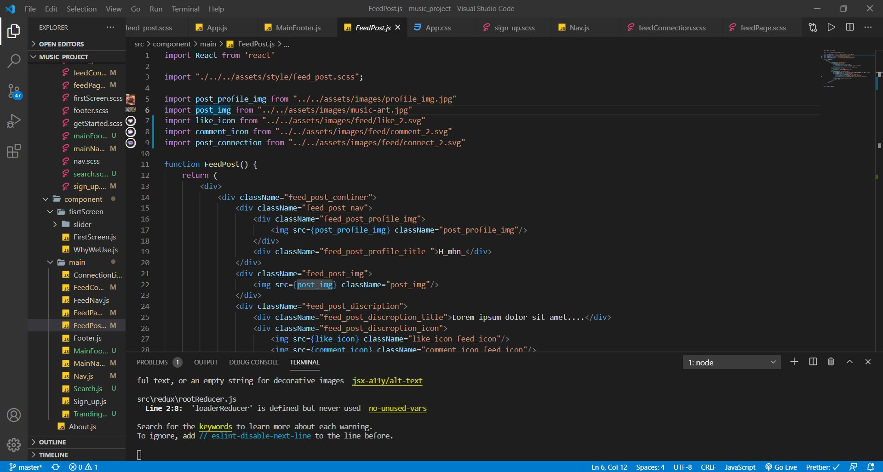

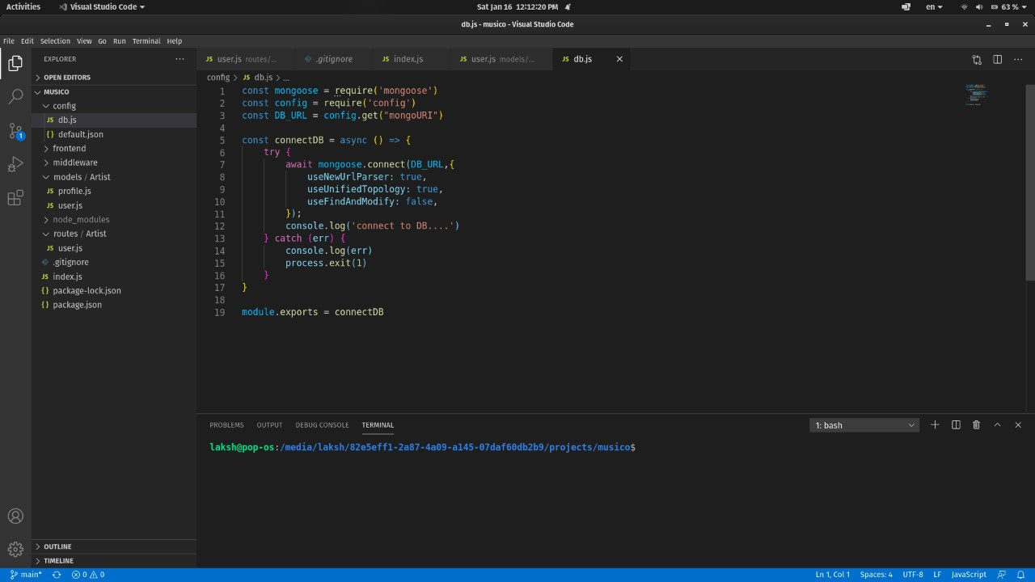

**12**

#### b ack E N D C O D E :

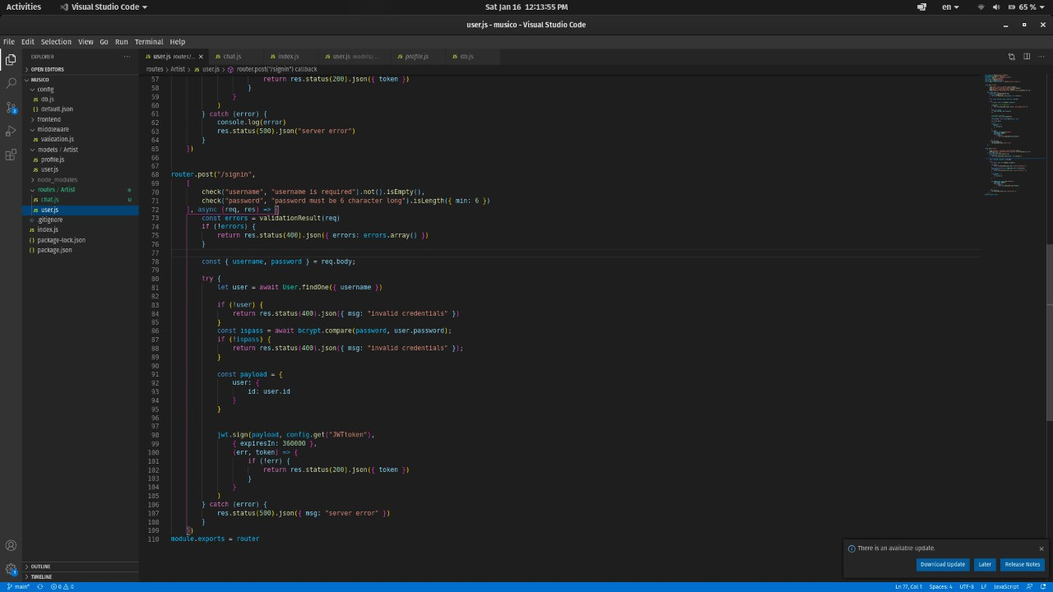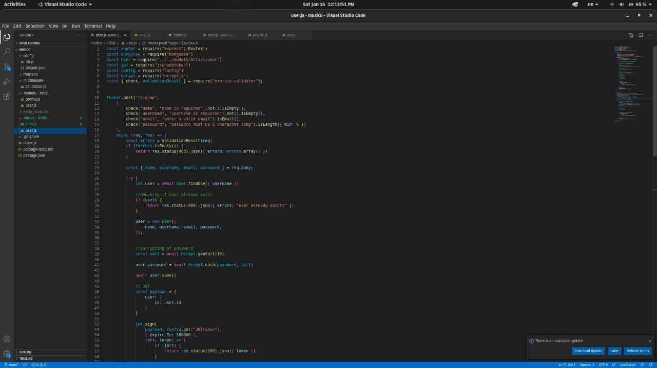

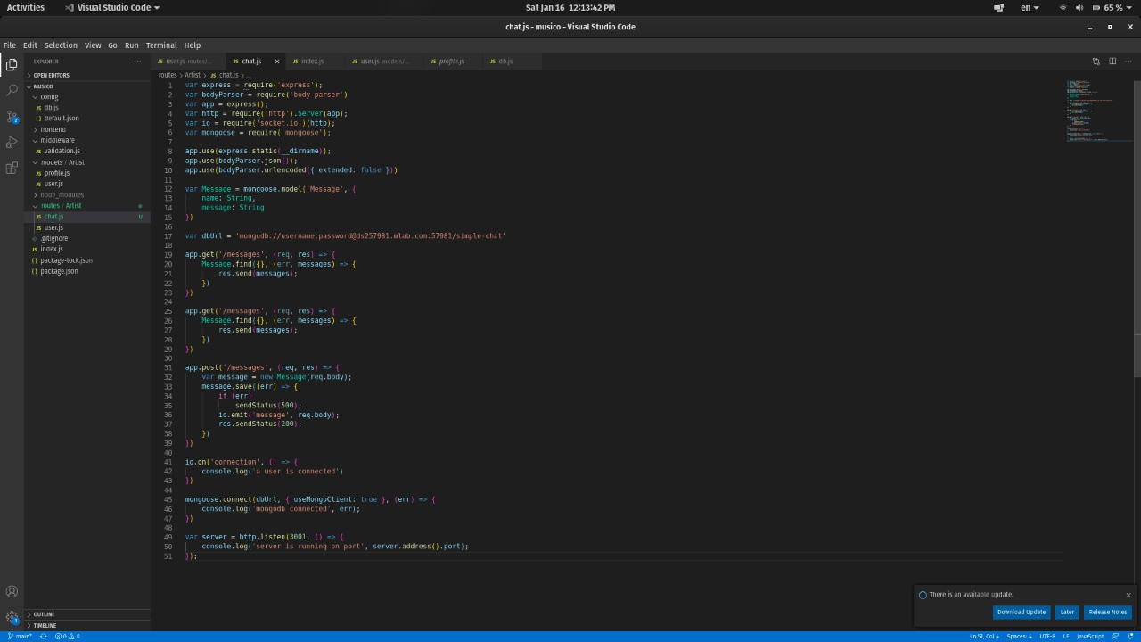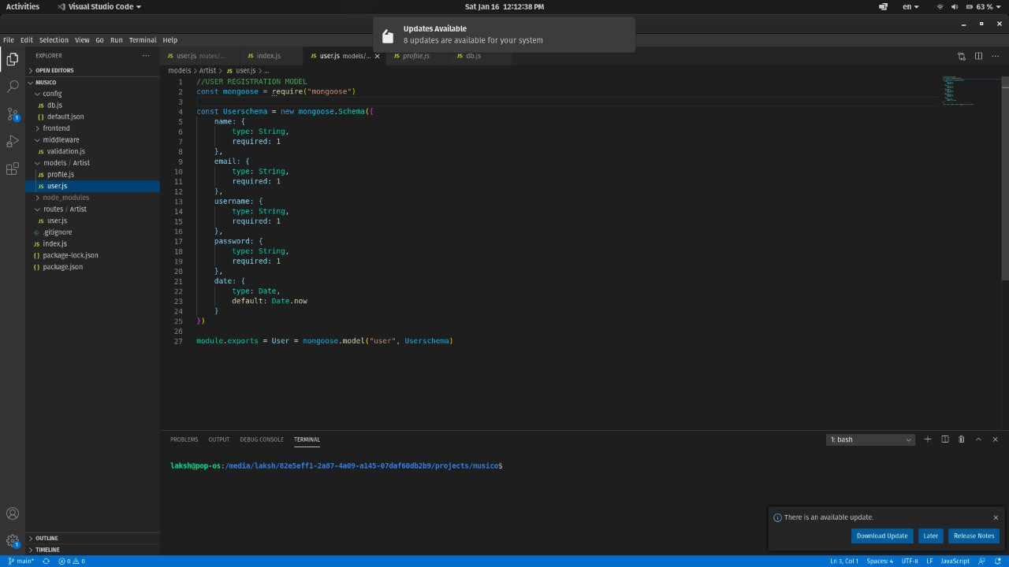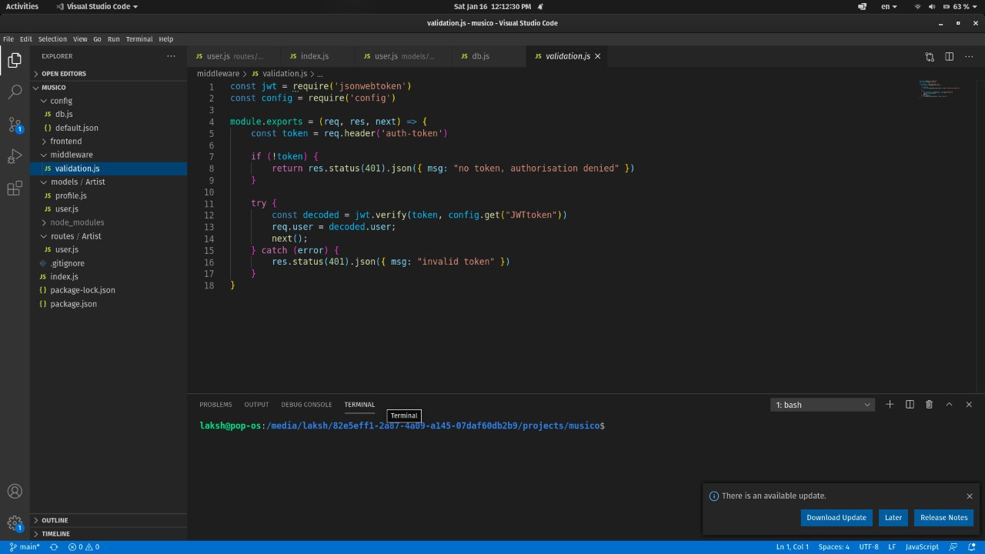

**13**

**14**

# U I SNAPSHOTS

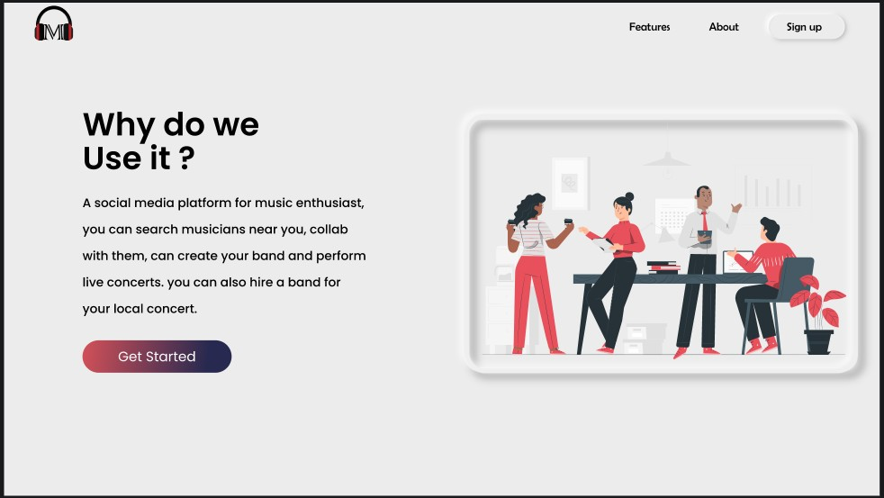

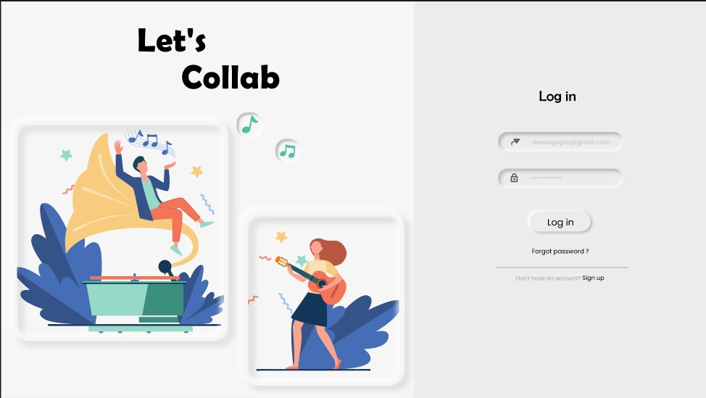

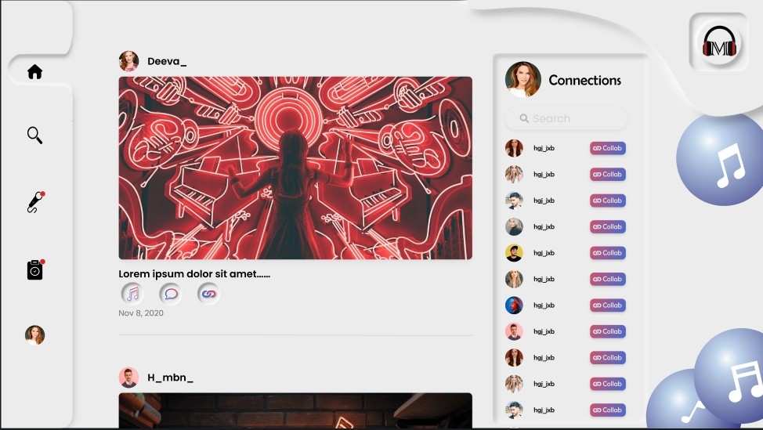

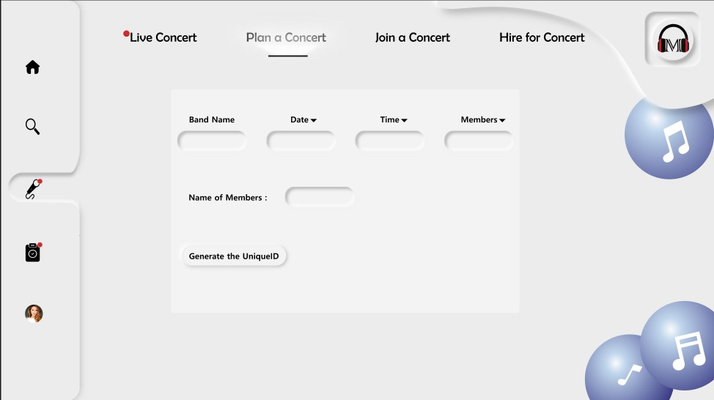

**15**

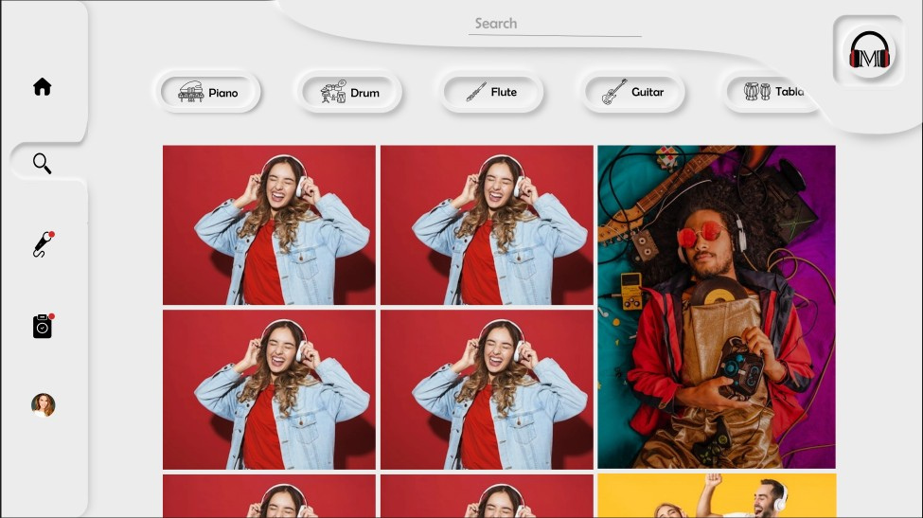

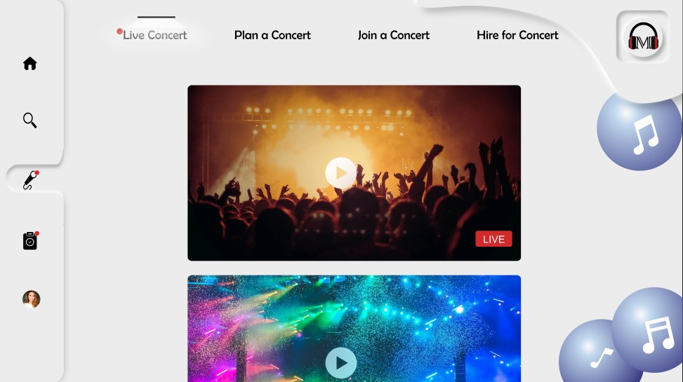

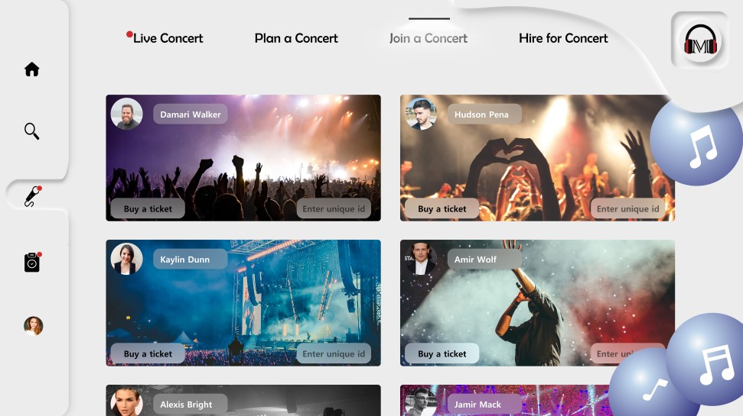

**16**

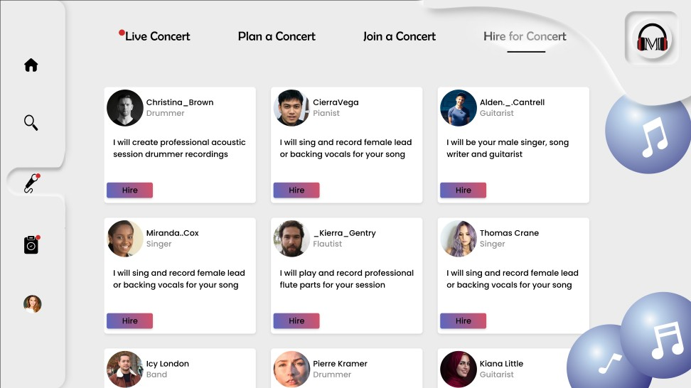

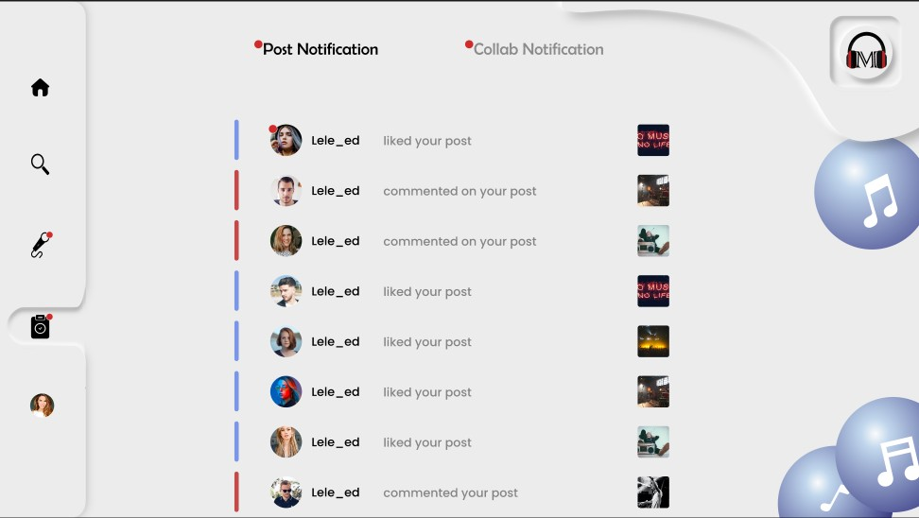

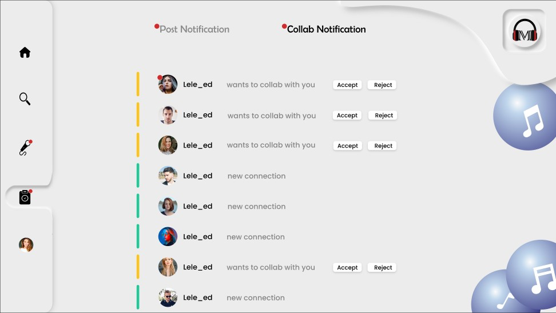

**17**

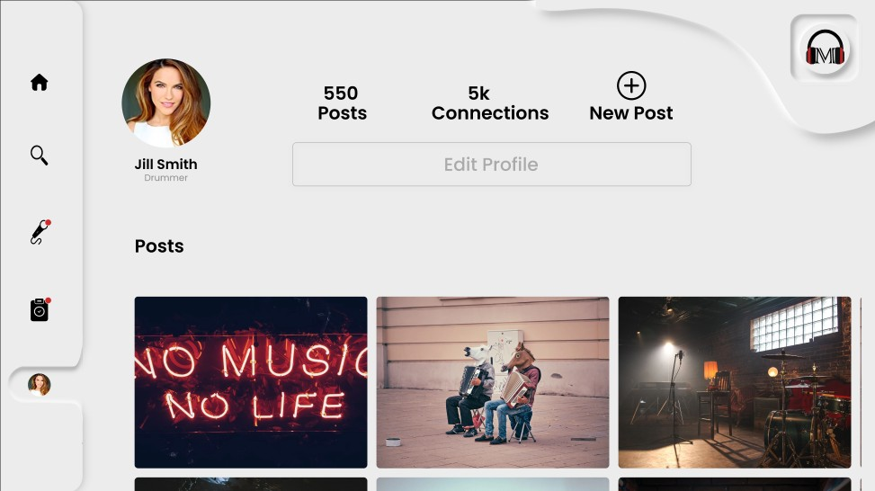

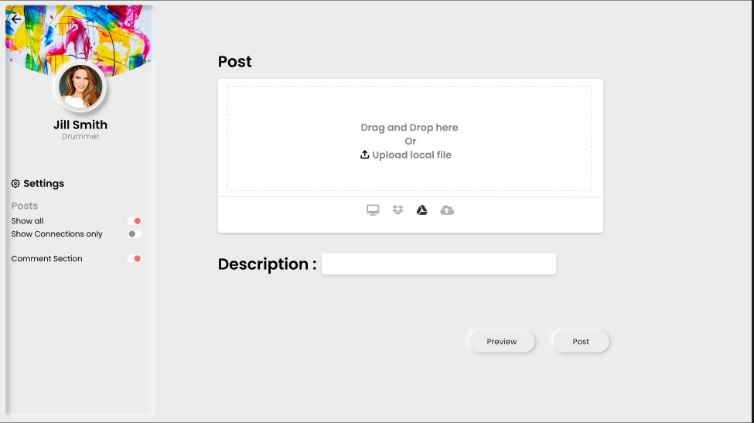

**18**

**FUTURE SCOPE**

In the future, we will add a “video call” feature to our app. By which musicians can collab easily(face-to-face) with other musicians from anywhere, which is very convenient for the performers.

**19**

# CONCLUSION

**Musico** is basically a web application that helps musicians to stay connected with other musicians nearby them and schedule online/offline concerts together.

Other people can hire musicians by this platform as all musicians are logged in to the app with a proper profile.

**20**

# REFERENCES

https://[www.kompoz.com/music/](http://www.kompoz.com/music/) https://[www.procollabs.com/](http://www.procollabs.com/) https://[www.bandhub.com/](http://www.bandhub.com/) https://[www.musicianwave.com/10-great-music-](http://www.musicianwave.com/10-great-music-) collaboration-websites-and-apps/