Q1 | Write an SQL query to find the top 5 highest-rated restaurants in Koramangala that serve North Indian cuisine, using the Zomato Bangalore dataset.
Code | SELECT name AS restaurant_name, location, cuisines, rate FROM zomato WHERE location LIKE '%Koramangala%' AND cuisines LIKE '%North Indian%' AND rate NOT IN ('NEW', '-') ORDER BY CAST(SUBSTRING_INDEX(rate, '/', 1) AS DECIMAL(3,1)) DESC LIMIT 5;
Output | 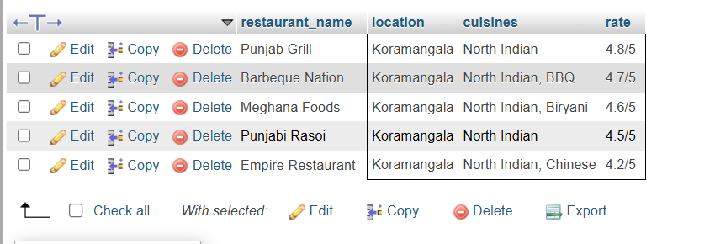

Q2 | Using SQL, calculate the average cost for two people for each cuisine type and list the 3 most expensive cuisines to eat in Bangalore.
Code | SELECT cuisines, AVG(approx_cost_for_two) AS average_cost FROM zomato GROUP BY cuisines ORDER BY average_cost DESC LIMIT 3;
Output | 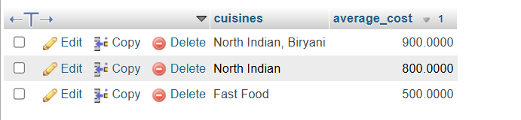

Q3 | Find all restaurants that offer online delivery but have a rating below 3.0, and suggest a marketing strategy to improve their ratings based on your findings.<br><br><em><strong>Hint:</strong> Look for patterns in location, cuisine, or price that might explain the low ratings.</em>
Code | SELECT name, location, cuisines, rate, online_order FROM zomato WHERE online_order = 'Yes' AND CAST(SUBSTRING_INDEX(rate, '/', 1) AS DECIMAL(3,1)) < 3.0;
Output | 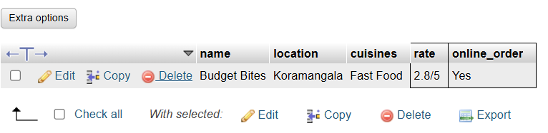

Q4 | Write an SQL query to segment restaurants into three market segments based on average cost for two: budget (below 400), mid-range (400-800), and premium (above 800). Count how many restaurants fall into each segment.
Code | SELECT CASE WHEN approx_cost_for_two < 400 THEN 'Budget' WHEN approx_cost_for_two BETWEEN 400 AND 800 THEN 'Mid-Range' ELSE 'Premium' END AS market_segment, COUNT(*) AS total_restaurants FROM zomato GROUP BY market_segment;
Output | 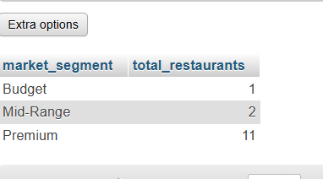

Q5 | Use ChatGPT or Copilot to help you write an SQL query that lists the top 10 most popular restaurant chains (by number of outlets) in the dataset, then run and validate the query yourself.<br><br><em><strong>Hint:</strong> Search for 'SQL group by count example' if you get stuck.</em>
Code | SELECT name AS restaurant_chain, COUNT(*) AS number_of_outlets FROM zomato GROUP BY name ORDER BY number_of_outlets DESC LIMIT 10;
Output | 