Q1 | Create a list called playlist_ids with 5 song IDs (as integers) that you might see in a Spotify playlist, and print the list.
Code | playlist_ids=[101,102,103,104,105]  print(playlist_ids)
Output | 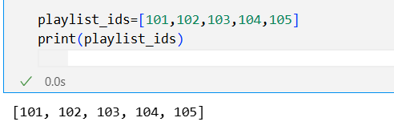

Q2 | Add two more song IDs to your playlist_ids list using both append() and extend(), then print the updated list.<br><br><em><strong>Hint:</strong> Use append() for a single ID and extend() for adding multiple IDs at once.</em>
Code | playlist_ids=[101,102,103,104,105]  playlist_ids.append(106)  playlist_ids.extend([107,108])  print(playlist_ids)
Output | 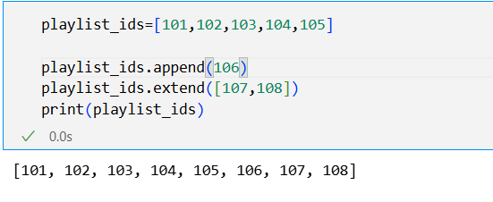

Q3 | Simulate removing the last played song from your playlist_ids list using pop(), and display the removed ID along with the remaining playlist.
code | playlist_ids=[101,102,103,104,105]  x = playlist_ids.pop()  print("Removed Song ID:", x)  print("Remaining Playlist:", playlist_ids)
Output | 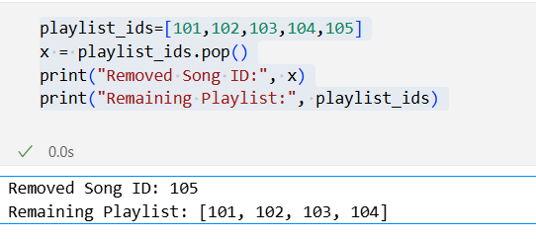

Q4 | Create a tuple called insta_filters with 4 Instagram filter names (as strings). Try to change the first filter name and observe what error you get.<br><br><em><strong>Hint:</strong> Tuples are immutable. Note down the error message.</em>
Code | insta_filters=("Gotham","Bliss","Aesthetic blur","Black.tone")  print(insta_filters)  insta_filters[0] = "Aden"
Output | 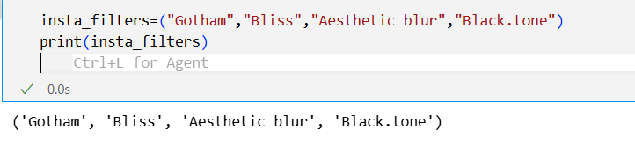  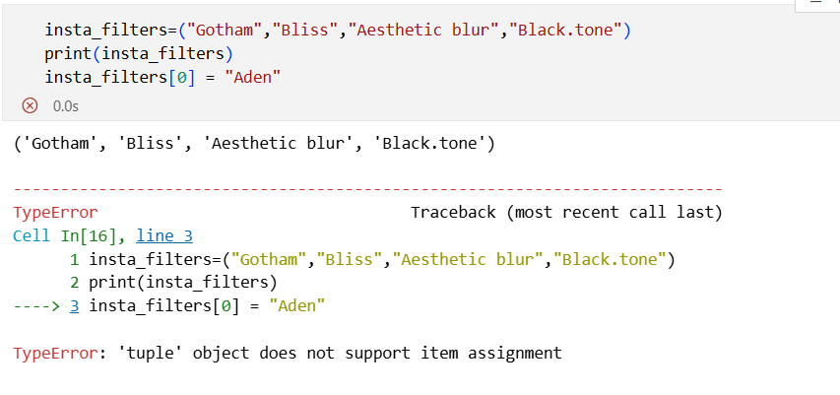

Q5 | Write a short Python script that takes a scenario (like a list of recent Zomato orders vs a tuple of fixed IPL team names) and prints which one should use a list and which should use a tuple, explaining your choice in a comment.
Code | zomato_orders = ["Pizza", "Burger", "Biryani"]  ipl_teams = ("CSK", "MI", "RCB", "KKR")  print("Zomato Orders (List):", zomato_orders)  print("IPL Teams (Tuple):", ipl_teams)
Output | 