Q1 | Use the requests library in Python to send a GET request to the public API https://jsonplaceholder.typicode.com/posts and print the titles of the first 5 posts.
Code | import requests  url = "https://jsonplaceholder.typicode.com/posts"  response = requests.get(url)  posts = response.json()  print("First 5 Post Titles:\n")  for post in posts[:5]:  print(post["title"])
Output | 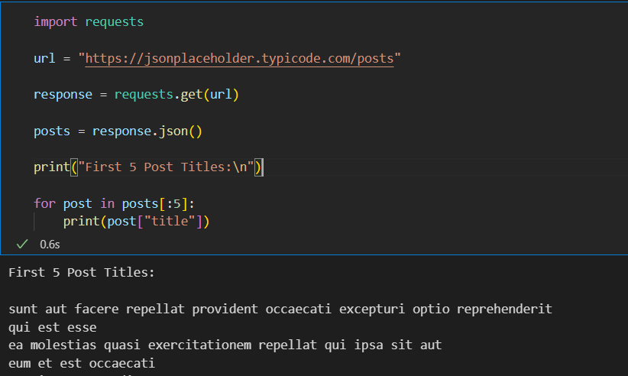

Q2 | Create a Python dictionary that represents a Zomato-style restaurant object with fields like name, location, cuisines, and ratings. Convert this dictionary to a JSON string using the json module and print the result.
Code | import json  restaurant = {  "name": "Pizza Palace",  "location": "Surat",  "cuisines": ["Italian", "Fast Food"],  "ratings": 4.5  }  restaurant_json = json.dumps(restaurant, indent=4)  print("Restaurant JSON:")  print(restaurant_json)
Output | 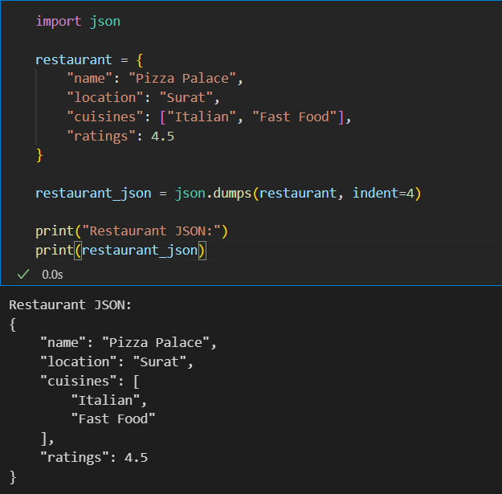

Q3 | Send a POST request to https://jsonplaceholder.typicode.com/posts to add a new playlist with fields: title, userId, and body. Print the status code and the JSON response.<br><br><em><strong>Hint:</strong> Use requests.post() and pass your data as a JSON payload.</em>
Code | import requests  url = "https://jsonplaceholder.typicode.com/posts"  playlist = {  "title": "My Favorite Songs",  "userId": 1,  "body": "Shape Of You, Levitating, Perfect"  }  response = requests.post(url, json=playlist)  print("Status Code:", response.status_code)  print("\nResponse JSON:")  print(response.json())
Output | 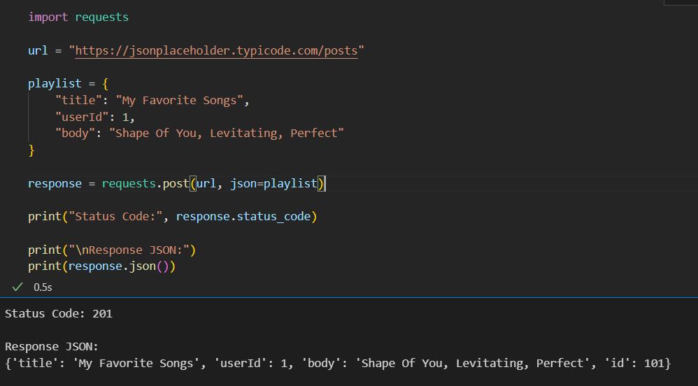

Q4 | Modify your GET request to https://jsonplaceholder.typicode.com/posts so it only fetches posts by userId=2 by passing the correct query parameter. Print the IDs of the returned posts.<br><br><em><strong>Hint:</strong> Use the 'params' argument in requests.get().</em>
Code | import requests  url = "https://jsonplaceholder.typicode.com/posts"  params = {  "userId": 2  }  response = requests.get(url, params=params)  posts = response.json()  print("Post IDs by User 2:\n")  for post in posts:  print(post["id"])
Output | 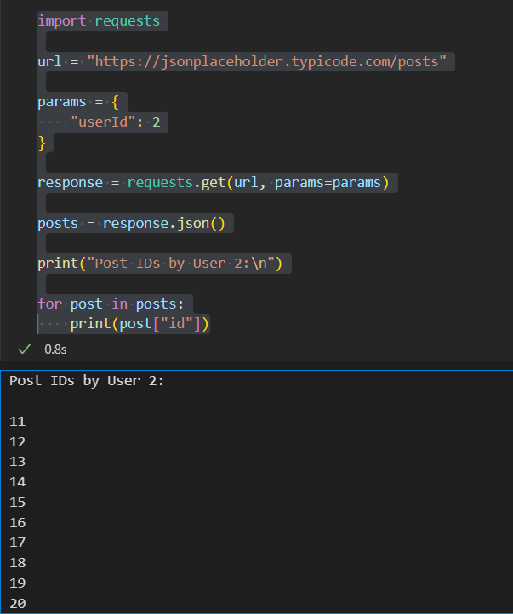

Q5 | Research using ChatGPT or Copilot to find out how to set custom HTTP headers (like 'Authorization') in a Python requests call. Write a short code snippet that sends a GET request to any API endpoint with a custom header and print the response status code.
Code | import requests  url = "https://jsonplaceholder.typicode.com/posts"  headers = {  "Authorization": "Bearer my_sample_token",  "User-Agent": "Python Requests"  }  response = requests.get(url, headers=headers)  print("Response Status Code:", response.status_code)
Output | 