Q1 | Fetch the current temperature and weather description for your city using the OpenWeatherMap API and print the results in a readable format.
Code | import requests  API_KEY = "d1fd6e3e94dabac639fc97b4011237e0"  CITY = "Ahmedabad"  url = f"https://api.openweathermap.org/data/2.5/weather?q={CITY}&appid={API_KEY}&units=metric"  try:  response = requests.get(url)  response.raise_for_status()  data = response.json()  temperature = data["main"]["temp"]  description = data["weather"][0]["description"]  print("===================================")  print(" WEATHER REPORT")  print("===================================")  print("City :", CITY)  print("Temperature :", temperature, "°C")  print("Weather :", description)  print("===================================")  except requests.exceptions.RequestException as e:  print("Error:", e)
Output | 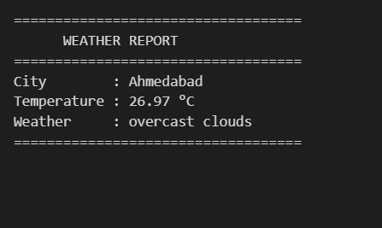

Q2 | Build a small Python script that fetches the latest price of Bitcoin and Ethereum from the CoinGecko API and displays them with the current date and time.
Code | import requests  from datetime import datetime  url = "https://api.coingecko.com/api/v3/simple/price?ids=bitcoin,ethereum&vs_currencies=usd"  try:  response = requests.get(url)  response.raise_for_status()  data = response.json()  bitcoin = data["bitcoin"]["usd"]  ethereum = data["ethereum"]["usd"]  now = datetime.now()  print("===== Cryptocurrency Prices =====")  print("Date:", now.strftime("%d-%m-%Y"))  print("Time:", now.strftime("%H:%M:%S"))  print()  print("Bitcoin : $", bitcoin)  print("Ethereum: $", ethereum)  except requests.exceptions.RequestException as e:  print("Error:", e)
Output | 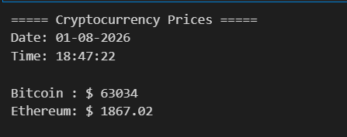

Q3 | Use the NASA Astronomy Picture of the Day (APOD) API to get today's image title and explanation, and save the image to your local system.<br><br><em><strong>Hint:</strong> The API returns a URL for the image — use requests to download it.</em>
Code | import requests  API_KEY = "DEMO_KEY"  url = f"https://api.nasa.gov/planetary/apod?api_key={API_KEY}"  try:  response = requests.get(url)  response.raise_for_status()  data = response.json()  print("===== NASA APOD =====")  print("Title:")  print(data["title"])  print()  print("Explanation:")  print(data["explanation"])  print()  image_url = data["url"]  image = requests.get(image_url)  with open("NASA_APOD.jpg", "wb") as file:  file.write(image.content)  print("Image downloaded successfully!")  print("Saved as NASA_APOD.jpg")  except requests.exceptions.RequestException as e:  print("Error:", e)
Output | 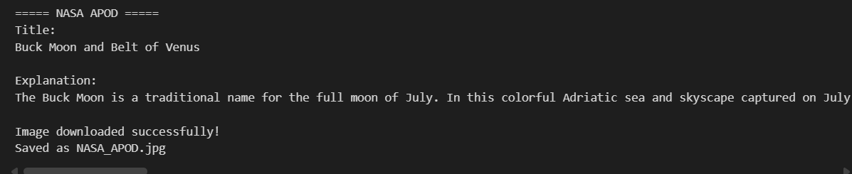

Q4 | Create a Python program that fetches the latest COVID-19 case numbers for India from a public COVID API and displays total cases, recovered, and deaths in a table format.
Code | import requests  url = "https://disease.sh/v3/covid-19/countries/India"  try:  response = requests.get(url)  response.raise_for_status()  data = response.json()  print("=" * 35)  print("COVID-19 Statistics - India")  print("=" * 35)  print(f"{'Total Cases':20}: {data['cases']}")  print(f"{'Recovered':20}: {data['recovered']}")  print(f"{'Deaths':20}: {data['deaths']}")  print("=" * 35)  except requests.exceptions.RequestException as e:  print("Error:", e)
Output | 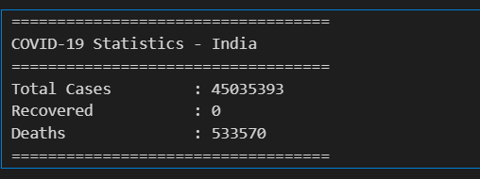

Q5 | Combine data from two APIs: fetch the current temperature in Mumbai from OpenWeatherMap and the latest Bitcoin price from CoinGecko, then display both results together in a single output.<br><br><em><strong>Constraint:</strong> Handle errors gracefully if either API call fails and show an appropriate message.</em>
Code | import requests  API_KEY = "d1fd6e3e94dabac639fc97b4011237e0"  CITY = "Ahmedabad"  url = f"https://api.openweathermap.org/data/2.5/weather?q={CITY}&appid={API_KEY}&units=metric"  try:  response = requests.get(url)  response.raise_for_status()  data = response.json()  temperature = data["main"]["temp"]  description = data["weather"][0]["description"]  print("===================================")  print(" WEATHER REPORT")  print("===================================")  print("City :", CITY)  print("Temperature :", temperature, "°C")  print("Weather :", description)  print("===================================")  except requests.exceptions.RequestException as e:  print("Error:", e)
Output | 