Q1 | Use re.findall() to extract all valid phone numbers from a given string in the format '+91-XXXXXXXXXX' (e.g., '+91-9876543210'). Print the list of found numbers.
Code | import re  text = """  Call me at +91-9773433347.  Office number is +91-9123456789.  Emergency contact: +91-9988776655.  """  phone_numbers = re.findall(r"\+91-\d{10}", text)  print("Phone Numbers Found:")  print(phone_numbers)
Output | 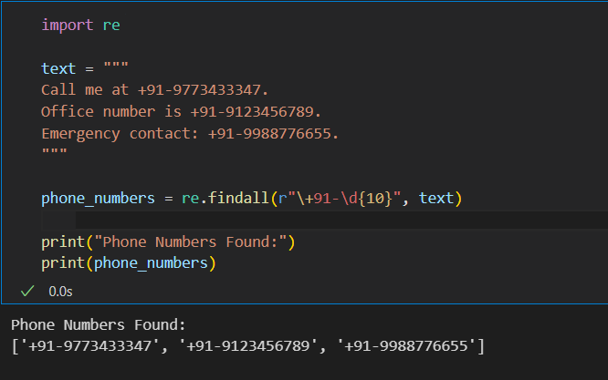

Q2 | Write a Python function using re.search() that checks if a string contains a valid date in the format 'DD/MM/YYYY'. The function should return True if a date is found, otherwise False.
Code | import re  def contains_date(text):  pattern = r"\b\d{2}/\d{2}/\d{4}\b"  if re.search(pattern, text):  return True  else:  return False  text1 = "Meeting is on 15/08/2026."  text2 = "No date is mentioned."  print(contains_date(text1))  print(contains_date(text2))
Output | 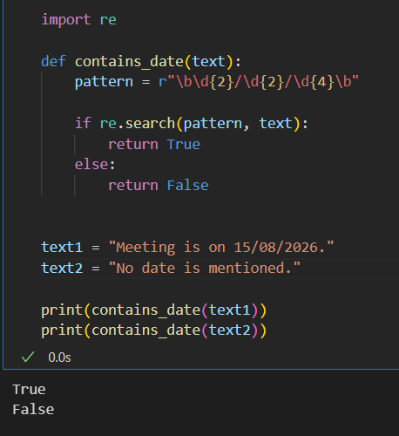

Q3 | Given a block of text containing multiple prices (like 'Rs. 299', 'Rs. 1500', etc.), use re.findall() to extract all the numeric price values as integers and print their sum.<br><br><em><strong>Hint:</strong> Look for patterns like 'Rs. ' followed by one or more digits.</em>
Code | import re  text = """  Pizza: Rs. 299  Burger: Rs. 150  Coke: Rs. 80  Ice Cream: Rs. 120  """  prices = re.findall(r"Rs\.\s*(\d+)", text)  prices = list(map(int, prices))  print("Prices:", prices)  print("Total Price:", sum(prices))
Output | 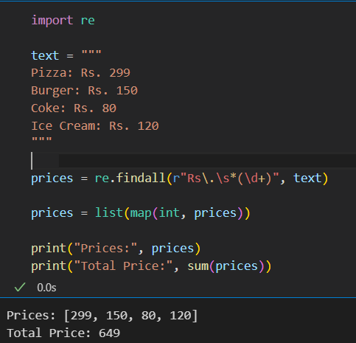

Q4 | Use re.sub() to replace all email addresses in a string with '[hidden email]' and print the modified string.<br><br><em><strong>Constraint:</strong> Do not use any external libraries except re.</em>
Code | import re  text = """  Contact us at Mrchauhan4123@gmail.com.  You can also email admin123@gmail.com.  """  new_text = re.sub(  r"[A-Za-z0-9._%+-]+@[A-Za-z0-9.-]+\.[A-Za-z]{2,}",  "[hidden email]",  text  )  print(new_text)
Output | 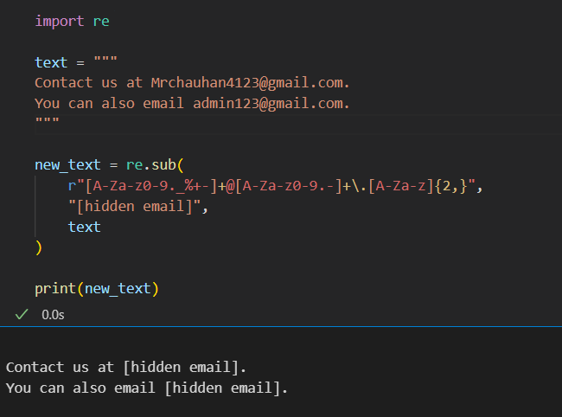

Q5 | Download a sample Instagram comments text file (or create your own with at least 10 lines), then write a Python script to extract all valid Instagram usernames (pattern: starts with '@', followed by letters, numbers, underscores, minimum 3 characters) using re.findall() and print the unique usernames.
Code | import re  with open("instagram_comments.txt", "r") as file:  comments = file.read()  usernames = re.findall(r"@[A-Za-z0-9_]{3,}", comments)  unique_usernames = sorted(set(usernames))  print("Instagram Usernames:")  for username in unique_usernames:  print(username)
Output | 