Q1 | Use the requests library to fetch the top 10 cryptocurrencies and their current prices in USD from the CoinGecko API (https://api.coingecko.com/api/v3/coins/markets?vs_currency=usd&order=market_cap_desc&per_page=10&page=1). Print the name and price of each coin.
Code | import requests  url = "https://api.coingecko.com/api/v3/coins/markets"  params = {  "vs_currency": "usd",  "order": "market_cap_desc",  "per_page": 10,  "page": 1  }  try:  response = requests.get(url, params=params)  response.raise_for_status()  coins = response.json()  print("=" * 45)  print(" Top 10 Cryptocurrencies")  print("=" * 45)  for coin in coins:  print(f"{coin['name']} : ${coin['current_price']}")  except requests.exceptions.RequestException as e:  print("Error:", e)
Output | 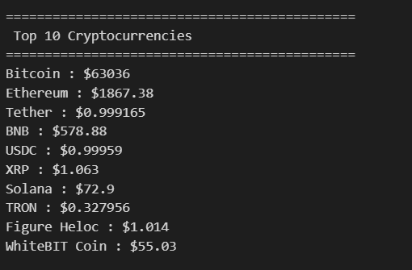

Q2 | Extend your script to also fetch and display the 24-hour price change percentage, 24-hour high, and 24-hour low for each of the top 10 cryptocurrencies.
Code | import requests  url = "https://api.coingecko.com/api/v3/coins/markets"  params = {  "vs_currency": "usd",  "order": "market_cap_desc",  "per_page": 10,  "page": 1  }  try:  response = requests.get(url, params=params)  response.raise_for_status()  coins = response.json()  print("=" * 90)  print(f"{'Coin':15} {'Price($)':12} {'24h Change %':15} {'24h High':15} {'24h Low':15}")  print("=" * 90)  for coin in coins:  print(f"{coin['name']:15} {coin['current_price']:<12} {coin['price_change_percentage_24h']:<15.2f} {coin['high_24h']:<15} {coin['low_24h']:<15}")  except requests.exceptions.RequestException as e:  print("Error:", e)
Output | 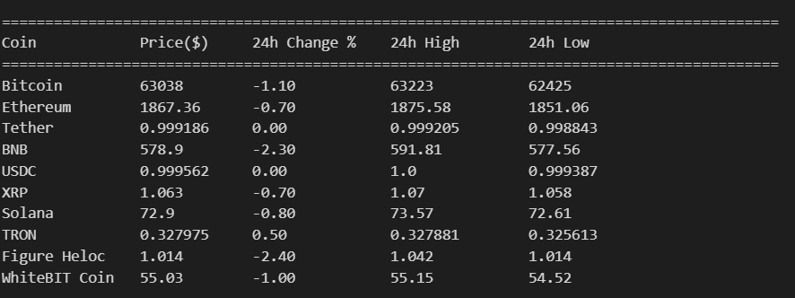

Q3 | Save the fetched data (name, current price, price change %, 24h high, 24h low) for the top 10 cryptocurrencies into a CSV file named crypto_prices.csv using the csv module.
Code | import requests  import csv  url = "https://api.coingecko.com/api/v3/coins/markets"  params = {  "vs_currency": "usd",  "order": "market_cap_desc",  "per_page": 10,  "page": 1  }  try:  response = requests.get(url, params=params)  response.raise_for_status()  coins = response.json()  with open("crypto_prices.csv", "w", newline="", encoding="utf-8") as file:  writer = csv.writer(file)  writer.writerow([  "Name",  "Current Price",  "24h Change %",  "24h High",  "24h Low"  ])  for coin in coins:  writer.writerow([  coin["name"],  coin["current_price"],  coin["price_change_percentage_24h"],  coin["high_24h"],  coin["low_24h"]  ])  print("Data saved successfully in crypto_prices.csv")  except requests.exceptions.RequestException as e:  print("Error:", e)
Output | 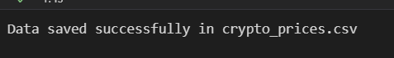

Q4 | Add error handling to your code so that if the API request fails or returns an error, your script prints a user-friendly message instead of crashing.<br><br><em><strong>Hint:</strong> Check the response status code and handle exceptions from the requests library.</em>
Code | import requests  url = "https://api.coingecko.com/api/v3/coins/markets"  params = {  "vs_currency": "usd",  "order": "market_cap_desc",  "per_page": 10,  "page": 1  }  try:  response = requests.get(url, params=params, timeout=10)  if response.status_code == 200:  coins = response.json()  print("=" * 90)  print(f"{'Coin':15} {'Price($)':12} {'24h Change %':15} {'24h High':15} {'24h Low':15}")  print("=" * 90)  for coin in coins:  print(f"{coin['name']:15} {coin['current_price']:<12} {coin['price_change_percentage_24h']:<15.2f} {coin['high_24h']:<15} {coin['low_24h']:<15}")  else:  print("Error: API returned status code", response.status_code)  except requests.exceptions.Timeout:  print("Error: The request timed out. Please try again.")  except requests.exceptions.ConnectionError:  print("Error: Please check your internet connection.")  except requests.exceptions.RequestException as e:  print("An unexpected error occurred:", e)
Output | Success  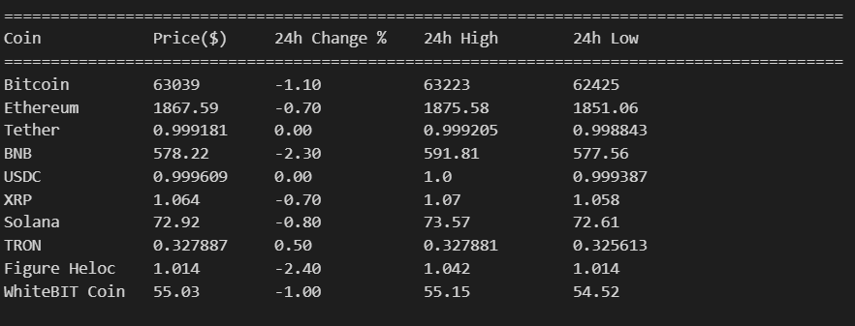  Error  