Q1 | Use the requests library to send a POST request to https://jsonplaceholder.typicode.com/posts with a JSON payload containing a title, body, and userId, then print the response status code and JSON data.
Code | import requests  url = "https://jsonplaceholder.typicode.com/posts"  data = {  "title": "Python API",  "body": "Learning POST requests in Python.",  "userId": 1  }  response = requests.post(url, json=data)  print("Status Code:", response.status_code)  print("Response JSON:")  print(response.json())
Output | 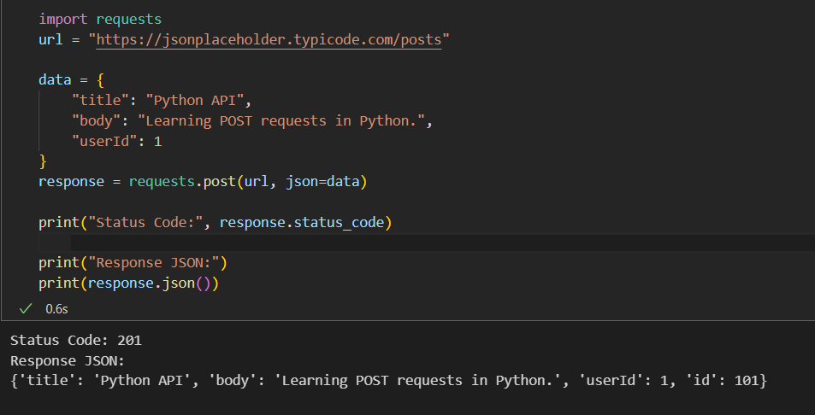

Q2 | Build a Python script that lets a user enter a new playlist name and description, sends this data as JSON in a POST request to a mock API endpoint (such as https://jsonplaceholder.typicode.com/posts), and prints the playlist ID returned by the API.
Code | 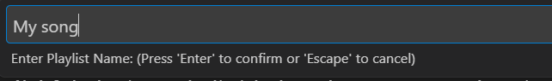  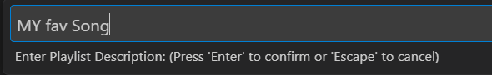  import requests  url = "https://jsonplaceholder.typicode.com/posts"  playlist_name = input("Enter Playlist Name: ")  playlist_description = input("Enter Playlist Description: ")  data = {  "title": playlist_name,  "body": playlist_description,  "userId": 1  }  response = requests.post(url, json=data)  result = response.json()  print("\nPlaylist Created Successfully!")  print("Playlist ID:", result["id"])
Output | 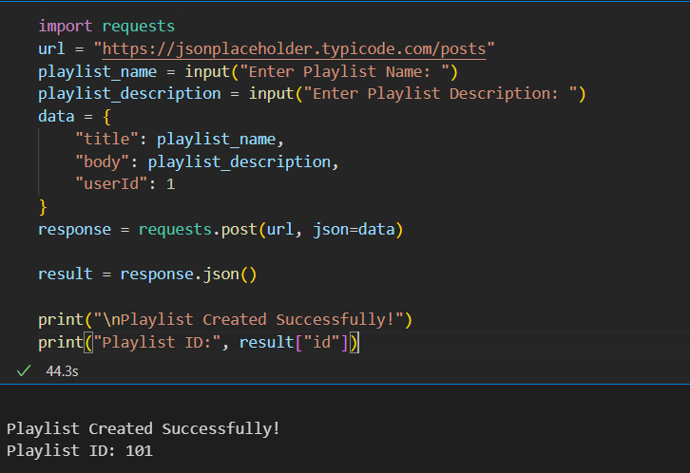

Q3 | Send a POST request to https://reqres.in/api/users with a JSON object containing a username and job, then parse the response to extract and print the created user's ID and creation timestamp.<br><br><em><strong>Hint:</strong> Use response.json() to access the returned data.</em>
Code | import requests  url = "https://jsonplaceholder.typicode.com/posts"  payload = {  "username": "Rahul",  "job": "Python Developer"  }  response = requests.post(url, json=payload)  print("Status Code:", response.status_code)  data = response.json()  print("Created User ID:", data["id"])
Output | 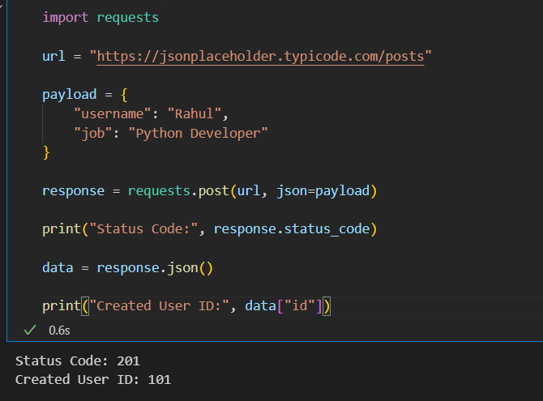

Q4 | Write a script that fetches the latest 5 posts from https://jsonplaceholder.typicode.com/posts, parses the JSON response, and saves the post titles and userIds to a CSV file called posts.csv.<br><br><em><strong>Hint:</strong> Use the csv module for writing to CSV.</em>
Code | import requests  import csv  url = "https://jsonplaceholder.typicode.com/posts"  response = requests.get(url)  posts = response.json()  with open("posts.csv", "w", newline="", encoding="utf-8") as file:  writer = csv.writer(file)  writer.writerow(["userId", "title"])  for post in posts[:5]:  writer.writerow([post["userId"], post["title"]])  print("posts.csv created successfully.")
Output | 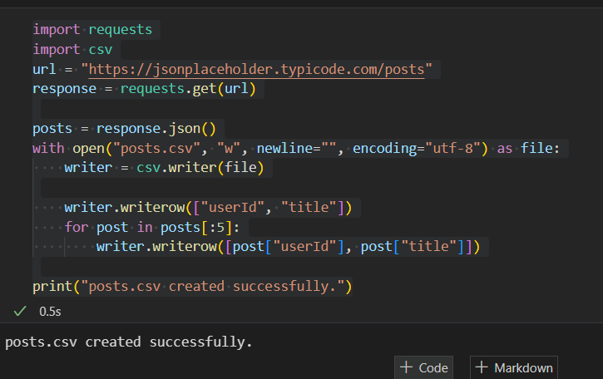

Q5 | Modify your script to save the same API data (latest 5 posts from https://jsonplaceholder.typicode.com/posts) into a JSON file named posts.json instead of CSV.
Code | import requests  import json  url = "https://jsonplaceholder.typicode.com/posts"  response = requests.get(url)  posts = response.json()  with open("posts.json", "w", encoding="utf-8") as file:  json.dump(posts[:5], file, indent=4)  print("posts.json created successfully.")
Output | 