Q1 | Create a text file named playlist.txt and write the names of 5 songs you listened to this week, each on a new line using Python's open() function in write mode.
Code | with open("playlist.txt", "w") as file:  file.write("Shape Of You\n")  file.write("Blinding Lights\n")  file.write("Levitating\n")  file.write("Senorita\n")  file.write("Perfect\n")  print("playlist.txt has been created successfully.")
Output | 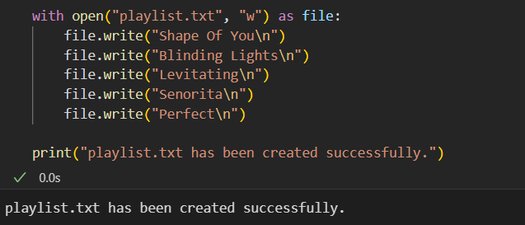

Q2 | Read the playlist.txt file you created and display each song name in uppercase letters using Python
Code | with open("playlist.txt", "r") as file:  for song in file:  print(song.strip().upper())
Output | 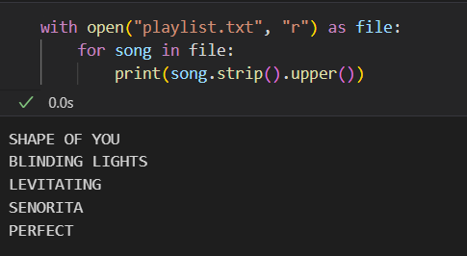

Q3 | Download a sample CSV file of IPL match scores (you can create your own with columns: match_id, team1, team2, winner) and write a Python script to read the file and print the winner of each match using the csv module.
Code | import csv  with open("ipl_matches.csv", "r") as file:  reader = csv.DictReader(file)  print("IPL Match Winners:")  for row in reader:  print(f"Match {row['match_id']}: {row['winner']}")
Output | 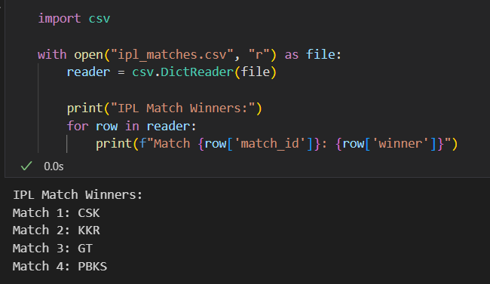

Q4 | Find a public JSON file of trending movies (or create your own movies.json with at least 3 movie objects containing title, year, and rating), then use the json module in Python to load the file and print the title and rating of each movie.
Code | import json  with open("movies.json", "r") as file:  movies = json.load(file)  print("Movie Ratings:")  for movie in movies:  print(f"{movie['title']} - Rating: {movie['rating']}")
Output | 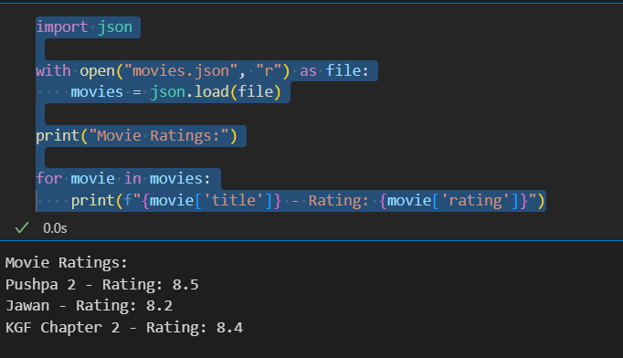

Q5 | Use the pathlib module to check if a file called 'my_fav_apps.json' exists in your current directory, and if not, create it and write a JSON array of your top 3 mobile apps (e.g., Instagram, Zomato, Paytm) with their names and categories.<br><br><em><strong>Hint:</strong> Use Path('my_fav_apps.json').exists() to check for the file, and json.dump() to write the data.</em>
Code | from pathlib import Path  import json  file_path = Path("my_fav_apps.json")  if not file_path.exists():  apps = [  {"name": "Instagram", "category": "Social Media"},  {"name": "Zomato", "category": "Food Delivery"},  {"name": "Paytm", "category": "Payments"}  ]  with open(file_path, "w") as file:  json.dump(apps, file, indent=4)  print("my_fav_apps.json created successfully.")  else:  print("my_fav_apps.json already exists.")
Output | 