Q1 | Create a Python class called Product with attributes name and price, and a method get_discounted_price() that returns the price after applying a 10% discount.
Code | class Product:  def __init__(self, name, price):  self.name = name  self.price = price  def get_discounted_price(self):  return self.price * 0.90  product = Product("Shoes", 2000)  print("Product:", product.name)  print("Original Price: ₹", product.price)  print("Discounted Price: ₹", product.get_discounted_price())
Output | 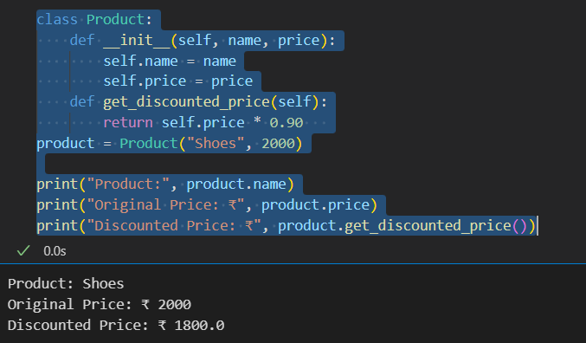

Q2 | Now create a subclass called Electronics that inherits from Product and overrides the get_discounted_price() method to apply a 20% discount instead of 10%.
Code | class Product:  def __init__(self, name, price):  self.name = name  self.price = price  def get_discounted_price(self):  return self.price * 0.90  class Electronics(Product):  def get_discounted_price(self):  return self.price * 0.80  laptop = Electronics("Laptop", 50000)  print("Product:", laptop.name)  print("Original Price: ₹", laptop.price)  print("Discounted Price: ₹", laptop.get_discounted_price())
Output | 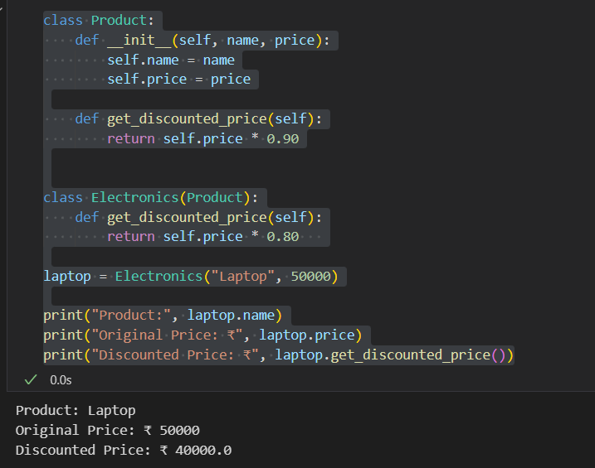

Q3 | Write a function show_final_price(item) that takes any Product or Electronics object and prints its name and the discounted price by calling get_discounted_price(). Demonstrate polymorphism by passing both a Product and an Electronics object to this function.
Code | class Product:  def __init__(self, name, price):  self.name = name  self.price = price  def get_discounted_price(self):  return self.price * 0.90  class Electronics(Product):  def get_discounted_price(self):  return self.price * 0.80  def show_final_price(item):  print(f"{item.name} - Final Price: ₹{item.get_discounted_price()}")  product = Product("Notebook", 100)  electronic = Electronics("Smartphone", 30000)  show_final_price(product)  show_final_price(electronic)
Output | 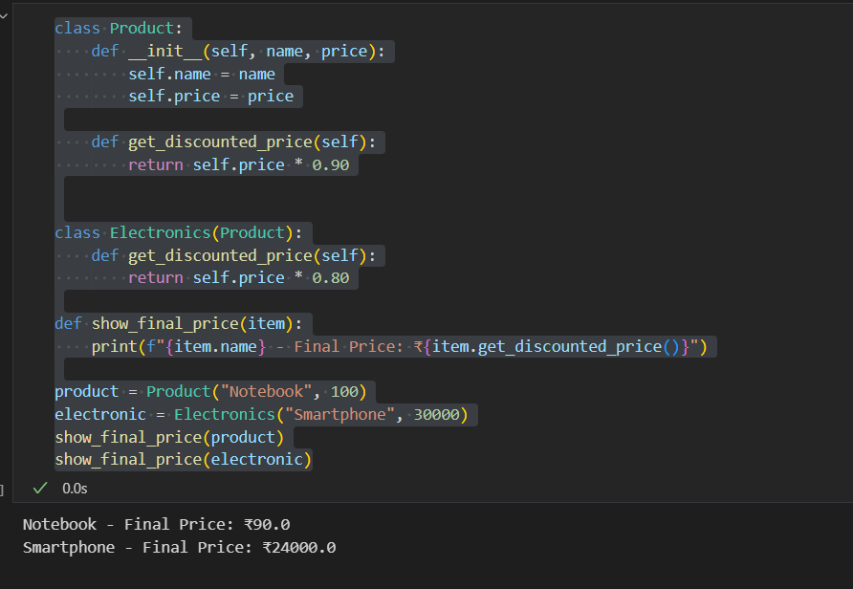

Q4 | Build a simple Ticket class for a movie booking app with a method get_final_price(). Then, create a subclass PremiumTicket that overrides get_final_price() to add a 50 rupee convenience fee. Show both in action by creating objects and printing their final prices.<br><br><em><strong>Hint:</strong> Use super() in PremiumTicket to reuse the parent method and add the extra fee.</em>
Code | class Ticket:  def __init__(self, movie_name, price):  self.movie_name = movie_name  self.price = price  def get_final_price(self):  return self.price  class PremiumTicket(Ticket):  def get_final_price(self):  return super().get_final_price() + 50  normal = Ticket("Avengers", 250)  premium = PremiumTicket("Avengers", 250)  print("Normal Ticket Price: ₹", normal.get_final_price())  print("Premium Ticket Price: ₹", premium.get_final_price())
Output | 