Q1 | Define a Python class called Song with attributes title, artist, and duration (in seconds). Create an object for your favorite song and print its details.
Code | class Song:  def __init__(self, title, artist, duration):  self.title = title  self.artist = artist  self.duration = duration  favorite_song = Song("Shape Of You", "Ed Sheeran", 233)  print("Song Details")  print("Title:", favorite_song.title)  print("Artist:", favorite_song.artist)  print("Duration:", favorite_song.duration, "seconds")
Output | 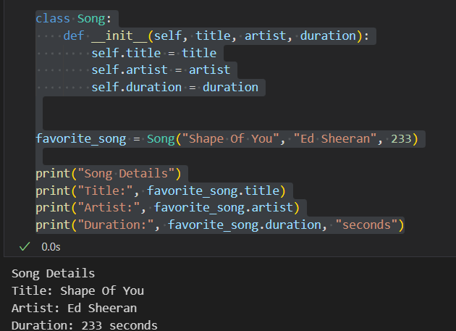

Q2 | Add a method play_preview(self) to the Song class that prints 'Playing 30-second preview of [title] by [artist]'. Call this method using the object you created.
Code | class Song:  def __init__(self, title, artist, duration):  self.title = title  self.artist = artist  self.duration = duration  def play_preview(self):  print(f"Playing 30-second preview of {self.title} by {self.artist}")  favorite_song = Song("Shape Of You", "Ed Sheeran", 233)  favorite_song.play_preview()
Output | 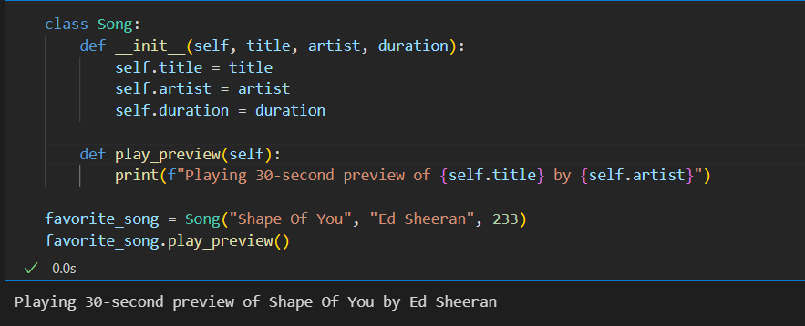

Q3 | Create a class called FoodOrder with attributes: restaurant_name, items (list), and total_price. Write an __init__() constructor to initialize these, then create an object representing your last Zomato or Swiggy order and print its details.
Code | class FoodOrder:  def __init__(self, restaurant_name, items, total_price):  self.restaurant_name = restaurant_name  self.items = items  self.total_price = total_price  order = FoodOrder(  "Zomato",  ["Pizza", "Burger"],  650  )  print("Food Order Details")  print("Restaurant:", order.restaurant_name)  print("Items:", order.items)  print("Total Price: ₹", order.total_price)
Output | 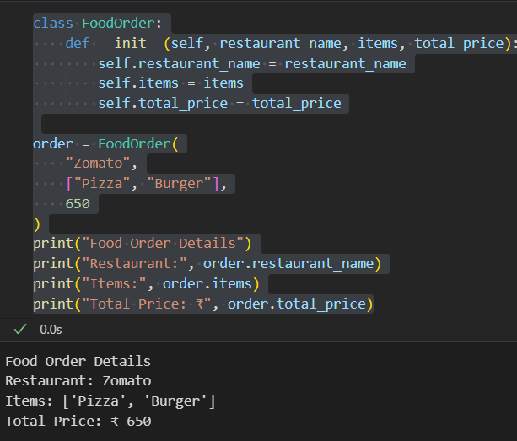

Q4 | Extend the FoodOrder class by adding a method add_item(self, item_name, item_price) that adds the item to the items list and updates total_price. Demonstrate by adding two items to your order and printing the updated total.
Code | class FoodOrder:  def __init__(self, restaurant_name, items, total_price):  self.restaurant_name = restaurant_name  self.items = items  self.total_price = total_price  def add_item(self, item_name, item_price):  self.items.append(item_name)  self.total_price += item_price  order = FoodOrder(  "Swiggy",  ["Pizza"],  300  )  order.add_item("Burger", 150)  order.add_item("Coke", 50)  print("Restaurant:", order.restaurant_name)  print("Items:", order.items)  print("Updated Total Price: ₹", order.total_price)
Output | 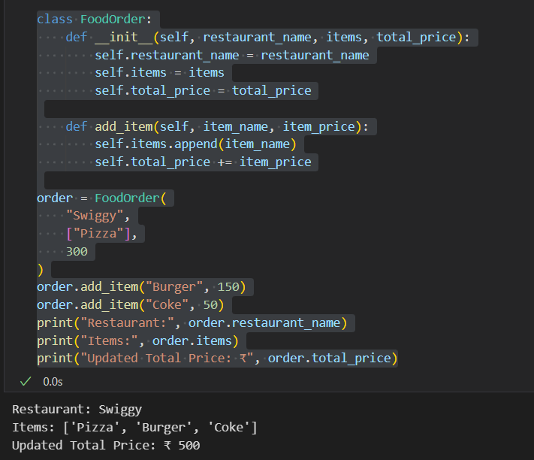

Q5 | Refactor your Song class so that the duration attribute is optional in the constructor (default to 0 if not provided).<br><br><em><strong>Hint:</strong> Use a default argument for duration in the __init__() method.</em>
Code | class Song:  def __init__(self, title, artist, duration=0):  self.title = title  self.artist = artist  self.duration = duration  song1 = Song("Shape Of You", "Ed Sheeran", 233)  song2 = Song("Perfect", "Ed Sheeran")  print("Song 1")  print(song1.title, "-", song1.artist, "-", song1.duration, "seconds")  print()  print("Song 2")  print(song2.title, "-", song2.artist, "-", song2.duration, "seconds")
Output | 