Q1 | Write a Python function called get_song_duration_per_minute that divides the total duration of a Spotify playlist (in minutes) by the number of songs, and handles the case where the number of songs is zero using try, except, and finally blocks.
Code | def get_song_duration_per_minute(total_duration, number_of_songs):  try:  average = total_duration / number_of_songs  print("Average duration per song:", average, "minutes")  except ZeroDivisionError:  print("Error: Number of songs cannot be zero.")  finally:  print("Calculation completed.")  get_song_duration_per_minute(120, 10)  get_song_duration_per_minute(120, 0)
Output | 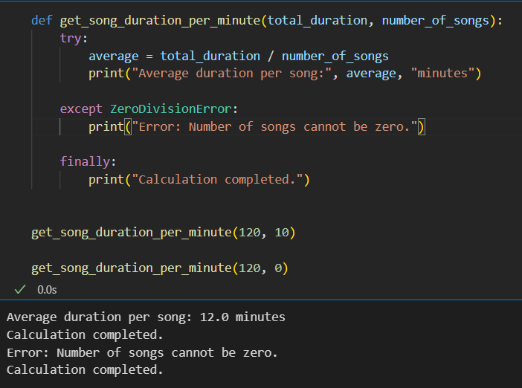

Q2 | Build a Flipkart-style price-per-item calculator: take total cart amount and item count as input, perform division, and use try-except to catch and display a user-friendly message if the item count is zero.
Code | try:  total_amount = float(input("Enter total cart amount: "))  item_count = int(input("Enter number of items: "))  price_per_item = total_amount / item_count  print("Price per item: ₹", price_per_item)  except ZeroDivisionError:  print("Item count cannot be zero. Please enter at least one item.")  except ValueError:  print("Please enter valid numbers.")  finally:  print("Thank you for using the Flipkart calculator.")
Output | 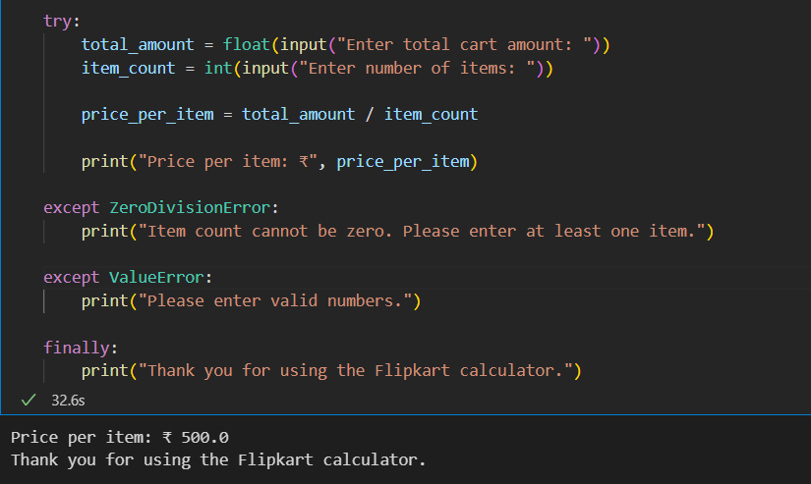

Q3 | Create a Paytm cashback calculator that asks for total spend and number of offers applied, then divides spend by offers to show average cashback per offer. If the number of offers is zero, raise a custom exception called NoOffersApplied and display a custom error message.<br><br><em><strong>Hint:</strong> Define your own exception class by subclassing Exception.</em>
Code | 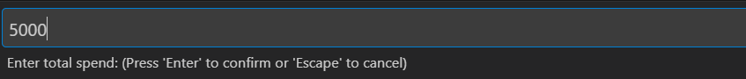  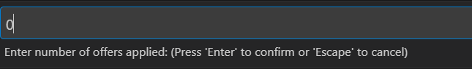  class NoOffersApplied(Exception):  pass  try:  total_spend = float(input("Enter total spend: "))  offers = int(input("Enter number of offers applied: "))  if offers == 0:  raise NoOffersApplied("No offers were applied.")  average_cashback = total_spend / offers  print("Average cashback per offer:", average_cashback)  except NoOffersApplied as e:  print("Custom Error:", e)  except ValueError:  print("Please enter valid numbers.")  finally:  print("Calculation Finished.")
Output | 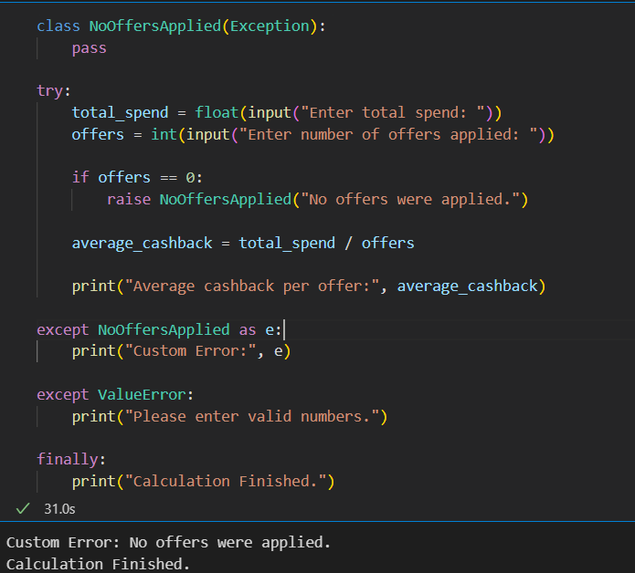

Q4 | Refactor the following buggy code to handle exceptions correctly so it never crashes and always prints 'Thank you for using the calculator' at the end, even if an exception occurs:<br><br>def calculate_average_rating(total_rating, num_reviews):<br> return total_rating / num_reviews<br>print(calculate_average_rating(500, 0))
Code | def calculate_average_rating(total_rating, num_reviews):  try:  average = total_rating / num_reviews  return average  except ZeroDivisionError:  return "Error: Number of reviews cannot be zero."  finally:  print("Thank you for using the calculator")  print(calculate_average_rating(500, 0))
Output | 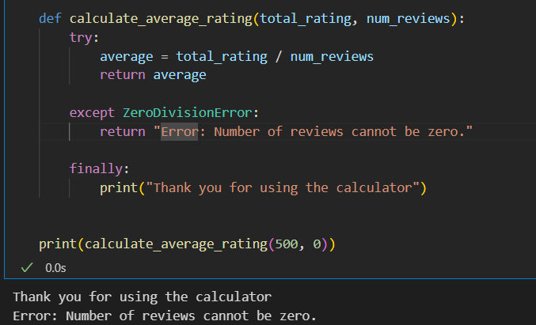

Q5 | Write a function called safe_divide_for_zomato that takes two numbers (bill amount and number of people), uses try, except, else, and finally to divide the bill and print the result, print a custom error if division by zero, and always print 'Split calculation done' at the end.
Code | def safe_divide_for_zomato(bill_amount, number_of_people):  try:  result = bill_amount / number_of_people  except ZeroDivisionError:  print("Error: Number of people cannot be zero.")  else:  print("Each person should pay:", result)  finally:  print("Split calculation done")  safe_divide_for_zomato(2000, 4)  print()  safe_divide_for_zomato(2000, 0)
Output | 