Q1 | Create a Python class called Playlist with a private attribute _songs (a list) and a public method add_song(song) to add a song title to the playlist. Print the playlist after adding 3 songs.
Code | class Playlist:  def __init__(self):  self._songs = []  def add_song(self, song):  self._songs.append(song)  def show_playlist(self):  print("Playlist:", self._songs)  playlist = Playlist()  playlist.add_song("Shape Of You")  playlist.add_song("Levitating")  playlist.add_song("Blinding Lights")  playlist.show_playlist()
Output | 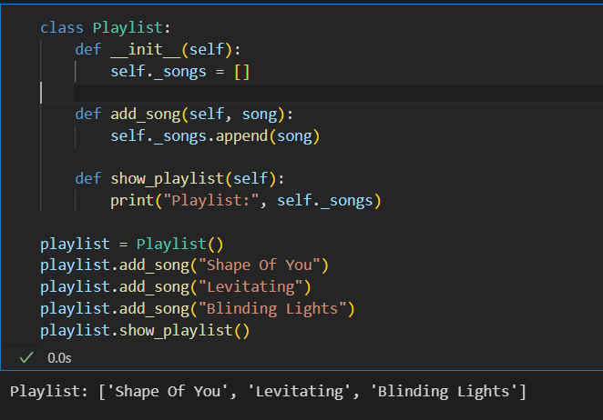

Q2 | Build a Product class for a Flipkart-style app with a private attribute _price. Implement get_price() and set_price() methods to access and update the price. Demonstrate setting and getting the price for a product object.
Code | class Product:  def __init__(self, name, price):  self.name = name  self._price = price  def get_price(self):  return self._price  def set_price(self, new_price):  self._price = new_price  product = Product("Wireless Mouse", 799)  print("Original Price: ₹", product.get_price())  product.set_price(999)  print("Updated Price: ₹", product.get_price())
Output | 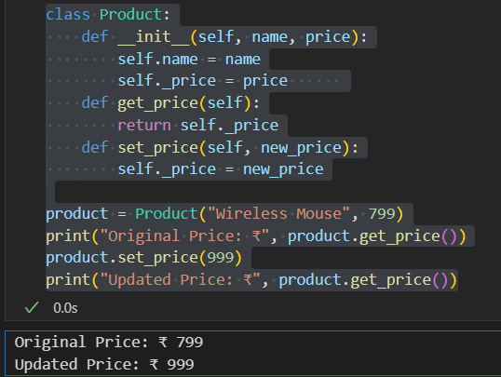

Q3 | Create a Movie class with a private attribute _rating (float between 0 and 10). Write getter and setter methods for _rating. The setter should only allow values between 0 and 10; if an invalid value is given, print an error message.<br><br><em><strong>Constraint:</strong> Do not allow direct access to _rating outside the class.</em>
Code | class Movie:  def __init__(self, title, rating):  self.title = title  self._rating = 0  self.set_rating(rating)  def get_rating(self):  return self._rating  def set_rating(self, rating):  if 0 <= rating <= 10:  self._rating = rating  else:  print("Error: Rating must be between 0 and 10.")  movie = Movie("Pushpa 2", 8.5)  print("Movie:", movie.title)  print("Rating:", movie.get_rating())  movie.set_rating(12)  movie.set_rating(9.2)  print("Updated Rating:", movie.get_rating())
Output | 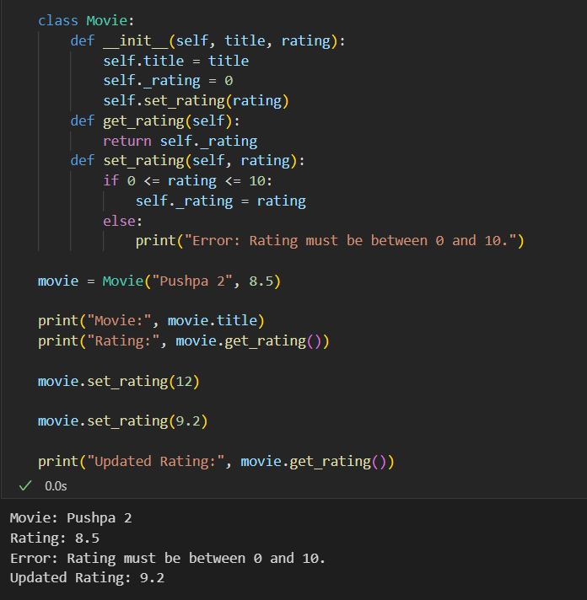

Q4 | Design a simple abstract class PaymentMethod with an abstract method pay(amount). Then, create two subclasses: Paytm and PhonePe, each implementing pay(amount) to print a different message. Instantiate both and call their pay methods with any amount
Code | from abc import ABC, abstractmethod  class PaymentMethod(ABC):  @abstractmethod  def pay(self, amount):  pass  class Paytm(PaymentMethod):  def pay(self, amount):  print(f"Paid ₹{amount} using Paytm.")  class PhonePe(PaymentMethod):  def pay(self, amount):  print(f"Paid ₹{amount} using PhonePe.")  paytm = Paytm()  phonepe = PhonePe()  paytm.pay(500)  phonepe.pay(1000)
Output | 