Q1 | Write a recursive function in Python called print_playlist_songs(songs) that takes a list of song names (like a Spotify playlist) and prints each song name one by one using recursion.
Code | def print_playlist_songs(songs):  if len(songs) == 0:  return  print(songs[0])  print_playlist_songs(songs[1:])  playlist = [  "Shape Of You",  "Blinding Lights",  "Levitating",  "Senorita"  ]  print_playlist_songs(playlist)
Output | 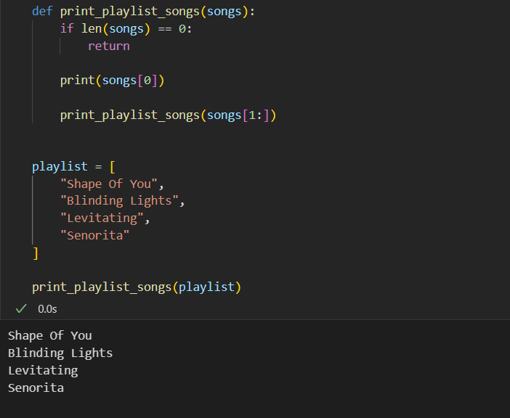

Q2 | Create a recursive function count_unread_messages(messages) that takes a nested dictionary representing WhatsApp chat groups and subgroups, and returns the total number of unread messages across all groups.<br><br><em><strong>Hint:</strong> Each group can have a 'count' key for unread messages and a 'subgroups' key with a list of more groups.</em>
Code | def count_unread_messages(group):  total = group.get("count", 0)  for subgroup in group.get("subgroups", []):  total += count_unread_messages(subgroup)  return total  messages = {  "name": "Family",  "count": 10,  "subgroups": [  {  "name": "Cousins",  "count": 5,  "subgroups": []  },  {  "name": "Friends",  "count": 8,  "subgroups": [  {  "name": "College Friends",  "count": 3,  "subgroups": []  }  ]  }  ]  }  print("Total Unread Messages:", count_unread_messages(messages))
Output | 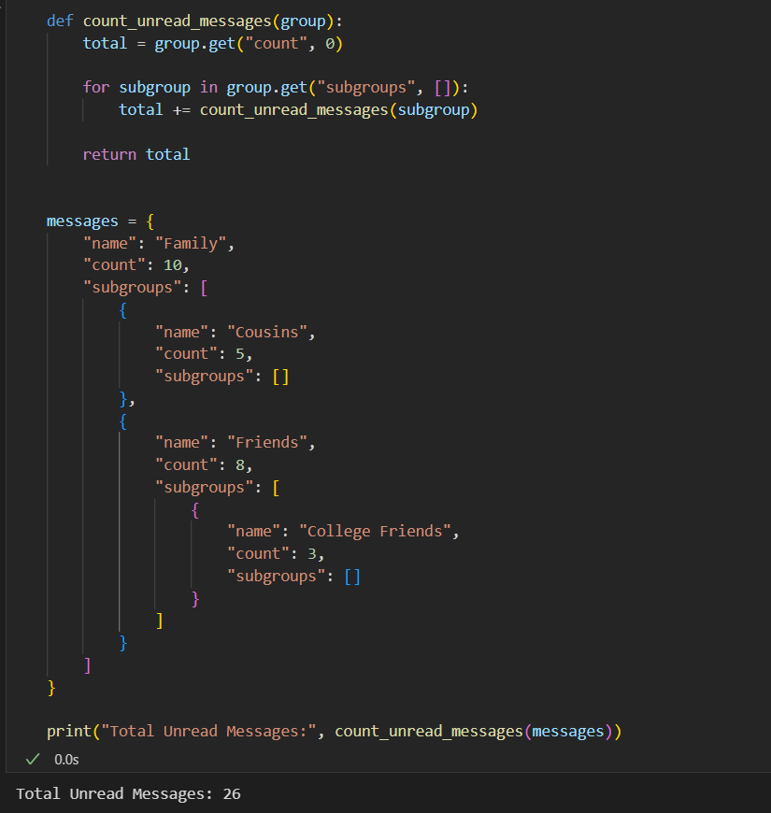

Q3 | Given the following code, identify which variables are local and which are global, and explain what will be printed when you call outer() and then print(x) at the end:<br><br>```python  x = 'global'  def outer():  x = 'outer'  def inner():  nonlocal x  x = 'inner'  inner()  print('Inside outer:', x)  outer()  print('Outside:', x)  ```<br><br><em><strong>Hint:</strong> Focus on the scope of x inside and outside the functions.</em>
Code | x = "global"  def outer():  x = "outer"  def inner():  nonlocal x  x = "inner"  inner()  print("Inside outer:", x)  outer()  print("Outside:", x)
Output | 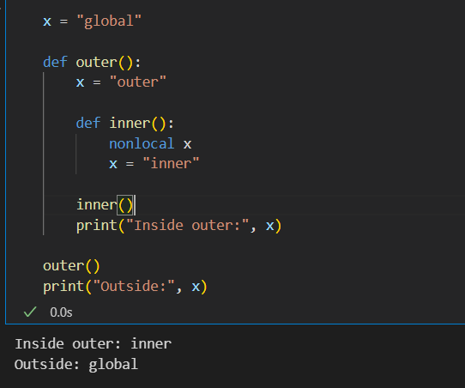

Q4 | Build a recursive function format_number_short(n) that takes a number (like a follower count on Instagram or YouTube) and returns it as a string in short format: 1500 as '1.5K', 1200000 as '1.2M', 500 as '500'.
Code | def format_number_short(n):  if n < 1000:  return str(n)  elif n < 1000000:  return str(round(n / 1000, 1)) + "K"  else:  return str(round(n / 1000000, 1)) + "M"  numbers = [500, 1500, 25000, 1200000]  for num in numbers:  print(num, "->", format_number_short(num))
Output | 