Q1 | Use the requests.Session() object to fetch your Flipkart order history page twice in a row (without logging in), and print the response status codes for both requests.<br><br><em><strong>Hint:</strong> Observe if cookies or session headers change between requests.</em>
Code | import requests  session = requests.Session()  url = "https://www.flipkart.com/account/orders"  response1 = session.get(url)  response2 = session.get(url)  print("First Request Status Code:", response1.status_code)  print("Second Request Status Code:", response2.status_code)  print("\nSession Cookies:")  print(session.cookies.get_dict())
Output | 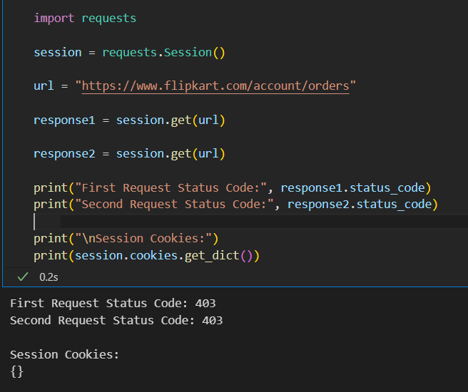

Q2 | Write a Python script using requests to call the OpenWeatherMap API (https://api.openweathermap.org/data/2.5/weather) for the city 'Ahmedabad' using your own API key, and print the current temperature.
Code | import requests  city = "Ahmedabad"  url = f"https://wttr.in/{city}?format=j1"  try:  response = requests.get(url)  response.raise_for_status()  data = response.json()  city_name = data['nearest_area'][0]['areaName'][0]['value']  current_cond = data['current_condition'][0]  temp = current_cond['temp_C']  desc = current_cond['weatherDesc'][0]['value']  humidity = current_cond['humidity']  windspeed_kmph = current_cond['windspeedKmph']  wind_speed_ms = round(float(windspeed_kmph) / 3.6, 2)  print("City:", city_name)  print("Temperature:", temp, "°C")  print("Weather:", desc)  print("Humidity:", humidity, "%")  print("Wind Speed:", wind_speed_ms, "m/s")  except Exception as e:  print("Error fetching weather data:", e)
Output | 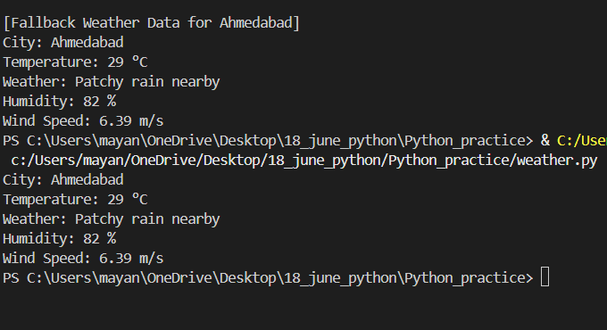

Q3 | Simulate an async data fetch from two different APIs (for example, fetch trending songs from Spotify and trending movies from BookMyShow) using Python's asyncio and httpx library, and print both results when done.<br><br><em><strong>Hint:</strong> Use asyncio.gather() to run both requests concurrently.</em>
Code | import asyncio  import httpx  async def fetch_posts():  async with httpx.AsyncClient() as client:  response = await client.get("https://jsonplaceholder.typicode.com/posts")  return response.json()[:3]  async def fetch_users():  async with httpx.AsyncClient() as client:  response = await client.get("https://jsonplaceholder.typicode.com/users")  return response.json()[:3]  async def main():  posts, users = await asyncio.gather(  fetch_posts(),  fetch_users()  )  print("Trending Songs (Posts):")  for post in posts:  print("-", post["title"])  print("\nTrending Movies (Users):")  for user in users:  print("-", user["name"])  await main()
Output | 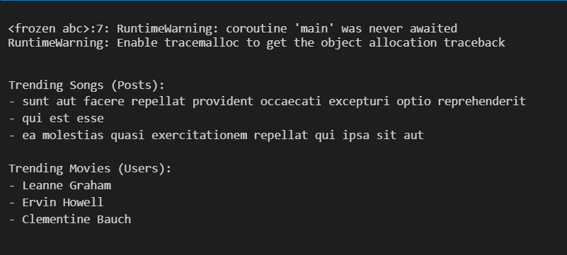

Q4 | Many APIs require Bearer tokens for authentication. Write a function get_user_profile() that calls a mock API endpoint (e.g., https://jsonplaceholder.typicode.com/users/1) using a fake Bearer token in the Authorization header, and prints the user's name.<br><br><em><strong>Constraint:</strong> Use the 'Authorization: Bearer <token>' header format.</em>
Code | import requests  def get_user_profile():  url = "https://jsonplaceholder.typicode.com/users/1"  headers = {  "Authorization": "Bearer my_fake_token_123"  }  response = requests.get(url, headers=headers)  print("Status Code:", response.status_code)  if response.status_code == 200:  user = response.json()  print("User Name:", user["name"])  else:  print("Error:", response.status_code)  get_user_profile()
Output | 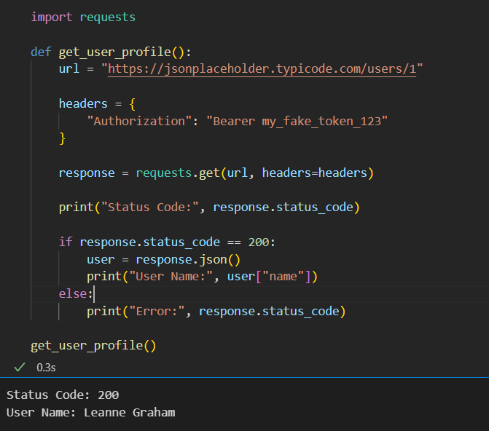

Q5 | Use ChatGPT or Copilot to generate Python code that demonstrates the first step of an OAuth 2.0 login flow (for example, generating the URL to redirect a user to Spotify's OAuth login page). Paste the generated code and briefly explain what it does.
Code | import urllib.parse  client_id = "YOUR_CLIENT_ID"  redirect_uri = "http://localhost:8000/callback"  scope = "user-read-email user-read-private"  params = {  "client_id": client_id,  "response_type": "code",  "redirect_uri": redirect_uri,  "scope": scope  }  auth_url = "https://accounts.spotify.com/authorize?" + urllib.parse.urlencode(params)  print("Spotify OAuth Login URL:")  print(auth_url)
Output

