Q1 | Use iter() and next() to manually loop through a list of your 5 favorite food delivery apps (like Zomato, Swiggy, Domino's, etc.) and print each app name one by one.
Code | apps = ["Zomato", "Swiggy", "Domino's", "Pizza Hut", "Uber Eats"]  app_iterator = iter(apps)  print(next(app_iterator))  print(next(app_iterator))  print(next(app_iterator))  print(next(app_iterator))  print(next(app_iterator))
Output | 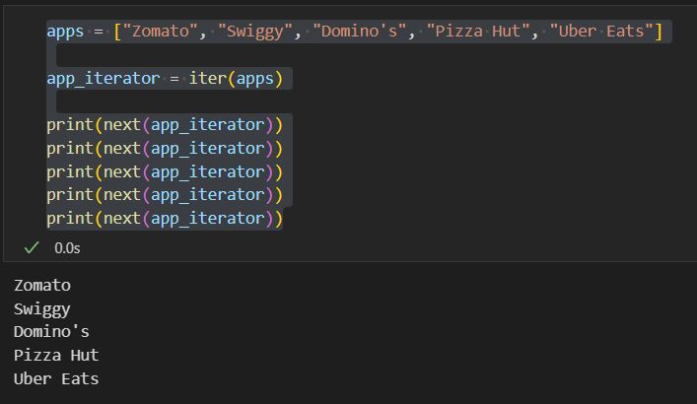

Q2 | Write a generator function called playlist_generator that takes a list of song names and yields each song one at a time, simulating a Spotify playlist shuffle.
Code | def playlist_generator(songs):  for song in songs:  yield song  songs = [  "Shape Of You",  "Blinding Lights",  "Levitating",  "Senorita",  "Perfect"  ]  playlist = playlist_generator(songs)  for song in playlist:  print(song)
Output | 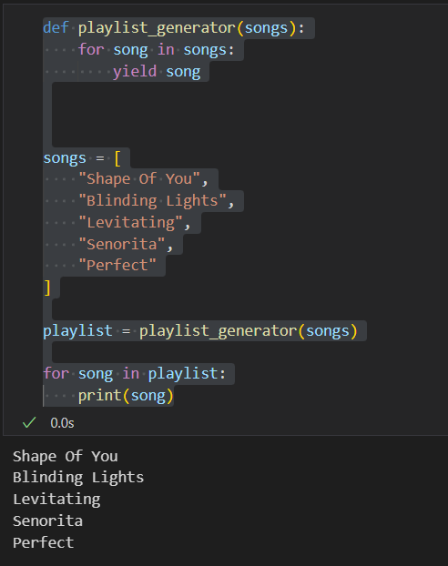

Q3 | Use enumerate() to print out the index and name of each item in a shopping cart list (e.g., ['Pizza', 'Burger', 'Fries', 'Coke']) like Flipkart displays item numbers in your cart.
Code | cart = ["Pizza", "Burger", "Fries", "Coke"]  for index, item in enumerate(cart, start=1):  print(f"Item {index}: {item}")
Output | 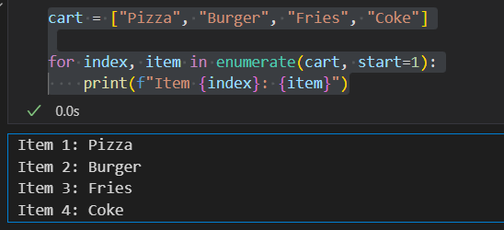

Q4 | Given two lists — one with cricket team names and one with their IPL points — use zip() to pair each team with its points and print them in the format: 'Team: Mumbai Indians, Points: 18'.
Code | teams = [  "Mumbai Indians",  "Chennai Super Kings",  "Royal Challengers Bangalore",  "Kolkata Knight Riders"  ]  points = [18, 16, 14, 12]  for team, point in zip(teams, points):  print(f"Team: {team}, Points: {point}")
Output | 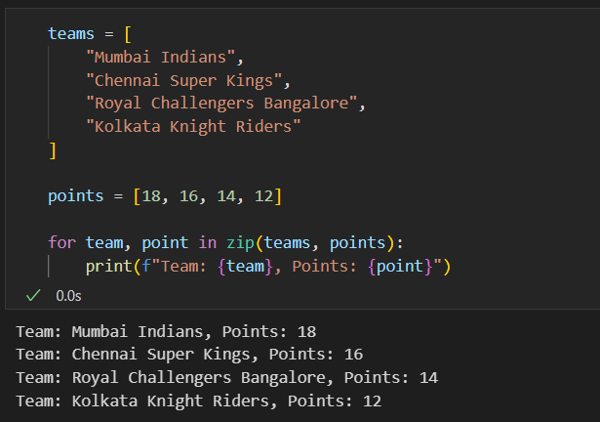

Q5 | Create a generator function called order_id_generator that yields a new order ID (starting from 1001) each time it's called, similar to how Zomato or Swiggy generates unique order numbers.<br><br><em><strong>Hint:</strong> Use the yield statement inside a loop to generate the next ID.</em>
Code | def order_id_generator():  order_id = 1001  while True:  yield order_id  order_id += 1  orders = order_id_generator()  print(next(orders))  print(next(orders))  print(next(orders))  print(next(orders))  print(next(orders))
Output | 